UNITED STATES
SECURITIES AND EXCHANGE COMMISSION
Washington, D.C. 20549
FORM 8-K
CURRENT REPORT
Pursuant to Section 13 or 15(d) of the Securities Exchange Act of 1934
Date of Report (Date of earliest event reported): October 5, 2026

SERVE ROBOTICS INC.
(Exact Name of Registrant as Specified in Charter)
Delaware |  |  |  |  |  | 001-42023 |  |  |  |  |  | 85-3844872
(State or Other Jurisdiction  of Incorporation) |  |  |  |  |  | (Commission File Number) |  |  |  |  |  | (IRS Employer  Identification No.)
1360 Bayport Avenue  San Carlos, California |  |  |  |  |  | 94070
(Address of Principal Executive Offices) |  |  |  |  |  | (Zip Code)
(818) 860-1352
(Registrant’s telephone number, including area code)

N/A
(Former Name or Former Address, if Changed Since Last Report)
Check the appropriate box below if the Form 8-K filing is intended to simultaneously satisfy the filing obligation of the registrant under any of the following provisions:
☐ Written communications pursuant to Rule 425 under the Securities Act (17 CFR 230.425)
☐ Soliciting material pursuant to Rule 14a-12 under the Exchange Act (17 CFR 240.14a-12)
☐ Pre-commencement communications pursuant to Rule 14d-2(b) under the Exchange Act (17 CFR 240.14d-2(b))
☐ Pre-commencement communications pursuant to Rule 13e-4(c) under the Exchange Act (17 CFR 240.13e-4(c))
Securities registered pursuant to Section 12(b) of the Act:
Title of each class |  |  |  |  |  | Trading Symbol(s) |  |  |  |  |  | Name of each exchange on which registered
Common Stock, par value $0.0001 per share |  |  |  |  |  | SERV |  |  |  |  |  | The Nasdaq Capital Market
Indicate by check mark whether the registrant is an emerging growth company as defined in Rule 405 of the Securities Act of 1933 (§230.405 of this chapter) or Rule 12b-2 of the Securities Exchange Act of 1934 (§240.12b-2 of this chapter).
Emerging growth company ☒
If an emerging growth company, indicate by check mark if the registrant has elected not to use the extended transition period for complying with any new or revised financial accounting standards provided pursuant to Section 13(a) of the Exchange Act. ☐

Item 2.02. Results of Operations and Financial Condition.

On October 5, 2026, Serve Robotics Inc. (the “Company”) made available on its website a Company investor presentation that may be used in presentations to investors from time to time, updated to include additional information regarding the Company’s cost of revenue for the year ending December 31, 2026. The cost of revenue is based on preliminary unaudited information and management estimates for the second half of the year ending December 31, 2026, is not a comprehensive statement of the Company’s financial results as of and for the second half of the fiscal year ending December 31, 2026, and is subject to completion of the Company’s financial closing procedures. The Company’s independent registered public accounting firm has not conducted an audit or review of, and does not express an opinion or any other form of assurance with respect to, these preliminary estimates.
A copy of the investor presentation is furnished as Exhibit 99.1 to this Current Report on Form 8-K.

Item 7.01. Regulation FD Disclosure.

The information disclosed in Item 2.02 above is incorporated by reference into this Item 7.01.

The information in this Form 8-K (including Exhibits 99.1) shall not be deemed “filed” for purposes of Section 18 of the Securities Exchange Act of 1934, as amended (the “Exchange Act”), or otherwise subject to the liabilities of that section, nor shall it be deemed incorporated by reference in any filing under the Securities Act of 1933, as amended, or the Exchange Act, except as expressly set forth by specific reference in such a filing.

Forward-Looking Statements

This Current Report on Form 8-K contains “forward-looking statements” within the meaning of the Private Securities Litigation Reform Act of 1995. Such forward-looking statements can be identified by the use of words such as “should,” “may,” “intends,” “anticipates,” “believes,” “estimates,” “projects,” “forecasts,” “expects,” “plans,” “proposes” and similar expressions. Forward-looking statements contained in this Current Report on Form 8-K include statements regarding the Company’s preliminary unaudited expectations for cost of revenue for the year ending December 31, 2026. Although the Company believes that the expectations reflected in these forward-looking statements are based on reasonable assumptions, there are a number of risks, uncertainties and other important factors that could cause actual results to differ materially from such forward-looking statements, including the factors discussed under the heading “Risk Factors” in the Company’s Annual Report on Form 10-K for the year ended December 31, 2025, as updated by its other filings with the Securities and Exchange Commission. Forward-looking statements speak only as of the date of the document in which they are contained, and the Company does not undertake any duty to update any forward-looking statements, except as may be required by law.

Item 9.01. Financial Statements and Exhibits.
(d)List of Exhibits.
Exhibit  Number |  |  |  |  |  | Description
99.1 |  |  |  |  |  | Investor Presentation, dated October 2026
104 |  |  |  |  |  | Cover Page Interactive Data File (embedded within the Inline XBRL document)

1

SIGNATURES
Pursuant to the requirements of the Securities Exchange Act of 1934, the registrant has duly caused this report to be signed on its behalf by the undersigned hereunto duly authorized.
 |  |  | Serve Robotics Inc.
Dated: October 5, 2026 |  |  | /s/ Brian Read
 |  |  | Brian Read
 |  |  | Chief Financial Officer
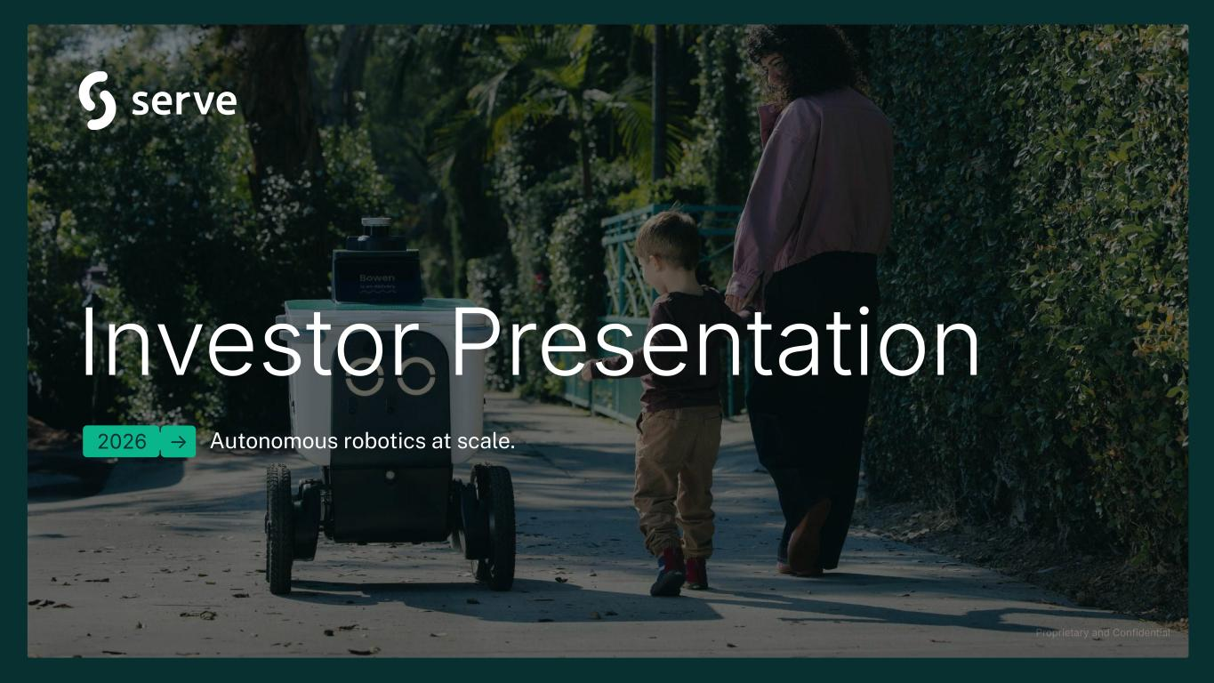
2
Proprietary and Confidential Investor Presentation 2026 Autonomous robotics at scale.→

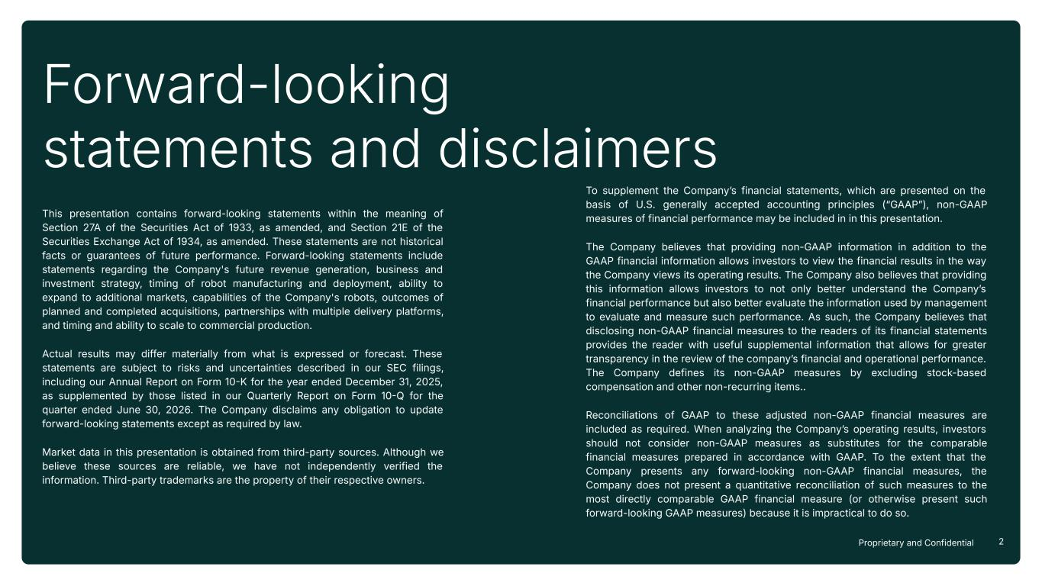
2Proprietary and Confidential Forward-looking statements and disclaimers This presentation contains forward-looking statements within the meaning of Section 27A of the Securities Act of 1933, as amended, and Section 21E of the Securities Exchange Act of 1934, as amended. These statements are not historical facts or guarantees of future performance. Forward-looking statements include statements regarding the Company's future revenue generation, business and investment strategy, timing of robot manufacturing and deployment, ability to expand to additional markets, capabilities of the Company's robots, outcomes of planned and completed acquisitions, partnerships with multiple delivery platforms, and timing and ability to scale to commercial production. Actual results may differ materially from what is expressed or forecast. These statements are subject to risks and uncertainties described in our SEC filings, including our Annual Report on Form 10K for the year ended December 31, 2025, as supplemented by those listed in our Quarterly Report on Form 10Q for the quarter ended June 30, 2026. The Company disclaims any obligation to update forward-looking statements except as required by law. Market data in this presentation is obtained from third-party sources. Although we believe these sources are reliable, we have not independently verified the information. Third-party trademarks are the property of their respective owners. To supplement the Companyʼs financial statements, which are presented on the basis of U.S. generally accepted accounting principles (“GAAPˮ), non-GAAP measures of financial performance may be included in in this presentation. The Company believes that providing non-GAAP information in addition to the GAAP financial information allows investors to view the financial results in the way the Company views its operating results. The Company also believes that providing this information allows investors to not only better understand the Companyʼs financial performance but also better evaluate the information used by management to evaluate and measure such performance. As such, the Company believes that disclosing non-GAAP financial measures to the readers of its financial statements provides the reader with useful supplemental information that allows for greater transparency in the review of the companyʼs financial and operational performance. The Company defines its non-GAAP measures by excluding stock-based compensation and other non-recurring items.. Reconciliations of GAAP to these adjusted non-GAAP financial measures are included as required. When analyzing the Companyʼs operating results, investors should not consider non-GAAP measures as substitutes for the comparable financial measures prepared in accordance with GAAP. To the extent that the Company presents any forward-looking non-GAAP financial measures, the Company does not present a quantitative reconciliation of such measures to the most directly comparable GAAP financial measure (or otherwise present such forward-looking GAAP measures) because it is impractical to do so.

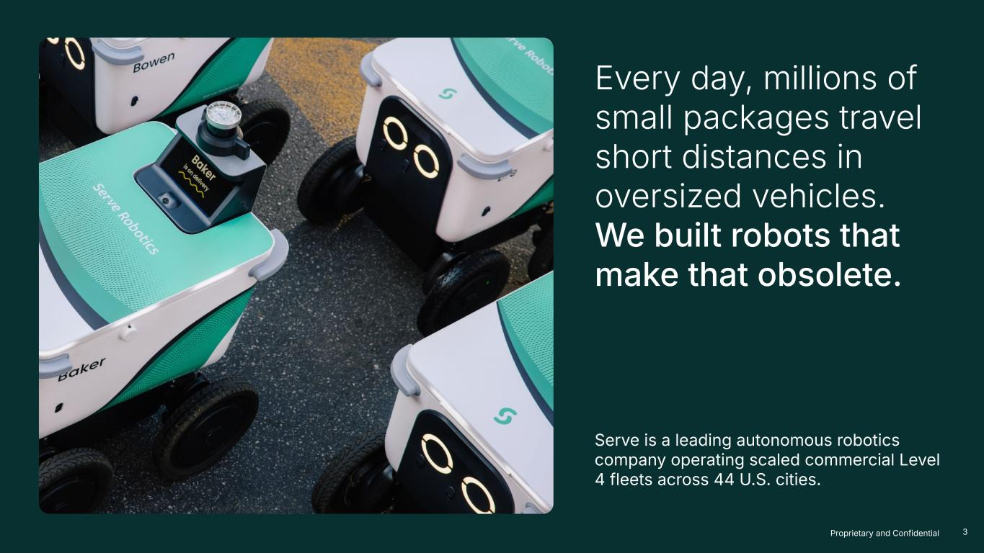
3Proprietary and Confidential Every day, millions of small packages travel short distances in oversized vehicles. We built robots that make that obsolete. Serve is a leading autonomous robotics company operating scaled commercial Level 4 fleets across 44 U.S. cities.

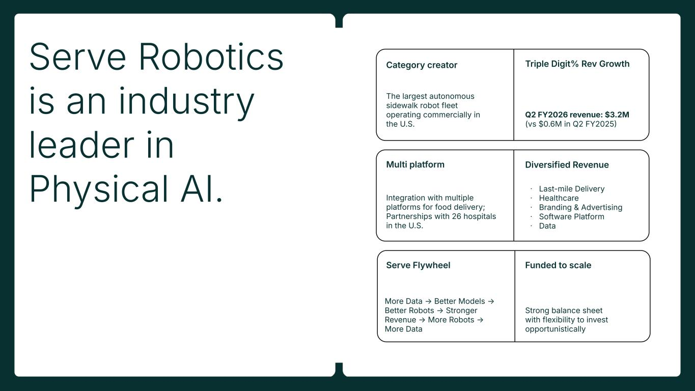
4Proprietary and Confidential Category creator The largest autonomous sidewalk robot fleet operating commercially in the U.S. Multi platform Integration with multiple platforms for food delivery; Partnerships with 26 hospitals in the U.S. Triple Digit% Rev Growth Q2 FY2026 revenue: $3.2M (vs $0.6M in Q2 FY2025 Diversified Revenue ᐧ Last-mile Delivery ᐧ Healthcare ᐧ Branding & Advertising ᐧ Software Platform ᐧ Data Funded to scale Strong balance sheet with flexibility to invest opportunistically Serve Flywheel More Data → Better Models → Better Robots → Stronger Revenue → More Robots → More Data Serve Robotics is an industry leader in Physical AI.

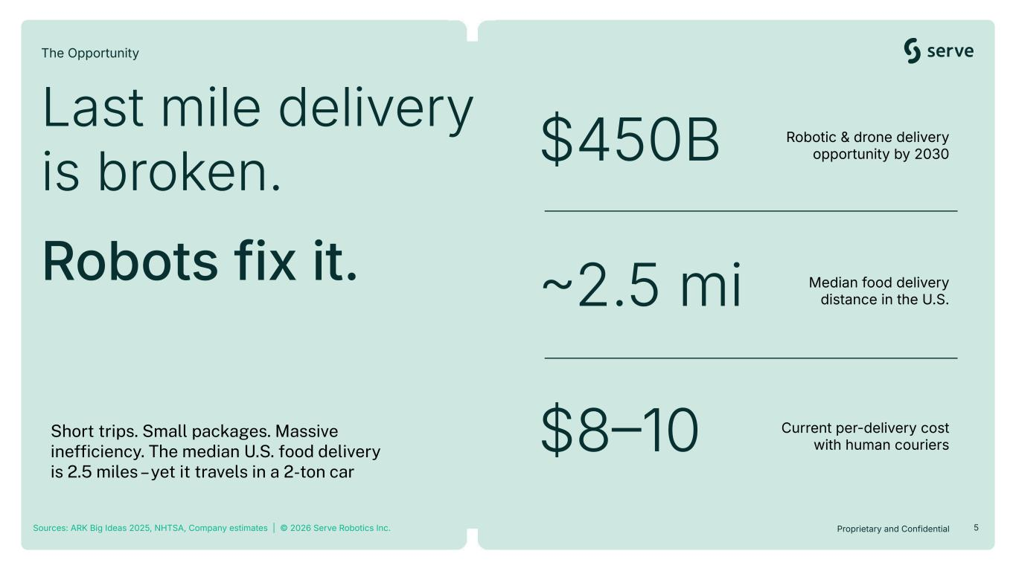
5Proprietary and Confidential $450B Robotic & drone delivery opportunity by 2030 2.5 mi Median food delivery distance in the U.S. $810 Current per-delivery cost with human couriers Sources: ARK Big Ideas 2025, NHTSA, Company estimates | © 2026 Serve Robotics Inc. Short trips. Small packages. Massive inefficiency. The median U.S. food delivery is 2.5 miles – yet it travels in a 2-ton car Last mile delivery is broken. Robots fix it. The Opportunity

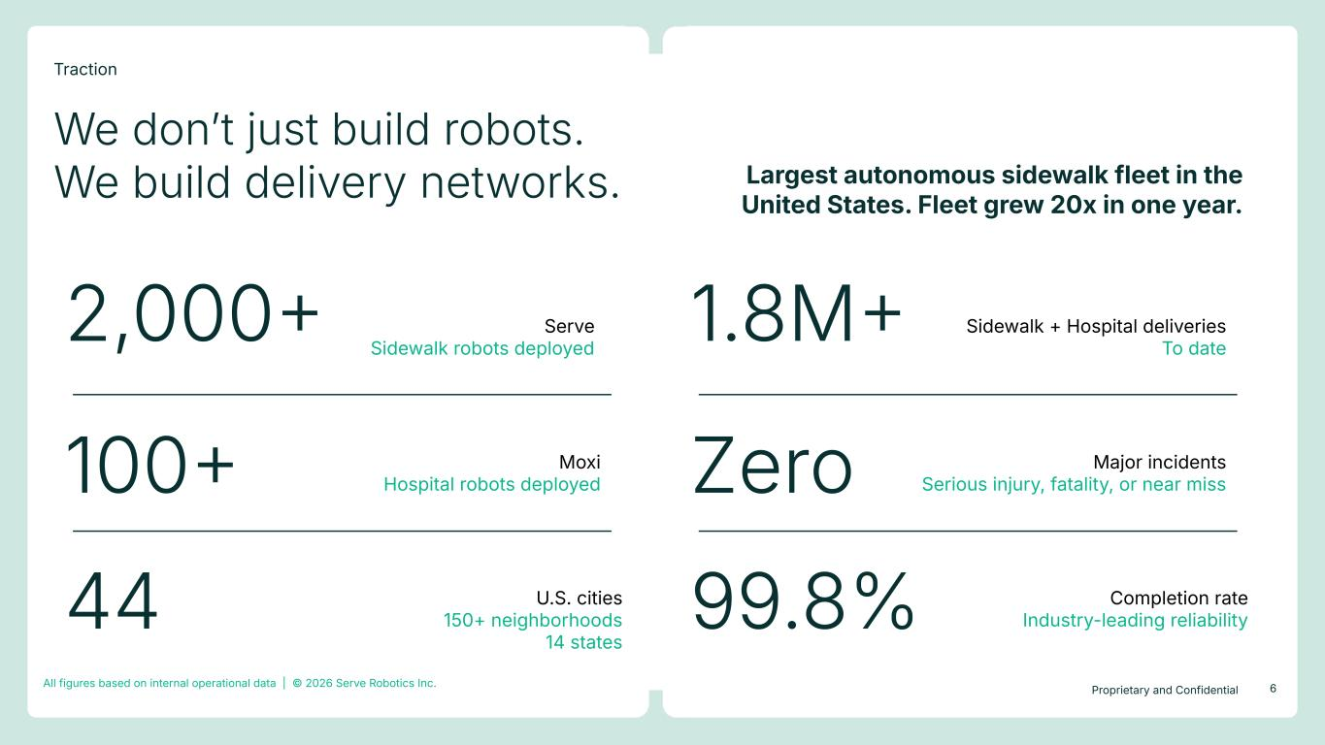
6Proprietary and Confidential 1.8M Sidewalk + Hospital deliveries To date Zero Major incidents Serious injury, fatality, or near miss 99.8% Completion rate Industry-leading reliability 2,000 100 Moxi Hospital robots deployed 44 U.S. cities 150+ neighborhoods 14 states We donʼt just build robots. We build delivery networks. Largest autonomous sidewalk fleet in the United States. Fleet grew 20x in one year. All figures based on internal operational data | © 2026 Serve Robotics Inc. Traction Serve Sidewalk robots deployed

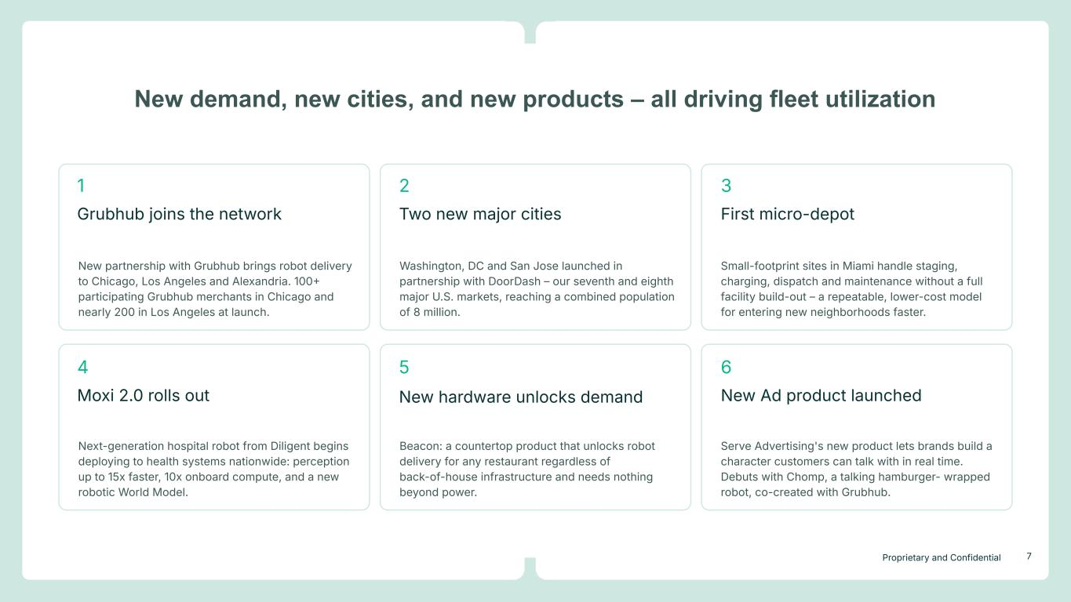
7Proprietary and Confidential Washington, DC and San Jose launched in partnership with DoorDash – our seventh and eighth major U.S. markets, reaching a combined population of 8 million. New demand, new cities, and new products – all driving fleet utilization Grubhub joins the network New partnership with Grubhub brings robot delivery to Chicago, Los Angeles and Alexandria. 100 participating Grubhub merchants in Chicago and nearly 200 in Los Angeles at launch. Small-footprint sites in Miami handle staging, charging, dispatch and maintenance without a full facility build-out – a repeatable, lower-cost model for entering new neighborhoods faster. Next-generation hospital robot from Diligent begins deploying to health systems nationwide: perception up to 15x faster, 10x onboard compute, and a new robotic World Model. Beacon: a countertop product that unlocks robot delivery for any restaurant regardless of back-of-house infrastructure and needs nothing beyond power. Serve Advertising's new product lets brands build a character customers can talk with in real time. Debuts with Chomp, a talking hamburger- wrapped robot, co-created with Grubhub. 1 Two new major cities 2 First micro-depot 3 Moxi 2.0 rolls out 4 New hardware unlocks demand 5 New Ad product launched 6

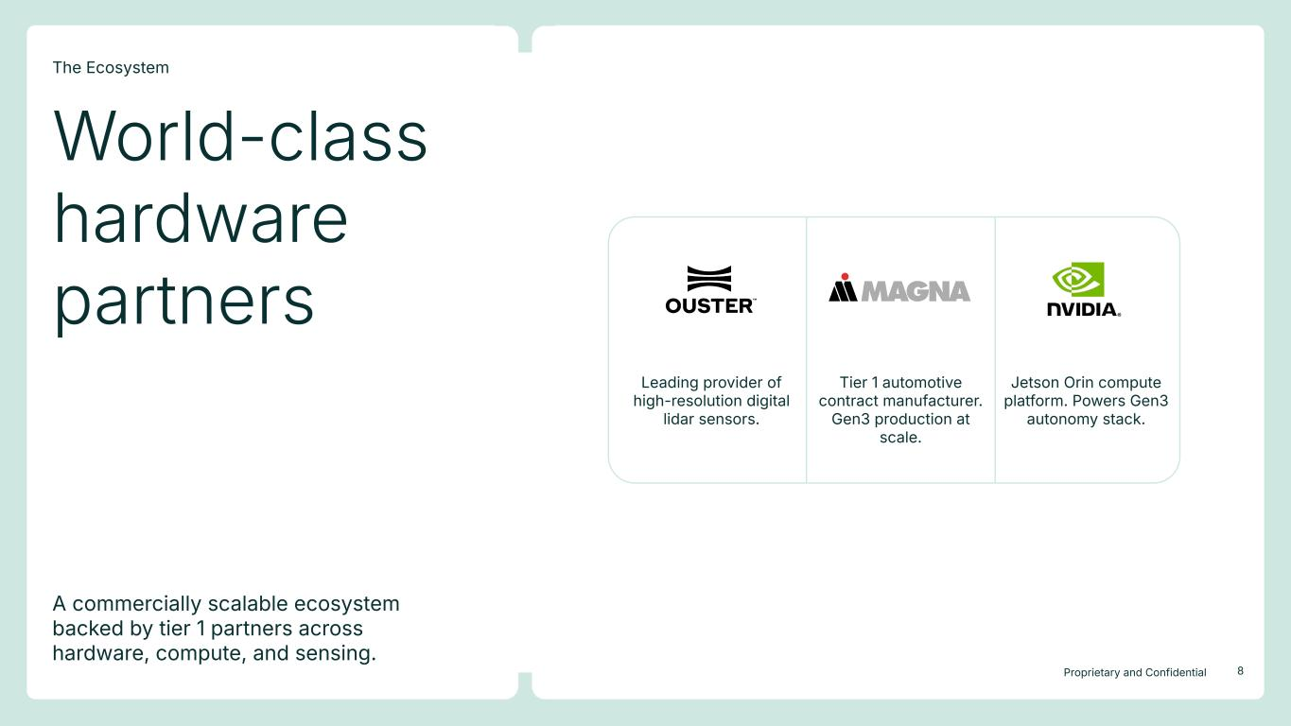
8Proprietary and Confidential A commercially scalable ecosystem backed by tier 1 partners across hardware, compute, and sensing. World-class hardware partners The Ecosystem Leading provider of high-resolution digital lidar sensors. Tier 1 automotive contract manufacturer. Gen3 production at scale. Jetson Orin compute platform. Powers Gen3 autonomy stack.

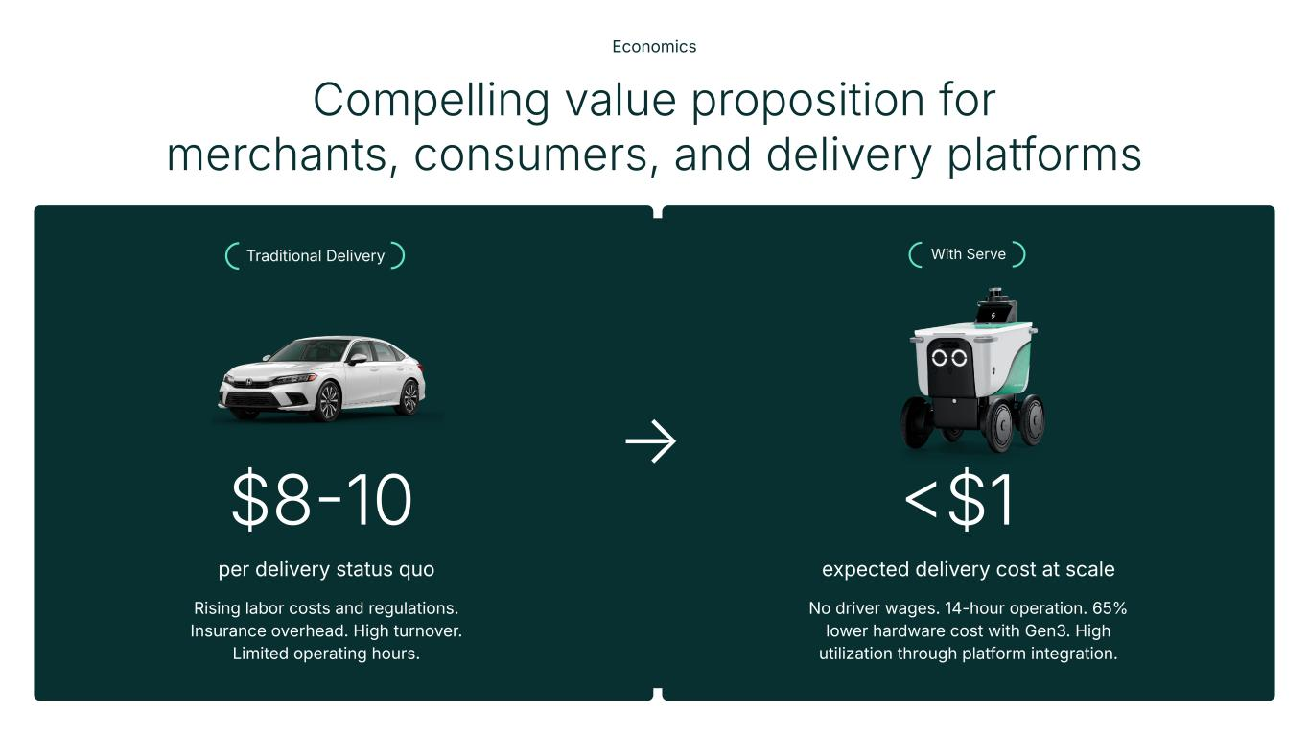
Compelling value proposition for merchants, consumers, and delivery platforms Economics With Serve Rising labor costs and regulations. Insurance overhead. High turnover. Limited operating hours. No driver wages. 14-hour operation. 65% lower hardware cost with Gen3. High utilization through platform integration. $810 per delivery status quo $1 expected delivery cost at scale Traditional Delivery →

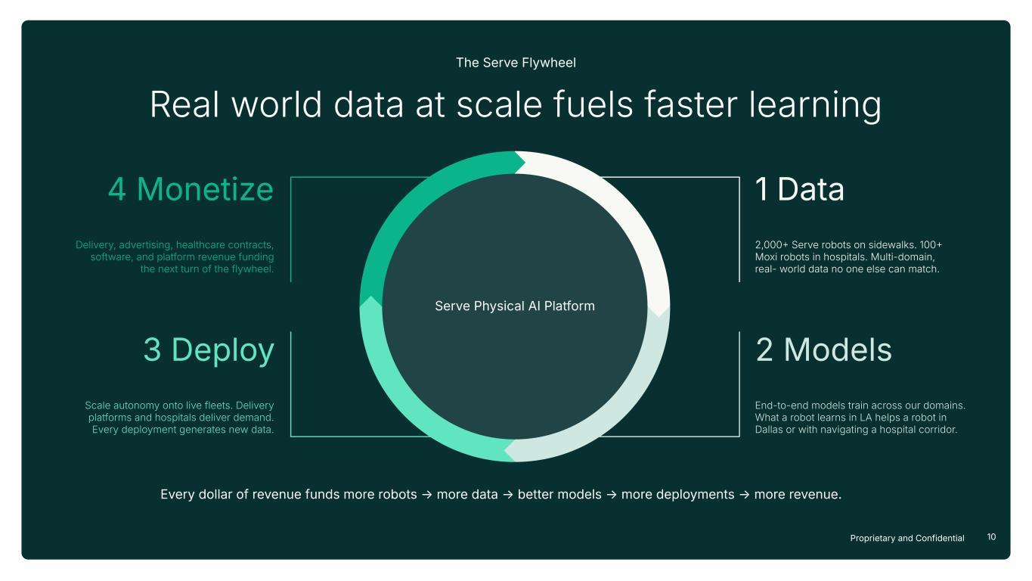
10Proprietary and Confidential Every dollar of revenue funds more robots → more data → better models → more deployments → more revenue. 2,000 Serve robots on sidewalks. 100 Moxi robots in hospitals. Multi-domain, real- world data no one else can match. 1 Data End-to-end models train across our domains. What a robot learns in LA helps a robot in Dallas or with navigating a hospital corridor. 2 Models Scale autonomy onto live fleets. Delivery platforms and hospitals deliver demand. Every deployment generates new data. 3 Deploy Delivery, advertising, healthcare contracts, software, and platform revenue funding the next turn of the flywheel. 4 Monetize Real world data at scale fuels faster learning The Serve Flywheel Serve Physical AI Platform

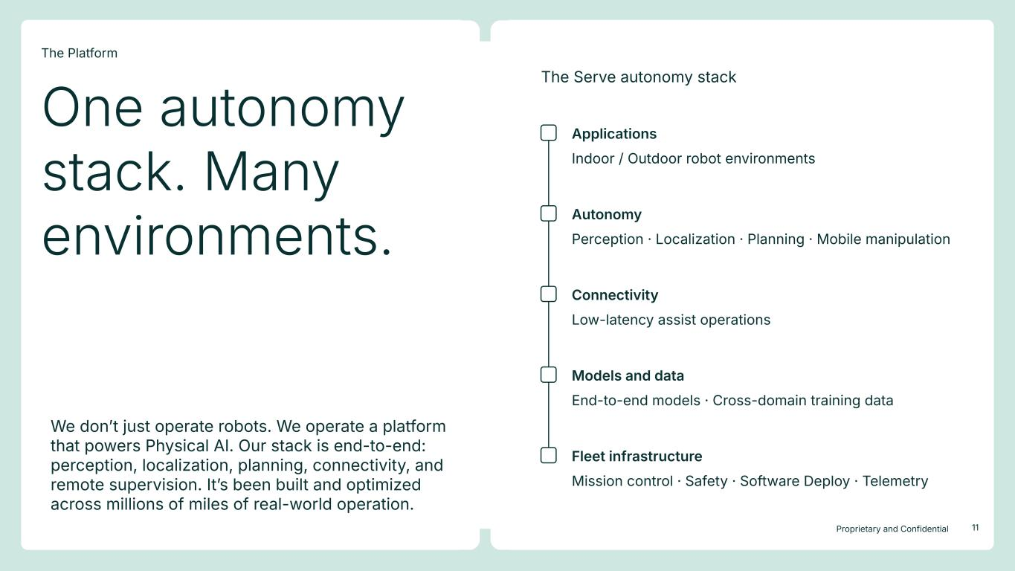
11Proprietary and Confidential We donʼt just operate robots. We operate a platform that powers Physical AI. Our stack is end-to-end: perception, localization, planning, connectivity, and remote supervision. Itʼs been built and optimized across millions of miles of real-world operation. Indoor / Outdoor robot environments Applications Perception · Localization · Planning · Mobile manipulation Autonomy Low-latency assist operations Connectivity End-to-end models · Cross-domain training data Models and data Mission control · Safety · Software Deploy · Telemetry Fleet infrastructure The Serve autonomy stack One autonomy stack. Many environments. The Platform

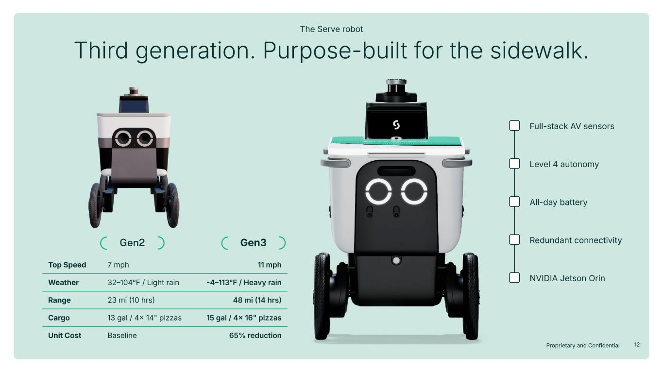
12Proprietary and Confidential Gen2 Gen3 Top Speed 7 mph 11 mph Weather 32104°F / Light rain 4113°F / Heavy rain Range 23 mi 10 hrs 48 mi 14 hrs Cargo 13 gal / 4 14" pizzas 15 gal / 4 16" pizzas Unit Cost Baseline 65% reduction Third generation. Purpose-built for the sidewalk. The Serve robot Full-stack AV sensors Level 4 autonomy All-day battery Redundant connectivity NVIDIA Jetson Orin

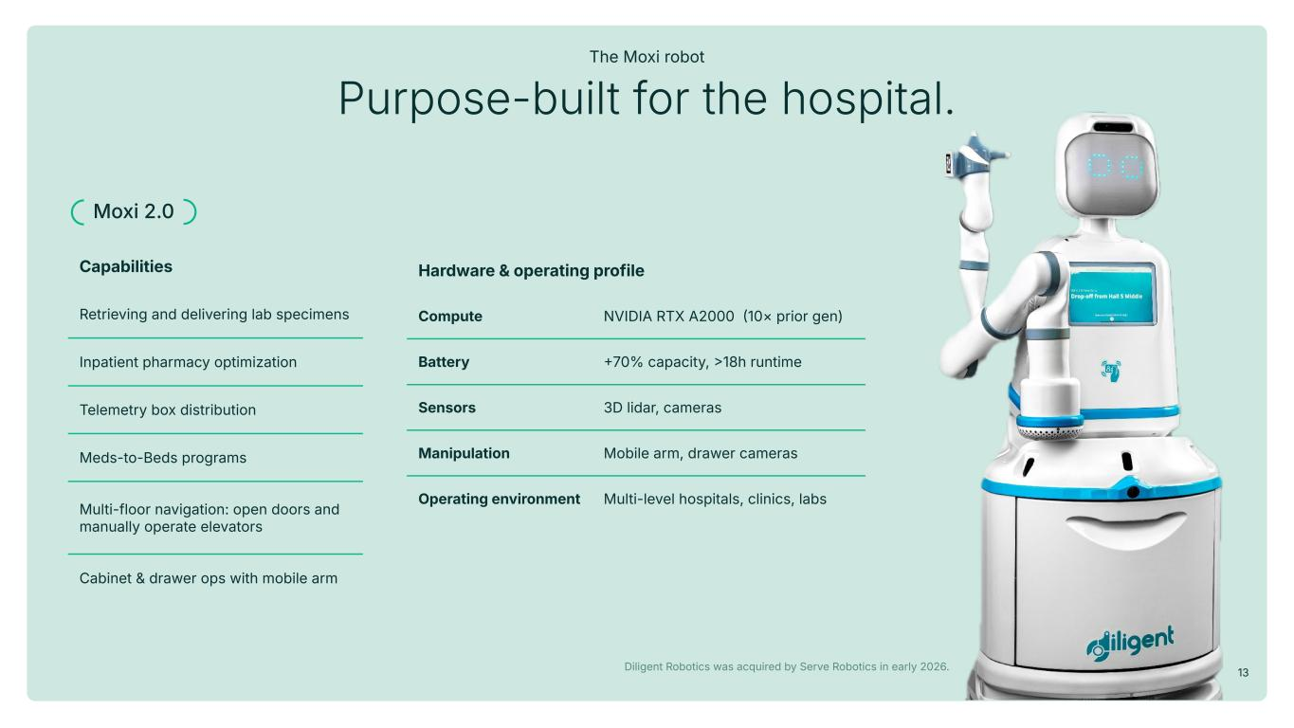
13Proprietary and Confidential Purpose-built for the hospital. The Moxi robot Hardware & operating profile Compute NVIDIA RTX A2000 10× prior gen) Battery 70% capacity, 18h runtime Sensors 3D lidar, cameras Manipulation Mobile arm, drawer cameras Operating environment Multi-level hospitals, clinics, labs Diligent Robotics was acquired by Serve Robotics in early 2026. Moxi 2.0 Capabilities Retrieving and delivering lab specimens Inpatient pharmacy optimization Telemetry box distribution Meds-to-Beds programs Multi-floor navigation: open doors and manually operate elevators Cabinet & drawer ops with mobile arm

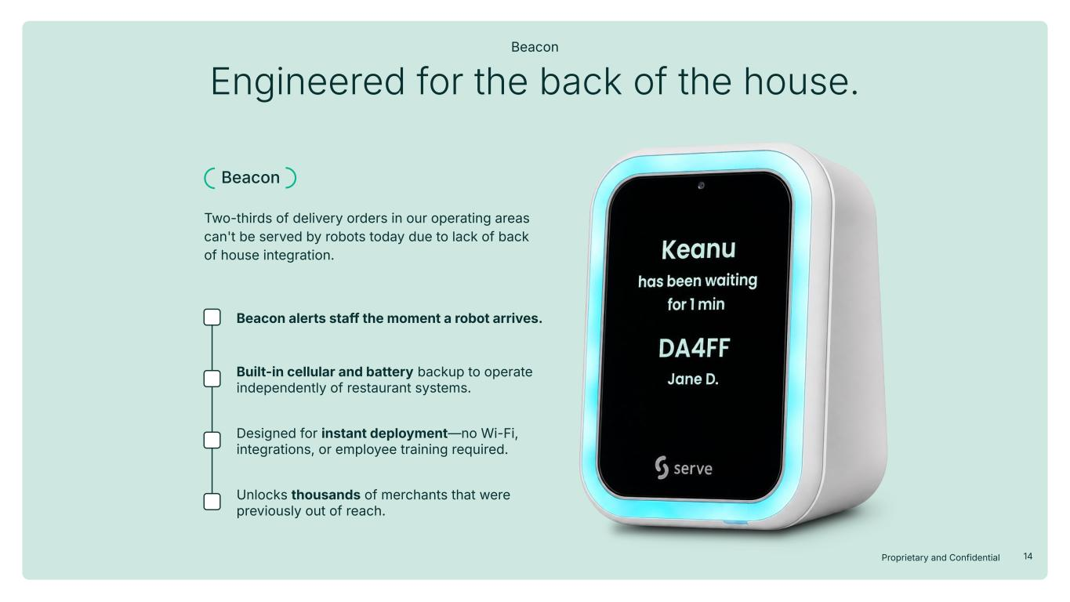
14Proprietary and Confidential Engineered for the back of the house. Beacon Beacon alerts staff the moment a robot arrives. Built-in cellular and battery backup to operate independently of restaurant systems. Designed for instant deployment—no Wi-Fi, integrations, or employee training required. Unlocks thousands of merchants that were previously out of reach. Beacon Two-thirds of delivery orders in our operating areas can't be served by robots today due to lack of back of house integration.

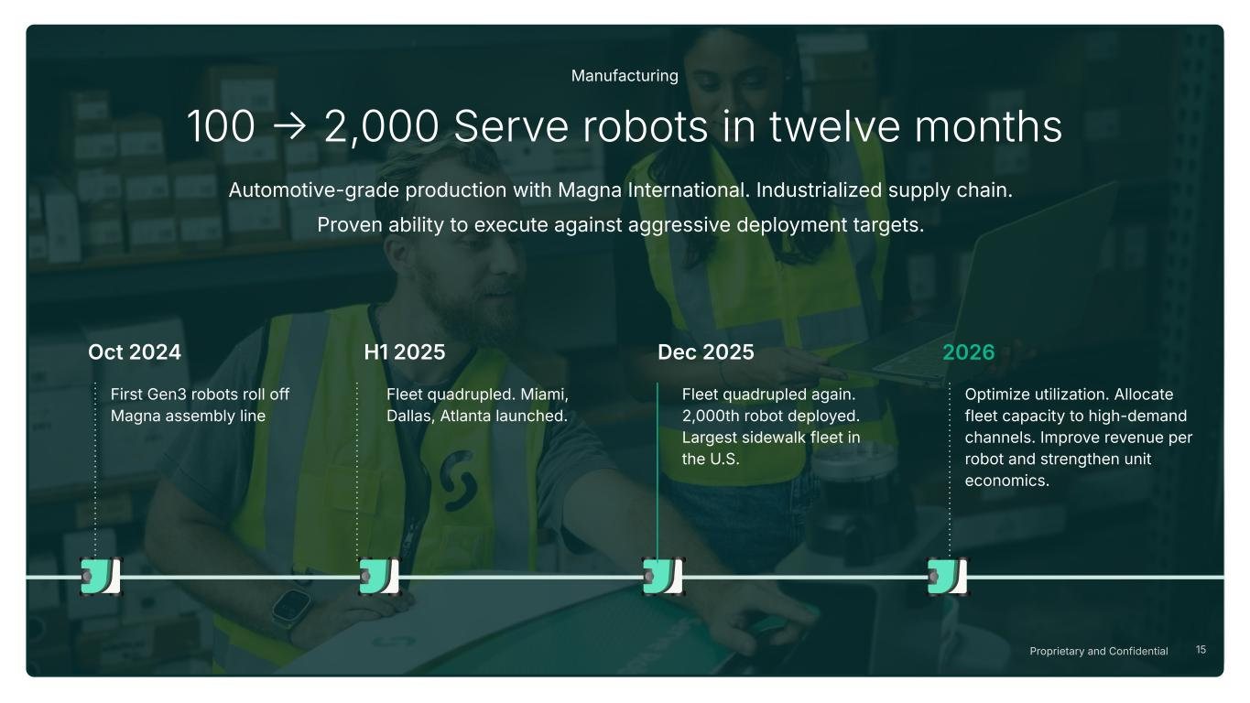
15Proprietary and Confidential First Gen3 robots roll off Magna assembly line Oct 2024 Fleet quadrupled. Miami, Dallas, Atlanta launched. H1 2025 Dec 2025 Fleet quadrupled again. 2,000th robot deployed. Largest sidewalk fleet in the U.S. 2026 Optimize utilization. Allocate fleet capacity to high-demand channels. Improve revenue per robot and strengthen unit economics. 100  2,000 Serve robots in twelve months Manufacturing Automotive-grade production with Magna International. Industrialized supply chain. Proven ability to execute against aggressive deployment targets.

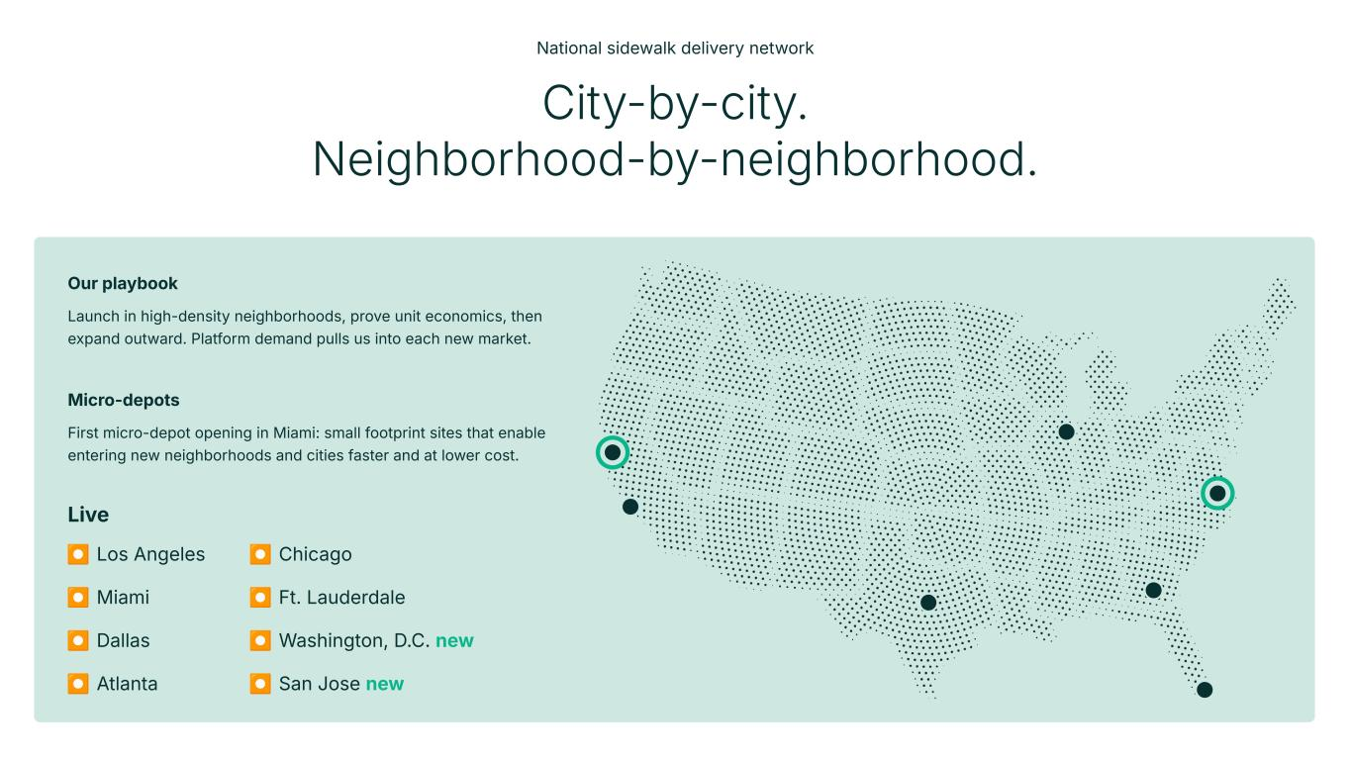
⏺ Los Angeles ⏺ Miami ⏺ Dallas ⏺ Atlanta Live City-by-city. Neighborhood-by-neighborhood. National sidewalk delivery network Our playbook Launch in high-density neighborhoods, prove unit economics, then expand outward. Platform demand pulls us into each new market. ⏺ Chicago ⏺ Ft. Lauderdale ⏺ Washington, D.C. new ⏺ San Jose new Micro-depots First micro-depot opening in Miami: small footprint sites that enable entering new neighborhoods and cities faster and at lower cost.

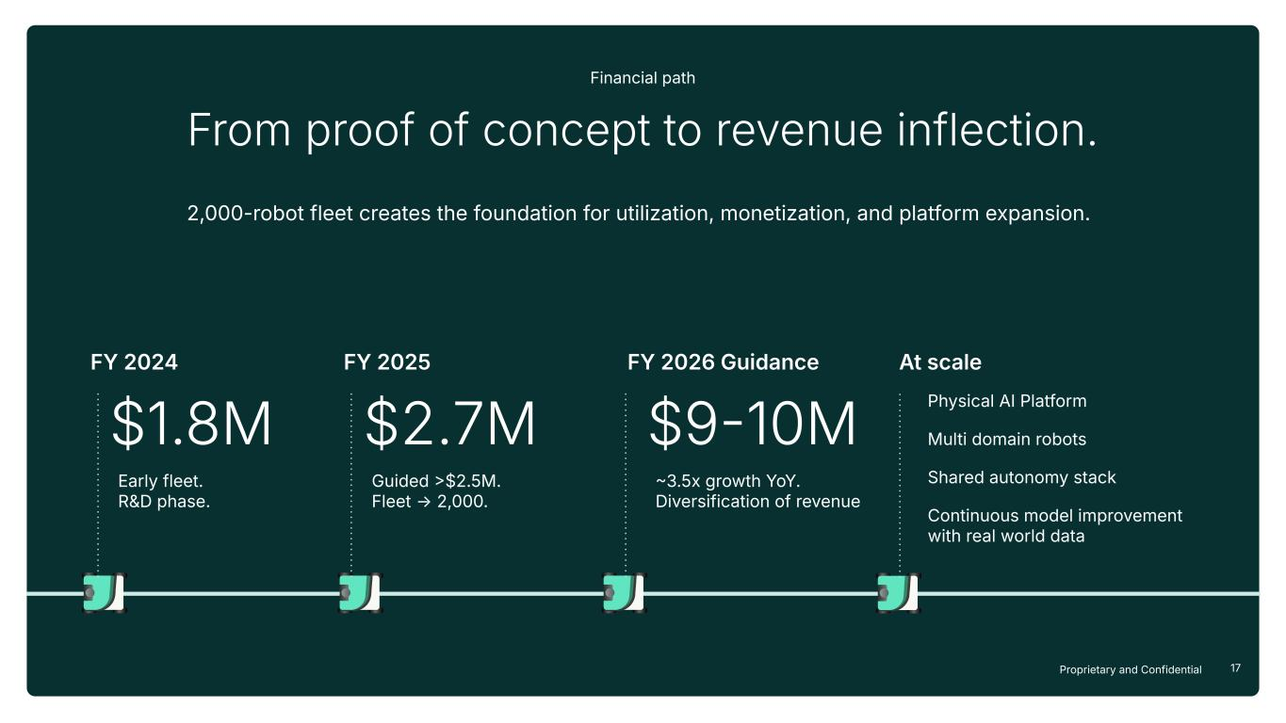
17Proprietary and Confidential From proof of concept to revenue inflection. Financial path 2,000-robot fleet creates the foundation for utilization, monetization, and platform expansion. FY 2024 FY 2025 $1.8M Early fleet. R&D phase. $2.7M Guided $2.5M. Fleet → 2,000. FY 2026 Guidance $910M 3.5x growth YoY. Diversification of revenue At scale Physical AI Platform Multi domain robots Shared autonomy stack Continuous model improvement with real world data

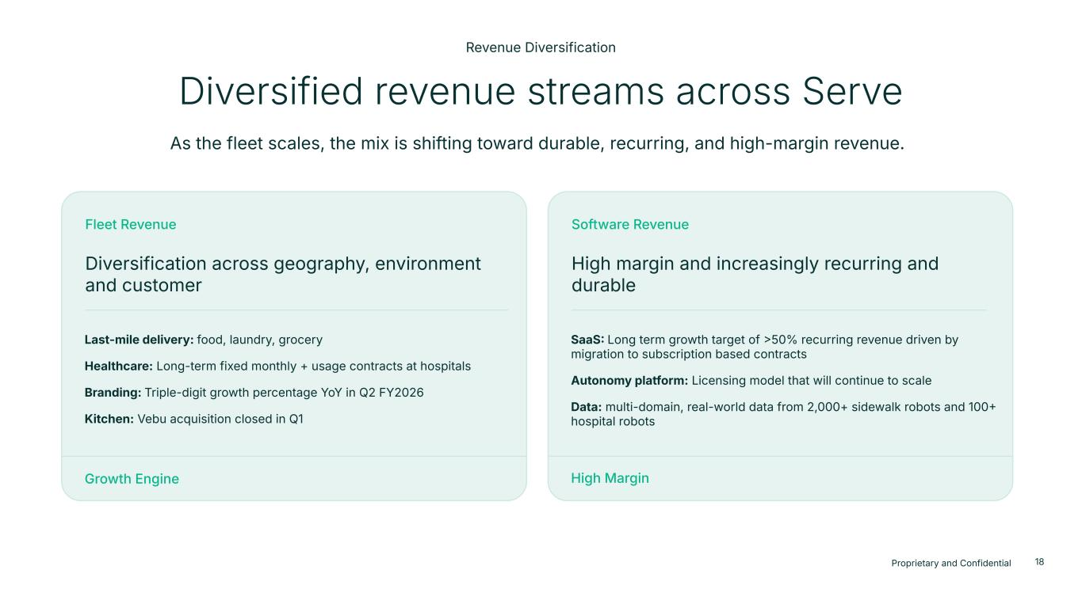
18Proprietary and Confidential 18 Diversification across geography, environment and customer Fleet Revenue Growth Engine Diversified revenue streams across Serve Revenue Diversification Last-mile delivery: food, laundry, grocery Healthcare: Long-term fixed monthly + usage contracts at hospitals Branding: Triple-digit growth percentage YoY in Q2 FY2026 Kitchen: Vebu acquisition closed in Q1 High margin and increasingly recurring and durable Software Revenue High Margin SaaS Long term growth target of 50% recurring revenue driven by migration to subscription based contracts Autonomy platform: Licensing model that will continue to scale Data: multi-domain, real-world data from 2,000+ sidewalk robots and 100 hospital robots As the fleet scales, the mix is shifting toward durable, recurring, and high-margin revenue.

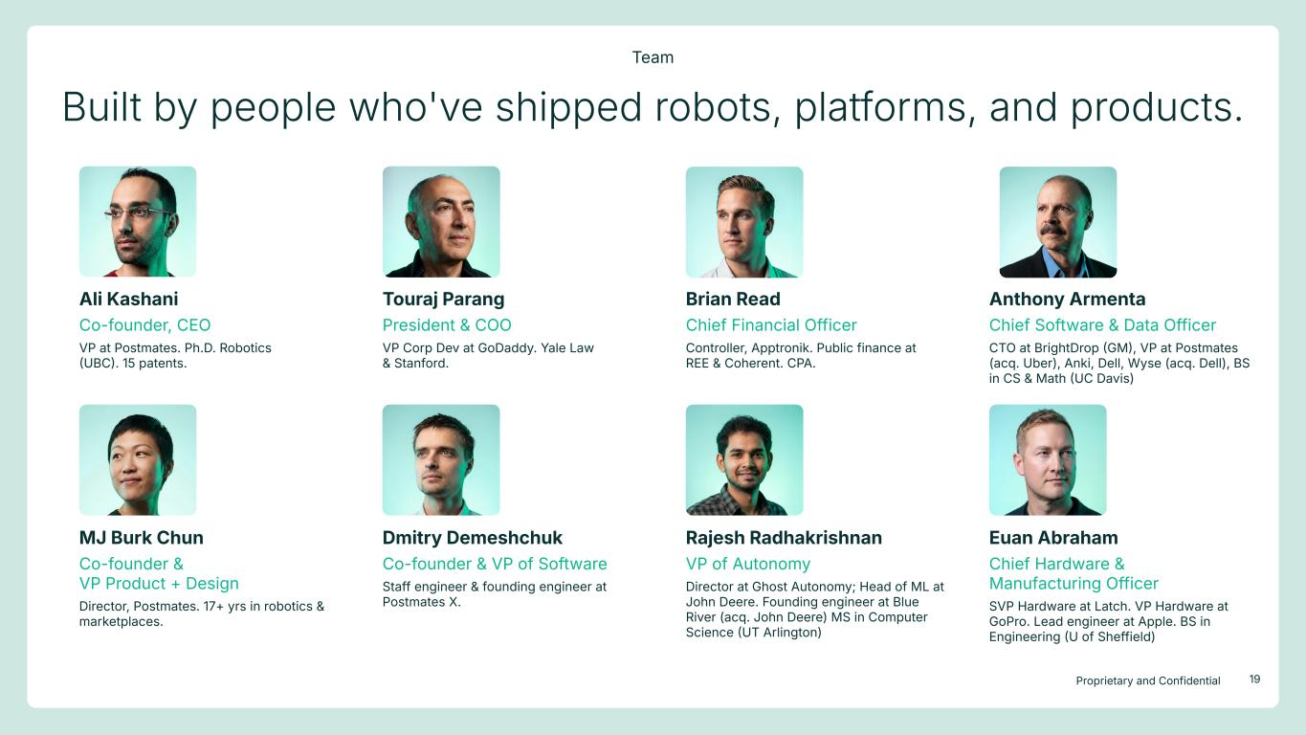
19Proprietary and Confidential Built by people who've shipped robots, platforms, and products. Team Ali Kashani Co-founder, CEO VP at Postmates. Ph.D. Robotics UBC. 15 patents. Touraj Parang President & COO VP Corp Dev at GoDaddy. Yale Law & Stanford. MJ Burk Chun Co-founder & VP Product + Design Director, Postmates. 17+ yrs in robotics & marketplaces. Brian Read Chief Financial Officer Controller, Apptronik. Public finance at REE & Coherent. CPA. Dmitry Demeshchuk Co-founder & VP of Software Staff engineer & founding engineer at Postmates X. Anthony Armenta Chief Software & Data Officer CTO at BrightDrop GM, VP at Postmates (acq. Uber), Anki, Dell, Wyse (acq. Dell), BS in CS & Math UC Davis) Rajesh Radhakrishnan VP of Autonomy Director at Ghost Autonomy; Head of ML at John Deere. Founding engineer at Blue River (acq. John Deere) MS in Computer Science UT Arlington) Euan Abraham Chief Hardware & Manufacturing Officer SVP Hardware at Latch. VP Hardware at GoPro. Lead engineer at Apple. BS in Engineering U of Sheffield)

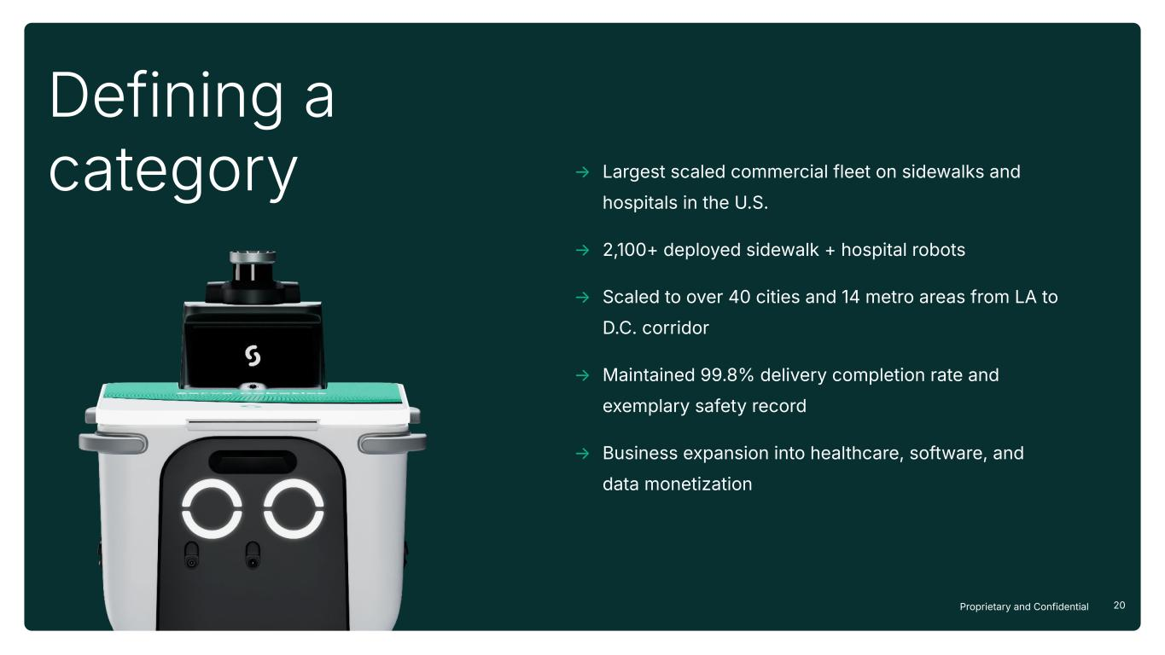
20Proprietary and Confidential Defining a category → Largest scaled commercial fleet on sidewalks and hospitals in the U.S. → 2,100+ deployed sidewalk + hospital robots → Scaled to over 40 cities and 14 metro areas from LA to D.C. corridor → Maintained 99.8% delivery completion rate and exemplary safety record → Business expansion into healthcare, software, and data monetization

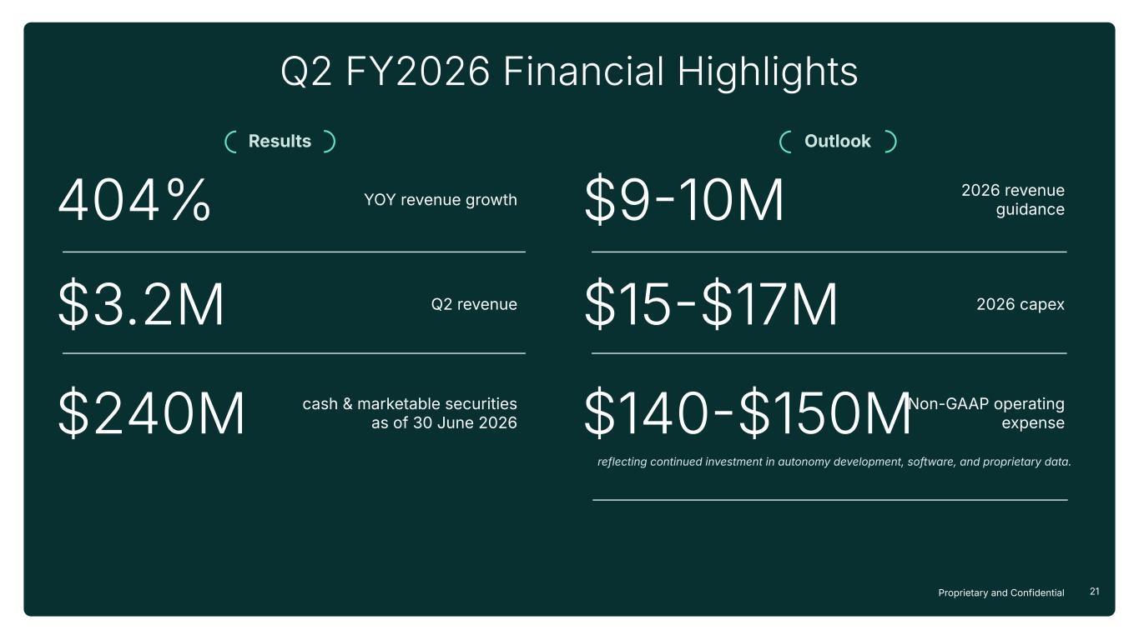
21Proprietary and Confidential Q2 FY2026 Financial Highlights $3.2M Q2 revenue 404% $240M cash & marketable securities as of 30 June 2026 Results Outlook YOY revenue growth $910M 2026 revenue guidance $15$17M 2026 capex $140$150MNon-GAAP operating expense reflecting continued investment in autonomy development, software, and proprietary data.

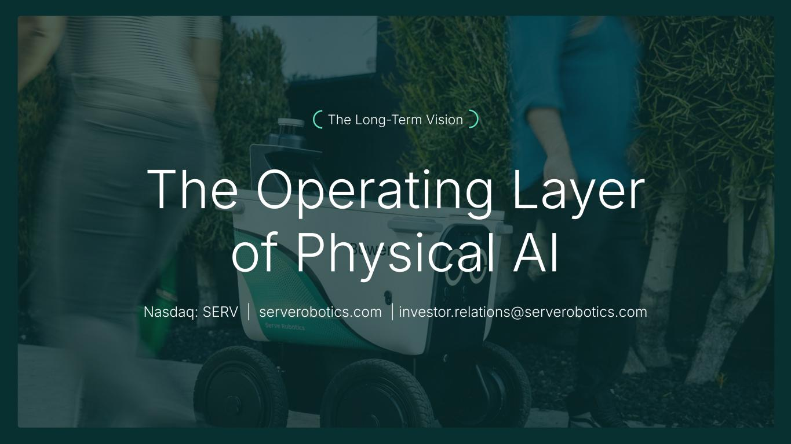
Slide 16 Header: The Long-Term Vision Unbundling the car for dense cities Specialized autonomous robots for everyday urban tasks. ● Safer streets ● Lower emissions ● More efficient local commerce Design direction: Strong closing image. Minimal text. One idea only. The Operating Layer of Physical AI Nasdaq: SERV | serverobotics.com | investor.relations@serverobotics.com The Long-Term Vision

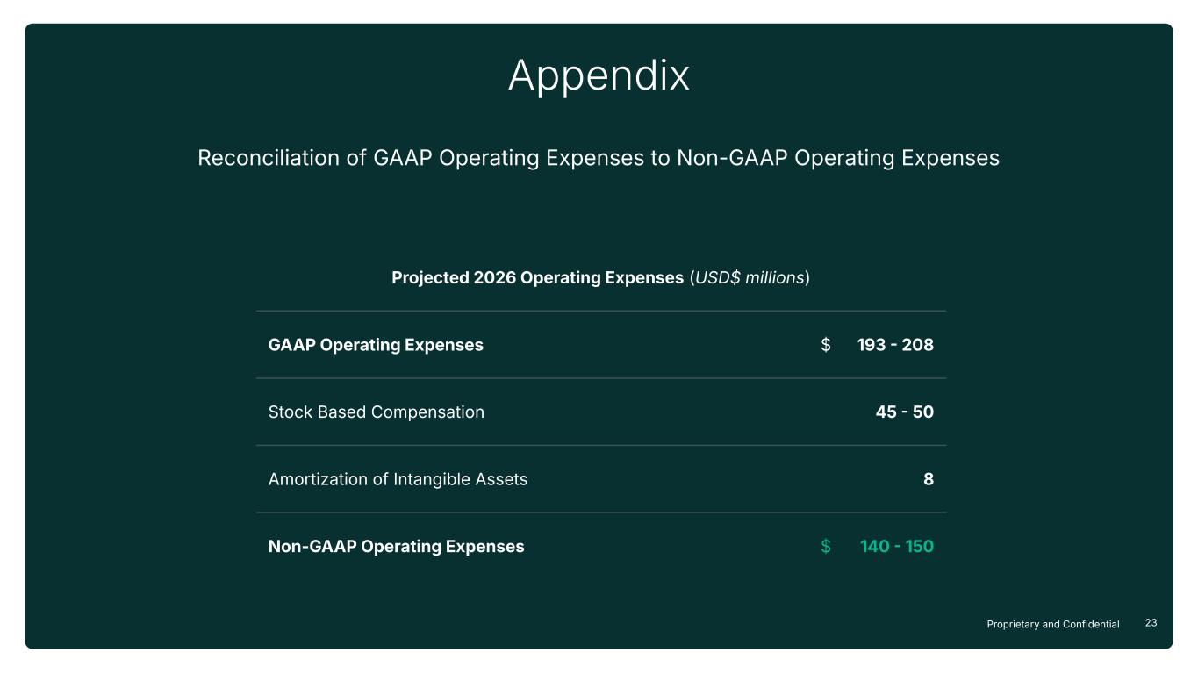
23Proprietary and Confidential Appendix Projected 2026 Operating Expenses (USD$ millions) GAAP Operating Expenses $ 193  208 Stock Based Compensation 45  50 Amortization of Intangible Assets 8 Non-GAAP Operating Expenses $ 140  150 Reconciliation of GAAP Operating Expenses to Non-GAAP Operating Expenses

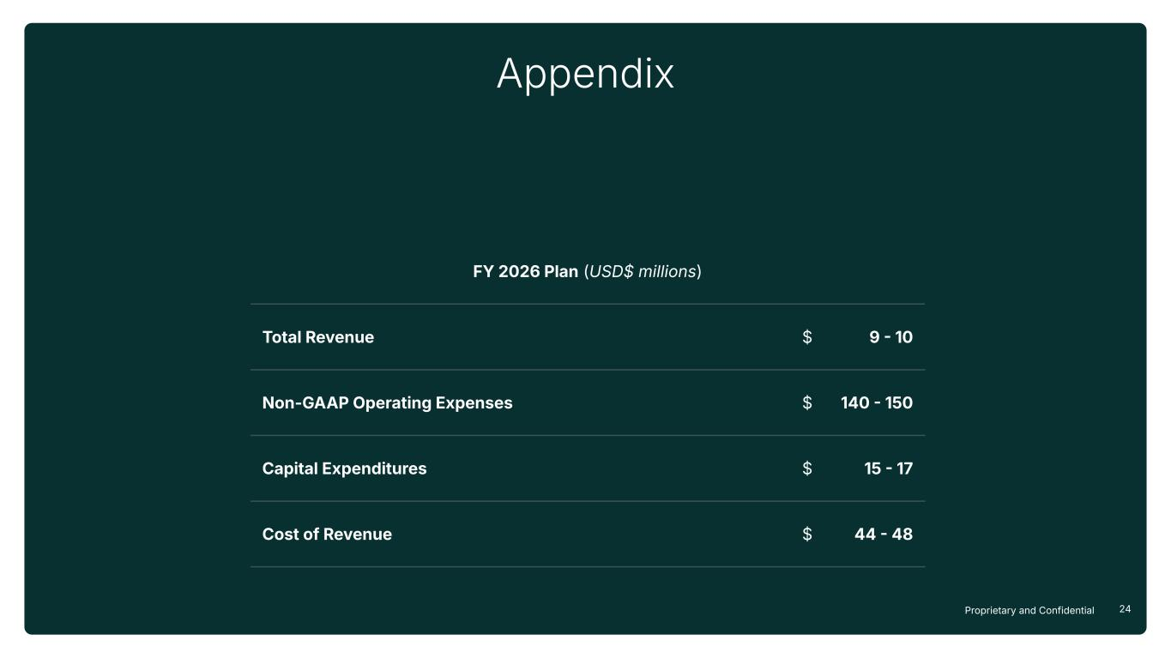
24Proprietary and Confidential Appendix FY 2026 Plan (USD$ millions) Total Revenue $ 9  10 Non-GAAP Operating Expenses $ 140  150 Capital Expenditures $ 15  17 Cost of Revenue $ 44  48

