Table of Contents

UNITED STATES

SECURITIES AND EXCHANGE COMMISSION

WASHINGTON, D.C. 20549

FORM 10-K

(Mark One)

x ANNUAL REPORT PURSUANT TO SECTION 13 OR 15(d) OF THE SECURITIES EXCHANGE ACT OF 1934

For the fiscal year ended December 31, 2025

or

o TRANSITION REPORT PURSUANT TO SECTION 13 OR 15(d) OF THE SECURITIES EXCHANGE ACT OF 1934

For the transition period from _________ to __________

 | COMMISSION FILE NUMBER 001-42023
 |  |  | SERVE ROBOTICS INC.
(Exact name of registrant as specified in its charter)
Delaware |  |  |  |  |  |  |  | 85-3844872
(State or other jurisdiction of |  |  |  |  |  |  |  | (I.R.S. Employer
incorporation or organization) |  |  |  |  |  |  |  | Identification No.)
730 Broadway |  |  |  |  |  |  |  | (818) 860-1352
Redwood City, CA 94063 |  |  |  |  |  |  |  | (818) 860-1352
(Address of principal executive offices) (Zip Code) |  |  |  |  |  |  | (Registrant’s telephone number, including area code)
Securities registered pursuant to Section 12(b) of the Act:
Title of each class |  |  | Trading Symbol(s) |  |  |  |  | Name of each exchange on which registered
Common Stock par value $0.0001 per share |  |  | SERV |  |  |  |  | The Nasdaq Capital Market

Securities registered pursuant to Section 12(g) of the Act:

Common Stock, $0.0001 par value per share

Indicate by check mark if the registrant is a well-known seasoned issuer, as defined in Rule 405 of the Securities Act. Yes o No x Indicate by check mark if the registrant is not required to file reports pursuant to Section 13 or 15(d) of the Act. Yes o No x

Indicate by check mark whether the registrant (1) has filed all reports required to be filed by Section 13 or 15(d) of the Securities Exchange Act of 1934 during the preceding 12 months (or for such shorter period that the registrant was required to file such reports), and (2) has been subject to such filing requirements for the past 90 days. Yes x No o

Indicate by check mark whether the registrant has submitted electronically every Interactive Data File required to be submitted pursuant to Rule 405 of Regulation S-T (§232.405 of this chapter) during the preceding 12 months (or for such shorter period that the registrant was required to submit such files). Yes x No o

Indicate by check mark whether the registrant is a large accelerated filer, an accelerated filer, a non-accelerated filer, a smaller reporting company, or an emerging growth company. See the definitions of “large accelerated filer,” “accelerated filer,” “smaller reporting company,” and “emerging growth company” in Rule 12b-2 of the Exchange Act.

Large accelerated filer | o | Accelerated filer | o
Non-accelerated filer | x | Smaller reporting company | x
 |  | Emerging growth company | x

If an emerging growth company, indicate by check mark if the registrant has elected not to use the extended transition period for complying with any new or revised financial accounting standards provided pursuant to Section 13(a) of the Exchange Act. o

Indicate by check mark whether the registrant has filed a report on and attestation to its management’s assessment of the effectiveness of its internal control over financial reporting under Section 404(b) of the Sarbanes-Oxley Act (15 U.S.C. 7262(b)) by the registered public accounting firm that prepared or issued its audit report. o

If securities are registered pursuant to Section 12(b) of the Act, indicate by check mark whether the financial statements of the registrant included in the filing reflect the correction of an error to previously issued financial statements. o

Indicate by check mark whether any of those error corrections are restatements that required a recovery analysis of incentive-based compensation received by any of the registrant’s executive officers during the relevant recovery period pursuant to § 240.10D-1(b). o

Indicate by check mark whether the registrant is a shell company (as defined in Rule 12b-2 of the Exchange Act) Yes o No x

The aggregate market value of the common stock held by non-affiliates of the registrant on June 30, 2025, the last business day of its most recently completed second fiscal quarter, was $584.9 million based on the closing price of the registrant’s common stock as reported by The Nasdaq Capital Market on that date.

As of March 10, 2026, the registrant had a total of 75,690,177 shares of its common stock, par value $0.0001 per share, issued and outstanding.

DOCUMENTS INCORPORATED BY REFERENCE

Portions of the registrant’s Definitive Proxy Statement to be filed with the Securities and Exchange Commission no later than 120 days after the end of the registrant’s fiscal year ended December 31, 2025, are incorporated by reference in Part III of this Annual Report on Form 10-K.

Table of Contents

 |  |  |  |  |  |  |  |  |  |  |  |  |  |  |  |  | TABLE OF CONTENTS
 |  |  |  |  |  |  |  |  |  |  |  |  |  |  |  |  |  |  |  |  |  |  |  |  |  |  |  |  |  | Page
 |  |  |  |  |  |  |  |  |  |  |  |  |  |  |  |  |  |  |  |  | PART I
Item 1. | Business |  |  |  |  |  |  |  |  |  |  |  |  |  |  |  |  |  |  |  |  |  |  |  |  |  |  |  |  | 1
Item 1A. | Risk Factors |  |  |  |  |  |  |  |  |  |  |  |  |  |  |  |  |  |  |  |  |  |  |  |  |  |  |  |  | 8
Item 1B. | Unresolved Staff Comments |  |  |  |  |  |  |  |  |  |  |  |  |  |  |  |  |  |  |  |  |  |  |  |  |  |  |  |  | 36
Item 1C. | Cybersecurity |  |  |  |  |  |  |  |  |  |  |  |  |  |  |  |  |  |  |  |  |  |  |  |  |  |  |  |  | 36
Item 2. | Properties |  |  |  |  |  |  |  |  |  |  |  |  |  |  |  |  |  |  |  |  |  |  |  |  |  |  |  |  | 37
Item 3. | Legal Proceedings |  |  |  |  |  |  |  |  |  |  |  |  |  |  |  |  |  |  |  |  |  |  |  |  |  |  |  |  | 37
Item 4. | Mine Safety Disclosures |  |  |  |  |  |  |  |  |  |  |  |  |  |  |  |  |  |  |  |  |  |  |  |  |  |  |  |  | 37
 |  |  |  |  |  |  |  |  |  |  |  |  |  |  |  |  |  |  | PART II
Item 5. | Market for Registrant’s Common Equity, Related Stockholder Matters and Issuer Purchases of Equity Securities |  |  |  |  |  |  |  |  |  |  |  |  |  |  |  |  |  |  |  |  |  |  |  |  |  |  |  |  | 38
Item 6. | [Reserved] |  |  |  |  |  |  |  |  |  |  |  |  |  |  |  |  |  |  |  |  |  |  |  |  |  |  |  |  | 40
Item 7. | Management’s Discussion and Analysis of Financial Condition and Results of Operation |  |  |  |  |  |  |  |  |  |  |  |  |  |  |  |  |  |  |  |  |  |  |  |  |  |  |  |  | 40
Item 7A. | Quantitative and Qualitative Disclosures about Market Risk |  |  |  |  |  |  |  |  |  |  |  |  |  |  |  |  |  |  |  |  |  |  |  |  |  |  |  |  | 49
Item 8. | Financial Statements and Supplementary Data |  |  |  |  |  |  |  |  |  |  |  |  |  |  |  |  |  |  |  |  |  |  |  |  |  |  |  |  | F-1
Item 9. | Changes in and Disagreements with Accountants on Accounting and Financial Disclosure |  |  |  |  |  |  |  |  |  |  |  |  |  |  |  |  |  |  |  |  |  |  |  |  |  |  |  |  | 58
Item 9A. | Controls and Procedures |  |  |  |  |  |  |  |  |  |  |  |  |  |  |  |  |  |  |  |  |  |  |  |  |  |  |  |  | 58
Item 9B. | Other Information |  |  |  |  |  |  |  |  |  |  |  |  |  |  |  |  |  |  |  |  |  |  |  |  |  |  |  |  | 59
Item 9C. | Disclosure Regarding Foreign Jurisdictions That Prevent Inspections |  |  |  |  |  |  |  |  |  |  |  |  |  |  |  |  |  |  |  |  |  |  |  |  |  |  |  |  | 60
 |  |  |  |  |  |  |  |  |  |  |  |  |  |  |  |  |  |  | PART III
Item 10. | Directors, Executive Officers and Corporate Governance |  |  |  |  |  |  |  |  |  |  |  |  |  |  |  |  |  |  |  |  |  |  |  |  |  |  |  |  | 61
Item 11. | Executive Compensation |  |  |  |  |  |  |  |  |  |  |  |  |  |  |  |  |  |  |  |  |  |  |  |  |  |  |  |  | 61
Item 12. | Security Ownership of Certain Beneficial Owners and Management and Related Stockholder Matters |  |  |  |  |  |  |  |  |  |  |  |  |  |  |  |  |  |  |  |  |  |  |  |  |  |  |  |  | 61
Item 13. | Certain Relationships and Related Transactions, and Director Independence |  |  |  |  |  |  |  |  |  |  |  |  |  |  |  |  |  |  |  |  |  |  |  |  |  |  |  |  | 61
Item 14. | Principal Accounting Fees and Services |  |  |  |  |  |  |  |  |  |  |  |  |  |  |  |  |  |  |  |  |  |  |  |  |  |  |  |  | 61
 |  |  |  |  |  |  |  |  |  |  |  |  |  |  |  |  |  |  | PART IV
Item 15. | Exhibits, Financial Statement Schedules |  |  |  |  |  |  |  |  |  |  |  |  |  |  |  |  |  |  |  |  |  |  |  |  |  |  |  |  | 62
Item 16. | Form 10-K Summary |  |  |  |  |  |  |  |  |  |  |  |  |  |  |  |  |  |  |  |  |  |  |  |  |  |  |  |  | 62
 | Exhibit Index |  |  |  |  |  |  |  |  |  |  |  |  |  |  |  |  |  |  |  |  |  |  |  |  |  |  |  |  | 63
 | Signatures |  |  |  |  |  |  |  |  |  |  |  |  |  |  |  |  |  |  |  |  |  |  |  |  |  |  |  |  | 65

i

Table of Contents

SPECIAL NOTE REGARDING FORWARD-LOOKING STATEMENTS

This Annual Report on Form 10-K contains “forward-looking statements” within the meaning of the Private Securities Litigation Reform Act of 1995, Section 27A of the Securities Act of 1933, as amended (the “Securities Act”), and Section 21E of the Securities Exchange Act of 1934, as amended (the “Exchange Act”). All statements other than statements of historical facts contained in this Annual Report on Form 10-K, including statements regarding our future results of operations or financial condition, business strategy and plans, and objectives of management for future operations, are forward-looking statements. In some cases, you can identify forward-looking statements by terms such as “may,” “will,” “should,” “could,” “would,” “expect,” “intend,” “seek,” “plan,” “anticipate,” “believe,” “estimate,” “project,” “predict,” “potential,” “might,” “forecast,” “continue,” or the negative of those terms, and similar expressions and comparable terminology intended to reference future periods. Forward-looking statements include, but are not limited to, statements about:

- our status as an early-stage company with minimal revenue, a history of losses, and a limited operating history, which may make it difficult to evaluate the future of our business and prospects;

- our ability to execute our business strategy to expand our addressable market and effectively manage our growth;

- our use of artificial intelligence (“AI”) and machine learning technologies, which introduces new risks and uncertainties related to accuracy, bias, intellectual property, and regulatory scrutiny;

- a significant portion of our revenue being concentrated with a small number of customers;

- our ability to commercialize our products at a large scale efficiently and effectively;

- our substantial reliance on relationships with suppliers and service providers for the parts and components in our robots, as well as for the manufacture of our robots;

- our ability to attract and retain highly qualified personnel, including engineers, robotics experts, and machine learning specialists;

- the requirement for significant capital to fund our operations and growth, and the risk that financing may not be available when needed or on acceptable terms;

- our robots' reliance on sophisticated software technology that incorporates third-party components and networks to operate;

- potential defects, glitches, or malfunctions in our products that could compromise performance, lead to injury or property damage, and result in product recalls or product liability claims;

- safety incidents arising from human supervision, connectivity issues, third-party software, or automation that could cause injury, trigger recalls, or result in uninsured product liability and warranty claims;

- accessibility concerns or failure to comply with disability access laws may result in claims, operational restrictions, or reputational harm;

- the inability of our supply chain to deliver certain key electrical components, such as semiconductors;

- unfavorable changes in interest rates, foreign currency exchange rates, and inflationary pressures that may increase our operating costs;

- our dependence on discretionary spending patterns in the areas in which we operate and in the economy at large;

- competition in an industry subject to rapid technological change, where competitors may have or attain more resources and greater market recognition than we do;

- important assumptions about the market demand, pricing, adoption rates, and sales cycle for our current and future products and services being inaccurate;

- our ability to protect, maintain, and enforce our intellectual property rights;

- potential claims of infringement of third-party intellectual property rights;

- the unproven nature of our video and LiDAR licensing model and our ability to generate recurring revenue at expected levels;

- security breaches and other disruptions that could compromise our proprietary information and expose us to liability;

- cybersecurity risks to our operational systems, security systems, infrastructure, integrated software in our products, and data processed by us or third-party vendors;

- evolving laws, regulations, standards, policies, and contractual obligations related to privacy and data security, including the California Consumer Privacy Act (“CCPA”), the Illinois Biometric Information Privacy Act (“BIPA”), the General Data Protection Regulation (“GDPR”), and the Health Insurance Portability and Accountability Act of 1996 (“HIPAA”);

- our internal use of AI, generative AI, and machine learning tools that may expose us to heightened cybersecurity risks;

- tariffs imposed by the United States and other countries, as well as changing trade relations, regional and international conflicts, and political conditions;

- the use of emerging technologies like AI, machine learning, and generative AI requiring us to navigate an uncertain legal and regulatory landscape;

- evolving privacy, data protection, and AI regulation that may restrict our ability to collect, process, and license video and LiDAR datasets;

- the evolving regulations around personal delivery devices, which could materially impact our business and growth prospects in new markets;

- compliance with complex laws and regulations in multiple jurisdictions, including product safety, data privacy, healthcare, and environmental regulations;

- the market price and trading volume of our common stock may be volatile and could decline significantly;

- our obligation to develop and maintain proper and effective internal control over financial reporting, and the presence of material weaknesses that increase the risk of material misstatement of our consolidated financial statements; and

- other risks and uncertainties, including those listed under Part I, Item 1A. “Risk Factors”.

Actual events or results may differ from those expressed in forward-looking statements. As such, you should not rely on forward-looking statements as predictions of future events. We have based the forward-looking statements contained in this Annual Report on Form 10-K primarily on our current expectations and projections about future events and trends that we believe may affect our business, financial condition, operating results, prospects, strategy, and financial needs. The outcome of the events described in these forward-looking statements is subject to risks, uncertainties, assumptions, and other factors described under Part I, Item 1A. “Risk Factors” and elsewhere in this Annual Report on Form 10-K. Moreover, we operate in a highly competitive and rapidly changing environment. New risks and uncertainties emerge from time to time, and it is not possible for us to predict all risks and uncertainties that could have an impact on the forward-looking statements contained in this Annual Report on Form 10-K. The results, events and circumstances reflected in the forward-looking statements may not be achieved or occur, and actual results, events or circumstances could differ materially from those described in the forward-looking statements.

In addition, statements that “we believe” and similar statements reflect our beliefs and opinions on the relevant subject. These statements are based on information available to us as of the date of this Annual Report on Form 10-K. While we believe that such information provides a reasonable basis for these statements, such information may be limited or incomplete. Our statements should not be read to indicate that we have conducted an exhaustive inquiry into, or review of, all relevant information. These statements are inherently uncertain, and investors are cautioned not to unduly rely on these statements.

The forward-looking statements made in this Annual Report on Form 10-K speak only as of the date on which the statements are made. We undertake no obligation to update any forward-looking statements made in this Annual Report on Form 10-K to reflect events or circumstances after the date of this Annual Report on Form 10-K or to reflect new information, actual results, revised expectations, or the occurrence of unanticipated events, except as required by law. We may not actually achieve the plans, intentions or expectations disclosed in our forward-looking statements, and you should not place undue reliance on our forward-looking statements.

ii

Table of Contents

PART I

Item 1. Business

Unless otherwise stated or the context otherwise indicates, all references to “Serve,” the “Company,” “we,” “our,” “us,” or similar terms refer to Serve Robotics Inc. together with its wholly-owned subsidiaries. Serve Operating Co. is our direct, wholly-owned subsidiary and holds all material assets and conducts all business activities and operations of Serve.

Glossary of Terms and Abbreviations

The following is a glossary of technical terms used in this Annual Report on Form 10-K:

GPU — Graphical Processing Unit

LiDAR — A digital sensor for measuring distance to objects which uses the principle of radar, but uses light from a laser

ODD — Operating Design Domain describes the specific operating conditions in which the automated driving system is designed to properly operate, including but not limited to roadway types, speed range, and environmental conditions

Reverse Logistics — A type of supply chain management that moves goods from customers back to the sellers or manufacturers Company Overview
We are engaged in developing technologies intended to enable sustainable, autonomous robotic solutions for public and commercial spaces. Our activities include the design, engineering, deployment, and operation of low-emission robotic systems built on our proprietary AI-enabled mobility platform. Our systems are designed to operate safely and efficiently in real world environments.

While food delivery remains our primary commercial application, we are expanding our platform into adjacent markets, customer segments, and operating environments where autonomous mobility can address labor constraints, improve service levels, and reduce emissions. We intend to leverage our core autonomy stack, fleet management infrastructure, and operational expertise to support additional use cases across both outdoor and indoor settings.

Our core technology originated in 2017 as a specialized project within Postmates Inc. (“Postmates”), an on-demand delivery company in the United States. Following the acquisition of Postmates by Uber Technologies, Inc. (“Uber”) in 2020, Uber’s leadership approved the contribution of the intellectual property and related assets associated with this project to our company in February 2021.

As of December 31, 2025, Serve’s fleet consisted of over 2,000 sidewalk delivery robots. We maintain platform-level integrations with food delivery platforms, such as Uber Eats and DoorDash, that enable our robots to transmit real-time presence and status information and to receive delivery requests associated with customer orders placed on those platforms.

In January 2026, subsequent to the period covered by this Annual Report on Form 10-K, we completed the acquisition of Diligent Robotics, Inc. (“Diligent”), a provider of AI-powered autonomous robot assistants for the healthcare industry. This acquisition extends our autonomy platform into indoor environments, initially into hospitals, and broadens our addressable market into healthcare and other commercial sectors. We expect to leverage Diligent’s technology alongside our existing platform to enhance product capabilities, accelerate deployment opportunities, and support scalable, recurring revenue growth through Diligent’s established commercial relationships with healthcare systems and institutions.

Tailwinds for Automation

Despite technological innovations of the past few decades as well as increased adoption of online commerce and home delivery, last-mile delivery has remained costly. While an ever-growing share of consumers is shopping online and demanding faster deliveries, a number of factors have contributed to keeping last-mile costs high:

- labor shortages caused by the aging population have led to wage inflation;

1

Table of Contents

- on-demand delivery companies in many jurisdictions are facing regulatory pressures to classify gig workers as employees, which would in turn increase labor costs; and

- cities across the United States have introduced maximum limits on how much delivery platforms can charge restaurants and merchants, highlighting the need to lower underlying delivery costs.

Labor cost inflation and regulatory pressures serve as tailwinds that are expected to accelerate the adoption of automated robotic last-mile delivery. Similarly, the healthcare industry is experiencing significant labor shortages, particularly among nursing and clinical support staff, which has created demand for autonomous solutions that can perform routine logistical tasks and free clinical staff to focus on patient care. While labor costs typically increase over time, hardware and technology costs typically decrease. We expect the cost of cameras, GPU processors, electric motors, batteries, and advanced sensors such as LiDAR to continue to decrease, while mobile networks are expected to become faster and more reliable with higher bandwidth and geographic coverage, which we believe will lead to a downward trend in the cost of building and operating robots.

Robot Operations

Our robots start each day at a central depot located near their operating area. The fleet is monitored through mobile connectivity and video streaming by remote human supervisors who can assist robots when necessary, such as at intersection crossings or when robots are unable to navigate certain conditions. On less frequent occasions, if a robot requires physical assistance, such as when a robot is too low on battery to return home or if it has been damaged, a nearby team member is dispatched to repair or return the robot.

Throughout the day, each robot receives a series of delivery orders from partnered merchants and delivery platforms. Upon acceptance of an order, the robot navigates to the pick-up location, waits outside, and notifies merchant staff, often through their existing delivery tablets or point-of-sale devices. Once the merchant staff load the package into the robot, it navigates to its drop-off destination. Upon arrival, customers meet the robot at the curb, unlock its cargo using their delivery app or on-screen instructions, and retrieve their package. At night, robots return to their central depot to be recharged, maintained, upgraded when necessary, and prepared for next morning’s deployment.

Serve’s third-generation robots are designed to carry more goods, enable more deliveries, and further reduce the cost of delivery thanks to higher speeds and increased battery capacity. They can reach up to 11 miles per hour (18 kilometers per hour) and travel as far as 48 miles (77 kilometers) on a single charge. They also feature an expanded 15 gallon (61 liter) cargo bin that holds four large 16-inch pizzas. Their new drivetrain is equipped with suspension to drive smoother and faster while protecting food quality, and their improved water resistance expands the robots’ ability to maneuver confidently in a wider range of weather conditions.

Importantly, these hardware and software enhancements support Serve’s commitment to safety on the sidewalk. In addition to market-leading safety capabilities, including fail-safe mechanical braking and autonomous collision avoidance, the third-generation robots feature enhanced emergency braking.

Following our acquisition of Diligent in January 2026, we also operate Moxi robots in hospital environments to assist clinical staff with logistical tasks. Moxi robots operate throughout hospital facilities, navigating hallways, using elevators, accessing secured areas via badge readers, and entering patient care areas to deliver medications, lab samples, and lightweight equipment and supplies. Moxi robots operate autonomously within hospital environments, using onboard sensors and AI to navigate dynamic spaces.

All of our robots are equipped with a number of security features designed to protect their cargo, data, and intellectual property from unauthorized access. The robots’ secure cargo compartment can only be unlocked through the delivery app’s interface or using a security code entered on the touch screen. Additionally, through the use of encrypted communication protocols and data storage as well as secure authentication methods, the data and software onboard each robot is protected from unauthorized access. All of our robots that operate outdoors are also equipped with redundant real-time location tracking systems as well as alarm and communication features to deter attempts at vandalism and enable quick recovery of assets in the unlikely event of theft.

2

Table of Contents

Impact of Robotic Automation

If automation decreases the cost of last-mile delivery and leads to increased adoption, we anticipate opportunities for impact over the long term, such as:

- Reduced Greenhouse Gas Emissions: We believe the use of robots and drones will reduce overall emissions caused by the use of large vehicles for moving small packages.

- Lower Delivery Costs: While all automated delivery robots still require a certain amount of human involvement (e.g., loading and unloading, maintenance, remote supervision), we believe labor is leveraged more efficiently, resulting in more deliveries and tasks per unit of human effort. Just as automation has done in the past, we expect a continued reduction of delivery costs over time.

- Increased On-Demand Adoption: On-demand services are largely luxuries afforded by affluent consumers today. We believe reducing delivery costs could make home delivery services affordable to more people.

- Easier Reverse Logistics: We believe reducing the cost of last-mile transportation will also encourage increased adoption of reverse logistics applications (e.g., more convenient package returns).

- More Local Commerce: We believe that increased adoption of home delivery will result in more commerce for local businesses.

- Increased Local Jobs: We believe increased delivery and local commerce activities resulting from a reduction in delivery costs could lead to more local jobs, ranging from increased staffing of local businesses, logistics operators who enable automated delivery networks to function, and human couriers who perform deliveries that automated services cannot perform.

- Higher Delivery Quality: Like most automated systems, robots are less prone to certain types of errors. For example, customers of food delivery platforms often experience missing items, mistaken orders, and lost or missed deliveries. An increased reliance on robotic technology may reduce such errors, creating a better experience for customers and merchants alike.

- Safer Roads: According to a report by the Governors Highway Safety Administration (the “GHSA”) published in July 2025, there were 7,148 pedestrians killed in motor vehicle crashes in 2024 in the United States and 1,166 cyclists killed in motor vehicle crashes in 2023. There are many factors that contribute to pedestrian and bicyclist fatalities and injuries as a result of motor vehicle accidents, including: speeding, distracted driving, drunk driving, and aggressive driving. Sidewalk delivery robots weigh significantly less and move at lower speeds than cars. We believe that replacing cars with sidewalk delivery robots could result in safer cities for pedestrians and cyclists.

- Improved Healthcare Efficiency and Patient Care: In healthcare settings, we believe robotic automation can address critical labor shortages by performing routine logistical tasks such as transporting supplies, medications, lab samples, linens, and equipment. Nurses may spend a significant portion of their shifts on non-clinical tasks, including walking to retrieve supplies and making deliveries. By allowing clinical staff to focus on direct patient care rather than non-clinical logistics, we believe autonomous robots like Moxi can improve both operational efficiency and patient outcomes.

Technology

Our robotic technology has been developed based on the following key principles:

- Humans and Machines: We believe that the most effective way to quickly realize the benefits of AI and autonomy in our lives is by designing solutions that leverage both human and machine intelligence in ways that are collaborative and complementary. Creating fully autonomous machines that are safe and reliable without any human intervention requires substantially more time and capital investment than creating machines that are mostly automated but can rely on occasional human support, especially when it comes to high consequence safety-critical decisions.

- Labor-Optimized: We believe the cost of advanced sensors and hardware will continue to decrease over the coming years, and optimizing against such costs can be premature and may yield diminishing long-term

3

Table of Contents

returns. Instead, we have continued to innovate by designing highly capable hardware and software solutions that optimize against the largest cost of delivery and logistics: labor.

- Robots Among People: We believe that building world-class hardware, software, AI and autonomy for robots to share spaces with people positions us to build market value and create a lasting legacy.

- Robotic Platform: Our mission is to build a superior robotic platform that can accelerate the adoption of robotic solutions beyond last-mile delivery.

The following are key highlights of our approach to technology development:

Artificial Intelligence

AI empowers Serve robots to navigate outdoor and indoor environments and interact with their environment safely and efficiently. We use the latest AI methodologies to design, train and deploy a host of models on Serve robots. Currently, our AI models are used to perform a variety of tasks, including identification of sidewalk surfaces, intersections, doorways, elevators, traffic signals, obstacles, pedestrians and vehicles, and projecting the trajectory of other dynamic agents.

Since we began development, we have continued to create AI models with new capabilities, while improving the performance of existing models. We expect to continue developing increasingly capable AI models to improve our robots’ performance and differentiate Serve from alternative products and solutions. In addition, we have completed various acquisitions of businesses engaged in the development of AI models with novel and differentiated capabilities, with the intention of further expanding and enhancing the Company’s portfolio of AI technologies, accelerating innovation, and supporting the integration of advanced capabilities across its products and services. As the broader field of AI advances, we expect to benefit from such advances by increasing the efficiency and effectiveness of our robots.

Level 4 Autonomy

In January 2022, we announced the deployment of a new generation of sidewalk delivery robots capable of operating at Level 4 autonomy. Level 4 autonomous robots can operate without humans in the loop for periods of time while they are operating in their intended operating environments (also known as “ODDs”). Specifically, our robots are capable of driving autonomously in certain environments without a remote human supervisor having to oversee their movement. This capability makes it possible to operate our robots at lower cost than remotely operated robots used by our competitors, because it enables a single remote supervisor to oversee multiple deliveries simultaneously.

Through frequent software updates, Serve’s AI models are continuously improved. We believe that over the coming years, we can steadily increase our robots’ autonomous capabilities using new and improved AI models and more training data including new edge cases encountered every day by our operating fleet.

Safety

Achieving Level 4 autonomy requires our robots to uphold rigorous safety standards. Organizationally, we adhere to the four standard components of a Safety Management System: Safety Risk Management, Safety Assurance, Safety Promotion, and Safety Policy. Together these components support a high level of safety performance and enable continuous safety improvement.

Operationally, each robot is equipped with robust onboard safety systems powered by Serve’s advanced sensors and AI capabilities. While highly trained remote supervisors are available to assist in specific, predefined situations, the robot is designed to operate safely and independently. This layered approach significantly reduces the likelihood of collisions, including during supervised operation.

At Serve, we believe that robots that rely primarily on human oversight cannot achieve the highest levels of safety due to the potential for human error. As a result, we focus on advancing our technology through multiple layers of redundant onboard safety systems to enable safe and reliable operation without undue dependence on human intervention. These systems incorporate diverse sensor modalities, including active sensors (such as LiDAR and ultrasonics) and passive sensors (such as cameras), allowing our robots to navigate complex environments with a high degree of reliability.

Serve also applies best-practice processes for the development of safety-critical systems, ensuring these processes are scalable across product design, manufacturing, and operations. Clearly defined requirements and verification methods allow us to deliver products and services that are demonstrably safe.

4

Table of Contents

Our robots have a wide range of capabilities related to safety, such as:

- Automatic emergency braking: If a remote supervisor unintentionally places a robot at risk of collision, the robot is designed to automatically override the command and stop.

- Obstacle detection and avoidance: Our robots use multiple sensor modalities to detect and avoid obstacles in real time, including vehicles, pedestrians, furniture, medical equipment, and other dynamic objects in both outdoor and indoor environments.

- Fail-safe mechanical braking: In the event of a power, electronic, or compute failure, robots are designed to automatically come to a complete stop using a mechanically designed fail-safe braking system. This provides an additional layer of protection beyond electronic braking alone.

Manufacturing

Our robots are designed by Serve’s internal team of mechanical, electrical, and systems engineers to meet product requirements while optimizing for component availability and manufacturing scalability.

Most components are widely commercially available or fabricated from raw materials using common manufacturing processes including machining, molding, stamping, and additive manufacturing from multiple sources. However, certain highly complex components are obtained from single or limited sources, and we may have to compete for access to such components against other participants in the robotics, consumer electronics, and automotive markets. These components can at times be subject to industry-wide shortages, resulting in long lead times and significant pricing fluctuations. Under these circumstances and to maintain production schedules, it may be necessary to temporarily source alternate higher-priced compatible components. Key suppliers of single and limited source components include NVIDIA Corporation, Ouster, Inc., and other vendors providing cameras, ultrasonic sensors, electronic motors, and modems. To mitigate such supply risks, we routinely search for more available alternatives and/or enter into strategic partnerships and agreements to secure pricing and supply of components.

Manufacturing and assembly of robots are performed by third-party contract manufacturers. We also engage a contract manufacturing firm for the production of various subassembly components. Business Strategy

After more than eight years of research and development investment in AI, autonomy, safety, and efficiency of our robots, we are in a leading position to partner with some of the world’s largest food delivery platforms, restaurants, retailers, healthcare systems, and convenience brands to augment their logistics and delivery capabilities with autonomous robotics solutions.

Through a series of commercial agreements with delivery partners, the Company has expanded its operational footprint and achieved a significant deployment milestone, with approximately 2,000 sidewalk delivery robots deployed across multiple geographic markets. These contractual relationships enable the Company to integrate its autonomous delivery solutions into partner platforms and support scaled commercial operations. We plan to continue growing our delivery operations and establish Serve as a global leader in automated last-mile delivery. We also intend to extend the applications of our autonomy platform beyond sidewalk delivery into complementary environments and verticals where autonomous navigation among people is required, such as indoor logistics and healthcare settings. Our growth will be facilitated by continued investment in our hardware, software and AI developments that increase the performance and efficiency of our fleet. Looking ahead, we plan to increase utilization of our robot fleet by advancing performance, safety, and user experience; broadening use cases and partnerships; and expanding integration with third-party platforms and services.

Our robots can perform other value-add tasks while in operation and capture additional revenues, such as out-of-home (“OOH”) branding. Similar to billboards and buses, brands are placing ads on Serve robots’ exteriors. Our robots are also utilized in experiential advertising initiatives, including one-time promotional events, brand activations, and appearances in film and other media. These engagements allow advertisers to leverage the visibility and novelty of our robotic platforms to enhance brand awareness and consumer engagement in real-world environments.

We are also engaging partners in software-based services that complement our core robotic operations, including recurring software licensing and data monetization. Alongside our strategic partners, we continue evaluating additional applications of the technology we have developed.

5

Table of Contents

Competition

The global market for autonomous robots is highly competitive, and we expect competitive conditions to intensify as a significant and increasing number of established companies and new entrants seek to enter or expand within this market. In addition, we face competition from traditional methods, including human couriers in last-mile delivery and manual logistics workflows in healthcare, as well as from other autonomous robotics providers.

Environmental Impact

According to the International Energy Agency, passenger vehicles emitted 3.2 billion metric tons of CO2 in 2023. The Bureau of Transportation Statistics estimates that in 2023, 16.2% of car trips were taken for shopping and errands, which are activities that are particularly well-suited to robotic delivery. If half of all shopping trips could be completed by sidewalk delivery robots, the scaled deployment of robotic delivery could reduce global passenger car emissions attributable to such trips from approximately 259 megatons to less than 10 megatons per year. This is a reduction of over 96% as estimated by a study published in Transportation Research Part D: Transport and Environment (Volume 85, August 2020, 102443).

Government Regulations

In the United States, delivery robots are generally allowed to operate on most sidewalks by default. Over twenty-five states and a number of cities have put in place legal frameworks to explicitly permit the use of sidewalk delivery robots. The instances of cities welcoming sidewalk delivery robots exceed the examples in which their operations were banned. This positive regulatory momentum for sidewalk delivery robots may be due to a number of factors:

- Robots Inherently Safer: Cars carry more kinetic energy than sidewalk delivery robots and therefore pose a significantly greater risk of serious injury or fatality. In the United States alone, vehicle collisions result in approximately 40,000 deaths per year and injure thousands of additional pedestrians and cyclists. Replacing unnecessary car trips with robotic delivery can make cities safer for pedestrians and cyclists.

- Robots Reduce Emissions: Many cities have established targets for reducing carbon emissions, and robots can help advance these environmental initiatives by offering a more sustainable delivery option that produces a fraction of the emissions associated with personal vehicles.

- Robots Reduce Congestion: Deliveries often originate in high-traffic areas where restaurants and shops tend to be located. Shifting these trips from cars to robots can reduce traffic congestion and ease parking challenges in urban areas.

- Robots Reduce Delivery Cost for Local Merchants: Recently, a number of cities have implemented restrictions on how much delivery platforms can charge restaurants for their services. Robots can offer a lower-cost alternative, helping merchants remain competitive while lowering their overall delivery expenses.

We are subject to various federal, state and local laws and regulations that govern aspects of our business operations. While costs associated with compliance with laws and regulations have increased as the number and scope of regulations have increased, the total costs incurred have not had, and are not currently expected to have, a material effect on our capital expenditures, results of operations or competitive position. See Part I, Item 1A. “Risk Factors” for discussion of risks relating to federal, state, local and international laws and regulations applicable to our business.

Intellectual Property

Our success and ability to compete are significantly dependent on our core technology and intellectual property. As of December 31, 2025, we had 62 active patent matters in various jurisdictions: Australia (1 patent), Canada (6 patents), China (2 patents), the European Patent Office (3 patents), Japan (2 patents), the Republic of Korea (2 patents), the United States (44 patents) and the World Intellectual Property Organization (2 patents). As of December 31, 2025, we have been granted 36 of the 62 patents for which we have applied — 4 in Canada, 1 in China, 2 in the European Patent Office and 29 in the United States. Our granted patents will expire between May 2029 and June 2042, assuming that all maintenance fees are paid, no portion of the patent has been terminally disclaimed and the patent has not been invalidated. In certain jurisdictions, and in certain circumstances, patent terms can be extended or shortened.

We seek to protect our intellectual property and proprietary rights, including our proprietary technology and software, by relying on a combination of federal, state, and common law rights in the United States and other countries, as well as on contractual measures. However, these laws, agreements, and procedures provide only limited protection for our technology.

6

Table of Contents

Although we currently primarily operate within the United States, the laws of some foreign countries do not protect our proprietary rights to as great an extent as domestic laws, and many foreign countries do not enforce these laws as diligently as government agencies and private parties in the United States.

We encourage our employees to continue to invent and develop new technologies so as to maintain our competitiveness in the marketplace. We generally enter into confidentiality and non-disclosure agreements with our employees, consultants, vendors and customers, and generally limit access to and distribution of our proprietary information. We also enter into invention assignment agreements with our employees and consultants, which give us the rights to their inventions during the term of the agreements.

Despite our best efforts, our means of protecting our proprietary rights may be inadequate. It is possible that our current patents, or patents we may later acquire, may be successfully challenged or invalidated in whole or in part. It is also possible that we may not obtain issued patents for our pending patent applications or other inventions we seek to protect. In that regard, we sometimes permit certain intellectual property to lapse or go abandoned under appropriate circumstances and due to uncertainties inherent in prosecuting patent applications, sometimes patent applications are rejected and we subsequently abandon them. It is also possible that any patent issued to us may not provide us with any competitive advantages, or that the patents of others may harm or altogether preclude our ability to do business. Moreover, unauthorized parties and our competitors may attempt to copy aspects of our products or obtain and use information that we regard as proprietary, or independently develop technology that is similar to ours thereby rendering our protected products less valuable if the design is favorably received in the marketplace.

Human Capital Management

We strongly believe our employees are our greatest assets. We value and support hiring exceptional talent to develop our core technology and drive our business growth. We strive to meet these objectives by offering competitive pay and benefits in a diverse, inclusive, and safe workplace. In addition, we provide opportunities for our employees to grow and develop their careers.

As of December 31, 2025, we employed a total of 370 full-time and 10 part-time employees globally, of which 359 employees were based in the United States, and 21 employees were based in Canada through our wholly-owned Canadian subsidiary. By primary job function, approximately 38% of our employees have engineering or product roles, 49% are in operations, and 13% have business development or other administrative roles. None of our employees are represented by a labor union or covered by a collective bargaining agreement. We consider our relationship with our employees to be in good standing.

Competitive Pay and Benefits

We provide compensation and benefits packages that we believe are competitive within our industry. We use a combination of cash and equity compensation, and other benefits to attract, motivate and retain our employees, including equity awards, retirement programs, flexible or paid time off based on department, and health and wellness benefits. In addition, we benchmark our compensation and benefits packages periodically to remain competitive with our peers and attract and support our talent acquisition and retention efforts.

Employee Recruitment, Retention, and Development

We believe our corporate culture, competitive compensation and benefits programs, and career growth and development opportunities promote employee tenure and retention and reduce employee turnover. We have maintained high employee retention since becoming an independent company in 2021 and continue to monitor employee turnover rates closely, as our success depends on retaining and investing in our highly skilled technical staff.

Diversity, Equity, and Inclusion

We are committed to fostering a diverse, equitable, and inclusive workplace. We believe that an inclusive environment, that recognizes and values the unique backgrounds, experiences, and perspectives of our employees, enhances our organizational effectiveness. Accordingly, we seek to cultivate a culture in which all employees are empowered to contribute meaningfully to the Company’s success.

7

Table of Contents

Safety, Health, and Wellness

We prioritize the safety, health, and well-being of our employees. We are committed to an injury-free workplace and provide comprehensive workplace training and support to reduce or eliminate health and safety risks.

Available Information

We are a public company, and our Annual Reports on Form 10-K, Quarterly Reports on Form 10-Q, Current Reports on Form 8-K and any amendments to such reports are filed with the Securities and Exchange Commission (the “SEC"). We are subject to the informational requirements of the Exchange Act and file or furnish reports, proxy statements, and other information with the SEC. Such reports and other information filed by us with the SEC will be available free of charge on our website at www.serverobotics.com when such reports are available on the SEC’s website. The SEC maintains a website that contains reports, proxy and information statements, and other information that issuers file electronically with the SEC at www.sec.gov. Our website is www.serverobotics.com, and we can be contacted at investor.relations@serverobotics.com.

The contents of the websites referred to above are not incorporated into this filing. Further, our references to the URLs for these websites are intended to be inactive textual references only. Item 1A. Risk Factors
Investment in our stock involves a high degree of risk. You should consider carefully the risks described below, together with other information in this Annual Report on Form 10-K and our other filings with the SEC, before making investment decisions regarding our stock. If any of the following risks and uncertainties, or if any other risks and uncertainties, actually occurs, our business, financial condition, or operating results could differ materially from the plans, projections, and other forward-looking statements included in Part II, Item 7. “Management’s Discussion and Analysis of Financial Condition and Results of Operations” and elsewhere in this Annual Report on Form 10-K and in our other public filings. In addition, if any of the following risks and uncertainties, or if any other risks and uncertainties, actually occurs, our business, financial condition, or operating results could be harmed substantially, which could cause the market price of our stock to decline, perhaps significantly. Moreover, the risks described below are not the only ones that we face. Additional risks not presently known to us or that we currently deem immaterial may also affect our business, operating results, prospects or financial condition.

Summary Risk Factors

Our business is subject to a number of risks, including risks that may prevent us from achieving our business objectives or may adversely affect our business, financial condition, results of operations, cash flows, and prospects. These risks are discussed more fully below and include, but are not limited to, risks related to:

Risks Related to Our Business and Operations

- our status as an early-stage company with minimal revenue, a history of losses, and a limited operating history, which may make it difficult to evaluate the future of our business and prospects;

- our ability to execute our business strategy to expand our addressable market and effectively manage our growth;

- our use of AI and machine learning technologies, which introduces new risks and uncertainties related to accuracy, bias, intellectual property, and regulatory scrutiny;

- a significant portion of our revenue being concentrated with a small number of customers;

- our ability to commercialize our products at a large scale efficiently and effectively;

- our substantial reliance on relationships with suppliers and service providers for the parts and components in our robots, as well as for the manufacture of our robots;

- our ability to attract and retain highly qualified personnel, including engineers, robotics experts, and machine learning specialists; and

- the requirement for significant capital to fund our operations and growth, and the risk that financing may not be available when needed or on acceptable terms.

Risks Related to Our Products and Technology

- our robots’ reliance on sophisticated software technology that incorporates third-party components and networks to operate; 8

Table of Contents

- potential defects, glitches, or malfunctions in our products that could compromise performance, lead to injury or property damage, and result in product recalls or product liability claims;

- safety incidents arising from human supervision, connectivity issues, third-party software, or automation that could cause injury, trigger recalls, or result in uninsured product liability and warranty claims;
- accessibility concerns or failure to comply with disability access laws may result in claims, operational restrictions, or reputational harm; and

- the inability of our supply chain to deliver certain key electrical components, such as semiconductors.

Risks Related to Our Industry and External Environment

- unfavorable changes in interest rates, foreign currency exchange rates, and inflationary pressures that may increase our operating costs;

- our dependence on discretionary spending patterns in the areas in which we operate and in the economy at large;

- competition in an industry subject to rapid technological change, where competitors may have or attain more resources and greater market recognition than we do; and

- important assumptions about the market demand, pricing, adoption rates, and sales cycle for our current and future products and services being inaccurate.

Risks Related to Intellectual Property

- our ability to protect, maintain, and enforce our intellectual property rights;

- potential claims of infringement of third-party intellectual property rights; and

- the unproven nature of our video and LiDAR licensing model and our ability to generate recurring revenue at expected levels.

Risks Related to Cybersecurity and Privacy

- security breaches and other disruptions that could compromise our proprietary information and expose us to liability;

- cybersecurity risks to our operational systems, security systems, infrastructure, integrated software in our products, and data processed by us or third-party vendors;

- evolving laws, regulations, standards, policies, and contractual obligations related to privacy and data security, including the CCPA, BIPA, GDPR, and HIPAA; and
- our internal use of AI, generative AI, and machine learning tools that may expose us to heightened cybersecurity risks.

Risks Related to Our Regulatory Environment

- tariffs imposed by the United States and other countries, as well as changing trade relations, regional and international conflicts, and political conditions;

- the use of emerging technologies like AI, machine learning, and generative AI requiring us to navigate an uncertain legal and regulatory landscape;

- evolving privacy, data protection, and AI regulation that may restrict our ability to collect, process, and license video and LiDAR datasets;

- the evolving regulations around personal delivery devices, which could materially impact our business and growth prospects in new markets; and

- compliance with complex laws and regulations in multiple jurisdictions, including product safety, data privacy, healthcare, and environmental regulations.

Risks Related to Ownership of Our Common Stock

- the market price and trading volume of our common stock may be volatile and could decline significantly; and

- our obligation to develop and maintain proper and effective internal control over financial reporting, and the presence of material weaknesses that increase the risk of material misstatement of our consolidated financial statements.

9

Table of Contents

Risks Related to Our Business and Operations

We are an early-stage company with minimal revenue, a history of losses, and a limited operating history, which may make it difficult to evaluate the future of our business and prospects, and we cannot assure you that we will be able to operate profitably.

We are an early-stage company. We were formed and commenced operations in January 2021. We face all the risks faced by newer companies, including significant competition from existing and emerging competitors, some of which are established and have better access to capital. In addition, as a new business, we may encounter unforeseen expenses, difficulties, complications, delays, and other known and unknown factors. We will need to transition from an early-stage company to a company capable of supporting larger scale commercial activities. If we are not successful in such a transition, our business, results, and financial condition will be harmed.

We have a limited operating history, which may make it difficult to evaluate the future of our business and prospects. Any evaluation of our business and our prospects must be considered in light of the uncertainties, delays, difficulties and expenses commonly experienced by companies at this stage, which generally include unanticipated problems and additional costs relating to the development and testing of products, product approval or clearance, regulatory compliance, production, product introduction and marketing, and competition.

We have not been profitable to date, and we expect operating losses for the near future. During the years ended December 31, 2025 and 2024, we generated revenue of $2.7 million and $1.8 million, respectively, and incurred a net loss of $101.4 million and $39.2 million, respectively. Our losses are driven mainly by our investments in research and development costs, and there can be no assurance that we will not continue to incur net losses in the future. We may not succeed in expanding our customer base and product offerings and even if we do, may never generate revenue that is significant enough to achieve profitability. Even if we do achieve profitability, we may not be able to sustain or increase profitability on a quarterly or annual basis. Furthermore, we may not be able to control overhead expenses even if our operations successfully expand. Our failure to become and remain profitable would depress our value and could impair our ability to raise capital, expand our business, diversify our product offerings, or even continue our operations.

As a company with a limited operating history, it is difficult to accurately forecast our revenues and operating results, and these could fluctuate in the future due to a number of factors. These factors may include adverse changes in companies’ interests in our robotic and branding services, companies’ available dollars to invest in our services, general economic conditions, our ability to market our company to other companies, headcount and other operating costs, and general industry and regulatory conditions and requirements. Our operating results may fluctuate from year to year due to the factors listed above and others not listed, which may make it difficult to evaluate the future of our business and prospects. At times, these fluctuations may be significant and could impact our ability to operate our business. There can be no assurance that our efforts will be successful or that we will ultimately be able to attain profitability.

If we fail to execute our business strategy to expand our addressable market and effectively manage our growth, we may not be able to design, develop, manufacture, market and launch new generations of our robotic systems successfully, which could negatively impact our long-term growth prospects.

We intend to invest significantly in order to expand our business. Any failure to manage our growth effectively could materially and adversely affect our business, prospects, financial condition and results of operations. We expect our expansion to include:

- expanding our management, engineering, and product teams;

- identifying and recruiting individuals with the appropriate relevant experience;

- launching commercialization of new products and services;

- forecasting production and revenue;

- entering into relationships with one or more third-party design for manufacturing partners and third-party contract manufacturers and/or expanding our internal manufacturing capabilities;

- controlling expenses and investments in anticipation of expanded operations;

- carrying out acquisitions and entering into collaborations, in-licensing arrangements, joint ventures, strategic alliances or partnerships;

10

Table of Contents

- expanding and enhancing internal information technology, safety, and security systems;

- conducting demonstrations;

- expanding into new markets and geographies;

- expanding our ODD into new environments;

- entering into new agreements with suppliers, manufacturers and service providers; and

- implementing and enhancing administrative infrastructure, systems, and processes.

Growing our business is critical to our ability to continually invest in research and development, expand our manufacturing capacity, and commercialize new generations of our robots. A key part of this strategy is to leverage our robotic technology leadership and expand our addressable market into complementary and adjacent markets by investing in new technologies and geographies. Many of these markets are emerging or dynamic, and it is difficult to predict trends of these markets, including any potential growth. Moreover, we have a limited history of commercializing and selling our robots into these markets. This expansion strategy may require a significant investment of capital and human resources, disrupt our operations, and impose substantial demands on management time. If these markets do not develop as we anticipate, or if we are unable to commercialize, increase market awareness of, or gain adoption of our solutions within them, our ability to design, develop, manufacture, market, and launch new generations of our robots may be impaired and our business, financial performance, and long-term growth prospects could be adversely affected.

We have acquired, and may in the future acquire, other companies, employee teams, or technologies, which could divert our management’s attention, result in additional indebtedness or dilution to our stockholders, or otherwise disrupt our operations and adversely affect our operating results.

We have acquired, and may in the future acquire, other companies, employee teams, or technologies to complement or expand our applications, enhance our technical capabilities, obtain personnel, or otherwise offer growth opportunities. The pursuit of acquisitions may divert the attention of management, disrupt ongoing business, and cause us to incur various expenses in identifying, investigating, and pursuing suitable acquisitions, whether or not they are consummated. These impacts may continue through integration activities.

Moreover, we may be unable to complete proposed transactions in a timely manner or at all, due to a failure to obtain any necessary funding to complete an acquisition in a timely manner or on favorable terms, the failure to obtain required regulatory or other approvals, litigation, or other disputes, which may obligate us to pay a termination fee.

We also may not achieve the anticipated benefits from an acquisition due to a number of factors, including:

- increased competition for suitable acquisition and strategic transaction targets, which could increase prices and adversely affect our ability to consummate deals on favorable or acceptable terms;

- transaction-related lawsuits or claims;

- difficulties associated with managing a larger, more complex, combined company;

- difficulties integrating the technologies and operations, including compensation structures, existing contracts, and personnel of an acquired business;

- difficulties retaining, integrating, and motivating key employees or business partners of an acquired business, and difficulties retaining or motivating our existing key employees or business partners after an acquisition;

- difficulties retaining key customers or suppliers, as applicable, of an acquired business;

- challenges integrating internal controls, procedures and policies and accounting, finance and forecasting practices of acquired businesses with our own, especially in the context of international businesses;

- challenges relating to the structure of an investment, such as governance, accountability, operations, expense sharing and decision-making conflicts that may arise in the context of a joint venture or other majority ownership investments;

11

Table of Contents

- challenges with integrating the brand identity of an acquired company with our own, as applicable;

- difficulties in operating a geographically dispersed organization, including as a result of different time zones, languages, and cultural, political and business practices;

- currency, regulatory and compliance risks associated with non-U.S. jurisdictions and entry into new markets;

- diversion of financial and management resources from existing operations or alternative acquisition or investment opportunities;

- failure to identify the problems, liabilities, or other shortcomings or challenges of an investment or acquired business, technology, or asset, including issues related to intellectual property, regulatory compliance practices, litigation, security vulnerabilities, trust and safety practices, brand management, revenue recognition or other accounting practices, or employee or user issues;

- the enactment of new laws or regulations that are adverse to an investment or acquired business, or impede our ability to achieve the expected benefits of such investments;

- new or expanded licensing, permitting, and compliance obligations as we enter new markets or lines of business (including sector-specific, privacy and data security, AI, labor, tax, import/export, and foreign investment controls), which may require costly operational changes and ongoing compliance expenditures;

- regulatory challenges from antitrust or other regulatory authorities that may block, delay, or impose conditions (such as divestitures, ownership, or operational restrictions or other structural or behavioral remedies) on the completion of transactions or the integration of acquired businesses;

- an acquired business or investment in new technologies, products, or services cannibalizing a portion of our existing business;

- additional stock-based compensation issued or assumed in connection with an acquisition or strategic transaction, which could dilute existing stockholders, reduce earnings per share, and adversely affect our stock price and results of operations;

- impairment charges associated with goodwill, long-lived assets, investments and other acquired intangible assets;

- lack of experience in new markets, products, or technologies;

- difficulty in integrating operations and assets of an acquired foreign entity with differences in language, culture, or country-specific currency and regulatory risks;

- the inability to obtain (or a material delay in obtaining) regulatory approvals necessary to complete transactions or to integrate operations, or potential remedies imposed by regulatory authorities as a condition to or following the completion of a transaction, which may include divestitures, ownership or operational restrictions or other structural or behavioral remedies;

- the failure of strategic acquisitions to perform as expected or to meet financial projections, which may be heightened due to recent macroeconomic events and market volatility;

- counterparty delays or deferrals of business decisions or shifts to competitors by third parties with whom we or an acquired business work as a result of an acquisition; and

- adverse market reaction to an acquisition, particularly if we are unable to achieve any expected benefits in our results of operations, or if the anticipated benefits are not realized as rapidly or to the extent anticipated or if the transaction costs are greater than expected.

In addition, a significant portion of the purchase price of companies we acquire may be allocated to acquired goodwill and other indefinite-lived intangible assets, which must be assessed for impairment at least annually. In the future, if our acquisitions do not yield expected returns, we may be required to take charges to our operating results based on this impairment assessment process, which could adversely affect our operating results. Moreover, we may experience

12

Table of Contents

additional or unexpected changes in how we are required to account for our acquisitions pursuant to U.S. generally accepted accounting principles (“U.S. GAAP”), including arrangements that we may assume in an acquisition.

Acquisitions could also result in use of substantial portions of our available cash, which may limit other potential uses of cash, and dilutive issuances of equity securities or the issuance of debt, which could adversely affect our operating results. If we finance acquisitions by issuing debt, we could face constraints related to the terms of and repayment obligation related to the incurrence of such indebtedness. In addition, if an acquired business fails to meet our expectations, our business, financial condition, and operating results may suffer.

Our use of AI and machine learning technologies introduces new risks and uncertainties.

We operate in a highly competitive environment in which innovation is critical, and our future success depends on many factors, including our use of developing technologies. However, our use of new AI technologies introduces new risks and uncertainties. The development, adoption and use of AI technologies is still in the early stages and involves significant risks and uncertainties, which may expose us to legal, reputational, and financial harm. AI algorithms and training methodologies may be flawed and datasets may be overbroad, insufficient, or contain biased or inaccurate information. Additionally, rapid technological changes and competitive pressures may require significant ongoing investment to maintain effective and responsible AI capabilities. While we aim to develop and use AI responsibly and attempt to identify and mitigate ethical and legal issues presented by its use, we may be unsuccessful in identifying or resolving issues before they arise. The use of AI may give rise to risks related to harmful content, accuracy, bias, intellectual property infringement or misappropriation, defamation, privacy, cybersecurity and health and safety, among others, and also bring the possibility of new or enhanced governmental or regulatory scrutiny, litigation or other legal liability, or ethical concerns that could adversely affect our business, reputation or financial results.

If we fail to develop AI solutions and services that meet our customers’ and our own internal needs, we may fail to realize the anticipated benefits of our investments in AI or lose our competitive advantage, which could adversely affect our business, financial condition and results of operations.

Our success depends on our ability to differentiate our product and keep pace with emerging technologies. We are increasingly applying AI-based technologies to our robotics platforms and services and to our own internal operations. We have made significant investments in AI and are continuing to incur significant development and operational costs to develop and deploy our AI solutions and services for ourselves and for our customers. These investments may not generate the expected returns in the timeframe anticipated or at all, due to, among other things, rapid technological change, evolving and uncertain regulatory frameworks, restrictions on data use, privacy, security, and export controls, third-party licensing and IP risks related to data, models, and tools, potential bias, errors, or unpredictability in model outputs, and increased competition. If we fail to continue to develop AI solutions and services that meet our customers’ and our own internal needs, we may fail to realize the anticipated benefits of our investments in AI, which could adversely affect our business, financial condition and results of operations. Furthermore, failure to innovate or match the pace of AI advancements in our industry could put us at a competitive disadvantage.

If we choose to expand into international markets, we may be exposed to new and heightened risks.

Historically, we have generated our revenues from customers in the United States. As we expand our operations internationally as part of our long-term growth strategy, this expansion of our international operations will subject us to a variety of risks and challenges, including:

- sales and customer service challenges associated with operating in different countries;

- increased management travel, infrastructure and legal compliance costs associated with having multiple international operations;

- difficulties in receiving payments from different geographies, including difficulties associated with currency fluctuations, payment cycles, transfer of funds or collecting accounts receivable, especially in emerging markets;

- variations in economic or political conditions between each country or region;

- economic and political uncertainty around the world and adverse effects arising from economic interdependencies across countries and regions;

13

Table of Contents

- uncertainty around a potential reverse or renegotiation of international trade agreements and partnerships;

- compliance with foreign laws and regulations (including local regulations relating to sidewalks and other pedestrian utilized areas, privacy, security, and AI) and the risks and costs of non-compliance with such laws and regulations;

- ability to hire, retain and train local employees and the ability to comply with foreign labor laws and local labor requirements, such as representations by an internal labor committee in France which is affiliated with an external trade union and the applicability of collective bargaining arrangements at the national level in certain European countries;

- compliance with laws and regulations for foreign operations, import and export control laws, tariffs, trade barriers, economic sanctions and other regulatory or contractual limitations on our ability to sell our software in certain foreign markets, and the risks and costs of non-compliance;

- heightened risks of unfair or corrupt business practices in certain geographies and of improper or fraudulent sales arrangements that may impact financial results and result in restatements of financial statements and irregularities in financial statements;

- reduced protection for intellectual property rights in certain countries and practical difficulties and costs of enforcing rights abroad; and

- compliance with the laws of numerous foreign taxing jurisdictions and overlapping of different tax regimes and digital tax imposed on our operations in foreign taxing jurisdictions.

Any of these risks could adversely affect our international operations, reduce our revenues from outside the United States or increase our operating costs, adversely affecting our business, results of operations and financial condition and growth prospects. There can be no assurance that all of our employees, independent contractors and business partners will comply with the formal policies we have and will implement, or applicable laws and regulations. Violations of laws or key control policies by our employees, independent contractors and channel partners could result in delays in revenue recognition, financial reporting misstatements, fines, penalties or the prohibition of the importation or exportation of our robots and services and could have a material adverse effect on our business and results of operations.

Litigation or legal proceedings could expose us to significant liabilities, occupy a considerable amount of our management’s time and attention, and damage our reputation.

We may, from time to time, be a party to various litigation claims and legal proceedings. We will evaluate these claims and proceedings to assess the likelihood of unfavorable outcomes and estimate, if possible, the amount of potential losses. Claims made or threatened by our suppliers, distributors, customers, competitors, or current or former employees could adversely affect our relationships, damage our reputation or otherwise adversely affect our business, financial condition or results of operations. The costs associated with defending legal claims and paying damages could be substantial. Our reputation could also be adversely affected by such claims, whether or not such claims are successful.

We may in the future become subject to claims and litigation alleging violations of the securities laws or other related claims, which could harm our business and require us to incur significant costs. Significant litigation costs could impact our ability to comply with certain financial covenants under our credit agreement. We are generally obliged, to the extent permitted by law, to indemnify our current and former directors and officers who are named as defendants in these types of lawsuits. Regardless of the outcome, such litigation may require significant attention from management and could result in significant legal expenses, settlement costs or damage awards that could have a material impact on our business, results of operations and financial condition.

Our management team has broad discretion in making strategic decisions to execute our growth plans, and there can be no assurance that our management’s decisions will result in successful achievement of our business objectives or will not have unintended consequences that negatively impact our growth prospects.

Our management team will have broad discretion in making strategic decisions to execute our growth plans and may devote time and company resources to new or expanded solution offerings, potential acquisitions, prospective customers or other initiatives that may not necessarily improve our operating results or contribute to our growth. Management’s failure to make strategic decisions that are ultimately accretive to our growth may result in unfavorable returns and uncertainty about our prospects, each of which could cause the price of our common stock to decline.

14

Table of Contents

Our management as a group has limited experience operating a publicly traded company.

Our management team may not successfully or effectively manage operating as a public company subject to significant regulatory oversight and reporting obligations under U.S. securities laws. Our executive officers as a group have limited experience in the management of a publicly traded company. Given their limited experience in dealing with the increasingly complex laws governing public companies, they may need to devote more time to compliance activities, leaving less time to manage and grow our business. Complying with these obligations requires significant additional costs and resources, including implementing new systems and hiring experienced finance and legal personnel, and we may not have adequate personnel with the appropriate level of knowledge, experience and training in the accounting policies, practices or internal control over financial reporting required of public companies. Furthermore, deficiencies in our disclosures or controls could result in SEC inquiries, enforcement actions, shareholder litigation, or penalties. Any failure by us to effectively and efficiently meet our obligations as a publicly traded company could have a material adverse effect on our business, prospects, financial condition and operating results and/or result in legal liability or other negative consequences.

Our directors may be engaged in a range of business activities that could result in conflicts of interest.

We may be subject to various potential conflicts of interest because some of our officers and directors may be engaged in a range of business activities that could result in conflicts of interest. In addition, our executive officers and directors may devote time to their outside business interests, so long as such activities do not materially or adversely interfere with their duties owed to us. In some cases, our executive officers and directors may have fiduciary obligations associated with these business interests that interfere with their ability to devote time to our business and affairs and that could adversely affect our operations. These business interests could require significant time and attention from our executive officers and directors. In addition, we may also become involved in other transactions which conflict with the interests of our directors and the officers who may from time-to-time deal with persons, firms, institutions or companies with which we may be dealing, or which may be seeking investments similar to those desired by us. The interests of these persons could conflict with our interests.

Our failure to attract and retain highly qualified personnel in the future could harm our business.

We are an innovative technology company. We intend to continue hiring a significant number of additional personnel, including engineers, design, production and operations personnel and service technicians for our robotic systems and services. Because of the innovative nature of our technology, we may struggle to locate or attract qualified individuals for important positions, such as software engineers, robotics engineers, machine vision and machine learning experts and others, which could affect our ability to grow and expand our business. Competition for individuals with experience designing, producing and servicing robots and their software is intense, and we may also face strong competition for qualified individuals from numerous other companies, including other similarly situated technology companies, many of whom have greater financial and other resources than we do.

In addition, new hires often require significant training and, in many cases, take significant time before they achieve full productivity. We may incur significant costs to attract and retain qualified personnel, including significant expenditures related to salaries and benefits and compensation expenses related to equity awards, and we may lose new employees to our competitors or other companies before we realize the benefit of our investment in recruiting and training them. Moreover, new employees may not be or become as productive as we expect, as we may face challenges in adequately or appropriately integrating them into our workforce and culture. If we are unable to attract, integrate and retain suitably qualified individuals who can meet our technical, operational and managerial requirements, on a timely basis or at all, our business, results of operations and financial condition could be adversely affected.

A significant portion of our revenue is concentrated with a small number of customers.

A significant portion of our revenue is concentrated with a limited number of customers. For the years ended December 31, 2025 and 2024, sales to the customers individually representing more than 10% of total revenues accounted for 55% and 91% of our total revenue, respectively. There are inherent risks whenever a large percentage of total revenues are concentrated with a limited number of customers. If any of these customers were to breach, cancel or amend our agreement, it may have an outsized effect on our revenue, cash on hand, and profitability. In addition, we may have an increased interest in accepting less favorable terms of any amendment as a result.

15

Table of Contents

Failure to retain existing or attract future partnerships with merchants and consumers could have an effect on our revenue, revenue growth and margins, and our business, financial condition and results of operations could be adversely affected.

Our projected revenue relies on our ability to maximize utilization of our robot fleet and our ability to cost-effectively grow our partnerships, including in new markets. Our sidewalk delivery robots may be unable to maximize utilization due to a variety of reasons, including insufficient merchant participation, platform partner matching algorithms, failure to deliver a commercial grade product and a lack of product acceptance by merchants and/or delivery recipients. To date, we have been able to continually increase our robot utilization through our existing strategic partnerships driven by the continued improvement in our integration, high merchant participation and widespread product acceptance by users of the partnered food delivery platforms. We are in varying stages of integration with our strategic partners and therefore have not yet achieved desired levels of utilization with our partners. To achieve profitability, we will need to continue to improve our utilization targets with all strategic partners above current levels and maintain those levels with other partners as well. As this requires cooperation by third parties, there is no guarantee that it will be achieved within a specific timeframe.

Our financial projections also anticipate generating revenues from brand sponsors who would pay to place their branding on our robots as a form of OOH branding. OOH branding on robots is a new phenomenon and as such, an unproven model. To date, for our limited number of robots, we have been able to run periodic OOH advertising campaigns with several brands in varying sectors including real estate, fashion and entertainment. OOH advertising represented 15% and 16% of our revenues for the years ended December 31, 2025 and 2024, respectively. In the future, if we are unable to realize these sales, our business model and go-to-market strategy will be jeopardized.

Our revenue and other financial projections also include revenue generated through software services. These partnerships are typically short-term for the duration of the project or subscription. Partners have no obligation to renew their contracts or subscriptions after they expire, and these contracts and subscriptions may not be renewed on the same or more profitable terms. We may not be able to accurately predict future trends of our partnerships, and our project rates may decline or fluctuate because of several factors, including their satisfaction or dissatisfaction with our products and services, the prices of our services, the prices of the products and services offered by our competitors or reductions in partner spending levels.

We have limited experience commercializing our products at a large scale and may not be able to do so efficiently or effectively.

We have limited experience commercializing robotic systems at a large scale and may not be able to do so efficiently or effectively. A key element of our long-term business strategy is the continued growth in sales, marketing, training, customer service and maintenance and servicing operations, including hiring personnel with the necessary experience. Managing and maintaining these operations is expensive and time consuming, and an inability to leverage such an organization effectively or at all could inhibit potential sales or subscriptions and the penetration and adoption of our products into new markets. In addition, certain decisions we make regarding staffing in these areas in our efforts to maintain an adequate spending level could have unintended negative effects on our revenues, such as by weakening the sales, marketing and maintenance and servicing infrastructures or lowering the quality of customer service.

Our ability to deploy, operate and scale our Moxi robots depends on hospital access, operational practices and financial health, which can change and may be outside our control.

Our Moxi robots operate in hospital environments and are subject to a range of healthcare regulations and hospital-specific policies. Changes in hospital leadership, shifts in strategic priorities or evolving regulatory requirements, or the adoption of new internal policies or risk management procedures could restrict or prohibit the use of our robots and may impact our ability to maintain or expand our presence in existing facilities or enter new ones. Additionally, hospitals can face staffing constraints, cost pressures and liquidity challenges that may limit capital spending, delay purchases or interrupt operations, which could in turn reduce orders, delay deployments or reduce utilization of our robots in their facilities. Hospitals or regulators may also require modifications to, suspension of, or limitations on the use of third‑party equipment, which could disrupt or reduce our robot operations at customer sites. Any of these factors could negatively impact our ability to deploy, operate or scale our robots, and could adversely affect our business, financial condition and results of operations.

16

Table of Contents

We will require significant capital to fund our operations and growth, and financing may not be available when needed or on acceptable terms. Additionally, any equity or equity‑linked financing could dilute our stockholders, and any debt financing could impose restrictive covenants and increase our financial obligations.

We will require significant capital to operate our business and fund our capital expenditures for the next several years. We will not be able to continue product development and our commercial deliveries, or scale our operations, if we cannot raise additional debt and/or equity financing. The level and timing of future expenditure will depend on a number of factors, many of which are outside our control. While we expect that we will have sufficient capital to fund our currently planned operations, it is possible that we will need to raise additional capital to fund our business, including to finance ongoing research and development costs, manufacturing, any significant unplanned or accelerated expenses, and new strategic alliances or acquisitions. The fact that we have limited experience commercializing our robotic systems on a large scale, coupled with the fact that our products represent a new product category in the commercial and robotic market, means we have limited historical data on the demand for our robotic systems. In addition, we expect our capital expenditures to continue to be significant in the foreseeable future as we continue generational improvements for our commercial products, and that our level of capital expenditures will be significantly affected by customer demand for our robotic systems. As a result, our future capital requirements may be uncertain and actual capital requirements may be different from those we currently anticipate. Our future capital needs and other business reasons could require us to sell additional equity or debt securities or obtain a credit facility. Such financing might not be available to us in a timely manner or on terms that are acceptable, or at all, and there is no guarantee that such funds, if raised, would be sufficient. Furthermore, the sale of additional equity or equity-linked securities could dilute our existing stockholders. The incurrence of indebtedness would result in increased debt service obligations and could result in operating and financing covenants that would restrict our operations.

Our ability to obtain the necessary financing to carry out our business plan is subject to a number of factors, including general market conditions and investor acceptance of our business model. These factors may make the timing, amount, terms, and conditions of such financing unattractive or unavailable to us. If we are unable to raise sufficient funds, we will have to significantly reduce our spending, delay or cancel our planned activities or substantially change our corporate structure. If we cannot raise additional funds when we need or want them, we may be forced to curtail or discontinue our operations or abandon our growth plans, which could adversely impact the Company, its business, development, financial condition, operating results or prospects.

Earnout or other contingent consideration from acquisitions may not be attained and could adversely affect our business, financial condition, results of operations and cash flows.

In connection with acquisitions or other strategic transactions, we have, and may agree in the future, to pay earnout or other contingent consideration tied to the post‑closing performance of the acquired business or achievement of certain specified milestones, and there is no assurance such milestones will be attained. Failure to achieve earnout targets may reflect integration challenges, changes in market conditions, strategic or operational adjustments, or regulatory and compliance constraints encountered by the combined business. If earnout consideration is not earned or is disputed, we could face disagreements or litigation with sellers, incur additional costs to manage or resolve disputes, and divert management attention from ongoing operations. Conversely, if earnout milestones are achieved, we may be required to make additional cash payments or issue equity or other consideration, which could increase our expenses, reduce our cash, dilute our existing stockholders, or contribute to volatility in our results depending on the structure and accounting for such arrangements. Earnout consideration can also create misaligned incentives or short‑term decision‑making at acquired businesses and may complicate integration planning. Any of these events could adversely affect our business, financial condition, results of operations and cash flows.

We may be unable to adequately control the costs associated with our operations.

We will require significant capital to develop and grow our business, including developing and producing our commercial robotic systems and other products, establishing or expanding design, research and development, production, operations and maintenance and service facilities and building our brand and partnerships. We have incurred and expect to continue incurring significant expenses which will impact our profitability, including research and development expenses, procurement costs, business development, operation and integration expenses as we build and deploy our robotic fleet, and general and administrative expenses as we scale our operations, identify and commit resources to investigate new areas of demand and incur costs as a public company. In addition, we may incur significant costs servicing, maintaining and refurbishing our robots, and we expect that the cost to repair and service our robots will increase over time as they age. Our ability to become profitable in the future will not only depend on our ability to complete the design and development of our

17

Table of Contents

robots to meet projected performance metrics, identify and investigate new areas of demand and successfully market our robotic services, but also to sell, whether outright or through subscriptions, our systems at prices needed to achieve our expected margins and control our costs, including the risks and costs associated with operating, maintaining and financing our robots. If we are unable to efficiently design, develop, manufacture, market, deploy, distribute and service our robots in a cost-effective manner, our margins, profitability and prospects would be materially and adversely affected.

Our robots rely on sophisticated software technology that may incorporate third-party components and networks to operate.

Our robots may require certain third-party software and networks to function safely and effectively. As such, our future revenues and financial projections rely on our ability to maintain access to third-party components that are currently utilized to operate our fleet or may become necessary to operate our fleet in the future. There is a risk that these third-party components may become difficult or costly to replace.

In addition, integration of new third-party components may require significant work and require substantial investment of our time and resources. Our use of additional or alternative third-party software would require us to enter into new license agreements with third parties, which may not be available on commercially reasonable terms or at all. Furthermore, performance degradation, including failure of integration, or lack of access to necessary third-party components could result in poor performance or even grounding of our entire fleet, which could adversely impact our ability to continue our operations.

Additionally, the software powering our technology systems incorporates software covered by open-source licenses. The terms of many open-source licenses have not been interpreted by U.S. courts, and there is a risk that the licenses could be construed in a manner that imposes unanticipated conditions or restrictions on our ability to operate our systems. In the event that portions of our proprietary software are determined to be subject to an open-source license, we could be required to publicly release the affected portions of our source code or re-engineer all or a portion of our technology systems, each of which could reduce or eliminate the value of our technology systems. Such risk could be difficult or impossible to eliminate and could adversely affect our business, financial condition, and results of operations.

The benefits to customers of our products could be supplanted by other technologies or solutions or competitors’ products that utilize similar technology to ours in a more effective way.

The benefits to customers of our products could be supplanted by other technologies or solutions or competitors’ products that utilize similar technology to ours in a more effective way. We cannot be sure that alternative technologies or improvements to AI, industrial automation or other technologies, processes or industries will not match or exceed the benefits of our products or be more cost effective than our products. The development of any alternative technology that could compete with or supplant our products may materially and adversely affect our business, prospects, financial condition and operating results, including in ways we do not currently anticipate. Any failure by us to develop new or enhanced technologies or processes, or to react to changes in existing technologies, could materially delay our development and introduction of new and enhanced products, which could result in the loss of competitiveness of our robotic systems and solutions, decreased revenue and a loss of market share to competitors. Our research and development efforts may not be sufficient to adapt to new or changing technologies. While we plan to upgrade and adapt our robotic systems and solutions as we or others develop new technology, our robotic systems and solutions may not compete effectively with alternative products if we are not able to source and integrate the latest technology into our systems and solutions.

The benefits of our products to customers and projected return on investment have not been substantiated through long-term trials or use.

Our core products’ benefits to customers and projected return on investment have not been substantiated through long-term trials or use. We currently have a limited frame of reference by which to evaluate the performance of our robotic systems upon which our business prospects depend. There can be no assurance that such robotic systems will provide their expected benefit to customers. Our robotic systems may not perform consistently with customers’ expectations or effectively compete with other robotics products which may become available. Any failure of our robotic systems and software to perform as expected could harm our reputation and result in adverse publicity, lost revenue, delivery delays, product recalls, product liability claims and significant warranty and other expenses and could have a material adverse impact on our business, prospects, financial condition and operating results. Additionally, problems and defects experienced by competitors or others in the robotics market could, by association, have a negative impact on perception and customer demand for our robotic systems.

18

Table of Contents

Defects, glitches, or malfunctions in our products could compromise the performance of our products, lead to injury or property damage, and result in product recalls or lower than expected return on investment for customers, each of which could adversely affect our results of operations, financial condition and our reputation.

The design, manufacture and marketing of our products involve certain inherent risks, and our software or hardware may experience errors or performance problems in the future. Our products incorporate sophisticated computer software and hardware, both of which are subject to potential errors or failures, particularly when new features are introduced. Such issues, including manufacturing or design defects, glitches, malfunctions, connectivity issues between the central processing unit and peripheral vehicle subsystems, operator errors, unanticipated use of our robotic systems, or inadequate disclosure of risks relating to the use of our robots, among others, could compromise the performance of our products, lead to injury or property damage, and result in product recalls or lower than expected return on investment for customers.

We conduct extensive testing of our robots, in some instances in collaboration with our customers, to ensure that any such issues can be identified and addressed in advance of commercial launch of the products. However, there can be no assurance that we will be able to identify all such issues or that, if identified, our efforts to address them will be effective in all cases. In addition, although we intend to be involved in material decisions in the supply chain and manufacturing process, given that we also rely on our partners to meet our quality standards, we may not always be aware of manufacturing defects that could occur at our third-party manufacturers.

Such adverse events could lead to unexpected failures in our products and could result, in certain cases, in the removal of our products from the market, which could result in significant costs. To the extent any manufacturing defect occurs, our agreement with the third-party manufacturer may contain a limitation on the third-party manufacturer’s liability, and therefore we could be required to incur the majority of related costs. Product defects or recalls could also result in negative publicity, damage to our reputation or, in the event of regulatory developments, delays in new product acceptance.

Because our robots operate in public spaces, safety incidents arising from human supervision, connectivity issues, third-party software or automation could cause injury, trigger recalls or result in uninsured product liability and warranty claims that adversely affect our business.

Our ability to attract and retain customers (including merchants, platform partners and brand sponsors) is heavily dependent on our reputation for safety and reliability. Our safety track record has been instrumental in helping us attract and retain our existing customers. Because we operate in public spaces, the performance of our robots is highly visible and we must maintain the highest standards for public safety. For our sidewalk delivery robots, our operating procedures and automated systems are designed to ensure that they yield the right of way to vehicles, pedestrians or sidewalk and road users, as they are programmed to cross only at controlled intersections during a pedestrian “walk” signal and to slow down or stop if a pedestrian approaches the delivery robot from any direction. Our partners require timely reporting of any material safety incidents, and if they are not confident in our ability to maintain safe operations, our commercial relationships may be jeopardized.

To date, we have not experienced material safety incidents, nor have our partners raised any concerns about our safety standards and track record. However, any actual or perceived public safety incidents, whether caused by human error, technical malfunction, or other factors, or any actual or perceived association with public health and safety incidents or regulatory inquiry, in the case of our Moxi robots, could put our commercial relationships and financial viability at risk. Any such occurrence could delay market acceptance of our products, damage our reputation, result in product recalls, increase service and warranty costs, lead to product liability claims and cause a loss of revenue.

Furthermore, the use of our robots, including our sidewalk delivery robots and Moxi robots, in public and commercial environments could result in bodily injury, property damage, or other harms, and we anticipate that as part of our ordinary course of business we may be subject to product liability and warranty claims alleging defects in the design or manufacture of our products. A product liability claim, regardless of its merit or eventual outcome, could result in significant legal defense costs and high punitive damage payments. Although we maintain product liability insurance, the coverage is subject to deductibles and limitations, and may not be adequate to cover future claims. Additionally, we may be unable to maintain our existing product liability insurance in the future at satisfactory rates or adequate amounts. Our insurance coverage is subject to deductibles, exclusions, limits, and renewal risk and may not cover all damages in the event of a claim. Contractual indemnities from suppliers or manufacturing partners may be limited, disputed, or unenforceable. Any significant claim, recall, or adverse safety event could harm our reputation and materially adversely affect our business, results of operations and financial condition.

19

Table of Contents

Accessibility concerns or failure to comply with disability access laws may result in claims, operational restrictions, or reputational harm.

Our sidewalk delivery robots operate on public sidewalks in high-density urban environments across multiple U.S. markets. In these environments, our sidewalk delivery robots share pedestrian infrastructure with individuals with disabilities, including those who use wheelchairs, mobility devices, or canes. If our sidewalk delivery robots obstruct pathways or curb ramps, or otherwise impede access for individuals with disabilities, or if we fail to comply with applicable accessibility laws, we could face claims under the Americans with Disabilities Act, state accessibility laws, or local disability access ordinances, as well as negative publicity and increased regulatory scrutiny.

As our fleet of sidewalk delivery robots has grown, we have faced increased public attention regarding accessibility concerns. Incidents involving sidewalk delivery robots and individuals with disabilities have led some jurisdictions to ban or restrict sidewalk delivery operations.

If additional jurisdictions adopt similar restrictions, or if regulators in our current or target markets impose new accessibility requirements, revoke or decline to renew our permits, or terminate our pilot programs, our ability to maintain or expand operations could be materially adversely affected. We proactively engage with disability rights advocates and work with municipal regulators to address accessibility and safety concerns, but there can be no assurance these efforts will prevent adverse regulatory actions, permit denials, or operational restrictions.

Any claims, litigation, regulatory restrictions, or high-profile incidents involving our robots and individuals with disabilities could harm our reputation and materially adversely affect our business, financial condition, and results of operations.

Even if we successfully market our robotic systems, the purchase or subscription, adoption and use of these systems may be materially and negatively impacted if our customers resist their use and adoption.

We have designed and developed our robotic systems with the goal of reducing operating costs and greenhouse gases. Even if we successfully market our products and services to customers, the purchase, adoption and the use of the products may be materially and negatively impacted if our customers resist or delay the use and adoption of these new technology products and services. Customers may resist or delay the adoption of our products and services for several reasons, including lack of confidence in autonomous and semi-autonomous vehicles. If our customers resist or delay adoption of our robotic services, our business, prospects, financial condition and operating results will be materially and adversely affected.

We are substantially reliant on our relationships with suppliers and service providers for the parts and components in our robots, as well as for the manufacture of our robots, and disruptions or loss of these partners could delay production and harm our business.

Our future business depends in large part on our ability to execute our plans to design, develop, manufacture, market, deploy and service our robots on time. Our robots contain hundreds of components that are assembled by third-party manufacturing partners. Collaboration with third parties for the engineering, design, manufacturing and testing of robots is subject to risks related to operations outside our control. We could experience delays if our current or future partners cease doing business with us, miss agreed-upon timelines, experience capacity constraints or otherwise fail to deliver components or manufacture robots as expected, or experience outages, transitions, or other disruptions. Similarly, the expiration of agreements governing such arrangements or the transition of services between providers could lead to the loss of institutional knowledge or service disruptions.

For example, certain of our remote piloting services are currently provided by third-party vendors, including service centers outside of the United States. Services provided pursuant to arrangements with these third-party vendors could be disrupted due to events outside of their control such as power failures, cybersecurity incidents, internet traffic congestion or increased latency, natural disasters, or deterioration in their economic condition. Furthermore, we may experience potential disputes with partners, and we could be affected by adverse publicity related to our partners whether or not such publicity is related to their collaboration with us, any of which could adversely affect our relationships, brand or prospects. Our ability to successfully build a premium brand could also be adversely affected by perceptions about the quality of robots we produce with our manufacturing partners or of other robots they manufacture. Any such disputes could lead to a loss of these relationships.

While we have not experienced any material impacts of such disruptions to date, disruptions that result from our reliance on third parties as service providers or the loss of these relationships, whether for these reasons or others, could delay production and harm our business.

20

Table of Contents

Severe weather conditions and climate change could have a material adverse impact on our business by negatively impacting the operations of our robots.

Our robots are designed to operate in a range of environmental conditions commonly encountered in markets in which we operate. While earlier deployments focused on warm and dry climates, our current generation of robots is capable of operating in rain and snow, and we have launched and expect to continue launching in regions that experience such conditions.

Notwithstanding these expanded capabilities, severe weather events and the effects of climate change, including extreme temperatures, heavy precipitation, flooding, or other adverse conditions, may exceed the operating limits of our robots or require us to temporarily suspend operations to ensure safety and reliability. While we intend to continue enhancing our robots’ environmental resilience with each new generation, there can be no assurance that these efforts will fully mitigate the risks posed by severe or extreme weather conditions, which could reduce our operating hours, increase maintenance costs, delay geographic expansion, or otherwise adversely affect our business.

The inability of our supply chain to deliver certain key electrical components, such as semiconductors, could materially adversely affect our business, financial condition and results of operations.

Certain highly complex components used to manufacture our robots are obtained from single or limited sources that we may have to compete for with other participants in the robotics, consumer electronics and automotive markets. Global supply chain problems directly impact our ability to obtain these components cost-effectively. If our supply chain fails to deliver products to us in sufficient quality or quantity on a timely basis, we will be challenged to meet our target production and development timelines and could incur significant additional expenses for expedited freight and other related costs. Our supply chain may also be adversely impacted by events outside of our control, including macroeconomic events, trade restrictions and economic recessions.

Our robots are reliant on semiconductors. In recent years, there has been an ongoing shortage of semiconductors. The semiconductor supply chain is complex, with capacity constraints occurring throughout. We have and will continue to work closely with our suppliers to minimize any potential adverse impacts of the global semiconductor chip shortage and monitor the availability of semiconductor chips and other key components and any other supply chain inefficiencies that may arise. In an effort to mitigate these risks, in some cases, we may have to incur higher costs due to investment in supply chain resiliency and to secure available inventory or make non-cancelable purchase commitments with semiconductor suppliers, which introduce inventory risk if our forecasts and assumptions prove inaccurate. Furthermore, if we are not able to mitigate the impact of the semiconductor chip shortage, any direct or indirect supply chain disruptions may have a material adverse impact on our business, financial condition and results of operations.

We, any manufacturing partners and suppliers may rely on complex machinery for production, which involves a significant degree of risk and uncertainty in terms of operational performance and costs.

We, any third-party manufacturing partners and suppliers may rely on complex machinery for the production, assembly, repair and maintenance of our robotic systems, which involves a significant degree of uncertainty and risk in terms of operational performance and costs. Our operational facilities, and those of any third-party manufacturing partners and suppliers, consist, or are expected to consist, of large-scale machinery combining many components. These components may suffer unexpected malfunctions from time to time and may require repairs and spare parts to resume operations, which may not be available when needed. Unexpected malfunctions of these components may significantly affect the intended operational efficiency of such machinery. Operational performance and costs can be difficult to predict and are often influenced by factors outside of our or any third-party manufacturing partners’ and suppliers’ control, such as, but not limited to, scarcity of natural resources, environmental hazards and remediation, costs associated with decommissioning of machines, labor disputes and strikes, difficulty or delays in obtaining governmental permits, damages or defects in electronic systems, industrial accidents, fire, seismic activity and natural disasters. Should these operational risks materialize, they may result in the personal injury to or death of workers, the loss of production equipment, damage to production facilities, monetary losses, delays and unanticipated fluctuations in production, environmental damage, administrative fines, increased insurance costs and potential legal liabilities, all which could have a material adverse effect on our business, prospects, financial condition and operating results.

Consolidation in the healthcare industry could have an adverse effect on our business, financial condition or results of operations.

The healthcare industry has been consolidating, and organizations continue to consolidate purchasing decisions for many of our healthcare provider customers. As the healthcare industry consolidates, competition to provide products and services is

21

Table of Contents

expected to continue to intensify, resulting in pricing pressures and decreased average selling prices. In addition, for smaller hospitals or groups that do not consolidate with larger networks, these entities may face increasing cost and/or competitive pressures, which could impact their ability to purchase our products or services or make contractual payments over time. We expect that market demand, government regulation, third-party payer coverage and reimbursement policies, government contracting requirements, new entrants, technology and societal pressures will continue to change the worldwide healthcare industry, resulting in further consolidation, which may exert further downward pressure on prices of our Moxi robot and may have a material adverse impact on our business, financial condition or results of operations.

Risks Related to Intellectual Property

If we cannot protect, maintain and enforce our intellectual property rights, our competitive position and business could be adversely affected.

Our success, in large part, depends on our ability to protect and maintain the proprietary nature of our technology. We must prosecute and maintain our existing patents and obtain new patents. However, some of our proprietary information may not be patentable, and there can be no assurance that others will not utilize similar or superior solutions to compete with us. We cannot guarantee that we will develop proprietary products that are patentable, or that, if issued, any patent will give us a competitive advantage, or that such patent will not be challenged by third parties. The process of obtaining patents can be time consuming and offers no guarantee of success, as a patent may not be granted or may provide insufficient scope or strength to protect the intended intellectual property. We cannot guarantee that our means of protecting our proprietary rights will suffice or that others will not independently develop competitive technology or design around patents or other intellectual property rights issued to us. Any patents that we or our licensors have obtained or obtain in the future may be challenged, invalidated, or unenforceable. If necessary, we intend to initiate actions to protect our intellectual property, which will be costly and time consuming. If we are unable to adequately protect our intellectual property, we could lose valuable competitive advantages, and our business could suffer as a result.

We may be subject to claims of infringement of third-party intellectual property rights.

Our operating results may be adversely affected if third parties claim that our products infringed their patent, copyright, or other intellectual property rights. We cannot assure that our products do not, or will not in the future, infringe patents held by others. Although there have been no allegations made to this effect, we cannot be sure that we will not receive such correspondence from third parties or competitors in the future. Such assertions could lead to expensive and unpredictable litigation, diverting the attention of management and technical personnel. Litigation may be necessary to enforce our intellectual property rights, to protect our trade secrets, to determine the validity and scope of the proprietary rights of others, or to defend against claims of infringement or invalidity, misappropriation, or other claims. Any such litigation could result in substantial costs and diversion of our resources. Moreover, any settlement of or adverse judgment resulting from such litigation could require us to obtain a license to continue to use the technology that is the subject of the claim, or otherwise restrict or prohibit our use of the technology. Any required licenses may not be available to us on acceptable terms, if at all. An unsuccessful result in such litigation could adversely affect our business, including injunctions, exclusion orders, and royalty payments to third parties.

Because our video and LiDAR licensing model is new and operates within an evolving legal and commercial framework, we may be unable to generate recurring revenue at expected levels, which could impair our planned data licensing revenue stream.

We have limited experience with licensing our video and LiDAR data for use by third‑party AI companies to train their models. Our ability to generate recurring and scalable revenue from this strategy is unproven. Demand for our datasets may be unpredictable and episodic, as model training needs can be irregular and may not translate into renewals. Pricing, usage rights, and volume commitments are still developing in this market, and counterparties with substantial purchasing power, including major technology companies and brokers, may exert pressure for lower prices, broader usage rights, exclusivity or other terms that may be less favorable to us. If we are unable to effectively market our datasets, secure repeat purchases, or expand usage with existing customers, or if counterparties shift to alternative sources of data, synthetic data, internally generated data, or open datasets, our growth and margins could be negatively impacted.

Our data licensing model also depends on our continued ability to lawfully collect and distribute the video and LiDAR data we obtain through our robots. Changes in laws or interpretations could limit what we can capture or sell, require costly modifications to our collection and processing workflows or necessitate contractual restructuring. If we fail to obtain and maintain necessary rights and permissions, adhere to usage restrictions or adequately address data quality, traceability and safety concerns associated with model training, we could face customer disputes, termination rights, indemnification claims, reputational harm or regulatory inquiries, all of which could impair our planned data licensing revenue stream.

22

Table of Contents

Risks Related to Cybersecurity and Privacy

Security breaches and other disruptions could compromise our proprietary information and expose us to liability, including class action litigation and regulatory penalties, which would cause our business and reputation to suffer.

We rely on trade secrets, technical know-how, and other unpatented proprietary information relating to our product development and manufacturing activities to provide us with competitive advantages. We protect this information by entering into confidentiality agreements with our employees, consultants, strategic partners and other third parties. We implement reasonable administrative, technical, and physical safeguards for computer systems and networks to prevent unauthorized access to, and the dissemination of, our proprietary information.

We face internal and external physical and data security threats. For example, current, departing, or former employees or third parties could attempt to improperly use or access our facilities, robots, computer systems or networks to copy, obtain, or misappropriate our proprietary information or otherwise interrupt our business. Like others, we are also subject to significant operational and system or network disruptions from numerous causes, including environmental threats, utility outages, IP theft, facilities access issues, ransomware attacks, computer viruses, data loss, denial-of-service and other common cyber-attacks.

Security breaches, computer malware, phishing, spoofing and other cyber-attacks have become more prevalent and sophisticated in recent years. We do not believe that such attacks have caused us any material damage to date, but because the techniques used by computer hackers and others to access or sabotage networks constantly evolve and generally are not recognized until launched against a target, we may be unable to anticipate, counter or ameliorate all these techniques. As a result, our business confidential and our customers’ proprietary information may be misappropriated, and we cannot predict the impact of any future incident. Any loss of such information could harm our competitive position, result in a loss of customer confidence in the adequacy of our threat mitigation and detection processes and procedures, cause us to incur significant costs to remedy the damages caused by the incident, and divert management and other resources. In addition, the costs related to cyber-attacks or other security threats or computer systems and our ability to timely recover disruptions to our business operations may not be fully insured or indemnified by others.

We routinely implement improvements to our facilities, robot fleet, computer and network security safeguards, and we are devoting increasing resources to the security of our information technology systems. However, we cannot be sure that such system improvements will be sufficient to deter, prevent or limit the damage from any physical threat, future cyber-attack, network or operational disruptions. As a result, the occurrence of any of the events described above could result in the loss or theft of our intellectual property or client data and other sensitive information due to cybersecurity breaches, diversion of the management’s attention and other resources, or otherwise adversely affect our internal operations, reputation, financial results or stock price.

We are subject to cybersecurity risks to our robot fleet, operational systems, security systems, infrastructure, integrated software in our products and data processed by us or third-party vendors.

Our business and operations involve the collection, storage, processing and transmission of personal data and certain other sensitive and proprietary data of collaborators, customers and others. Additionally, we maintain sensitive and proprietary information relating to our business, such as our own proprietary information and personal data relating to our employees. We may be a target for attacks by state-sponsored actors and others designed to disrupt our operations or to attempt to gain access to our systems or data that is processed or maintained in our business. Additionally, we are subject to increased security risks due to many personnel and third-party partners working remotely, some of which are located outside of the United States.

We are at risk for interruptions, outages and breaches of our: (a) operational systems, including business, financial, accounting, product development, data processing or production processes, owned by us or our third-party vendors or suppliers; (b) facility security systems, owned by us or our third-party vendors or suppliers; (c) transmission control modules or other in-product technology, owned by us or our third-party vendors or suppliers; (d) the integrated software in our units; (e) customer data that we process or that our third-party vendors or suppliers process on our behalf; or (f) to describe the cybersecurity and operational risks that are related to outsourced overseas hardware and electronics supply chain manufacturers. If any of the supply chain (parts) (manufacturers) have interruptions or cybersecurity deficiencies, that would also have a direct impact on our operations. Because techniques used to obtain unauthorized access to or to sabotage information systems change frequently and may not be known until launched against a target, we may be unable to anticipate or prevent these attacks, react in a timely manner, or implement adequate preventive measures, and may face delays in our detection or remediation of, or other responses to, security breaches and other privacy-and security-related

23

Table of Contents

incidents. Such incidents could: materially disrupt our operational systems; result in loss of intellectual property, competitive advantage, trade secrets or other proprietary or competitively sensitive information; compromise certain information of customers, employees, suppliers, or others; jeopardize the security of our facilities; or affect the performance of in-product technology and the integrated software in our units. Certain efforts may be state-sponsored or supported by significant financial and technological resources, making them even more difficult to detect, remediate, and otherwise respond to.

We have included products and services that utilize data connectivity to monitor performance and identify opportunities to enhance performance and for safety and cost-saving preventative maintenance, but these products and services cannot guarantee we have identified all performance, cost-savings and safety issues. The availability and effectiveness of these products and services depend on the continued operation of information technology and communications systems. Our systems are vulnerable to damage or interruption from, among others, physical theft, fire, terrorist attacks, natural disasters, power loss, war, telecommunications failures, viruses, denial or degradation of service attacks, ransomware, social engineering schemes, insider theft or misuse or other attempts to harm our systems.

We have implemented certain systems and processes that are designed to protect our data and systems, prevent data loss, and prevent other security breaches and security incidents, but these security measures cannot guarantee security. The IT, infrastructure, business processes and third-party service providers used in our business may be vulnerable to cyberattacks or security breaches, and third parties may be able to access data, including personal data and other sensitive and proprietary data of us and our customers, collaborators and partners, our employees’ personal data, or other sensitive and proprietary data, accessible through those systems. Employee error, malfeasance, or other errors in the storage, use, or transmission of any of these types of data could result in an actual or perceived privacy or security breach or other security incident.

Moreover, there are inherent risks associated with developing, improving, expanding and updating our current systems, such as the disruption of our data management, procurement, production execution, finance, supply chain and sales and service processes. These risks may affect our ability to manage our data and inventory, procure parts or supplies or manufacture, deploy, deliver and service our units, adequately protect our intellectual property or achieve and maintain compliance with, or realize available benefits under, applicable laws, regulations and contracts. We cannot be sure that these systems upon which we rely, including those of our third-party vendors or suppliers, will be effectively implemented, maintained or expanded as planned. If we do not successfully implement, maintain or expand these systems as planned, our operations may be disrupted, our ability to accurately and timely report our financial results could be impaired, and deficiencies may arise in our internal control over financial reporting, which may impact our ability to certify our financial results. Moreover, our proprietary information or intellectual property could be compromised or misappropriated, and our reputation may be adversely affected. If these systems do not operate as we expect them to, we may be required to expend significant resources to make corrections or find alternative sources for performing these functions.

Any actual or perceived security breach or security incident, or any systems outages or other disruption to systems used in our business, could interrupt our operations, result in loss or improper access to, or acquisition or disclosure of, data or a loss of intellectual property protection, harm our reputation and competitive position, reduce demand for our products, damage our relationships with consumers, partners, collaborators, or others, or result in claims, including class action litigation, regulatory investigations, and proceedings and significant legal, regulatory and financial exposure, and any such incidents or any perception that our security measures are inadequate could lead to loss of confidence in us and harm to our reputation, any of which could adversely affect our business, financial condition and results of operations. If consumer trust is affected due to safety or cybersecurity concerns, it could reduce the adoption or selected use of our services. Any actual or perceived breach of privacy or security, or other security incident, impacting any entities with which we share or disclose data (including, for example, our third-party technology providers) could have similar effects. We expect to incur significant costs in an effort to detect and prevent privacy and security breaches and other privacy- and security-related incidents and may face increased costs and requirements to expend substantial resources in the event of an actual or perceived privacy or security breach or other incident.

Unauthorized access to or misuse of the data we sell or license could expose us to liability and harm our business.

If the video or LiDAR data we sell or license is accessed, used, or disclosed in an unauthorized manner due to a cybersecurity breach, third-party contractual non-compliance or inadvertent internal error or misconfiguration, insufficient contractual protections, misuse by third parties or other reasons, we could be subject to claims, including class action litigation, regulatory actions, or reputational harm. We rely on agreements with our customers and partners to protect the data we provide, but we cannot guarantee that these measures will be sufficient to prevent all unauthorized uses or

24

Table of Contents

disclosures. Any such incident could result in loss of customer trust, legal liability, and adverse effects on our business and results of operations.

We are subject to evolving laws, regulations, standards, policies and contractual obligations related to privacy and security laws and regulations, and our actual or perceived failure to comply with such obligations could result in litigation, harm our reputation, subject us to significant fines and liability, or otherwise adversely affect our business, prospects, financial condition and operating results.

We are subject to or affected by a number of federal, state and local laws and regulations, as well as contractual obligations and industry standards, that impose certain obligations and restrictions with respect to data privacy and security, and govern our collection, storage, retention, protection, use, processing, transmission, sharing and disclosure of personal information, including that of our employees, customers and others. Most jurisdictions have enacted laws requiring companies to notify individuals, regulatory authorities and others of security breaches involving certain types of data. Such laws may be inconsistent or may change or additional laws may be adopted. Compliance with applicable privacy and data security laws and regulations is a continuously evolving, rigorous and time-intensive process, and as such, we cannot guarantee full compliance with all privacy and data security laws and regulations applicable to us. In addition, our agreements with certain customers may require us to notify them in the event of a security breach. Such mandatory disclosures are costly, could lead to negative publicity, result in penalties or fines, result in litigation, may cause our customers to lose confidence in the effectiveness of our security measures and require us to expend significant capital and other resources to respond to and/or alleviate problems caused by the actual or perceived security breach.

The global data protection landscape is rapidly evolving, and implementation standards and enforcement practices are likely to remain uncertain for the foreseeable future. We may not be able to monitor and react to all developments in a timely manner. As we expand our operations, we may be subject to the CCPA, BIPA, and other similar state privacy laws and regulations relating to privacy and data security may increase our compliance costs and potential liability.

Additionally, as our international presence expands, we may become subject to or face increasing obligations under laws and regulations in countries outside the United States, many of which, such as the GDPR and national laws supplementing the GDPR, as well as legislation substantially implementing the GDPR in the United Kingdom, are significantly more stringent than those currently enforced in the United States. Many other jurisdictions globally are considering or have enacted legislation providing for local storage of data or otherwise imposing privacy, data protection and data security obligations in connection with the collection, use and other processing of personal data.

Aspects of our operations, including the operations of our Moxi robot, may create, receive, maintain, or transmit protected health information (“PHI”), causing us to be deemed a “business associate” under HIPAA, as amended by the Health Information Technology for Economic and Clinical Health Act (“HITECH”), and the implementing Privacy, Security, and Breach Notification Rules. In the United States, HIPAA imposes privacy, security, and breach notification obligations on covered entities and their business associates to limit the use and disclosure of individually identifiable health information without patient consent and to ensure the confidentiality, integrity, and availability of individually identifiable health information in electronic form. Entities that are found to be in violation of HIPAA, as a result of a breach of unsecured protected health information, a complaint about privacy practices, or an audit by the U.S. Department of Health and Human Services (“HHS”), may be subject to significant civil, criminal, and administrative fines and penalties and/or additional reporting and oversight obligations if they are required to enter into a resolution agreement and corrective action plan with HHS through settlement agreements. Further, in the case of a breach, litigation often ensues. Additionally, in the United States, whether or not HIPAA applies, according to the Federal Trade Commission (the “FTC”), violating consumers’ privacy rights or failing to take appropriate steps to keep consumers’ personal information secure may constitute unfair and/or deceptive acts or practices in violation of Section 5(a) of the FTC Act. Additionally, federal and state consumer protection laws are increasingly being applied by the FTC and states’ attorneys general to regulate the collection, use, storage, and disclosure of personal information, through websites or otherwise. There are also state general privacy laws and health data specific privacy laws that place limits on the use and disclosure of non-HIPAA consumer health data.

We publish privacy policies and other documentation regarding our collection, processing, use and disclosure of personal information and/or other confidential information. Although we endeavor to comply with our published policies and other documentation, we may at times fail to do so or may be perceived to have failed to do so. Moreover, despite our efforts, we may not be successful in achieving compliance, including if our employees, contractors, service providers or vendors fail to comply with our published policies and documentation. Such failures can subject us to potential action by governmental or regulatory authorities if they are found to be deceptive, unfair, or misrepresentative of our actual practices. We are also aware of certain media reports relating to the alleged use of our robots as elements in law enforcement surveillance efforts.

25

Table of Contents

As a general policy, we do not share data with law enforcement, except in certain narrow circumstances where (1) we are required to share data when served with a warrant or subpoena, or (2) there are insurance claims, active incident investigations, or acts of armed violence or theft attempts involving our personnel or property. Public perception of our involvement in such surveillance activities could harm our reputation, and consequently, our business prospects and financial condition. Any actual or perceived inability of us to adequately address privacy and security concerns or comply with applicable laws, rules and regulations relating to privacy, data protection or data security, or applicable privacy notices, could lead to investigations, claims and proceedings by governmental entities and private parties, damages for contract breach and other significant costs, penalties and other liabilities. Any such claims or other proceedings could be expensive and time-consuming to defend and could result in adverse publicity. Any of the foregoing may have an adverse effect on our business, prospects, results of operations and financial condition.

Because we operate our Moxi robots in hospitals, we may face evolving and uncertain regulatory and compliance requirements that could restrict or delay deployments, increase costs and materially harm our business, financial condition and results of operations.

Our Moxi robots do not perform clinical functions or provide patient care; however, we operate within regulated healthcare environments and rely on access to hospitals, which subjects us to an evolving and uncertain regulatory landscape. Changes in laws, regulations, such as those governing infection control, workplace safety or the use of autonomous equipment, could increase compliance burdens or restrict our operations. For example, regulators could determine that certain features or use cases of our robots render them subject to medical device or other healthcare-specific regulation, triggering additional requirements related to design controls, quality systems, labeling, reporting or premarket clearance or approval. Separately, workplace safety, robotics, autonomous systems or other rules could impose constraints on how our robots are deployed, where they can operate, or the level of human oversight required. Hospitals may adopt or tighten internal policies, credentialing, and vendor risk management standards that are more restrictive than applicable law, which could delay or prevent deployments or require costly modifications. Failure to timely comply with existing or new requirements, or adverse findings in audits, inspections, or incident investigations, could lead to penalties, contractual remedies, loss of facility access, forced product changes, product holds, reputational harm or loss of revenue. Even the perception that our systems could be regulated more stringently may cause customers to defer purchasing decisions, extend sales cycles or demand pricing or indemnity concessions. Any of these outcomes could materially and adversely affect our business, financial condition, and results of operations.

Our internal use of AI, generative AI, and machine learning tools may expose us to heightened cybersecurity risks.

As we expand our use of AI, generative AI, and machine learning tools in our day-to-day business activities, the associated cybersecurity risks are intensifying, increasing the potential for system vulnerabilities and exposure to malicious threats. Our use of AI, generative AI, and machine learning tools in our internal operations could expose us to cybersecurity-related costs and risks, including: (i) the potential introduction of new vulnerabilities or cybersecurity risks within our information technology systems; (ii) the potential inadvertent or unauthorized release of our confidential or proprietary information resulting from the use (whether or not authorized) of AI or machine learning tools by our employees, contractors, agents, representatives, vendors or customers;

- the potential loss of our intellectual property or our potential infringement of the intellectual property rights of third parties resulting from the use (whether or not authorized) of AI or machine learning tools in our operations; (iv) potential legal or reputational harms due to unauthorized exposure of sensitive data or unauthorized use of intellectual property resulting from the use of AI, generative AI, and machine learning tools; (v) potential compromise to safety if AI-related cybersecurity incidents affect our operational systems or result in decision-making based on biased, incorrect, or compromised AI models or information; and (vi) the increased difficulty in detecting, containing, or mitigating cyberattacks due to the rapid evolution and increased adoption of AI, generative AI, and machine learning tools by threat actors. While we aim to develop and use AI, generative AI, and machine learning tools responsibly and to proactively identify and mitigate cybersecurity issues presented by their use, we may be unsuccessful in identifying or resolving such issues before they arise. Any of these risks could have a materially adverse effect on our business, financial condition and results of operations.

Risks Related to our Industry and External Environment

Unfavorable changes in interest rates and foreign currency exchange rates may adversely affect our financial condition, liquidity and results of operations.

Fluctuations in interest rates and foreign exchange rates may negatively impact our business. These rates are highly sensitive to many factors beyond our control, including general economic conditions, both domestic and foreign, and the monetary and fiscal policies of various governmental and regulatory authorities. Any of such widespread economic

26

Table of Contents

conditions could negatively impact our supply chain partners and the industry as a whole, which could materially decrease our profits and cash flow. For example, we have experienced increased costs in acquiring parts for our robots as a result of the global semiconductor industry facing shortages in supply as well as inflation and increased interest rates. If adverse macroeconomic conditions persist, including inflationary pressures, unfavorable changes in foreign currency exchange rates or further increases in interest rates, we and our supply chain partners may be forced to raise prices or incur additional costs, which could further impact our profitability and cash flow.

Our business depends on discretionary spending patterns in the areas in which the restaurants on our partners’ platforms operate and in the economy at large. Economic downturns or other events (like widespread health/pandemic outbreaks) impacting the United States and global economy could materially adversely affect our results of operations.

Purchases at restaurants and food and beverage hospitality services locations are discretionary for consumers and we are therefore susceptible to changes in discretionary spending patterns or economic slowdowns in the geographic areas in which restaurants on our partners’ platforms operate and in the economy at large. Discretionary consumer spending can be impacted by general economic conditions, unemployment, consumer debt, inflation, rising gasoline prices, interest rates, consumer confidence and other macroeconomic factors. We believe that consumers generally are more willing to make discretionary purchases, including delivery, dine-in or carryout of restaurant meals, during favorable economic conditions. Disruptions in the overall economy, including high unemployment, pandemic events, inflation, rising gasoline prices, financial market volatility and unpredictability, and the related reduction in consumer confidence, could negatively affect food and beverage sales throughout the restaurant industry, including orders through our partners’ platforms. Additionally, merchants on our partners’ platforms may be negatively impacted by general economic conditions, supply chain issues, labor shortages, inflation, or other macroeconomic factors, which could negatively impact their ability to fulfill orders. There is also a risk that if uncertain economic conditions persist for an extended period of time or worsen, consumers might make long-lasting changes to their discretionary spending behavior, including ordering food for delivery, dine-in or carryout less frequently. The ability of the U.S. economy to handle this uncertainty is likely to be affected by many national and international factors that are beyond our control. These factors, including national, regional and local politics and economic conditions, disposable consumer income and consumer confidence, also affect discretionary consumer spending. If any of these factors cause restaurants to cease operations or cease using our partners’ platforms, it could also significantly harm our financial results, for the reasons set forth elsewhere in these risk factors. Continued uncertainty in or a worsening of the economy, generally or in a number of our markets, and diners’ reactions to these trends could adversely affect our business and cause us to, among other things, reduce the number and frequency of new market openings or cease operations in existing markets.

Inflationary pressures may increase our operating costs and adversely affect our business, financial condition and results of operations.

Inflation increases the cost of labor and materials needed to build and operate robots. For example, we have observed an increase in cost of labor for managing and maintaining robots in the field over the past several years. Over a longer time horizon, technological improvements may continue to reduce the cost of our key components such as sensors, batteries and computers; however, such reductions may not occur as quickly or as extensively as we expect, or at all. While we expect the unit cost of labor for operating robots to increase over time with inflation, robotic solutions leverage labor more efficiently than human labor. As such, we believe labor inflation increases the cost of human labor and similar alternatives to robots more than it increases the cost of robots, and that improvements in robot autonomy will continue to reduce the rate of labor usage over time. Nevertheless, our relative cost advantage could narrow if inflation accelerates, if component cost reductions slow, if wage growth outpaces productivity gains, or if improvements in robot autonomy do not reduce the rate of labor usage as anticipated. Any of these developments could require us to raise prices, accept lower margins, or both, which could reduce customer demand and have a material adverse effect on our business, financial condition and results of operations.

We operate in a competitive industry that is subject to rapid technological change, and competitors may have or attain more resources and/or greater market recognition than we do.

Our competitor base may change or expand as we continue to develop and commercialize our robotic systems in the future. Some of these companies are direct competitors, while others provide adjacent services such as delivery with autonomous vehicles on streets that could impact our market. A number of these companies may have, or may attain, more resources and/or greater market recognition than we do. These or other competitors may develop new technologies or products that provide superior results to customers or are less expensive than our products. Our technologies and products could have reduced competitiveness by such developments.

27

Table of Contents

Our competitors may respond more quickly to new or emerging technologies, undertake more extensive marketing campaigns, have greater financial, marketing, manufacturing and other resources than we do, or may be more successful in attracting potential customers, employees and strategic partners. In addition, potential customers could have long-standing or contractual relationships with competitors. Potential customers may be reluctant to adopt our products, particularly if they compete with or have the potential to compete with or diminish the need/utilization of products or technologies supported through these existing relationships. If we are not able to compete effectively, our business, prospects, financial condition, and operating results will be negatively impacted.

In addition, because we operate in a new market, the actions of our competitors could adversely affect our business. Adverse events such as product defects or legal claims with respect to competing or similar products could cause reputational harm to the robotics market on the whole and, accordingly, our business.

If use of the internet via websites, mobile devices and other platforms, particularly with respect to online food ordering, does not continue, our business and growth prospects will be harmed.

Our business and growth prospects are substantially dependent upon the continued use of the internet as an effective medium of transactions by diners. Internet use may not continue to develop at historical rates, and diners may not continue to use the internet and other online services to order their food at current or increased growth rates or at all, which could adversely impact our business, results of operation and financial condition. In addition, the internet and mobile applications may not continue to be accepted as a viable platform or resource for a number of reasons, including:

- actual or perceived lack of security of information or privacy protection;

- possible disruptions, computer viruses or other damage to internet servers, users’ computers or mobile applications;

- excessive governmental regulation; and

- unacceptable delays due to actual or perceived limitations of wireless networks.

Any of these developments could reduce online order volumes, increase customer acquisition costs or impair engagement, which could harm our growth prospects.

Our products and services are disruptive, and important assumptions about the market demand, pricing, adoption rates and sales cycle, for our current and future products and services may be inaccurate.

The market demand for and adoption of our robots is unproven, and important assumptions about the characteristics of targeted markets, pricing and sales cycles may be inaccurate, including due to evolving regulatory and safety standards, or resistance by customer employees and labor unions, all of which are outside of our control, could cause delays or otherwise impair adoption of these new technologies, which may adversely affect our growth, financial position and prospects. Given the evolving nature of the markets in which we operate, it is difficult to predict customer demand or adoption rates for our products or the future growth of the markets we expect to target. If one or more of the targeted markets experience a shift in customer or prospective customer demand, our products may not compete as effectively, if at all, and they may not be fully developed into commercial products. If demand for our robots does not develop as expected or if we cannot accurately forecast pricing, adoption rates and sales cycle for our products, our business, results of operations and financial condition will be adversely affected.

Adverse developments affecting the financial services industry, such as actual events or concerns involving liquidity, defaults, or non-performance by domestic and international financial institutions or transactional counterparties, could adversely affect our business, financial condition and results of operations.

Actual events involving reduced or limited liquidity, defaults, non-performance or other adverse developments that affect domestic and international financial institutions or other companies in the financial services industry or the financial services industry generally, or concerns or rumors about any events of these kinds, have in the past and may in the future lead to market-wide liquidity problems. However, investor concerns regarding the U.S. or international financial systems could result in less favorable commercial financing terms, including higher interest rates or costs and tighter financial and operating covenants, or systemic limitations on access to credit and liquidity sources, thereby making it more difficult for us to acquire financing on acceptable terms or at all. Any decline in available funding or access to our cash and liquidity resources could, among other risks, adversely impact our ability to meet our operating expenses, financial obligations or fulfill our other obligations, or result in breaches of our financial and/or contractual obligations. Any of these impacts, or

28

Table of Contents

any other impacts resulting from the factors described above or other related or similar factors not described above, could have material adverse impacts on our liquidity and our current and/or projected business operations, financial condition and results of operations.

We are dependent on general economic conditions.

Our future performance will be subject to factors beyond our control, including general economic conditions and conditions in the robotics industry. Our business model depends on companies purchasing our robotic and branding services, and is thus dependent on national and international economic conditions. Uncertain economic conditions have created volatility in the United States. Such adverse national and international economic conditions may reduce the future availability of dollars companies have to spend on our services, which would negatively impact our revenues and possibly our ability to continue operations. For example, rising labor costs in recent years have led to increased interest in last-mile automation, while higher interest rates have resulted in a decrease in investment activity and overall capital allocation to hardware startups. The worsening of global economic conditions has in the past adversely affected, and could in the future adversely affect, our business, financial condition or results of operations, and the worsening of economic conditions in certain specific regions of the country could impact the expansion and success of our businesses in such areas.

We face risks related to natural disasters, health epidemics and other outbreaks, which could significantly disrupt our operations.

Our facilities or operations, or those of any third-party manufacturers or suppliers, could be adversely affected by events outside of our or their control, such as natural disasters, wars, health epidemics and other calamities. Our robots are charged overnight and rely on broadband internet connectivity to operate; therefore, power outages and broadband connectivity disruptions would adversely impact our operations. Furthermore, as hardware, our robots can be damaged or irreparably destroyed by the effects of fire, floods, typhoons, earthquakes, power loss, telecommunications failures, break-ins, war, riots, terrorist or malicious attacks or similar events.

Risks Related to our Regulatory Environment

Tariffs imposed by the United States and other countries, as well as changing trade relations, regional and international conflicts, and political conditions could have a material adverse effect on our business and results of operations.

Changes in United States and foreign governments’ trade policies, as well as volatility caused by regional and international conflicts, and the political climate in the United States, have resulted in, and may continue to result in, tariffs on imports into and exports from the United States. Tariffs on certain products can increase our costs of doing business. If we are unable to recover these costs, our business may be adversely impacted. Diminished trade relations, conflicts between the United States and other countries, and any escalation of tariffs could have a material adverse effect on our financial performance and results of operations.

Use of emerging technologies like AI, machine learning and generative AI, will require us to navigate an uncertain legal and regulatory landscape, and failure to comply with these rapidly evolving laws and regulations may negatively impact our ability to grow our business.

We continue to utilize and evaluate emerging technologies like AI, machine learning and generative AI for incorporation into our business. The domestic and international regulatory landscape surrounding these emerging technologies including AI, is rapidly evolving and uncertain, and may require us to incur significant costs to modify, maintain, or align our business practices, solutions and services to comply with domestic and foreign rules and regulations, the nature of which cannot be determined at this time and may be inconsistent from jurisdiction to jurisdiction.

This increasing divergence globally among AI regulations, which will require us to navigate a fragmented regulatory landscape, may impose significant requirements on how we design, build and deploy AI and handle non-personal data for ourselves or limit our ability to incorporate certain AI capabilities into our offerings. As we expand into new markets and scale deployments, we may be required to implement new governance controls, documentation, testing, monitoring, auditability, transparency, and human oversight measures, and to modify our models, datasets, and product designs to meet jurisdiction-specific requirements. This may negatively impact our ability to expand into new markets if we are unable to comply with their regulatory requirements. Violations of these laws or regulations may lead to reputational damage, financial penalties and increased regulatory scrutiny and oversight. This could adversely affect our business, financial condition or results of operations.

29

Table of Contents

Evolving privacy, data protection, and AI regulation may restrict our ability to collect, process, and license video and LiDAR datasets, increase our compliance costs or expose us to investigations, fines or litigation.

Our business model includes collecting, processing, and licensing large-scale video and LiDAR datasets to third parties for model training. Global, federal, state, and local laws and regulations governing privacy, data protection, and AI technologies are rapidly evolving and, in some cases, unclear or inconsistent, including with respect to biometric identifiers, geolocation, in-vehicle or bystander recordings, profiling, and automated decision-making. Regulators may impose or expand requirements such as consent, notice, purpose limitation, data minimization, security safeguards, impact assessments, algorithmic transparency, and opt-out rights, as well as restrictions on cross-border data transfers and broker registration. Compliance may require significant changes to our data collection practices, technical infrastructure, and contractual frameworks, and may increase costs and delay product and licensing timelines. Any perceived or actual noncompliance by us or our vendors or customers could result in regulatory inquiries, enforcement actions, administrative orders, fines, data deletion or use restrictions, mandatory remediation, private litigation (including class actions), or suspension of our data licensing activities, any of which could adversely affect our reputation, operations and financial results.

We may become subject to new or changing governmental regulations relating to the design, manufacturing, marketing, distribution, servicing or use of our products, including as a result of climate change, and a failure to comply with such regulations could have an adverse effect on our business operations.

We are subject to federal, state and local laws and regulations in the United States as well as applicable laws and regulations in each foreign jurisdiction in which we do business. These laws and regulations govern, among other things, the design, manufacturing, marketing, distribution, servicing, or use of our products. A failure to comply with such regulations could lead to withdrawal or recall of our products from the market, delay our projected revenues, increase cost, or make our business unviable if we are unable to modify our products to comply. Such laws and regulations may require us to pause sales and modify our products, which could result in a material adverse effect on our revenues and financial condition. Such laws and regulations can also give rise to liability such as fines and penalties, property damage, bodily injury and cleanup costs. Capital and operating expenses needed to comply with laws and regulations can be significant, and violations may result in substantial fines and penalties, third-party damages, suspension of production or a cessation of our operations. Any failure to comply with such laws or regulations could lead to withdrawal or recall of our products from the market.

Further, concerns over environmental pollution and climate change have produced significant legislative and regulatory efforts on a global basis, and we believe this will continue both in scope and in the number of countries participating. These changes could directly increase the cost of energy, which may have an effect on the way we manufacture products or utilize energy to produce our products. In addition, any new regulations or laws in the environmental area might increase the cost of raw materials or key components we use in our products. Environmental regulations may require us to reduce product energy usage and to participate in compulsory recovery and recycling of our products or components. We are unable to predict how any future changes will impact us and if such impacts will be material to our business.

Climate change laws, environmental regulations, and other similar measures may also have an effect on the operating activities of our customers, which may, in turn, reduce the demand for our products and services. To the extent increasing concentrations of greenhouse gases in the Earth’s atmosphere may produce climate changes that have significant physical effects, such as increased frequency and severity of storms, droughts, floods and other climatic events, such events could have a material adverse effect on the Company and potentially subject the Company to further regulation.

Foreign and domestic antitrust laws could significantly affect our ability to expand our business through acquisitions, joint ventures or other strategic transactions.

Acquisitions and strategic investments as part of our growth strategy could subject us to enhanced scrutiny under U.S. and foreign antitrust and competition laws and foreign investment review regimes. Certain transactions may require premerger notification and clearance (including under the Hart-Scott-Rodino Antitrust Improvements Act in the United States) and reviews by other regulators, which can result in lengthy investigations, extensive information requests, operational restrictions, or injunctions that delay or prevent closing. Competition or foreign investment authorities may challenge a transaction or require commitments that limit how we integrate or operate the acquired business or otherwise diminish the strategic value of the transaction. Increasing scrutiny of acquisitions involving robotics, automation, AI, data, and other sensitive technologies may heighten the risk of extended reviews, mitigation agreements, or prohibition in certain jurisdictions. We could incur substantial costs, devote significant management time, and experience business disruption responding to these reviews and operating under hold‑separate or other constraints. Failure to comply with premerger

30

Table of Contents

notification, “gun‑jumping,” information‑sharing, or interlocking directorate rules could result in significant fines and penalties and harm our reputation and ability to consummate current or future transactions. Even after closing, we may be subject to ongoing monitoring, consent decrees, or private litigation challenging our transactions. Any delay, prohibition, required remedy, or related enforcement action could adversely affect our business, financial condition, results of operations, and prospects.

We are subject to domestic and foreign anti-corruption and anti-money laundering laws and regulations. We can face criminal liability and other serious consequences for violations, which can harm our business, prospects, financial condition and operating results.

We are subject to the U.S. Foreign Corrupt Practices Act of 1977, as amended (the “FCPA”), the U.S. domestic bribery statute contained in 18 U.S.C. § 201, the U.S. Travel Act, and other anti-corruption, anti-bribery and anti-money laundering laws in countries in which we conduct activities. In addition, we may become subject to other anti-corruption, anti-bribery and anti-money laundering laws if we expand our operations into new jurisdictions. Anti-corruption laws are interpreted broadly and prohibit companies and their employees, business partners, third-party intermediaries, representatives, and agents from authorizing, promising, offering or providing, directly or indirectly, improper payments or anything else of value to government officials, political candidates, political parties, or commercial partners for the purpose of obtaining or retaining business or securing an improper business advantage.

We have direct and indirect interactions with foreign officials, including in furtherance of sales to governmental entities in non-U.S. countries. We sometimes leverage third parties to conduct our business abroad, and our third-party business partners, representatives, and agents may have direct or indirect interactions with officials and employees of government agencies or state-owned or affiliated entities. We can be held liable for the corrupt or other illegal activities of our employees or these third parties, even if we do not explicitly authorize or have actual knowledge of such activities. The FCPA and other applicable laws and regulations also require that we keep accurate books and records and maintain internal controls and compliance procedures designed to prevent any such actions. While we have policies and procedures to address compliance with such laws, there can be no assurance that all of our employees, business partners, third-party intermediaries, representatives and agents will not take actions in violation of our policies and applicable law, for which we may be ultimately held responsible. Our exposure for violating these laws increases as our international presence expands and as we increase sales and operations in foreign jurisdictions.

Any violations of the laws and regulations described above may result in whistleblower complaints, adverse media coverage, investigations, substantial civil and criminal fines and penalties, damages, settlements, prosecution, enforcement actions, imprisonment, the loss of export or import privileges, suspension or debarment from government contracts, tax reassessments, breach of contract and fraud litigation, reputational harm and other consequences, any of which could adversely affect our business, prospects, financial condition and operating results. In addition, responding to any investigation or action will likely result in a significant diversion of management’s attention and resources and significant defense costs and other professional fees.

The evolving regulations around personal delivery devices (or public mobile robots), could materially impact our business and growth prospects in new markets.

Sidewalk robots, as opposed to autonomous vehicles operating on public streets, are not by default prohibited from operations in most jurisdictions. But there is no guarantee that the current permissive environment will not change in the future, especially as more sidewalk robots get deployed. While we currently have the requisite permits and support from local municipalities in areas we operate, any change in regulations or permit requirements could adversely impact our business. While we proactively engage with lawmakers, academics, standards-setting organizations, urban planning nonprofits, disability rights advocates, senior citizen organizations, pedestrian advocacy groups and regional bicycle coalitions to anticipate and mitigate potential regulatory challenges, we cannot be assured that such efforts will be successful, and failure to achieve favorable outcomes may have an adverse effect on our business, prospects, results of operations and financial condition.

Over two dozen states across the United States have enacted legislation regulating personal delivery devices (“PDDs”), also known as public mobile robots (“PMRs”), using a definition that includes sidewalk delivery robots such as ours. While these regulations have been largely industry-friendly and intended to streamline the rollout of PDDs in those jurisdictions, they are not yet uniform and may present some challenges as we seek to deploy in new markets. For example, Washington state has an unladen weight restriction below 120lbs, and the City of Santa Monica and New York state both prohibit the operation of autonomous devices on sidewalks. These ordinances and statutes require amendments in order for us to expand into those jurisdictions.

31

Table of Contents

In some municipal jurisdictions, such as the cities of Chicago and Los Angeles, PDDs are still regulated under pilot programs at the discretion of the cities’ departments of transportation. These frameworks may require ongoing discussions and positive community feedback to enable further deployment and market expansion. We expect that some number of jurisdictions that are granting their first PDD licenses will create pilot programs as well prior to full commercial regulatory licensing.

Furthermore, the cellular network and radio systems contained in our robots are regulated by the U.S. Federal Communications Commission (the “FCC”), which allocates cellular and wireless bandwidth to ensure minimal conflict between operators. And the battery packs within our robots use custom lithium-ion cells. The transportation and effective storage of lithium-ion batteries is tightly regulated by the U.S. Department of Transportation (the “DOT”) and other regulatory bodies. Any failure to comply with the DOT’s storage and transport requirements or the FCC’s regulations on wireless communications could result in fines, loss of permits and licenses or other regulatory consequences, which could limit our ability to manufacture and deliver our robotic systems and negatively affect our business, prospects, financial condition, results of operations and cash flows.

Expanding our products, services, and geographic footprint may subject us to additional and evolving regulatory, licensing, and compliance obligations.

As we aim to introduce new products and services and expand into new markets, including through acquisitions, we expect to become subject to additional regulations, restrictions, and licensing requirements. As we expand and localize our international activities, we expect that our obligations in the markets in which we operate will continue to increase. This may include laws and regulations surrounding product safety and certification, data privacy and cybersecurity, healthcare and financial services regulations, labor and employment, environmental, import/export controls, and foreign investment or national security reviews, among others. Obtaining and maintaining required approvals, certifications, and licenses can be costly and time‑consuming, and failure or perceived failure to comply may result in fines, penalties, injunctions, mandated product changes, delays in launches or deployments, restrictions on data use or cross‑border transfers, and contractual liability. Moreover, overlapping or inconsistent requirements across jurisdictions may require us to modify products, features, or operational processes on a country‑by‑country basis, increase compliance costs, and divert management attention, any of which could adversely affect our business, results of operations, financial condition, and prospects.

Changes to tax laws or exposure to additional tax liabilities may have a negative impact on our operating results.

Changes in U.S. federal and state tax laws and rates could adversely affect our results of operations and cash flows. It is also possible that changes in overall profitability, changes in U.S. GAAP, or changes in the valuation of deferred tax assets could adversely affect our future results of operations.

In addition, we regularly undergo tax audits in various jurisdictions in which we operate. Although we believe that our income tax provisions and accruals are reasonable and in accordance with U.S. GAAP, and that we prepare our tax filings in accordance with all applicable tax laws, the final determination with respect to any tax audits and any related litigation, could be materially different from our historical income tax provisions and accruals. The results of a tax audit or litigation could materially affect our operating results and cash flows in the periods for which that determination is made. In addition, future period net income may be adversely impacted by litigation costs, settlements, penalties and interest assessments.

Risks Related to Ownership of Our Common Stock

The market price and trading volume of our common stock may be volatile and could decline significantly.

Stock exchanges and quotation systems, including The Nasdaq Capital Market (“Nasdaq”), on which our common stock is listed or may be listed or quoted on in the future have from time to time experienced significant price and volume fluctuations. Even if an active, liquid and orderly trading market develops and is sustained for our common stock, the market price of our common stock may be volatile and could decline significantly. In addition, the trading volume in our common stock may fluctuate and cause significant price variations to occur. If the market price of our common stock declines significantly, you may be unable to resell your shares at or above the market price of our common stock as of the date of purchase. We cannot assure you that the market price of our common stock will not fluctuate widely or decline significantly in the future in response to a number of factors, including, among others, the following:

- the realization of any of the risk factors presented in this Annual Report on Form 10-K;

32

Table of Contents

- actual or anticipated differences in our estimates, or in the estimates of analysts, for our revenues, results of operations, level of indebtedness, liquidity or financial condition;

- additions and departures of key personnel;

- our ability to maintain the listing of our common stock on Nasdaq;

- failure to comply with the Sarbanes-Oxley Act or other laws or regulations;

- future issuances, sales, resales or repurchases or anticipated issuances, sales, resales or repurchases, of our common stock;

- publication of research reports about us, or our industry;

- the performance and market valuations of other similar companies;

- broad disruptions in the financial markets, including sudden disruptions in the credit markets;

- speculation in the press or investment community;

- actual, potential or perceived control, accounting or reporting problems; and

- changes in accounting principles, policies and guidelines.

In the past, securities class-action litigation has often been instituted against companies following periods of volatility in the market price of their shares. This type of litigation could result in substantial costs and divert our management’s attention and resources, which could have a material adverse effect on us.

We are obligated to develop and maintain proper and effective internal control over financial reporting. If we fail to develop and maintain an effective system of disclosure controls and internal control over financial reporting, our ability to produce timely and accurate financial statements or comply with applicable laws and regulations could be impaired. In addition, the presence of a material weakness increases the risk of material misstatement of the consolidated financial statements.

We are a public company and are required, pursuant to Section 404(a) of the Sarbanes-Oxley Act, to furnish a report by management on, among other things, the effectiveness of our internal control over financial reporting on our Annual Report on Form 10-K. Effective internal control over financial reporting is necessary for reliable financial reports and, together with adequate disclosure controls and procedures, such internal controls are designed to prevent fraud. Any failure to implement required new or improved controls, or difficulties encountered in their implementation, could cause us to fail to meet our reporting obligations. Ineffective internal controls could also cause investors to lose confidence in reported financial information, which could have a negative effect on the trading price of our common stock.

The report by management is required to include disclosure of any material weaknesses identified in internal control over financial reporting. However, for as long as we are an “emerging growth company” under the Jumpstart Our Business Startups Act of 2012 (the “JOBS Act”), our independent registered public accounting firm will not be required to attest to the effectiveness of internal control over financial reporting pursuant to Section 404(b) of the Sarbanes-Oxley Act. Management’s assessment of internal controls could detect problems with internal controls, and an independent assessment of the effectiveness of internal controls by our auditors could detect further problems that management’s assessment might not, and could result in the identification of material weaknesses that were not otherwise identified. Undetected material weaknesses in internal controls could lead to financial statement restatements and require us to incur the expense of remediation. We are required to disclose changes made in internal control and procedures on a quarterly basis. To comply with the public company requirements, we may need to undertake various actions, such as implementing new internal controls and procedures and hiring accounting or internal audit staff. The design and implementation of internal control over financial reporting has required and will continue to require significant time and resources from management and other personnel.

As a result of management’s assessment of our internal control over financial reporting as of December 31, 2025, management identified multiple material weaknesses in our internal controls over financial reporting. A “material weakness” is a deficiency, or combination of deficiencies, in internal control over financial reporting, such that there is more than a reasonable possibility that a material misstatement of our annual or interim financial statements will not be

33

Table of Contents

prevented or detected on a timely basis. Refer to Part II, Item 9A. “Controls and Procedures” within this Annual Report on Form 10-K for a full discussion of the results of management’s assessment.

If we are unable to assert that our internal control over financial reporting is effective, we could lose investor confidence in the accuracy and completeness of financial reports, which would cause the price of our common stock to decline, and we may be subject to investigation or sanctions by the SEC.

We are an emerging growth company and a smaller reporting company, and any decision on our part to comply only with certain reduced reporting and disclosure requirements applicable to emerging growth companies and smaller reporting companies could make our common stock less attractive to investors.

We are an “emerging growth company,” as defined in the JOBS Act, and, for as long as we continue to be an emerging growth company, we may choose to take advantage of exemptions from various reporting requirements applicable to other public companies but not to emerging growth companies, including:

- not being required to have our independent registered public accounting firm audit our internal control over financial reporting under Section 404 of the Sarbanes-Oxley Act;

- reduced disclosure obligations regarding executive compensation in our periodic reports and Annual Report on Form 10-K; and

- exemptions from the requirements of holding non-binding advisory votes on executive compensation and stockholder approval of any golden parachute payments not previously approved.

We will remain an emerging growth company until the earliest of (i) the end of the fiscal year following the fifth anniversary of the first sale of our common stock pursuant to a registration statement under the Securities Act; (ii) the last day of the fiscal year in which we have more than $1.235 billion in annual revenues; (iii) the date we become a “large accelerated filer,” with at least $700 million of equity securities held by non-affiliates; or (iv) the date on which we have issued, in any three-year period, more than $1.00 billion in non-convertible debt securities.

We cannot predict if investors will find our common stock less attractive if we choose to rely on any of the exemptions afforded emerging growth companies. If some investors find our common stock less attractive because we rely on any of these exemptions, there may be a less active trading market for our common stock and the market price of our common stock may be more volatile.

Under the JOBS Act, emerging growth companies can also delay adopting new or revised accounting standards until such time as those standards apply to private companies. We have elected to avail ourselves of this provision of the JOBS Act. As a result, we will not be subject to new or revised accounting standards at the same time as other public companies that are not emerging growth companies. Therefore, our consolidated financial statements may not be comparable to those of companies that comply with new or revised accounting pronouncements as of public company effective dates.

We are also a “smaller reporting company” as defined in the Exchange Act. We may continue to be a “smaller reporting company” even after we are no longer an emerging growth company. We may take advantage of certain of the scaled disclosures available to smaller reporting companies and will be able to take advantage of these scaled disclosures for so long as our voting and non-voting common stock held by non-affiliates is less than $250.0 million measured on the last business day of our second fiscal quarter, or our annual revenues are less than $100.0 million during the most recently completed fiscal year and our voting and non-voting common stock held by non-affiliates is less than $700.0 million measured on the last business day of our second fiscal quarter.

Anti-takeover provisions in our charter documents and under Delaware law could make an acquisition of us, which may be beneficial to our stockholders, more difficult and may prevent attempts by our stockholders to replace or remove our current management.

Our amended and restated certificate of incorporation and our amended and restated bylaws contain provisions that could delay or prevent a change in control of our company. These provisions could also make it difficult for stockholders to elect directors who are not nominated by current members of our Board or take other corporate actions, including effecting changes in our management. These provisions:

- establish a classified Board so that not all members of our board are elected at one time;

34

Table of Contents

- permit only the Board to establish the number of directors and fill vacancies on the board;

- provide that directors may only be removed “for cause” and only with the approval of two-thirds of our stockholders;

- require super-majority voting to amend some provisions in our amended and restated certificate of incorporation and amended and restated bylaws;

- authorize the issuance of “blank check” preferred stock that our board could use to implement a stockholder rights plan;

- eliminate the ability of our stockholders to call special meetings of stockholders;

- prohibit stockholder action by written consent, which requires all stockholder actions to be taken at a meeting of our stockholders;

- prohibit cumulative voting; and

- establish advance notice requirements for nominations for election to our board or for proposing matters that can be acted upon by stockholders at annual stockholder meetings.

In addition, our amended and restated certificate of incorporation provides that the Court of Chancery of the State of Delaware will be the exclusive forum for: any derivative action or proceeding brought on our behalf; any action asserting a breach of fiduciary duty; any action asserting a claim against us arising pursuant to the Delaware General Corporation Law (the “DGCL”), our amended and restated certificate of incorporation, or our amended and restated bylaws; or any action asserting a claim against us that is governed by the internal affairs doctrine.

Section 22 of the Securities Act creates concurrent jurisdiction for federal and state courts over all claims brought to enforce any duty or liability created by the Securities Act or the rules and regulations thereunder. Our amended and restated certificate of incorporation provides that the federal district courts of the United States of America will, unless we consent in writing to an alternative forum, be the exclusive forum for resolving any complaint asserting a cause of action arising under the Securities Act (“Federal Forum Provision”). Our decision to adopt a Federal Forum Provision followed a decision by the Supreme Court of the State of Delaware holding that such provisions are facially valid under Delaware law. While there can be no assurance that federal courts or state courts will follow the holding of the Delaware Supreme Court or determine that the Federal Forum Provision should be enforced in a particular case, application of the Federal Forum Provision means that suits brought by our stockholders to enforce any duty or liability created by the Securities Act must be brought in federal court and cannot be brought in state court. While neither the exclusive forum provision nor the Federal Forum Provision applies to suits brought to enforce any duty or liability created by the Exchange Act creates exclusive federal jurisdiction over all claims brought to enforce any duty or liability created by the Exchange Act or the rules and regulations thereunder. Accordingly, actions by our stockholders to enforce any duty or liability created by the Exchange Act or the rules and regulations thereunder also must be brought in federal court. Our stockholders will not be deemed to have waived our compliance with the federal securities laws and the regulations promulgated thereunder.

Any person or entity purchasing or otherwise acquiring or holding any interest in any of our securities shall be deemed to have notice of and consented to our exclusive forum provisions, including the Federal Forum Provision. These provisions may limit a stockholder’s ability to bring a claim in a judicial forum of their choosing for disputes with us or our directors, officers or other employees, which may discourage lawsuits against us and our directors, officers and other employees.

In addition, Section 203 of the DGCL may discourage, delay or prevent a change in control of our company. Section 203 imposes certain restrictions on mergers, business combinations and other transactions between us and holders of 15% or more of our common stock.

We do not intend to pay dividends for the foreseeable future and, as a result, your ability to achieve a return on your investment will depend on appreciation in the price of our common stock.

We have never declared or paid any cash dividends on our capital stock, and we do not intend to pay any cash dividends in the foreseeable future. Any determination to pay dividends in the future will be at the discretion of our Board. Accordingly, investors must rely on sales of their common stock after price appreciation, which may never occur, as the only way to realize any future gains on their investments.

35

Table of Contents

Item 1B. Unresolved staff comments

None.

Item 1C. Cybersecurity

Cybersecurity Risk Management and Strategy

We recognize the importance of assessing, identifying, and managing material risks associated with cybersecurity threats, as such term is defined in Item 106(a) of Regulation S-K. These risks include, among other things, operational risks; intellectual property theft; fraud; extortion; harm to robots, employees or customers; violation of privacy or security laws and other litigation, legal and reputational risks. We have implemented several cybersecurity processes, technologies, and controls to aid in our efforts to assess, identify, and manage such material risks.

Our cybersecurity risk management program is integrated with our overall enterprise risk management program. As part of these processes, and to ensure confidentiality, integrity and availability of critical data and systems, we have implemented various technologies that aid in the prevention, detection, investigation, response and remediation of vulnerabilities, cybersecurity incidents and risks. These technologies and processes include, but are not limited to, mobile device management, virtual private network security services, attack surface management services, cloud threat detection and response systems, cloud security posture management solutions, cloud-native security scanners and source code analysis tooling, continuous compliance monitoring, phishing simulation, and security awareness training solutions.

Evaluation and mitigation of third-party risks are included within our overall risk assessment process. We perform due diligence on third parties with access to our facilities, networks, systems, organization or client data to include third-party service providers who act as sub-processors assisting in the delivery and support of our services. Where necessary, we require third parties that could introduce significant cybersecurity risk, to agree by contract to employ technical, administrative and physical security safeguards and to agree to be subject to cybersecurity audits, which we conduct as appropriate. See the risk factor entitled “We are subject to cybersecurity risks to our robot fleet, operational systems, security systems, infrastructure, integrated software in our products and data processed by us or third-party vendors...” in Part I, Item 1A. “Risk Factors” in this report for more information.

Our security team is led by our VP of Security who has over 15 years of direct cybersecurity experience, including incident response, security operations and management. The VP of Security oversees our security and infrastructure teams, which are responsible for the continuous monitoring, reporting and response to threats and vulnerabilities discovered through the deployment and operation of these tools. As part of our risk management strategy, our cybersecurity team conducts routine vulnerability and risk assessments within our product operations and service environments. Our VP of Security oversees these assessments and ensures the results of these reviews and any incidents identified by security tooling are reported to senior management and the internal steering committee as part of the quarterly reporting process. As part of routine security assessments, if any material deficiencies relating to IT general controls over financial reporting are discovered, the VP of Security is required to report them directly to the executive management team and internal steering committee without delay.

In the last three fiscal years, we have not experienced, and are not aware of, any material cybersecurity incidents and the expenses we have incurred from cybersecurity incidents were immaterial. Our business strategy, results of operations and financial condition have not been materially affected by risks from cybersecurity threats, including as a result of previously identified cybersecurity incidents, but we cannot provide assurance that they will not be materially affected in the future by such risks or any future material incidents. For additional information about these risks, see Part I, Item 1A. “Risk Factors.” We have not incurred any penalties or entered into any settlements related to cybersecurity matters.

Cybersecurity Governance

Our internal steering committee and board of directors oversees our risk management strategies and processes, regarding risk assessment and risk management as they relate to cybersecurity. Our security and infrastructure teams are responsible for implementing and maintaining cybersecurity and data protection controls and practices for the protection of our robots, customer and company information, systems and data. The VP of Security in coordination with our internal steering committee, whose members include professionals from our executive team, general counsel, product and technology and finance teams, meet quarterly to review our Cybersecurity risk exposure, discuss internal and external threat actors and prioritize remediation strategies. The internal steering committee makes decisions on the avoidance, transference, acceptance and mitigation of our overall cybersecurity risk exposure.

36

Table of Contents

Our steering committee, typically in joint session with the full board of directors, meets quarterly with the Company’s executive leadership to receive reports regarding our overall security posture. These reports include updates on the implementation of cybersecurity controls, data security, risk assessments, the status of internal cybersecurity projects, technology compliance, employee awareness training and any notable incidents that have occurred within the quarter and related remediation efforts.

Item 2. Properties

Our current headquarters are located in Redwood City, California, where we lease 4,200 square feet of office and industrial space. In 2026, we will be relocating our headquarters to 1360 and 1390 Bayport Avenue in San Carlos, California. Our headquarters contain research and development, operations and selling, general and administrative functions, as well as test tracks for our robots. We also lease fourteen other facilities throughout the United States, three of which are offices and eleven of which are depot locations.

We believe our facilities are adequate and suitable for our current needs, and additional or alternative space is expected to be available should it be required to accommodate our operations. Item 3. Legal Proceedings

We are from time to time subject to various claims, lawsuits and other legal and administrative proceedings arising in the ordinary course of business. However, we do not consider any such claims, lawsuits or proceedings that are currently pending, individually or in the aggregate, to be material to our business or likely to result in a material adverse effect on our future operating results, financial condition or cash flows.

Item 4. Mine Safety Disclosures

Not applicable.

37

Table of Contents

Part II

Item 5. Market for Registrant’s Common Equity, Related Stockholder Matters and Issuer Purchases of Equity Securities

Market Information and Holders

The Company’s common stock is quoted on Nasdaq under the symbol “SERV”. As of December 31, 2025, there were approximately 126 stockholders of record of our common stock.

Dividends

We have never paid any cash dividends on our capital stock and do not anticipate paying any cash dividends on our common stock in the foreseeable future. We intend to retain future earnings to fund ongoing operations and future capital requirements. Any future determination to pay cash dividends will be at the discretion of our Board and will be dependent upon financial condition, results of operations, capital requirements and such other factors as the Board deems relevant.

Recent Sales of Unregistered Securities

Vayu Robotics, Inc. Acquisition

On August 15, 2025, the Company completed its acquisition of Vayu pursuant to the Agreement and Plan of Merger (the “Vayu Merger Agreement”), by and among the Company, Valencia Merger Sub I Inc., a Delaware corporation and the Company’s direct wholly-owned subsidiary, Valencia Merger Sub II LLC, a Delaware limited liability company and the Company’s direct wholly-owned subsidiary, Vayu and certain of Vayu’s securityholders, pursuant to which the Company issued 1,494,906 shares of its common stock in initial upfront consideration. The shares of the Company’s common stock were issued pursuant to an exemption from registration under Section 4(a)(2) of the Securities Act and/or Regulation D promulgated thereunder.

In accordance with the terms of the Vayu Merger Agreement, up to 560,000 shares of the Company’s common stock may be issued in the future as earnout consideration to Vayu stockholders and debtholders, contingent upon the achievement of certain autonomy performance milestones as set forth in the Vayu Merger Agreement. Any such shares will be issued pursuant to an exemption from registration under Section 4(a)(2) of the Securities Act and/or Regulation D promulgated thereunder.

In accordance with the terms of the Vayu Merger Agreement, upon the closing of the transaction, the Company also issued 4,000,000 warrants to a certain Vayu securityholder (the “KV Warrants”). Each KV Warrant entitles the holder to purchase one share of the Company’s common stock, subject to adjustment thereunder, at an exercise price of $10.36 per share (which amount is equal to the 10-day volume-weighted average price of the common stock prior to the closing of the transaction). The KV Warrants contain customary terms and are exercisable at any time on or after August 15, 2029, and terminate on August 15, 2031. The KV Warrants were issued pursuant to an exemption from registration under Section 4(a)(2) of the Securities Act.

August PIPE

On August 27, 2024, we entered into a Securities Purchase Agreement (the “August Purchase Agreement”) with a certain accredited and institutional investor for a private placement offering of pre-funded warrants (the “August Pre-Funded Warrants”) to purchase shares of our common stock and warrants exercisable for shares of our common stock (the “Common Warrants”). Pursuant to the August Purchase Agreement, on August 28, 2024, the Company sold 555,555 August Pre-funded Warrants exercisable for one share of common stock, together with the August Investor Warrants to purchase up to 555,555 shares of common stock. Each August Pre-Funded Warrant and accompanying August Investor Warrants were sold together at a combined offering price of $8.9999, for aggregate consideration of $5 million.

The August Pre-Funded Warrants are immediately exercisable, at a nominal exercise price of $0.0001, and may be exercised at any time until all of the August Pre-Funded Warrants are exercised in full. The Common Warrants have an exercise price of $10.00 per share (subject to adjustment as set forth in the Common Warrant), are exercisable upon issuance and will expire five and a half years from the date of issuance.

In addition, pursuant to the August Purchase Agreement, we agreed with the investor to exercise the Investor Warrants (as defined below) to purchase an aggregate of 2,500,000 shares of our common stock (the “Warrant Exchange”). The Investor

38

Table of Contents

Warrants were exercised at their exercise price of $6.00 per share. In consideration for the immediate exercise in full of the Investor Warrants for gross cash proceeds of approximately $15.0 million, the exercising holder received in a private placement new unregistered warrants (the “Exchange Warrants”) to purchase up to an aggregate of 2,200,000 shares of Common Stock with an exercise price of $10.00 per share. The Exchange Warrants are exercisable upon issuance and will expire five and a half years from the date of issuance.

These transactions were exempt from registration under Section 4(a)(2) of the Securities Act as not involving any public offering or Regulation D promulgated thereunder.

July PIPE

On July 23, 2024, we entered into a Securities Purchase Agreement (the “July Purchase Agreement”) with a certain accredited and institutional investor for a private placement offering of pre-funded warrants (the “July Pre-Funded Warrants”) to purchase shares of our common stock and warrants exercisable for our common stock (the “Investor Warrants”). Pursuant to the July Purchase Agreement, on July 24, 2024, we sold 2,500,000 July Pre-Funded Warrants, with each July Pre-Funded Warrant exercisable for one share of our common stock, together with Investor Warrants to purchase up to 2,500,000 shares of our common stock. Each July Pre-Funded Warrant and accompanying Investor Warrant were sold together at a combined offering price of $5.9999, for aggregate consideration of $15 million.

The July Pre-Funded Warrants are immediately exercisable, at a nominal exercise price of $0.0001, and may be exercised at any time until all of the July Pre-Funded Warrants are exercised in full. The Investor Warrants have an exercise price of $6.00 per share (subject to adjustment as set forth in the Investor Warrant), are exercisable upon issuance and will expire five and a half years from the date of issuance.

These transactions were exempt from registration under Section 4(a)(2) of the Securities Act as not involving any public offering or Regulation D promulgated thereunder.

Representative’s Warrant

On April 17, 2024, we entered into an underwriting agreement (the “Underwriting Agreement”) with Aegis Capital Corp. (“Aegis”) in connection with the public offering of 10,000,000 shares of our common stock at a public offering price of $4.00 per share (the “Offering”). Pursuant to the Underwriting Agreement, at the closing of the Offering on April 22, 2024, we issued to Aegis a warrant to purchase 500,000 shares of our common stock (the “Representative’s Warrant”). The Representative’s Warrant is exercisable at a per share exercise price equal to $5.00 and is exercisable at any time and from time to time, in whole or in part, commencing October 14, 2024. The Representative’s Warrant expires on April 17, 2029.

The issuance of the Representative’s Warrant was exempt from registration under the Securities Act pursuant to Section 4(a)(2) of the Securities Act.

Placement Agent’s Warrant

Pursuant to a placement agent’s agreement, Network 1 Financial Securities, Inc. (“Network 1”) served as the exclusive placement agent in connection with the Convertible Promissory Notes Offering (as defined below). In connection with the Convertible Promissory Notes Offering, we agreed to issue Network 1 (or its designated affiliates) warrants (the “Placement Agent’s Warrant”) to purchase 10% of the shares of the common stock issued upon conversion of the Convertible Promissory Notes that were issued to investors that Network 1 introduced to us.

In connection with the Offering, the Convertible Promissory Notes converted to shares of common stock, and on April 22, 2024, we issued Network 1 the Placement Agent’s Warrant to purchase up to $63,479 shares of common stock at an exercise price of $2.42 per share. The Placement Agent’s Warrant expires on April 17, 2029.

The issuance of the Placement Agent’s Warrant was exempt from registration under the Securities Act pursuant to Section 4(a)(2) of the Securities Act.

Magna Warrant

In connection with the strategic partnership with Magna New Mobility USA, Inc. (“Magna”), on February 7, 2024, the Company issued to Magna a warrant (the “Magna Warrant”) to purchase up to 2,145,000 shares of the Company’s

39

Table of Contents

common stock, par value $0.0001 per share (the “Magna Warrant Shares”), subject to adjustments as provided therein, at an exercise price per share of $0.01.

The Magna Warrant is exercisable in two equal tranches: (i) the first tranche became exercisable no later than May 15, 2024, subject to certain conditions; and (ii) the second tranche became exercisable upon the achievement by Magna of a certain manufacturing milestone as set forth in a production and purchase agreement to be entered into with respect to the contract manufacturing of the Company’s autonomous delivery robots by Magna or one of its affiliates. As of December 31, 2024, the manufacturing milestone was met and the second tranche was fully exercisable.

The Magna Warrant Shares that may be issued pursuant to the exercise of the Magna Warrant were offered and sold in a transaction exempt from registration under the Securities Act in reliance on Section 4(a)(2) of the Securities Act.

Convertible Promissory Notes Offering

At an initial closing on January 2, 2024 and subsequent closings on January 12, 2024, January 22, 2024 and January 26, 2024, we issued an aggregate of $5.0 million in convertible promissory notes (the “Convertible Promissory Notes”) to accredited investors (the “Convertible Promissory Notes Offering”).

These transactions were exempt from registration under Section 4(a)(2) of the Securities Act as not involving any public offering or Regulation D promulgated thereunder. Item 6. [Reserved]
Item 7. Management’s Discussion and Analysis of Financial Condition and Results of Operations

The following discussion and analysis of our financial condition and results of operations should be read in conjunction with our consolidated financial statements and the related notes included in Part II, Item 8. “Financial Statements and Supplementary Data,” of this Annual Report on Form 10-K.

In addition to our historical consolidated financial information, the following discussion contains forward-looking statements that reflect our plans, estimates, and beliefs. Our actual results could differ materially from those discussed in the forward-looking statements. You should review the sections titled “Cautionary Statement Regarding Forward-Looking Statements” and Part I, Item 1A. “Risk Factors,” for a discussion of factors that could cause actual results to differ materially from the results described in or implied by the forward-looking statements contained in this Annual Report on Form 10-K.

Overview

We are engaged in developing technologies intended to enable sustainable, autonomous robotic solutions for public spaces. Serve has developed an advanced, AI-powered robotics mobility platform that integrates proprietary hardware, AI, computer vision, and cloud-based fleet management software to enable autonomous operation in complex, real-world environments. We design, engineer, deploy, and operate low-emission robotic systems built on this platform.

Serve is shaping the future of sustainable, self-driving delivery. While food delivery remains our primary commercial application, we are expanding our platform into adjacent markets, customer segments, and operating environments where autonomous mobility can address labor constraints, improve service levels, and reduce emissions. We intend to leverage our core autonomy stack, fleet management infrastructure, and operational expertise to support additional use cases across both outdoor and indoor settings.

Our core technology originated in 2017 as a specialized project within Postmates, one of the pioneering food delivery startups in the United States. As of December 31, 2025, our fleet consisted of over 2,000 sidewalk delivery robots. We maintain platform-level integrations with major food delivery platforms, including Uber Eats and DoorDash, enabling real-time order dispatch, robot status updates, and operational coordination.

In addition to delivery revenue, we are developing supplementary revenue streams, including on-robot advertising and branding, fleet data monetization, and software licensing opportunities.

We plan to extend our autonomous mobility platform into indoor environments, including healthcare and other commercial settings. These initiatives are intended to broaden our addressable market beyond outdoor food delivery and reflect our strategy to deploy our AI-enabled robotics platform across multiple verticals. We expect to leverage complementary

40

Table of Contents

technologies, domain expertise, and commercial relationships to enhance product capabilities, accelerate deployment opportunities, and support scalable, recurring revenue growth over time.

Financial Overview

For the year ended December 31, 2025 and 2024, we generated revenues of $2.7 million and $1.8 million, respectively, and reported net loss of $101.4 million and $39.2 million, respectively.

As noted in our consolidated financial statements, as of December 31, 2025, we had an accumulated deficit of $208.9 million.

Recent Developments

Securities Purchase Agreement (October 2025)

On October 10, 2025, the Company entered into a securities purchase agreement with certain institutional investors pursuant to which the Company agreed to issue and sell, in a registered direct offering, an aggregate of 6,250,000 shares of the Company’s common stock, $0.0001 par value per share at a price of $16.00 per share. The gross proceeds to the Company from the registered direct offering were approximately $100.0 million, before deducting the placement agents’ fees and other offering expenses payable by the Company.

Acquisition of Vayu Robotics, Inc.

On August 15, 2025, the Company acquired all of the issued and outstanding equity of Vayu, which was accounted for under the acquisition method of accounting. Refer to the “Liquidity and Capital Resources” section for discussion of the purchase price and the acquisition’s impact on the Company’s liquidity.

Acquisition of Voysys AB

On April 1, 2025, the Company acquired from Phantom Auto Inc. all of the issued and outstanding equity of Voysys AB (“Voysys”), which was accounted for under the acquisition method of accounting. Refer to the “Liquidity and Capital Resources” section for discussion of the purchase price and the acquisition’s impact on the Company’s liquidity.

Securities Purchase Agreement (January 2025)

On January 7, 2025, the Company entered into a securities purchase agreement with a certain institutional investor pursuant to which the Company agreed to issue and sell, in a registered direct offering an aggregate of 4,210,525 shares of the Company’s common stock, $0.0001 par value per share at a price of $19.00 per share. The gross proceeds to the Company from the Registered Direct Offering were approximately $80.0 million, before deducting the placement agents’ fees and other offering expenses payable by the Company.

Outlook And Challenges Facing Our Business

There are a number of industry factors that affect our business which include, among others:

Overall Demand for Last-mile Delivery on Partner Platforms

Our potential for growth depends significantly on continued demand for last-mile delivery of food and other items on our partner platforms. This demand can fluctuate based on various market cycles and weather and local community health conditions, as well as evolving competitive dynamics. Our largest stream of projected revenue comes from maximizing utilization of our robots to perform deliveries on our partner platforms. Matching algorithms on these platforms as well as the extent of their merchant and end-customer participation in robotic delivery directly impacts the utilization rate of our robots, both of which can be challenging to predict. These uncertainties make demand difficult to forecast for us and our partners.

41

Table of Contents

Customer Concentration

A significant portion of our revenue is concentrated with a limited number of customers. The following table represents the concentration of revenue for all customers that accounted for more than 10% of our revenues for the years ended December 31, 2025 and 2024:

Year ended December 31,

2025 |  |  |  | 2024
Customer A sales as a percentage of total revenues |  | 37 % |  | 26 %
Customer B sales as a percentage of total revenues |  | 18 % |  | 65 %

A significant portion of our accounts receivable is concentrated with a limited number of customers. The following table represents the concentration of accounts receivable for all customers that account for more than 10% of our total accounts receivable as of December 31, 2025 and 2024:

December 31,

2025 |  |  |  | 2024
Customer A receivables as a percentage of total accounts receivable |  | 11 % |  | 12 %
Customer B receivables as a percentage of total accounts receivable |  | N/A |  | N/A
Customer C receivables as a percentage of total accounts receivable |  | 30 % |  | N/A
Customer D receivables as a percentage of total accounts receivable |  | 18 % |  | N/A
Customer E receivables as a percentage of total accounts receivable |  | N/A |  | 86 %

There are inherent risks whenever a large percentage of total revenues and accounts receivable are concentrated with a limited number of customers. The loss of any or all of these customers could have a negative impact on our planned operations.

Inflation and Market Considerations; Availability of Materials, Labor & Services

We consider most on-demand purchases as discretionary spending for consumers, and we are therefore susceptible to changes in discretionary spending patterns and economic slowdowns in the geographic areas in which merchants on our partners’ platforms operate and in the economy at large. Discretionary consumer spending can be impacted by general economic conditions, unemployment, consumer debt, inflation, gasoline prices, interest rates, consumer confidence and other macroeconomic factors. Inflation can lead to increased cost of material and labor for restaurants and merchants who may in turn raise prices on the items they sell and result in a reduction in demand for those items. To the extent inflation reduces economic activity and consumer demand for items we deliver, it could negatively impact our financial results. Continued uncertainty in or a worsening of the economy, generally or in a number of our markets, and consumers’ reactions to these trends could adversely affect our business and cause us to, among other things, reduce the number and frequency of new market openings or cease operations in existing markets. However, inflation can also serve as a tailwind that may accelerate the adoption of automated robotic last-mile delivery, as labor becomes more expensive and drives up the cost of delivery by humans.

Intellectual Property

We rely on patented and non-patented proprietary information relating to product development, manufacturing capabilities, and other core competencies of our business. Protection of intellectual property is critical. Therefore, steps such as additional patent applications, confidentiality, and non-disclosure agreements, as well as other security measures are important. While we believe we have a strong patent portfolio and there is, to our knowledge, no actual or threatened litigation against us for patent-related matters, litigation or threatened litigation is a common method to enforce or protect intellectual property rights. Such action may be initiated by or against us and would require significant management time and expense.

Supply Chain Constraints

We cannot be sure whether global supply chain shortages will affect our future robot build plans. In order to mitigate supply chain risks, we may need to incur higher costs to secure available inventory and place non-cancelable purchase

42

Table of Contents

commitments with our suppliers, which could introduce inventory risk if our forecasts and assumptions prove inaccurate. Higher costs of components would affect our cash runway and delays in the manufacturing of our robots would push out our revenue forecasts.

Governmental and Regulatory Conditions

Our potential for growth depends on continued permission and acceptance by local governments and municipalities where our robots perform deliveries. Changes in regulations such as the imposition of a cap on the number of robots or technical requirements such as robot size and weight restrictions or limitations on autonomy within a certain geographic area could reduce or limit our ability to generate revenues or impact our unit economics in those markets.

Components of Results of Operations

Revenue

Our revenue consists of fleet services, which includes revenue generated from delivery services, branding services, and data monetization; and software services, which includes revenue generated from licensing software to customers, and engineering and development projects.

Cost of Revenue

Cost of revenue consists primarily of allocations of depreciation on robot assets used for revenue producing activities, allocations of network costs, allocation of personnel time related to revenue activities, and costs related to data, software and similar costs that allow the robots to function as intended and for the Company to communicate with its robots while in service.

Research and Development Expenses

Research and development expenses primarily consist of costs incurred by research and development functions. These costs are expensed as incurred.

General and Administrative Expenses

General and administrative expenses primarily consist of costs incurred by general and administrative functions, including executive management and administrative functions, including finance and accounting, legal and human resources.

Operations Expenses

Operations expenses primarily consist of costs incurred by field operations functions.

Sales and Marketing Expenses

Sales and marketing expenses primarily consist of costs incurred by sales and marketing functions.

Other Income (Expense), Net

Other income (expense), net primarily includes the following items:

- Interest income, which consists primarily of interest earned on our cash and cash equivalents and marketable securities.

- Interest expense, which consists of stated rates of interest on financing instruments, fees incurred related to financing instruments or accretion of debt discounts.

- Realized gain (loss) on foreign currency translation, which consists primarily of remeasurement of transactions and monetary assets and liabilities denominated in currencies other than the functional currency at the end of the period.

- Realized gain (loss) from the sale or maturity of marketable securities.

- Change in fair value of derivative liability.

43

Table of Contents

- Other income (expense), net.

Results of Operations

Comparison of Results of Operations for the Years ended December 31, 2025 and 2024

The following table summarizes our operating results as reflected in our statements of operations during the years ended December 31, 2025 and 2024, respectively, and provides information regarding the dollar and percentage increase or decrease during such periods (in thousands).

 | Year Ended December 31, |  |  |  |  |  |  | Change
 | 2025 |  |  | 2024 |  |  |  | $ |  |  | %
Revenues | $ | 2,651 |  | $ | 1,813 |  | $ | 838 |  |  | 46 %
Cost of revenues |  | 18,033 |  |  | 1,888 |  |  | 16,145 |  |  | 855 %
Gross loss |  | (15,382) |  |  | (75) |  |  | (15,307) |  |  | 20409 %
Operating expenses:
Research and development |  | 45,267 |  |  | 24,255 |  |  | 21,012 |  |  | 87 %
General and administrative |  | 37,118 |  |  | 10,093 |  |  | 27,025 |  |  | 268 %
Operations |  | 12,101 |  |  | 3,289 |  |  | 8,812 |  |  | 268 %
Sales and marketing |  | 2,901 |  |  | 577 |  |  | 2,324 |  |  | 403 %
Total operating expenses |  | 97,387 |  |  | 38,214 |  |  | 59,173 |  |  | 155 %
Loss from operations |  | (112,769) |  |  | (38,289) |  |  | (74,480) |  |  | 195 %
Other income (expense):
Interest income |  | 7,271 |  |  | 1,279 |  |  | 5,992 |  |  | 468 %
Interest expense |  | (3) |  |  | (1,959) |  |  | 1,956 |  |  | (100)%
Realized gain on foreign currency translation |  | 2 |  |  | — |  |  | 2 |  |  | 100 %
Realized gain on investments |  | 391 |  |  | — |  |  | 391 |  |  | 100 %
Change in fair value of derivative liability |  | — |  |  | (222) |  |  | 222 |  |  | (100)%
Other income |  | 91 |  |  | — |  |  | 91 |  |  | 100 %
Net loss before income taxes |  | (105,017) |  |  | (39,191) |  |  | (65,826) |  |  | 168 %
Benefit from income taxes |  | 3,656 |  |  | — |  |  | 3,656 |  |  | 100 %
Net loss | $ | (101,361) |  | $ | (39,191) |  | $ | (62,170) |  |  | 159 %

Revenues increased by $0.8 million, or 46%, to $2.7 million, for the year ended December 31, 2025, compared with $1.8 million for the year ended December 31, 2024. This increase is due to strong operational execution and robot fleet expansion resulting in an increase of $1.0 million in fleet services revenue.

Cost of revenues increased by $16.1 million to $18.0 million for the year ended December 31, 2025, compared with $1.9 million for the year ended December 31, 2024, due primarily to the substantial expansion of our robot fleet, which drove an approximately 430% increase in headcount and an overall increase in scale-up related costs during the year.

Research and development expense increased by $21.0 million to $45.3 million for the year ended December 31, 2025, compared with $24.3 million for the year ended December 31, 2024, due primarily to an increase in headcount of approximately 130%, higher software-related expenses driven by expanded cloud platform usage, and increased depreciation expense.

General and administrative expense increased by $27.0 million to $37.1 million for the year ended December 31, 2025, compared with $10.1 million for the year ended December 31, 2024, due primarily to an approximately 175% increase in

44

Table of Contents

headcount, higher stock-based compensation expense, and increased professional fees largely related to acquisition activities.

Operations expense increased by $8.8 million to $12.1 million for the year ended December 31, 2025, compared with $3.3 million for the year ended December 31, 2024. The increase was primarily attributable to an approximately 105% increase in headcount, higher depreciation expense associated with the expansion of our robot fleet, and increased facility costs related to our entry into new markets.

Sales and marketing expenses increased by $2.3 million to $2.9 million for the year ended December 31, 2025, compared with $0.6 million for the year ended December 31, 2024. This increase was primarily due to an increase in headcount of approximately 365%.

Interest income increased by $6.0 million to $7.3 million for the year ended December 31, 2025, compared with $1.3 million for the year ended December 31, 2024, as a result of interest earned from cash on hand and marketable securities.

Interest expense decreased $2.0 million to $3.4 thousand for the year ended December 31, 2025, from the expense of $2.0 million for the year ended December 31, 2024. The prior year expense was primarily related to amortization of debt discount.

Realized gain on foreign currency translation had a negligible increase for both periods. Such gains resulted from the translation of the Company’s non-U.S. transactions to U.S. dollars.

Realized gain on investments increased by $0.4 million for the year ended December 31, 2025, compared with no realized gains for the year ended December 31, 2024, as a result of sales of marketable securities.

Key Metrics

We regularly review the following key business metrics to evaluate our business, measure our performance, identify trends affecting our business, formulate business plans, and make strategic decisions:

 | Three Months Ended December 31, |  |  |  |  |  | Year Ended December 31,
 | 2025 |  |  | 2024 |  |  | 2025 |  | 2024
Daily Active Robots |  | 547 |  |  | 57 |  | 273 |  | 52
Daily Supply Hours |  | 6,676 |  |  | 455 |  | 3,196 |  | 401

Daily Active Robots. We define daily active robots as the average number of robots performing daily deliveries during the period. Daily active robots reflect our operation team’s capacity to have active robots in the field performing deliveries or generating branding revenues. We closely monitor and strive to efficiently increase our daily active robots as we improve our autonomy and resultant human-to-robot ratios and increase the number of merchants and brand advertisers on our platform.

Daily Supply Hours. We define daily supply hours as the average number of hours our robots are ready to accept offers and perform daily deliveries during the period. Supply hours represent the aggregate number of robot hours per day during which we can utilize our robots for delivery. Supply hours increase as we add active robots and increase the operating window of those robots in a day. We closely monitor and strive to efficiently increase our fleet’s daily supply hours.

Liquidity and Capital Resources

As of December 31, 2025, we had current assets of $241.1 million and current liabilities of $13.3 million, including $106.2 million in cash and cash equivalents. Cash and cash equivalents consisted of cash on deposit with banks as well as an institutional money market account. Marketable securities consist of commercial paper, corporate bonds, U.S. government agency securities and U.S. Treasury securities.

We have generated significant operating losses from our operations as reflected in our accumulated deficit of $208.9 million as of December 31, 2025. Historically, we have funded our operations through issuance of equity and debt securities. To execute on our strategic initiatives and continue growing our business, we may incur operating losses and generate negative cash flows from operations in the future, and as a result, we may require additional capital resources. We

45

Table of Contents

believe our existing cash and cash equivalents will be sufficient to meet our working capital and capital expenditures needs for at least the next 12 months.

Our future capital expenditures will depend on many factors, including, but not limited to our growth, our ability to attract and retain customers, the continuing market acceptance of our offerings, the time and extent of spending to support our efforts to develop our platform, and the expansion of sales and marketing activities, the timing and extent of spending for policy initiatives. Further, we may in the future enter into arrangements to acquire or invest in businesses, products, services, and technologies. We may be required to seek additional equity or debt financing. If additional financing is required from outside sources, we may not be able to raise it on terms acceptable to us or at all. If we are unable to raise additional capital when desired, our business, financial condition, and results of operations could be adversely affected.

Cash Flows

The following table summarizes our cash flows for the periods indicated (in thousands):

Year Ended December 31,

 | 2025 |  |  | 2024 |  |  |  | Change
Net cash (used in) / provided by:
Operating activities | $ | (80,241) |  | $ | (21,542) |  | $ | (58,699)
Investing activities |  | (197,999) |  |  | (10,318) |  |  | (187,681)
Financing activities |  | 261,212 |  |  | 155,120 |  |  | 106,092
(Decrease) / increase in cash and cash equivalents | $ | (17,028) |  | $ | 123,260 |  | $ | (140,288)

Operating Activities

Net cash used in operating activities was $80.2 million and $21.5 million for the years ended December 31, 2025 and 2024, respectively. The increase in cash used in operating activities of $58.7 million was primarily driven by a net loss of $101.4 million, adjusted for certain non-cash items, including $21.3 million of stock-based compensation expense, and $8.2 million of depreciation expense.

Investing Activities

Net cash used in investing activities was $198.0 million and $10.3 million for the years ended December 31, 2025 and 2024, respectively. The increase of $187.7 million was primarily due to $152.3 million of net purchases of marketable securities during the year, as well as, purchases of property and equipment related to fleet construction.

Financing Activities

Net cash provided by financing activities was $261.2 million and $155.1 million for the years ended December 31, 2025 and 2024, respectively. The increase of $106.1 million was due to $170.8 million in proceeds from the issuance of common stock pursuant to a public offering, net of issuance costs, $78.7 million in proceeds from the issuance of pre-funded warrants to purchase common stock in connection with a private placement, net of issuance costs, and $11.4 million in proceeds from the exercise of warrants.

Off-Balance Sheet Transactions

During the periods presented, we did not have, and we do not currently have, off-balance sheet financing arrangements or any relationships with unconsolidated entities or financial partnerships, such as structured finance or special purpose entities, to facilitate off-balance sheet arrangements or other contractually narrow or limited purposes.

Critical Accounting Policies and Estimates

Our consolidated financial statements and the related notes thereto included in this Annual Report on Form 10-K are prepared in accordance with U.S. GAAP. The preparation of consolidated financial statements also requires us to make estimates and assumptions that affect the reported amounts of assets, liabilities, revenue, costs and expenses, and related disclosures. Our most critical accounting estimates relate to impairment of long-lived assets and stock-based compensation. These estimates require management’s judgment for inputs that are not observable. These estimates are developed based on historical experience and various other assumptions that we believe to be reasonable under the circumstances. Actual

46

Table of Contents

results could differ significantly from our estimates. To the extent that there are differences between our estimates and actual results, our future financial statement presentation, financial condition, results of operations, and cash flows may be affected. We believe that the accounting policies described below involve a greater degree of judgment and complexity, and are most critical to aid in fully understanding and evaluating our consolidated financial condition and results of operations.

Revenue Recognition

The Company accounts for revenue in accordance with Accounting Standards Codification 606, Revenue from Contracts with Customers (“ASC 606”). The Company determines revenue recognition through the following steps:

- Identification of a contract with a customer;

- Identification of the performance obligations in the contract;

- Determination of the transaction price;

- Allocation of the transaction price to the performance obligations in the contract; and

- Recognition of revenue when or as the performance obligations are satisfied.

Revenue is measured based on the consideration we expect to receive, which is based on the amount specified in the contract with our customer. Revenue is recognized when the performance obligations under the terms of the contract are satisfied, which generally occurs as control of the promised goods or services is transferred to customers. If appropriate under ASC 606, we allocate the transaction price to individually distinct performance obligations based on the relative standalone selling prices of the distinct good or service. As a practical expedient, the Company does not adjust the transaction price for the effects of a significant financing component if, at contract inception, the period between customer payment and the transfer of goods or services is expected to be one year or less.

The Company recognizes revenue from its fleet services when the performance obligation is satisfied. The fleet performs delivery services, branding services, and data monetization. For delivery services, the Company satisfies its performance obligation when the delivery is complete, which is the point in time control of the delivered product transfers to the customer. The Company’s performance obligation for branding services is to continually promote a brand over the duration of the contractual term, which is typically less than one year. The Company primarily recognizes revenue as branding services are rendered, based on the amount that it has the right to invoice. For data monetization arrangements, the Company satisfies its performance obligation upon the customer’s acceptance of the data transfer, at which time control of the data is deemed to have transferred to the customer.

The Company recognizes revenue from its software services over time. The Company utilizes labor hours as a measure of progress to estimate the percentage of completion of the performance obligation at each reporting period. Due to the nature of certain performance obligations, the estimation of progress based on expected overall labor hours requires judgment. The consideration that we expect to receive may include both fixed and variable amounts. Service fees that have been invoiced or paid prior to the related performance obligations being met are recorded as deferred revenue.

Cost of Revenue

Cost of revenue consists primarily of depreciation and network costs allocated to on-duty robot assets, direct labor, and other direct costs related to data, software, and services required for the robots to operate as intended.

The Company allocates the portion of depreciation expense and network costs recognized during each period based on fleet utilization. Fleet utilization is determined using the number of hours that a robot is actively completing a delivery compared to the total hours a robot is available for delivery. Fully depreciated assets are excluded from the calculation of utilization.

Direct labor costs are allocated to cost of revenue based on departments or resource with direct contact involvement. Each contract is assessed to determine which personnel will be directly involved in delivery of performance obligations. Direct labor typically includes roles in fleet management, hardware operations, and software engineering.

47

Table of Contents

Stock-Based Compensation

We account for stock-based compensation in accordance with ASC 718, Compensation - Stock Compensation. We measure all stock-based awards granted to employees, directors and non-employee consultants based on the fair value on the date of the grant and recognize compensation expense for those awards, net of estimated forfeitures, over the requisite service period, which is generally the vesting period of the respective award. For awards with service-based vesting conditions, we record the expense using the straight-line method. For awards with performance-based vesting conditions, we record the expense if and when we conclude that it is probable that the performance condition will be achieved.

We classify stock-based compensation expenses in our statements of operations in the same manner in which the award recipient’s payroll costs are classified or in which the award recipient’s service payments are classified.

The fair value of each stock option grant is estimated on the date of grant using the Black-Scholes option-pricing model. We estimate the volatility of common stock on the date of grant based on the weighted-average historical stock price volatility of our own shares or comparable publicly traded companies in our industry group. The expected term of our stock options has been determined using the “simplified” method for awards that qualify as “plain-vanilla” options. The risk-free interest rate is determined by reference to the U.S. Treasury yield curve in effect at the time of grant of the award for time periods approximately equal to the expected term of the award. Expected dividend yield is based on the fact that we have never paid cash dividends on common stock and do not expect to pay any cash dividends in the foreseeable future. Determining the appropriate fair value of stock-based awards requires subjective assumptions. The assumptions used in calculating the fair value of stock-based awards represent management’s best estimates and involve inherent uncertainties and the application of management’s judgment. As a result, if factors change and management uses different assumptions, stock-based compensation expenses could be materially different for future awards.

Business Combinations

The Company accounts for business combinations using the purchase method of accounting. The Company allocates the purchase consideration to the assets acquired and liabilities assumed generally based on their fair values at the acquisition date. The excess of the fair value of purchase consideration over the fair value of these assets acquired and liabilities assumed is recorded as goodwill. During the measurement period, the Company may obtain information to assist in determining the fair value of net assets acquired, which may differ from preliminary estimates. The Company applies any measurement period adjustments in the reporting period in which the adjustment amounts are determined. The accounting for business combinations requires estimates and judgment as to expectations for future cash flows of the acquired business, and the allocation of those cash flows to identifiable intangible assets, in determining the estimated fair value for assets acquired and liabilities assumed. The fair values assigned to tangible and intangible assets acquired and liabilities assumed are based on estimates and assumptions, as well as other information compiled by the Company, including valuations that use customary valuation procedures and techniques.

Certain of our acquisitions may include other forms of consideration, including mandatorily redeemable liabilities and other earn-out arrangements. As of the acquisition date, we record such consideration, as applicable, at the estimated fair value of the expected future payments associated with the obligation. Any changes to the recorded fair value of the consideration are recognized in earnings in the period in which they occur.

Transaction expenses are recognized separately from the business combination and are expensed as incurred. These expenses primarily include direct third-party professional fees for advisory and consulting services and other incremental costs related to the acquisition.

Recent Accounting Pronouncements

See Note 2 Summary of Significant Accounting Policies, to the consolidated financial statements included in Part II, Item 8. “Financial Statements and Supplementary Data,” of this Annual Report on Form 10-K.

Emerging Growth Company and Smaller Reporting Company Status

We are an “emerging growth company,” as defined in the JOBS Act. The JOBS Act provides that an emerging growth company can take advantage of an extended transition period for complying with new or revised accounting standards. This provision allows an emerging growth company to either early adopt or delay the adoption of some accounting standards until those standards would otherwise apply to private companies. We have elected to use the extended transition period under the JOBS Act until the earlier of the date on which we (i) are no longer an emerging growth company or (ii)

48

Table of Contents

affirmatively and irrevocably opt out of the extended transition period provided in the JOBS Act. As a result, our financial statements may not be comparable to companies that comply with new or revised accounting pronouncements as of public company effective dates.

We are also a “smaller reporting company,” as defined in Item 10(f) of Regulation S-K, and we will remain a smaller reporting company until the last day of the fiscal year in which (1) the market value of our common stock held by non-affiliates equals or exceeds $250 million as of the prior June 30, or (2) our annual revenues equaled or exceeded $100 million during such completed fiscal year or the market value of our common stock held by non-affiliates equals or exceeds $700 million as of the prior June 30.

If we are a smaller reporting company at the time we cease to be an emerging growth company, we may continue to rely on exemptions from certain disclosure requirements that are available to smaller reporting companies. Specifically, as a smaller reporting company we may choose to present only the two most recent fiscal years of audited financial statements in our Annual Report on Form 10-K. Similar to emerging growth companies, smaller reporting companies have reduced disclosure obligations regarding executive compensation.

Item 7A. Quantitative and Qualitative Disclosures about Market Risk

We are a smaller reporting company, as defined in Rule 12b-2 under the Exchange Act, for this reporting period and are not required to provide the information required under this item.

49

Table of Contents
Item 8. Financial Statements and Supplementary Data
 |  |  |  |  |  | INDEX TO CONSOLIDATED FINANCIAL STATEMENTS
 |  |  |  |  |  |  |  |  | Page
Report of Independent Registered Public Accounting Firm (PCAOB ID: #238) |  |  |  |  |  |  |  |  | F-2
Report of Independent Registered Public Accounting Firm (PCAOB ID: #3501) |  |  |  |  |  |  |  |  | F-3
Consolidated Balance Sheets |  |  |  |  |  |  |  |  | F-4
Consolidated Statements of Operations and Comprehensive Loss |  |  |  |  |  |  |  |  | F-5
Consolidated Statements of Stockholders’ Equity (Deficit) |  |  |  |  |  |  |  |  | F-6
Consolidated Statements of Cash Flows |  |  |  |  |  |  |  |  | F-7
Notes to Consolidated Financial Statements |  |  |  |  |  |  |  |  | F-8
 |  |  |  |  |  |  |  | F-1

Table of Contents

REPORT OF INDEPENDENT REGISTERED PUBLIC ACCOUNTING FIRM

To the Board of Directors and

Stockholders of Serve Robotics Inc.

Opinion on the Financial Statements

We have audited the accompanying consolidated balance sheet of Serve Robotics Inc. (the “Company”) as of December 31, 2024, the related consolidated statements of operations and comprehensive loss, stockholders’ equity (deficit), and cash flows for the year then ended, and the related notes (collectively referred to as the “financial statements”). In our opinion, the financial statements present fairly, in all material respects, the financial position of the Company as of December 31, 2024, and the results of its operations and its cash flows for the year then ended, in conformity with accounting principles generally accepted in the United States of America.

Basis for Opinion

These financial statements are the responsibility of the Company’s management. Our responsibility is to express an opinion on the Company’s financial statements based on our audit. We are a public accounting firm registered with the Public Company Accounting Oversight Board (United States) (PCAOB) and are required to be independent with respect to the Company in accordance with the U.S. federal securities laws and the applicable rules and regulations of the Securities and Exchange Commission and the PCAOB.

We conducted our audit in accordance with the standards of the PCAOB. Those standards require that we plan and perform the audit to obtain reasonable assurance about whether the financial statements are free of material misstatement, whether due to error or fraud. The Company is not required to have, nor were we engaged to perform, an audit of its internal control over financial reporting. As part of our audit, we are required to obtain an understanding of internal control over financial reporting, but not for the purpose of expressing an opinion on the effectiveness of the Company’s internal control over financial reporting. Accordingly, we express no such opinion.

Our audit included performing procedures to assess the risks of material misstatement of the financial statements, whether due to error or fraud, and performing procedures that respond to those risks. Such procedures included examining, on a test basis, evidence regarding the amounts and disclosures in the financial statements. Our audit also included evaluating the accounting principles used and significant estimates made by management, as well as evaluating the overall presentation of the financial statements. We believe that our audit provides a reasonable basis for our opinion.

/s/ dbbmckennon

Newport Beach, California

March 6, 2025
We have served as the Company’s auditor from 2022 to 2025.

F-2

Table of Contents

REPORT OF INDEPENDENT REGISTERED PUBLIC ACCOUNTING FIRM

To the Board of Directors and Stockholders of Serve Robotics Inc.

Opinion on the Financial Statements

We have audited the accompanying consolidated balance sheet of Serve Robotics Inc. and its subsidiaries (the "Company") as of December 31, 2025, and the related consolidated statements of operations and comprehensive loss, of stockholders’ equity (deficit) and of cash flows for the year then ended, including the related notes (collectively referred to as the "consolidated financial statements"). In our opinion, the consolidated financial statements present fairly, in all material respects, the financial position of the Company as of December 31, 2025, and the results of its operations and its cash flows for the year then ended in conformity with accounting principles generally accepted in the United States of America.

Basis for Opinion

These consolidated financial statements are the responsibility of the Company’s management. Our responsibility is to express an opinion on the Company’s consolidated financial statements based on our audit. We are a public accounting firm registered with the Public Company Accounting Oversight Board (United States) (PCAOB) and are required to be independent with respect to the Company in accordance with the U.S. federal securities laws and the applicable rules and regulations of the Securities and Exchange Commission and the PCAOB.

We conducted our audit of these consolidated financial statements in accordance with the standards of the PCAOB. Those standards require that we plan and perform the audit to obtain reasonable assurance about whether the consolidated financial statements are free of material misstatement, whether due to error or fraud. The Company is not required to have, nor were we engaged to perform, an audit of its internal control over financial reporting. As part of our audit we are required to obtain an understanding of internal control over financial reporting but not for the purpose of expressing an opinion on the effectiveness of the Company's internal control over financial reporting. Accordingly, we express no such opinion.

Our audit included performing procedures to assess the risks of material misstatement of the consolidated financial statements, whether due to error or fraud, and performing procedures that respond to those risks. Such procedures included examining, on a test basis, evidence regarding the amounts and disclosures in the consolidated financial statements. Our audit also included evaluating the accounting principles used and significant estimates made by management, as well as evaluating the overall presentation of the consolidated financial statements. We believe that our audit provides a reasonable basis for our opinion.

/s/ PricewaterhouseCoopers LLP

San Francisco, California

March 12, 2026

We have served as the Company’s auditor since 2025.

F-3

Table of Contents
 | Serve Robotics Inc.
 | Consolidated Balance Sheets
 | (In thousands, except share and per share data)
 |  | Year Ended December 31,
 |  | 2025 |  |  | 2024
ASSETS
Current assets:
Cash and cash equivalents |  | $ | 106,239 |  | $ | 123,266
Short-term marketable securities |  |  | 127,170 |  |  | —
Accounts receivable, net |  |  | 851 |  |  | 87
Inventory |  |  | — |  |  | 310
Prepaid expenses |  |  | 6,042 |  |  | 1,397
Other receivables |  |  | 696 |  |  | 192
Other current assets |  |  | 77 |  |  | —
Total current assets |  |  | 241,075 |  |  | 125,252
Property and equipment, net |  |  | 47,013 |  |  | 11,963
Long-term marketable securities |  |  | 26,344 |  |  | —
Intangible assets, net |  |  | 31,313 |  |  | —
Goodwill |  |  | 15,530 |  |  | —
Operating lease right-of-use assets |  |  | 5,369 |  |  | 1,808
Other non-current assets |  |  | 1,107 |  |  | 578
Total assets |  | $ | 367,751 |  | $ | 139,601
LIABILITIES AND STOCKHOLDERS’ EQUITY
Current liabilities:
Accounts payable |  | $ | 5,014 |  | $ | 4,902
Accrued liabilities |  |  | 6,482 |  |  | 655
Deferred revenue |  |  | 2 |  |  | 20
Operating lease liabilities, current |  |  | 1,800 |  |  | 666
Financing lease liabilities, current |  |  | — |  |  | 564
Total current liabilities |  |  | 13,298 |  |  | 6,807
Operating lease liabilities, non-current |  |  | 3,454 |  |  | 1,113
Deferred tax liabilities |  |  | 255 |  |  | —
Total liabilities |  |  | 17,007 |  |  | 7,920
Commitments and contingencies (Note 13)
Stockholders’ equity:
Preferred stock, $0.0001 par value, 10,000,000 shares authorized, no shares issued or outstanding as of both December 31, 2025 and 2024 |  |  | — |  |  | —
Common stock, $0.0001 par value; 300,000,000 shares authorized, 74,781,782 and 51,396,574 shares issued, and 74,734,949 and 51,288,566
shares outstanding as of December 31, 2025 and 2024, respectively |  |  | 7 |  |  | 5
Additional paid-in capital |  |  | 559,485 |  |  | 239,201
Accumulated other comprehensive income |  |  | 138 |  |  | —
Accumulated deficit |  |  | (208,886) |  |  | (107,525)
Total stockholders’ equity |  |  | 350,744 |  |  | 131,681
Total liabilities and stockholders’ equity |  | $ | 367,751 |  | $ | 139,601

See accompanying notes to these consolidated financial statements.

F-4

Table of Contents
 | Serve Robotics Inc.
 | Consolidated Statements of Operations and Comprehensive Loss
 | (In thousands, except share and per share data)
 |  |  | Year Ended December 31,
 |  |  | 2025 |  |  | 2024
Revenues |  | $ | 2,651 |  | $ | 1,813
Cost of revenues |  |  | 18,033 |  |  | 1,888
Gross loss |  |  | (15,382) |  |  | (75)
Operating expenses:
Research and development |  |  | 45,267 |  |  | 24,255
General and administrative |  |  | 37,118 |  |  | 10,093
Operations |  |  | 12,101 |  |  | 3,289
Sales and marketing |  |  | 2,901 |  |  | 577
Total operating expenses |  |  | 97,387 |  |  | 38,214
Loss from operations |  |  | (112,769) |  |  | (38,289)
Other income (expense):
Interest income |  |  | 7,271 |  |  | 1,279
Interest expense |  |  | (3) |  |  | (1,959)
Realized gain on foreign currency translation |  |  | 2 |  |  | —
Realized gain on investments |  |  | 391 |  |  | —
Change in fair value of derivative liability |  |  | — |  |  | (222)
Other income |  |  | 91 |  |  | —
Net loss before income taxes |  |  | (105,017) |  |  | (39,191)
Benefit from income taxes |  |  | 3,656 |  |  | —
Net loss |  | $ | (101,361) |  | $ | (39,191)
Other comprehensive income, net of tax:
Unrealized gain on investments |  |  | 189 |  |  | —
Other comprehensive income, before tax |  |  | 189 |  |  | —
Income tax expense related to items of other comprehensive income |  |  | (51) |  |  | —
Other comprehensive income, net of tax |  |  | 138 |  |  | —
Comprehensive loss |  | $ | (101,223) |  | $ | (39,191)
Weighted average common shares outstanding - basic and diluted |  |  | 62,284,449 |  |  | 36,658,834
Net loss per common share - basic and diluted |  | $ | (1.63) |  | $ | (1.07)

See accompanying notes to these consolidated financial statements.

F-5

Table of Contents

Serve Robotics Inc.

Consolidated Statements of Stockholders’ Equity (Deficit)

(In thousands, except share and per share data)

 | Common Stock |  |  |  |  |  | Additional Paid-in |  |  |  |  | Accumulated Other |  |  |  |  |  |  | Total Stockholders’
 |  |  |  |  |  |  |  |  |  | Subscription |  |  | Comprehensive |  |  | Accumulated |  |  | Total Stockholders’
 | Shares |  | Amount |  |  |  | Capital |  |  | Receivable |  |  | Income |  |  | Deficit |  |  | Equity (Deficit)
Balances at December 31, 2023 | 24,508,795 |  | $ | 2 |  | $ | 64,468 |  | $ | (170) |  | $ | — |  | $ | (68,334) |  | $ | (4,034)
Issuance of common stock pursuant to offering | 10,000,000 |  |  | 1 |  |  | 39,999 |  |  | — |  |  | — |  |  | — |  |  | 40,000
Offering costs | — |  |  | — |  |  | (4,151) |  |  | — |  |  | — |  |  | — |  |  | (4,151)
Conversion of convertible note and derivative liability into common
stock | 2,104,562 |  |  | — |  |  | 6,804 |  |  | — |  |  | — |  |  | — |  |  | 6,804
Issuance of common stock under the Sales Agreement and Equity
Distribution Agreement, net of offering costs | 5,698,992 |  |  | 1 |  |  | 77,595 |  |  | — |  |  | — |  |  | — |  |  | 77,596
Restricted stock awards repurchased | (233,208) |  |  | — |  |  | — |  |  | — |  |  | — |  |  | — |  |  | —
Interest on recourse loan | — |  |  | — |  |  | — |  |  | 4 |  |  | — |  |  | — |  |  | 4
Interest and forgiveness on recourse loans | — |  |  | — |  |  | — |  |  | 166 |  |  | — |  |  | — |  |  | 166
Issuance of pre-funded warrants to purchase common stock in
connection with private placement, net of issuance costs | 3,055,555 |  |  | — |  |  | 17,116 |  |  | — |  |  | — |  |  | — |  |  | 17,116
Vested restricted stock units | 377,284 |  |  | — |  |  | — |  |  | — |  |  | — |  |  | — |  |  | —
Exercise of warrants | 5,264,799 |  |  | 1 |  |  | 22,448 |  |  | — |  |  | — |  |  | — |  |  | 22,449
Exercise of options | 511,787 |  |  | — |  |  | 367 |  |  | — |  |  | — |  |  | — |  |  | 367
Stock-based compensation | — |  |  | — |  |  | 14,555 |  |  | — |  |  | — |  |  | — |  |  | 14,555
Net loss | — |  |  | — |  |  | — |  |  | — |  |  | — |  |  | (39,191) |  |  | (39,191)
Balances at December 31, 2024 | 51,288,566 |  |  | 5 |  |  | 239,201 |  |  | — |  |  | — |  |  | (107,525) |  |  | 131,681
Issuance of common stock, net of offering costs | 10,460,525 |  |  | 1 |  |  | 170,772 |  |  | — |  |  | — |  |  | — |  |  | 170,773
Issuance of common stock under the 2025 Equity Distribution
Agreement, net of offering costs | 6,499,935 |  |  | 1 |  |  | 78,722 |  |  | — |  |  | — |  |  | — |  |  | 78,723
Vayu Acquisition | 1,494,906 |  |  | — |  |  | 37,636 |  |  | — |  |  | — |  |  | — |  |  | 37,636
Short-swing profit disgorgement | — |  |  | — |  |  | 48 |  |  | — |  |  | — |  |  | — |  |  | 48
Vested restricted stock units | 2,437,895 |  |  | — |  |  | — |  |  | — |  |  | — |  |  | — |  |  | —
Exercise of warrants | 2,315,799 |  |  | — |  |  | 11,431 |  |  | — |  |  | — |  |  | — |  |  | 11,431
Exercise of options | 237,323 |  |  | — |  |  | 423 |  |  | — |  |  | — |  |  | — |  |  | 423
Stock-based compensation | — |  |  | — |  |  | 21,252 |  |  | — |  |  | — |  |  | — |  |  | 21,252
Other comprehensive income (loss) | — |  |  | — |  |  | — |  |  | — |  |  | 138 |  |  | — |  |  | 138
Net loss | — |  |  | — |  |  | — |  |  | — |  |  | — |  |  | (101,361) |  |  | (101,361)
Balances at December 31, 2025 | 74,734,949 |  | $ | 7 |  | $ | 559,485 |  | $ | — |  | $ | 138 |  | $ | (208,886) |  | $ | 350,744

See accompanying notes to these consolidated financial statements.

F-6

Table of Contents

Serve Robotics Inc.

Consolidated Statements of Cash Flows

(In thousands)

 | Year Ended December 31,
 | 2025 |  |  | 2024
Cash flows from operating activities:
Net loss | $ | (101,361) |  | $ | (39,191)
Adjustments to reconcile net loss to net cash used in operating activities:
Stock-based compensation |  | 21,252 |  |  | 14,555
Depreciation & amortization |  | 8,213 |  |  | 310
Deferred income taxes |  | (4,702) |  |  | —
Accretion of discount on available-for-sale securities |  | (1,073) |  |  | —
Amortization of debt discount |  | — |  |  | 1,678
Change in fair value of derivative liability |  | — |  |  | 222
Changes in operating assets and liabilities, net of effects of businesses acquired:
Accounts receivable, net |  | (697) |  |  | (84)
Inventory |  | — |  |  | 465
Prepaid expenses |  | (4,634) |  |  | (720)
Other receivables |  | (498) |  |  | (192)
Accounts payable |  | (2,017) |  |  | 872
Accrued liabilities |  | 6,707 |  |  | 477
Deferred revenue |  | (18) |  |  | 20
Operating lease liabilities |  | (1,413) |  |  | 46
Net cash used in operating activities |  | (80,241) |  |  | (21,542)
Cash flows from investing activities:
Purchases of marketable securities |  | (203,752) |  |  | —
Proceeds from maturities and sales of marketable securities |  | 51,500 |  |  | —
Purchases of property and equipment |  | (37,334) |  |  | (10,252)
Acquisitions, net of cash acquired |  | (7,502) |  |  | —
Security deposits |  | (506) |  |  | (66)
Capitalized implementation costs |  | (405) |  |  | —
Net cash used in investing activities |  | (197,999) |  |  | (10,318)
Cash flows from financing activities:
Proceeds from issuance of common, net of offering costs |  | 170,773 |  |  | 35,849
Proceeds from issuance of common stock under the 2025 Equity Distribution Agreement, net of offering costs |  | 78,723 |  |  | 77,596
Proceeds from exercise of warrants |  | 11,431 |  |  | 22,449
Proceeds from exercise of options |  | 423 |  |  | 367
Repayments of financing lease liability |  | (186) |  |  | (1,782)
Proceeds from short-swing profit disgorgement |  | 48 |  |  | —
Proceeds from issuance of pre-funded warrants to purchase common stock in connection with private placement, net of issuance costs |  | — |  |  | 17,116
Proceeds from convertible notes payable, net of offering costs |  | — |  |  | 4,845
Repayments of note payable |  | — |  |  | (1,250)
Repayment of note payable, related party |  | — |  |  | (70)
Net cash provided by financing activities |  | 261,212 |  |  | 155,120
Effect of exchange rate changes on cash and cash equivalents |  | 1 |  |  | —
Net change in cash and cash equivalents |  | (17,028) |  |  | 123,260
Cash and cash equivalents at beginning of year |  | 123,266 |  |  | 7
Cash and cash equivalents at end of year | $ | 106,239 |  | $ | 123,266
Supplemental disclosure of cash flow information:
Cash paid for interest | $ | 224 |  | $ | 203
Cash paid for income taxes | $ | — |  | $ | —
Supplemental disclosure of non-cash investing and financing activities:
Operating lease right-of-use assets obtained for lease obligations | $ | 4,818 |  | $ | 1,578
Purchases of property and equipment, accrued but not paid | $ | 1,723 |  | $ | 1,972
Conversion of convertible notes and derivative into common stock | $ | — |  | $ | 6,804

See accompanying notes to these consolidated financial statements.

F-7

Table of Contents

Serve Robotics Inc.

Notes to the Consolidated Financial Statements

1. NATURE OF OPERATIONS AND BUSINESS

Serve Operating Co. (formerly known as Serve Robotics Inc.) was incorporated in Delaware in January 2021 and is a direct wholly-owned subsidiary of Serve Robotics Inc. Serve Operating Co. holds all material assets and conducts all material business activities and operations of Serve Robotics Inc. All references to “Serve,” the “Company,” “we,” “our,” “us” or similar terms refer to Serve Robotics Inc. together with its wholly-owned subsidiaries.

The Company is headquartered in Redwood City, California.

Serve designs, develops, and operates low-emissions robots that serve people in public spaces, starting with food delivery. Serve has developed an advanced, AI-powered robotics mobility platform that integrates proprietary hardware, AI, computer vision, and cloud-based fleet management software to enable autonomous operation in complex, real-world settings.

Public Offering and Uplisting

On April 17, 2024, the Company entered into an underwriting agreement (the “Underwriting Agreement”) with an underwriter (the “Underwriter”) in connection with the public offering of 10,000,000 shares of the Company’s common stock, par value $0.0001, at a public offering price of $4.00 per share (the “Offering”). The Company’s net proceeds from the Offering, after deducting the underwriting discount and other estimated offering expenses payable by the Company, were approximately $35.8 million. As a result of the Offering, the Company’s common stock was approved for listing on The Nasdaq Capital Market and commenced trading under the ticker symbol “SERV” beginning on April 18, 2024. See Note 10.

2. SUMMARY OF SIGNIFICANT ACCOUNTING POLICIES

Basis of Presentation and Principles of Consolidation

The accompanying consolidated financial statements include the accounts of the Company and its wholly-owned subsidiaries. All intercompany transactions and balances have been eliminated in consolidation. The consolidated financial statements have been prepared in accordance with accounting principles generally accepted in the United States of America (“U.S. GAAP”). The Company’s fiscal year end is December 31.

Segment Information

Operating segments are defined as components of an entity for which discrete financial information is available that is regularly reviewed by the Chief Operating Decision Maker (“CODM”) in deciding how to allocate resources and in assessing performance. The Company’s Chief Executive Officer serves as the Company’s CODM. The CODM reviews financial information on a consolidated basis for purposes of making operating decisions, allocating resources, and evaluating financial performance. As such, the Company has one operating and reportable segment. See further information in Note 14.

Liquidity and Going Concern

As of December 31, 2025, our principal sources of liquidity were cash and cash equivalents and short-term marketable securities of $233.4 million, which consisted of unrestricted cash and cash equivalents on hand of $106.2 million and $127.2 million in short-term marketable securities. The Company has incurred recurring losses each year since its inception and continues to forecast operating and investing cash outflows.

Our projections of future cash needs and cash flows may differ from historical results. If current cash on hand, cash equivalents, and cash that may be used or generated from our business operations are insufficient to continue to operate our business, we will implement a plan to reduce operating and investing cash flows through reducing planned revenue growth, planned capital expenditures and planned operating expenses. Future business acquisitions will be evaluated based on whether resulting cash outflows will enable us to operate our business to be able to continue as a going concern.

Based on these plans, the Company expects it will be able to fund its operations for at least the next twelve months from the issuance of these consolidated financial statements. The Company’s consolidated financial statements have been prepared assuming the Company will continue as a going concern, which contemplates, among other things, the realization of assets and satisfaction of liabilities in the normal course of business.

F-8

Table of Contents

Serve Robotics Inc.

Notes to the Consolidated Financial Statements

We have and may continue to seek to obtain working capital during our fiscal year 2026 or thereafter through sales of our equity securities or convertible debt or through public or private debt facilities from various financial institutions where possible, though the availability of such funding, and applicable terms, will be dependent on prevailing market conditions.

If we do identify sources for additional funding, the sale of additional equity securities or convertible debt will result in dilution to our stockholders. We can give no assurance that we will generate sufficient cash flows in the future to satisfy our liquidity requirements or sustain future operations in the longer-term, or that other sources of funding, such as sales of equity or debt, would be available or would be approved by our securityholders, if needed, on favorable terms or at all. If we fail to obtain additional working capital as and when needed, such failure could have a material adverse impact on our business, results of operations and financial condition. Furthermore, such lack of funds may inhibit our ability to respond to competitive pressures or unanticipated capital needs, or may force us to reduce operating expenses, which would significantly harm the business and development of operations.

Use of Estimates

The preparation of the Company’s consolidated financial statements in conformity with U.S. GAAP requires management to make estimates and assumptions that affect the reported amounts of assets and liabilities, the disclosure of contingent assets and liabilities at the date of the financial statements, and the reported amounts of revenues and expenses during the reporting period. Significant estimates and assumptions reflected in these financial statements include, but are not limited to, valuation of acquired intangible assets and goodwill, impairment of long-lived assets and goodwill, estimated useful lives of amortizable long-lived assets, fair values of investments and other financial instruments, the incremental borrowing rate applied in lease accounting, allocation of depreciation and wireless network connectivity expenses to cost of revenue, and valuation of stock-based compensation. The Company bases its estimates on historical experience, known trends and other market-specific or other relevant factors that it believes to be reasonable under the circumstances. On an ongoing basis, management evaluates its estimates when there are changes in circumstances, facts and experience. Changes in estimates are recorded in the period in which they become known. Actual results could differ from those estimates.

Concentrations of Credit Risk

Financial instruments, consisting principally of cash and cash equivalents, are potentially subject to credit risk concentration. The Company generally maintains balances in various operating accounts at financial institutions that management believes to be credit worthy, in amounts that may exceed federally insured limits. The Company has not experienced any losses related to its cash and cash equivalents and does not believe that it is subject to unusual credit risk beyond the normal credit risk associated with commercial banking relationships.

A significant portion of our revenue is concentrated with a limited number of customers. The following table represents the concentration of revenue for all customers that accounted for more than 10% of our revenues for the years ended December 31, 2025 and 2024:

Year ended December 31,

2025 |  |  |  | 2024
Customer A sales as a percentage of total revenues |  | 37 % |  | 26 %
Customer B sales as a percentage of total revenues |  | 18 % |  | 65 %

A significant portion of our accounts receivable is concentrated with a limited number of customers. The following table represents the concentration of accounts receivable for all customers that account for more than 10% of our total accounts receivable as of December 31, 2025 and 2024:

December 31,

2025 |  |  |  | 2024
Customer A receivables as a percentage of total accounts receivable |  | 11 % |  | 12 %
Customer B receivables as a percentage of total accounts receivable |  | N/A |  | N/A
Customer C receivables as a percentage of total accounts receivable |  | 30 % |  | N/A
Customer D receivables as a percentage of total accounts receivable |  | 18 % |  | N/A
Customer E receivables as a percentage of total accounts receivable |  | N/A |  | 86 %
F-9

Table of Contents

Serve Robotics Inc.

Notes to the Consolidated Financial Statements

Business Combinations

The Company accounts for business combinations using the acquisition method of accounting, which requires, among other things, allocation of the fair value of purchase consideration to the tangible and intangible assets acquired and liabilities assumed at their estimated fair values on the acquisition date. The excess of the fair value of purchase consideration over the values of these identifiable assets and liabilities is recorded as goodwill. When determining the fair value of assets acquired and liabilities assumed, management makes significant estimates and assumptions, especially with respect to the valuation of intangible assets. Management’s estimates of fair value are based upon assumptions believed to be reasonable, but which are inherently uncertain and unpredictable and, as a result, actual results may differ from estimates. During the measurement period, not to exceed one year from the date of acquisition, the Company may record adjustments to the assets acquired and liabilities assumed, with a corresponding offset to goodwill if new information is obtained related to facts and circumstances that existed as of the acquisition date. Upon the conclusion of the measurement period or final determination of the fair value of assets acquired or liabilities assumed, whichever comes first, any subsequent adjustments are reflected in the consolidated statements of operations.

Acquisition-related costs are costs that the Company incurs to effect a business combination, such as advisory, legal, accounting, valuation, and consulting fees. These costs are expensed as incurred.

The Company recognized $2.0 million of acquisition costs during the year ended December 31, 2025. Acquisition costs recognized in the year ended December 31, 2024 were immaterial.

Cash and Cash Equivalents

The Company considers all highly liquid investments with maturities of three months or less at the date of purchase to be cash equivalents.

Marketable Securities

Marketable securities primarily consist of certificates of deposit, commercial paper, U.S. government agency securities, U.S. Treasury securities, corporate bonds and mutual funds. The Company invests in a diversified portfolio of marketable securities and limits the concentration of its investment in any particular security. Securities with maturities greater than three months but less than one year are included in current assets, and securities with maturities greater than one year are included in non-current assets on the consolidated balance sheets. All marketable securities are classified as available-for-sale and reported at fair value.

If the estimated fair value of an available-for-sale debt security is below its amortized cost basis, the Company evaluates the security for impairment. The Company considers its intent to sell the security or whether it is more likely than not that it will be required to sell the security before recovery of its amortized cost basis. If either of these criteria are met, the debt security’s amortized cost basis is written down to fair value through other expense, net in the consolidated statements of operations. If neither of these criteria are met, the Company evaluates whether unrealized losses have resulted from a credit loss or other factors. The factors considered in determining whether a credit loss exists include the extent to which fair value is less than the amortized cost basis, changes to the rating of the security by a rating agency, adverse conditions specifically related to the security, and other factors. An impairment relating to credit losses is recorded through an allowance for credit losses reported in other expense, net in the consolidated statements of operations. The allowance is limited to the amount by which the fair value of the debt security is below its amortized cost basis. When a credit loss exists, the Company compares the present value of cash flows expected to be collected from the debt security with the amortized cost basis of the security to determine what allowance amount, if any, should be recorded. Unrealized losses not resulting from credit losses are recorded in accumulated other comprehensive income (loss).

Fair Value Measurements

Certain assets and liabilities of the Company are carried at fair value under U.S. GAAP. Fair value is defined as the exchange price that would be received for an asset or paid to transfer a liability (an exit price) in the principal or most advantageous market for the asset or liability in an orderly transaction between market participants on the measurement date. Valuation techniques used to measure fair value must maximize the use of observable inputs and minimize the use of unobservable inputs. Financial assets and liabilities carried at fair value are to be classified and disclosed in one of the

F-10

Table of Contents

Serve Robotics Inc.

Notes to the Consolidated Financial Statements

following three levels of the fair value hierarchy, of which the first two are considered observable and the last is considered unobservable:

- Level 1—Quoted prices in active markets for identical assets or liabilities.

- Level 2—Observable inputs (other than Level 1 quoted prices), such as quoted prices in active markets for similar assets or liabilities, quoted prices in markets that are not active for identical or similar assets or liabilities, or other inputs that are observable or can be corroborated by observable market data.

- Level 3—Unobservable inputs that are supported by little or no market activity and that are significant to determining the fair value of the assets or liabilities, including pricing models, discounted cash flow methodologies and similar techniques.

The carrying values of the Company’s accounts receivable, prepaid expenses and accounts payable and accrued expenses approximate their fair values due to the short-term nature of these assets and liabilities.

See Note 6 for additional information regarding fair value measurements.

Accounts Receivable

Accounts receivable are derived from services delivered to customers and reported net of allowance. Each month, the Company reviews its receivables on a customer-by-customer basis and evaluates whether an allowance for credit loss is necessary based on any known or perceived collection issues. Any balances that are eventually deemed uncollectible are written off against the allowance after all means of collection have been exhausted and the potential for recovery is considered remote. As of December 31, 2025 and 2024, the Company determined that the allowance for credit losses was immaterial.

Property and Equipment

Property and equipment are stated at cost less accumulated depreciation. Depreciation expense is recognized using the straight-line method over the estimated useful life of the asset, which is three

- years for office equipment and four (4) years for the Company’s robot assets, and the shorter of the remaining lease term or estimated useful life for leasehold improvements. Estimated useful lives are routinely assessed by management for accuracy. Maintenance and repairs are charged to expense as incurred. When assets are retired or otherwise disposed of, the cost of these assets and related accumulated depreciation or amortization are eliminated from the consolidated balance sheets and any resulting gains or losses are included in the consolidated statements of operations in the period of disposal.

During the year ended December 31, 2025, certain amounts previously categorized as inventory were reclassified as property and equipment. The reclassification had an immaterial impact on our consolidated balance sheets.

Leases

The Company accounts for leases in accordance with ASC 842, Leases. The Company has elected not to apply the recognition requirements to leases with a term of twelve months or less. The Company does not separate non-lease components from lease components.

The Company determines if an arrangement is a lease, or includes an embedded lease, at inception for each contract or agreement. A contract is or contains an embedded lease if the contract meets all of the following criteria:

- there is an identified asset

- the Company obtains substantially all of the economic benefits of the asset

- the Company has the right to direct the use of the asset

The Company’s operating lease agreements include office and warehouse space, and cargo vans. Right-of-use assets (“ROU assets”) represent the right to use an underlying asset for the lease term and operating lease liabilities represent the obligation to make payments arising from the lease or embedded lease. Operating lease ROU assets and operating lease

F-11

Table of Contents

Serve Robotics Inc.

Notes to the Consolidated Financial Statements

liabilities are recognized at the commencement date based on the present value of the future minimum lease payments over the lease term. Operating lease ROU assets are based on the operating lease liabilities adjusted for prepayments, initial direct costs, lease incentives, and impairment of operating lease assets. As most leases do not provide an implicit rate, the Company uses an incremental borrowing rate based on the estimated rate of interest for a collateralized borrowing of a similar asset, with a similar term to the lease payments at the commencement date.

The operating lease ROU assets and operating lease liabilities include lease payments made, including variable amounts that are based on an index or rate, and exclude lease incentives. Variability that is not due to an index or rate, such as payments made based on usage or hourly rates (e.g., common area maintenance, utilities, real estate taxes or other costs) is excluded from the lease liability. Lease terms may include options to extend or terminate the lease.

Renewal option periods are included within the lease term and the associated payments are recognized in the measurement of the operating ROU asset and operating lease liability when exercise is at our discretion and is reasonably certain of being exercised. Over the lease term, the Company uses the effective interest rate method to account for the lease liability as lease payments are made and the ROU asset is amortized in a manner that results in straight-line expense recognition.

Intangible Assets, Net

Intangible assets primarily result from acquisitions. The accounting for acquisitions requires significant estimates and judgments based on assumptions that are believed to be reasonable. Intangible assets consist of developed technology, customer relationships, and trade names. Intangible assets are recorded at fair value as of the date of acquisition and amortized using a method consistent with the pattern of benefit, which is typically on a straight-line basis over their estimated useful lives, generally 5 to 25 years. The Company reviews identifiable amortizable intangible assets for impairment under the long-lived asset model described under “Impairment of Long-Lived Assets” below.

Impairment of Long-Lived Assets

Long-lived assets consist primarily of property and equipment, ROU assets, and definite-lived intangible assets, net. The Company evaluates its long-lived assets for impairment when events or changes in circumstances indicate the carrying amount of an asset or asset group (collectively, the “asset group”) may not be recoverable. An asset group represents the lowest level for which cash flows can be identified. Recoverability is measured by comparing the book value of the asset group to the expected future net undiscounted cash flows that the asset group is expected to generate. If we consider the asset group to be impaired, the impairment to be recognized equals the amount by which the carrying value of the asset group exceeds its fair value. Assets to be disposed of are reported at the lower of the carrying amount or the fair value less costs to sell. The Company did not recognize any impairment during the years ended December 31, 2025 or 2024.

Goodwill

Goodwill is recorded in connection with a business combination. The assets acquired and liabilities assumed are recognized at their fair value as of the acquisition date. Goodwill represents the excess of the purchase price over the estimated fair value of the net tangible and intangible assets acquired. Goodwill is not amortized but is tested for impairment at least annually or more frequently if events or changes in circumstances indicate that the asset may be impaired. The Company’s impairment tests are based on a single operating segment and reporting unit structure. If the carrying value of the reporting unit exceeds its fair value, an impairment charge is recognized for the excess of the carrying value of the reporting unit over its fair value.

As a result of the Company’s annual goodwill impairment test, the fair value of the reporting unit exceeded its carrying value. As such, no goodwill impairment charge was recorded in any of the periods presented in the accompanying consolidated financial statements.

Cloud Computing Arrangements

Cloud computing arrangements include services used to support certain internal corporate functions. The Company capitalizes costs incurred to implement cloud computing arrangements that are service contracts and records such amounts within other non-current assets on the consolidated balance sheets. These capitalized implementation costs are amortized on a straight-line basis over the expected term of the hosting arrangement, which is typically three years. The Company

F-12

Table of Contents

Serve Robotics Inc.

Notes to the Consolidated Financial Statements

assesses the recoverability of capitalized implementation costs in accordance with the policy disclosed under Impairment of Long-Lived Assets.

Deferred Offering Costs

The Company complies with the requirements of ASC 340-10-S99-1 with regards to offering costs. Prior to the completion of an offering, offering costs are capitalized. The deferred offering costs are charged to additional paid-in capital or as a discount to debt, as applicable, upon the completion of an offering or to expense if the offering is not completed. As of December 31, 2025 and 2024, there were no deferred offering costs.

Convertible Instruments

U.S. GAAP requires companies to bifurcate conversion options from their host instruments and account for them as free-standing derivative financial instruments when specified criteria are met, unless an exception applies for conventional host instruments. The Company evaluates its convertible instruments, options, warrants or other contracts to determine whether embedded components require separate derivative accounting under ASC 815, Derivatives and Hedging (“ASC 815”). The result of this accounting treatment is that the fair value of the derivative is marked-to-market at each balance sheet date and recorded as a liability. In the event that the fair value is recorded as a liability, the change in fair value is recorded in the consolidated statements of operations as other income (expense). Upon conversion or exercise of a derivative instrument, the instrument is marked to fair value at the conversion date and then that fair value is reclassified to equity. Equity instruments that are initially classified as equity and subsequently become subject to reclassification under ASC 815 are reclassified to liabilities at the fair value of the instrument on the reclassification date.

Loss Contingencies

The Company is involved in various lawsuits, claims, investigations, and proceedings that arise in the ordinary course of business. Certain of these matters include speculative claims for substantial or indeterminate amounts of damages. The Company records a liability when it is determined that it is both probable that a loss has been incurred and the amount can be reasonably estimated. If the Company determines that a loss is reasonably possible and the loss or range of loss can be reasonably estimated, the Company discloses the possible loss in the notes to the consolidated financial statements. Significant judgment is required to determine both probability and the estimated amount. The Company reviews these provisions on a quarterly basis and adjusts these provisions accordingly to reflect the impact of negotiations, settlements, rulings, advice of legal counsel, and updated information. Legal fees and other costs associated with such actions are expensed as incurred.

Accumulated Other Comprehensive Income (Loss)

Accumulated other comprehensive income (loss) primarily consists of unrealized gains and losses on available-for-sale marketable securities and foreign currency translation adjustments.

Available-for-sale securities are reported at fair value, with unrealized gains and losses included as a separate component of stockholders’ equity within accumulated other comprehensive income (loss).

The financial statements of the Company’s non-U.S. subsidiaries are translated from their functional currency, which is typically the local currency, into U.S. dollars. Assets and liabilities are translated at period end exchange rates, and revenue and expenses are translated using average monthly exchange rates. The resulting gain or loss is included in accumulated other comprehensive income (loss) on the consolidated balance sheets.

Stock-Based Compensation

The Company accounts for stock-based compensation in accordance with ASC 718, Compensation – Stock Compensation (“ASC 718”). The Company measures all stock-based awards granted to employees, directors and non-employee consultants based on the fair value on the date of the grant and recognizes compensation expense for those awards over the requisite service period, which is generally the vesting period of the respective award. For awards with service-based vesting conditions, the Company records the expense using the straight-line method. For awards with performance-based vesting conditions, the Company records the expense if and when the Company concludes that it is probable that the performance condition will be achieved.

F-13

Table of Contents

Serve Robotics Inc.

Notes to the Consolidated Financial Statements

The Company classifies stock-based compensation expense in its consolidated statements of operations in the same manner in which the award recipient’s payroll costs are classified or in which the award recipient’s service payments are classified.

The fair value of each stock option grant is estimated on the date of grant using the Black-Scholes option-pricing model. We estimate the volatility of common stock on the date of grant based on the weighted-average historical stock price volatility of our own shares or comparable publicly traded companies in our industry group. The expected term of the Company’s stock options has been determined utilizing the “simplified” method for awards that qualify as “plain-vanilla” options. The risk-free interest rate is determined by reference to the U.S. Treasury yield curve in effect at the time of grant of the award for time periods approximately equal to the expected term of the award. Expected dividend yield reflects the Company’s history of not paying cash dividends on common stock and its expectation that it will not pay cash dividends in the foreseeable future. Forfeitures are recognized as incurred. Determining the appropriate fair value of stock-based awards requires the input of subjective assumptions. The assumptions used in calculating the fair value of stock-based awards represent management’s best estimates and involve inherent uncertainties and the application of management’s judgment. As a result, if factors change and management uses different assumptions, stock-based compensation expense could be materially different for future awards.

Revenue Recognition

The Company accounts for revenue in accordance with ASC 606, Revenue from Contracts with Customers (“ASC 606”). The Company determines revenue recognition through the following steps:

- Identification of a contract with a customer;

- Identification of the performance obligations in the contract;

- Determination of the transaction price;

- Allocation of the transaction price to the performance obligations in the contract; and

- Recognition of revenue when or as the performance obligations are satisfied.

Revenue is measured based on the amount that reflects the consideration we expect to receive, which is based on the amount specified in the contract with our customer. Revenue is recognized when the performance obligations under the terms of the contract are satisfied, which generally occurs as control of the promised goods or services is transferred to customers. If appropriate under ASC 606, we allocate the transaction price to individually distinct performance obligations based on the relative standalone selling prices of the distinct good or service. As a practical expedient, the Company does not adjust the transaction price for the effects of a significant financing component if, at contract inception, the period between customer payment and the transfer of goods or services is expected to be one year or less.

The Company recognizes revenue on its fleet services when the performance obligation is satisfied. The fleet performs delivery services, branding services, and data monetization. For delivery services, the Company satisfies its performance obligation when the delivery is complete, which is the point in time control of the delivered product transfers to the customer. The Company’s performance obligation on branding services is to continually promote a brand over the duration of the contractual term, which is typically less than one year. The Company primarily recognizes branding revenue in the amount that it has the right to invoice as branding services are rendered. For data monetization arrangements, the Company satisfies its performance obligation upon the customer’s acceptance of the data transfer, at which time control of the data is deemed to have transferred to the customer.

The Company recognizes revenue on its software services over time based on the contract term. The Company determines measurable performance obligations, which are assessed on a contract by contract basis. The Company develops certain measures to estimate the progress of the performance obligation at each reporting period end. Software service fees that have been invoiced or paid but performance obligations have not been met are recorded as deferred revenue.As of December 31, 2025 and 2024, the Company had $1.8 thousand and $20.1 thousand, respectively, in deferred revenue pertaining to software services.

Cost of Revenue

Cost of revenue consists primarily of depreciation allocated to on-duty robot assets, direct labor, and other direct costs related to data, software, and services required for the robots to operate as intended.

F-14

Table of Contents

Serve Robotics Inc.

Notes to the Consolidated Financial Statements

The Company allocates the portion of depreciation expense and network costs recognized during each period based on fleet utilization. Fleet utilization is determined using the number of hours that a robot is actively completing a delivery compared to the total hours a robot is available for service. Fully depreciated assets are excluded from the calculation of utilization.

Direct labor costs are allocated to cost of revenue based on departments or resource with direct contact involvement. Each contract is assessed to determine which personnel will be directly involved in delivery of performance obligations. Direct labor typically includes roles in fleet management, hardware operations, and software engineering.

Sales and Marketing Expenses

Sales and marketing expenses represent costs incurred for sales and marketing functions, which consists primarily of product marketing costs, including branding, and employee compensation costs, including salaries, benefits, and stock-based compensation for sales and marketing personnel.

Operations Expenses

Operations expenses represent costs incurred for operations functions, which primarily consist of compensation costs, including stock based compensation, for field operations personnel that support the operation of our robot fleet, and lease expense associated with the facilities to operate our robot fleets.

General and Administrative Expenses

General and administrative expenses represent costs incurred for general and administrative functions, which primarily consists of personnel compensation costs, including stock-based compensation for executive management and administrative functions, including finance and accounting, legal, and human resources, as well as general corporate expenses and general insurance. These costs are expensed as incurred.

Research and Development Expenses

Research and development expenses represent costs incurred for research and development functions, which consists primarily of personnel compensation costs, including stock based compensation, for employees in engineering, design and product development, and prototype materials (hardware and software) costs incurred during the product design process. Substantially all of the Company’s research and development expenses are related to developing new products and services, improving existing products and services, and developing product production processes. These costs are expensed as incurred.

Advertising Costs

Advertising costs are expensed as incurred and recorded within operating expenses on our consolidated statements of operations. The Company recognized $0.2 million and $0.4 million of advertising expense for the years ended December 31, 2025 and 2024, respectively.

Income Taxes

Deferred income tax assets and liabilities are based on the temporary differences between the financial reporting basis and the income tax basis of the Company’s assets and liabilities using currently enacted tax rates and laws. Valuation allowances are established to reduce deferred tax assets to the amount ultimately expected to be realized. The realization of deferred tax assets is dependent upon the generation of taxable income during the periods in which those temporary differences become deductible for income tax purposes. Management considers the scheduled reversal of deferred tax liabilities, projected future taxable income, and tax-planning strategies in assessing the realizability of deferred tax assets. The Company will continue to evaluate its valuation allowance requirements in light of changing facts and circumstances and may adjust its deferred tax valuation allowances accordingly. It is reasonably possible that the Company will either add to or reverse a portion of its existing deferred tax asset valuation allowance in the future.

The Company recognizes liabilities for uncertain income tax positions based on a two-step process. The first step is to evaluate the tax position for recognition by determining if the weight of available evidence indicates that it is more likely than not that the position will be sustained on audit, including resolution of related appeals or litigation processes, if any.

F-15

Table of Contents

Serve Robotics Inc.

Notes to the Consolidated Financial Statements

The second step requires the Company to estimate and measure the tax benefit as the largest amount that is more than 50% likely to be realized upon ultimate settlement. It is inherently difficult and subjective to estimate such amounts, as the Company must determine the probability of various possible outcomes. The Company evaluates these uncertain tax positions on a quarterly basis or when new information becomes available to management. The evaluations are based on factors including, but not limited to, changes in facts or circumstances, changes in tax law, the successful settlement of issues under audit and new audit activity. Such a change in recognition or measurement could result in the recognition of a tax benefit or an increase in the related provision.

The Company includes interest and penalties related to income tax liabilities in benefit from income taxes in the Company’s consolidated statements of operations and comprehensive loss. Liabilities for income taxes payable, accrued interest and penalties that are due within one year of the balance sheet date are included in other current liabilities.

Net Loss per Share

Net earnings or loss per share is computed by dividing net income or loss by the weighted-average number of common shares outstanding during the period, excluding shares subject to redemption or forfeiture. The Company presents basic and diluted net earnings or loss per share. Diluted net earnings or loss per share reflect the weighted average number of shares issued and outstanding during the period, adjusted for potentially dilutive securities outstanding. Potentially dilutive securities are excluded from the computation of diluted net loss per share if their inclusion would be anti-dilutive. As all potentially dilutive securities were anti-dilutive as of December 31, 2025 and 2024, diluted net loss per share is the same as basic net loss per share for each year. Potentially dilutive items outstanding as of December 31, 2025 and 2024 are as follows:

 | December 31,
 | 2025 |  |  | 2024
Common stock warrants | 5,079,294 |  |  | 3,340,011
Stock options | 826,539 |  |  | 1,022,291
Unvested restricted stock awards subject to recourse and nonrecourse loans | 46,833 |  |  | 108,008
Unvested restricted stock units | 7,217,790 |  |  | 5,362,326
Total potentially dilutive shares | 13,170,456 |  |  | 9,832,636

Recent Accounting Pronouncements

Changes to U.S. GAAP are established by the Financial Accounting Standards Board (FASB), in the form of an Accounting Standards Updates (ASU), to the FASB’s ASC. The Company will adopt these changes according to the various timetables the FASB specifies. There were no recently adopted accounting standards which had a material impact on the Company’s consolidated financial position, results of operations, changes in stockholders’ equity and cash flows.

Recent Accounting Pronouncements Adopted

In November 2023, the FASB issued ASU 2023-07, “Segment Reporting (Topic 280) - Improvements to Reportable Segment Disclosures,” which enables investors to better understand an entity’s overall performance through enhanced disclosures about significant segment expenses. The guidance enhances interim disclosure requirements, clarifies circumstances in which an entity can disclose multiple segment measures of profit or loss, and provides new segment disclosure requirements for entities with a single reportable segment. The Company adopted the provisions of ASU 2023-07 as of December 31, 2024. Refer to Note 14 for additional information.

In December 2023, the FASB issued ASU 2023-09, “Income Taxes (Topic 740) - Improvements to Income Tax Disclosures,” which requires greater disaggregation of income tax disclosures related to the income tax reconciliation and income taxes paid. The amendments improve the transparency of income tax disclosures by requiring (1) consistent categories and greater disaggregation of information in the rate reconciliation and (2) income taxes paid disaggregated by jurisdiction. The new standard is effective for annual periods beginning after December 15, 2024. We prospectively

F-16

Table of Contents

Serve Robotics Inc.

Notes to the Consolidated Financial Statements

adopted ASU 2023-09 as of December 31, 2025. The additional required disclosures did not have a material impact on our consolidated financial statements.

Recent Accounting Pronouncements Not Yet Adopted

In November 2024, the FASB issued ASU 2024-03, “Income Statement-Reporting Comprehensive Income-Expense Disaggregation Disclosures (Subtopic 220-40): Disaggregation of Income Statement Expenses,” which requires the disaggregation of certain expenses in the notes of the financial statements to provide enhanced transparency into the expense captions presented on the face of the statements of operations. ASU 2024-03 is effective for annual reporting periods beginning after December 15, 2026, and interim periods within annual reporting periods beginning after December 15, 2027, and may be applied either prospectively or retrospectively. Early adoption is permitted. The adoption will require certain additional disclosure in the notes to the Company’s consolidated financial statements.

In May 2025, the FASB issued ASU 2025-03, “Business Combinations (Topic 805) and Consolidation (Topic 810): Determining the Accounting Acquirer in the Acquisition of a Variable Interest Entity,” which provides updates to the guidance for identifying the “accounting acquirer” in business combinations involving Variable Interest Entities (VIEs). ASU 2025-03 is effective for annual periods beginning after December 15, 2026. The Company is evaluating the impact of this standard, but it does not expect the standard to have an impact on its financial statements and related disclosures.

In July 2025, the FASB issued ASU 2025-05, “Financial Instruments-Credit Losses (Topic 326): Measurement of Credit Losses for Accounts Receivable and Contract Assets,” which provides a practical expedient for entities to estimate expected credit losses on current accounts receivable and current contract assets arising from revenue transactions accounted for under ASC 606. ASU 2025-05 is effective for the Company for annual periods beginning after December 15, 2025, and interim periods within those annual periods. The Company is evaluating the impact of this standard on its financial statements and related disclosures.

In September 2025, the FASB issued ASU 2025-06, “Intangibles-Goodwill and Other-Internal-Use Software (Subtopic 350-40): Targeted Improvements to the Accounting for Internal-Use Software,” which removes all references to prescriptive and sequential software development stages and establishes new criteria for the capitalization of internal-use software costs. ASU 2025-06 is effective for annual periods beginning after December 15, 2027, and interim periods within annual periods beginning after December 15, 2027. Early adoption is permitted. The Company is currently evaluating the impact of the adoption of this guidance on its consolidated financial statements and disclosures.

3. REVENUE

Revenue is generated from the Company’s operations in the United States. The following table presents our revenues disaggregated by service type. This level of disaggregation takes into consideration how the nature, amount, timing, and uncertainty of revenue and cash flows are affected by economic factors (in thousands):

 | Year Ended December 31,
 | 2025 |  |  | 2024
Fleet services | $ | 1,622 |  | $ | 627
Software services |  | 1,029 |  |  | 1,186
Total revenue | $ | 2,651 |  | $ | 1,813

Fleet Services

The Company derives revenue from its fleet of autonomous robots by offering delivery services, branding services, and data monetization. Delivery service revenue is derived from partnerships with delivery platforms to fulfill orders using the fleet of Serve robots. Branding service revenue is derived from fees paid by customers for the display of their company’s branding on Serve robots and/or by reserving robots for appearances at marketing opportunities. Data monetization revenue is derived from fees paid by customers for the transfer of data collected by the fleet.

Software Services

Software services revenue is derived from licensing software to customers, and engineering and development projects. Software licensing generates revenue from fees paid by customers for access to the Company’s proprietary software

F-17

Table of Contents

Serve Robotics Inc.

Notes to the Consolidated Financial Statements

platforms and/or hosting services. Engineering and development project revenue is derived from partnerships for the development of software solutions utilizing the internally developed technology platform.

4. ACQUISITIONS

Voysys AB Acquisition

On April 1, 2025, (the “Voysys Closing Date”), the Company acquired from Phantom Auto Inc., a Delaware corporation (“Phantom”) (i) all of the issued and outstanding equity of Voysys AB, a limited liability company duly incorporated and organized under the laws of Sweden (“Voysys”) and (ii) certain intellectual property, including registered patents, of Phantom. The acquisition was accounted for under the acquisition method of accounting. Voysys is a Swedish pioneer in ultra-low latency video streaming, connectivity, and teleoperation technology. The Company’s acquisition of Voysys enhances Serve’s technology stack to support its rapidly growing fleet of autonomous delivery robots.

The Company allocated the fair value of the purchase price consideration to the tangible assets, liabilities, and intangible assets acquired, based on their estimated fair values. The excess of the purchase price over those fair values is recorded as goodwill. The Company’s valuation assumptions of acquired assets and assumed liabilities require significant estimates, particularly for intangible assets. The acquired company’s intangible assets consist of customer relationships, trade name, and developed technology. The estimated fair value of customer relationships, trade name, and developed technology were determined using the multi-period excess earnings method and the relief from royalty method. Both methods require forward-looking estimates that are discounted to determine the fair value of the intangible asset using a risk-adjusted discount rate that is reflective of the level of risk associated with future estimates associated with the asset group, which could be affected by future economic and market conditions. The estimated fair value of the developed technology is also dependent on the selection of the royalty rate used in the valuation method.

The total purchase consideration was approximately $5.7 million in cash consideration. The goodwill of $4.3 million arising from the acquisition is attributed to the expected synergies, including future cost savings, and other benefits expected to be generated. Substantially all of the goodwill recognized is not expected to be deductible for tax purposes.

Acquisition related costs represent costs incurred for professional fees and other direct acquisition costs. These costs are recorded within general, and administrative expense in our consolidated statements of operations. In connection with the acquisition of Voysys, the Company recorded an insignificant amount of acquisition-related costs in the year ended December 31, 2025.

F-18

Table of Contents

Serve Robotics Inc.

Notes to the Consolidated Financial Statements

The Company’s allocation of the purchase price, based on the estimated fair value of the assets acquired and liabilities assumed as of the Voysys Closing Date, is as follows (in thousands):

 |  |  |  |  | April 1, 2025
Cash consideration paid |  |  |  | $ | 5,170
Escrow amount |  |  |  |  | 575
Purchase price |  |  |  |  | 5,745
Assets acquired:
Cash and cash equivalents |  |  |  |  | 111
Other current assets |  |  |  |  | 73
Other assets |  |  |  |  | 17
Intangible assets, net |  |  |  |  | 1,370
Total identifiable assets acquired |  |  |  |  | 1,571
Liabilities assumed:
Current liabilities |  |  |  |  | (153)
Total identifiable liabilities assumed |  |  |  |  | (153)
Fair value of identifiable assets, net of identifiable liabilities assumed |  |  |  |  | 1,418
Goodwill |  |  |  | $ | 4,327
The following table sets forth the components of intangible assets acquired (in thousands) and their estimated useful life as of the date of acquisition (in years):
 | Weighted Average Useful Life |  |  |  | April 1, 2025
Developed technology | 15 |  | $ |  | 980
Customer relationships | 25 |  | $ |  | 255
Trade names | 10 |  | $ |  | 135
Total intangible assets | 16 |  | $ |  | 1,370

Vayu Acquisition

On August 14, 2025, the Company entered into an Agreement and Plan of Merger by and among the Company, Valencia Merger Sub I Inc., a Delaware corporation and the Company’s direct wholly-owned subsidiary (“Valencia Merger Sub I”), Valencia Merger Sub II LLC, a Delaware limited liability company and the Company’s direct wholly-owned subsidiary (“Valencia Merger Sub II”), Vayu and certain of Vayu’s securityholders (the “Vayu Merger Agreement”).

Pursuant to the Vayu Merger Agreement, on August 15, 2025 (the “Vayu Closing Date”), (i) Valencia Merger Sub I merged with and into Vayu, with Vayu surviving as a direct wholly-owned subsidiary of the Company and (ii) Vayu subsequently merged with and into Valencia Merger Sub II, with Valencia Merger Sub II surviving the merger. In connection with the closing of the transactions contemplated by the Vayu Merger Agreement, the Company acquired all of the issued and outstanding equity of Vayu, which was accounted for under the acquisition method of accounting. Vayu is a pioneer in urban robot navigation using large-scale AI models, and the Company’s acquisition of Vayu supports the adoption of advanced AI-driven autonomy by integrating Vayu’s foundation model technology and simulation capabilities.

F-19

Table of Contents

Serve Robotics Inc.

Notes to the Consolidated Financial Statements

The total fair value of consideration paid in connection with the acquisition of Vayu consisted of the following:
 | Shares |  |  | Per Share |  |  | Total Consideration (in
 |  |  |  |  |  |  | thousands)
Cash paid for outstanding shares of Vayu common and preferred stock |  |  |  |  |  | $ | 1,875
Net working capital adjustment |  |  |  |  |  | $ | 310
Company common shares issuable to Vayu common and preferred stockholders | 1,539,906 |  | $ | 9.71 |  | $ | 14,952
Company warrants issued to Vayu SAFE holder, Khosla Ventures | 4,000,000 |  | $ | 5.41 |  | $ | 21,640
Replacement equity awards attributable to pre-combination service | — |  |  | — |  | $ | 734
Total purchase price consideration |  |  |  |  |  | $ | 39,511

The Company allocated the fair value of the purchase price consideration to the tangible assets acquired and liabilities assumed, based on estimated fair values. The excess purchase price over those fair values is recorded as goodwill. The Company’s valuation assumptions of acquired assets and assumed liabilities require significant estimates with respect to intangible assets. The acquired company’s intangible assets are comprised of developed technology. The estimated fair value of the developed technology was determined using the cost method, which estimates the value of an asset based on the current cost to replace or reproduce it, adjusted for physical deterioration, functional obsolescence, and economic factors. This method reflects the amount a market participant would need to invest to create an asset of comparable utility, considering current technology and development costs.

The total purchase consideration was approximately $39.5 million of cash, common stock, warrant, and replacement equity awards. The preliminary goodwill of $11.2 million arising from the acquisition is attributed to the expected synergies, including innovation synergies, and other benefits expected to be generated. Substantially all of the goodwill recognized is not expected to be deductible for tax purposes. The estimated fair value of the warrants was determined using the Black-Scholes model. The estimated fair value of the replacement equity awards attributable to pre-combination service was determined using the binomial lattice model.

In connection with Vayu Merger Agreement, the Company granted performance-based RSUs (“PRSUs”). 880,001 PRSUs were granted to certain employees and 560,000 PRSUs were granted to certain shareholders. All PRSUs will vest or commence vesting upon achievement of a specified operational target (the “Milestone”) by December 31, 2026 (the “Milestone Date”). In addition, the PRSUs may be subject to a continuous service condition.

Related to the acquisition of Vayu, the Company recorded $1.4 million of acquisition-related costs to general and administrative expenses on the consolidated statements of operations in the year ended December 31, 2025.

Certain data necessary to complete the purchase price allocation remains preliminary. The Company expects to complete the purchase price allocation within 12 months of the Vayu Closing Date, at which time the purchase price allocation set forth herein may be revised. The Company does not expect these revisions to be material. The Company utilized widely accepted income-based, market-based, and cost-based valuation approaches to perform the preliminary purchase price allocation.

During the quarter ended December 31, 2025, the Company recorded $3.8 million of deferred tax liabilities and correlating increase to goodwill in the preliminary allocation of the purchase price.

F-20

Table of Contents

Serve Robotics Inc.

Notes to the Consolidated Financial Statements

The Company’s preliminary allocation of the purchase price, based on the estimated fair value of the assets acquired and liabilities assumed as of the Vayu Closing Date, is as follows (in thousands):

 |  | August 15, 2025
Total purchase price consideration | $ | 39,511
Assets acquired:
Cash and cash equivalents |  | 6
Other current assets |  | 57
Intangible assets |  | 32,439
Total identifiable assets acquired |  | 32,502
Liabilities assumed:
Accounts payable |  | (366)
Other current liabilities |  | (44)
Deferred tax liability |  | (3,784)
Total identifiable liabilities assumed |  | (4,194)
Fair value of identifiable assets, net of identifiable liabilities assumed |  | 28,308
Goodwill | $ | 11,203

The following table sets forth the preliminary components of intangible assets acquired (in thousands) and their estimated useful life as of the date of acquisition (in years):

 | Weighted Average Useful Life |  |  |  | August 15, 2025
Developed technology | 5 |  | $ |  | 32,439
5. GOODWILL AND INTANGIBLE ASSETS, NET
Goodwill represents the excess of the cost over the net tangible and identifiable intangible assets of acquired businesses.
The changes in the carrying amount of goodwill during the year ended December 31, 2025 were as follows (in thousands):
 |  |  |  |  | Total
Balance as of December 31, 2024 |  |  |  | $ | —
Acquisitions |  |  |  |  | 15,530
Balance as of December 31, 2025 |  |  |  | $ | 15,530

Identifiable intangible assets acquired in business combinations are recorded based upon fair value at the date of acquisition. Carrying values are adjusted to reflect the impacts of foreign currency.

F-21

Table of Contents

Serve Robotics Inc.

Notes to the Consolidated Financial Statements

Intangible assets, net consisted of the following as of December 31, 2025 (in thousands):
 | Weighted-Average Remaining |  |  | Gross Carrying Value |  | Accumulated Amortization |  |  |  | Net Carrying Value
 | Useful Life (in years) |  |  |  |  |  |  |  |  | Net Carrying Value
Developed technology | 4.9 |  | $ | 33,419 |  | $ | (2,479) |  | $ | 30,940
Customer relationships | 24.3 |  |  | 255 |  |  | (7) |  |  | 248
Trade names | 9.3 |  |  | 135 |  |  | (10) |  |  | 125
Balance as of December 31, 2025 |  |  | $ | 33,809 |  | $ | (2,496) |  | $ | 31,313

Developed technology intangible assets are being amortized over 5 to 15 years. Customer relationships are being amortized over 25 years. Trade name intangible assets are being amortized over 10 years.

Amortization expense associated with the intangible assets was $2.5 million and zero for the years ended December 31, 2025 and 2024, respectively.

The estimated future amortization expense of intangible assets as of December 31, 2025 is as follows (in thousands):

Year Ending December 31, |  |  | Amortization Expense
2026 |  | $ | 6,577
2027 |  |  | 6,577
2028 |  |  | 6,577
2029 |  |  | 6,577
2030 |  |  | 4,144
Thereafter |  |  | 861
Total estimated future amortization expense |  | $ | 31,313
 | F-22

Table of Contents

Serve Robotics Inc.

Notes to the Consolidated Financial Statements

6. FAIR VALUE MEASUREMENTS

Assets Measured at Fair Value on a Recurring Basis

The following table sets forth the Company’s cash equivalents and marketable securities that were measured at fair value on a recurring basis by level within the fair value hierarchy as of

December 31, 2025 (in thousands):

 |  |  |  | Fair Value Measurements
 |  |  |  | as of December 31, 2025:
 | Level 1 |  |  | Level 2 |  |  | Level 3 |  |  |  | Total
Cash equivalents
Money market funds | $ | 86,714 |  | $ | — |  | $ | — |  | $ | 86,714
Commercial paper |  | — |  |  | 3,995 |  |  | — |  |  | 3,995
Short-term marketable securities
Certificates of deposit |  | — |  |  | 40,182 |  |  | — |  |  | 40,182
Commercial paper |  | — |  |  | 35,814 |  |  | — |  |  | 35,814
Corporate notes/bonds |  | — |  |  | 47,928 |  |  | — |  |  | 47,928
U.S. Government agencies |  | — |  |  | 1,251 |  |  | — |  |  | 1,251
U.S. Treasury securities |  | — |  |  | 1,995 |  |  | — |  |  | 1,995
Long-term marketable securities
Corporate notes/bonds |  | — |  |  | 20,341 |  |  | — |  |  | 20,341
U.S. Government agencies |  | — |  |  | 6,003 |  |  | — |  |  | 6,003
Total | $ | 86,714 |  | $ | 157,509 |  | $ | — |  | $ | 244,223

There were no Level 1, 2 or 3 assets or liabilities as of December 31, 2024.

The fair value of the Company’s Level 1 financial instruments is based on quoted market prices for identical instruments in active markets. The fair value of the Company’s Level 2 fixed income securities is obtained from independent pricing services, which may use quoted market prices for identical or comparable instruments in less active markets or model driven valuations using observable market data or inputs corroborated by observable market data.

Assets Measured at Fair Value on a Non-Recurring Basis

Derivative Liability

In connection with the issuance of the Company’s convertible notes, the Company recorded a derivative liability during the year ended December 31, 2024 (see Note 9). The fair value of the derivative liability was valued using a probability-weighted scenario analysis utilizing the terms of the notes under the with-or-without method and was therefore classified as a Level 3 asset. The Company determined a 100% probability of conversion into equity as the notes were converted into shares of the Company’s common stock upon the Offering in April 2024. Upon the consummation of the Offering in April 2024, all the convertible notes, including principal and accrued interest, were converted into 2,104,562 shares of the Company’s common stock. Accordingly, the related derivative liability was converted into additional paid-in capital as of April 2024.

F-23

Table of Contents

Serve Robotics Inc.

Notes to the Consolidated Financial Statements

- MARKETABLE SECURITIES

The following tables summarize the cost or amortized cost, gross unrealized gain, gross unrealized loss, and fair value of the Company’s cash equivalents and marketable securities (in thousands):

 |  |  |  |  | December 31, 2025
 |  |  |  |  | Unrealized
 | Cost or Amortized Cost |  |  |  | Gains |  | Losses |  |  |  | Estimated Fair Value
Cash equivalents
Money market funds | $ | 86,714 |  | $ | — |  | $ | — |  | $ | 86,714
Commercial paper |  | 3,995 |  |  | — |  |  | — |  |  | 3,995
Short-term marketable securities
Certificates of deposit |  | 40,001 |  |  | 181 |  |  | — |  |  | 40,182
Commercial paper |  | 35,814 |  |  | — |  |  | — |  |  | 35,814
Corporate notes/bonds |  | 47,912 |  |  | 16 |  |  | — |  |  | 47,928
U.S. Government agencies |  | 1,251 |  |  | — |  |  | — |  |  | 1,251
U.S. Treasury securities |  | 1,994 |  |  | 1 |  |  | — |  |  | 1,995
Long-term marketable securities
Corporate notes/bonds |  | 20,348 |  |  | — |  |  | (7) |  |  | 20,341
U.S. Government agencies |  | 6,005 |  |  | — |  |  | (2) |  |  | 6,003
Total | $ | 244,034 |  | $ | 198 |  | $ | (9) |  | $ | 244,223

For marketable securities with unrealized loss positions, the Company does not intend to sell these securities, and it is more likely than not that the Company will hold these securities until maturity or a recovery of the cost basis. No allowance for credit losses was recorded for these securities as of December 31, 2025.

8. PROPERTY AND EQUIPMENT, NET
The following is a summary of property and equipment, net (in thousands):
 |  | December 31,
 | 2025 |  |  |  | 2024
Robot assets | $ | 47,221 |  | $ | 4,610
Construction in progress |  | 3,357 |  |  | 7,826
Tooling |  | 2,111 |  |  | 1,799
Leasehold improvement |  | 414 |  |  | —
Office equipment |  | 375 |  |  | 332
Total |  | 53,478 |  |  | 14,567
Less: Accumulated depreciation |  | (6,465) |  |  | (2,604)
Property and equipment, net | $ | 47,013 |  | $ | 11,963

Depreciation expense was $4.3 million and $0.3 million for the years ended December 31, 2025 and 2024, respectively.

During the year, certain amounts previously categorized as inventory were reclassified to property and equipment. The reclassification had an immaterial impact on our consolidated balance sheets.

F-24

Table of Contents

Serve Robotics Inc.

Notes to the Consolidated Financial Statements

9. NOTES PAYABLE

Silicon Valley Bank

As of December 31, 2024, the Company made a full repayment of the loan in the amount of $1.3 million. During the year ending December 31, 2024, the Company recognized amortization of debt discount in the amount of $19.1 thousand. There was no activity during the year ended December 31, 2025.

Note Payable – Related Party

In December 2023, the Company issued a senior secured promissory note to its Chief Executive Officer for which Serve received $70.0 thousand in proceeds. The note bore interest at 7.67% per annum. The note was fully repaid on January 3, 2024.

January 2024 Convertible Note Payable

At various dates in January 2024, the Company issued to certain accredited investors convertible promissory notes in an aggregate amount of $5.0 million, for which the Company received $4.8 million in net proceeds (the “January Notes”). As a result, the Company incurred fees of $169.9 thousand which was recorded as a debt discount. The January Notes bore interest at a rate of 6.0% per year, compounded annually, and were due and payable upon request by each investor on or after the 12-month anniversary of the original issuance date of each note. The Company could not prepay or repay the January Notes in cash without the consent of the investors. The January Notes were to convert upon a qualified offering into the Company’s common stock at the lesser of the price paid per share multiplied by 75% or the quotient resulting from dividing $80.0 million by the outstanding shares of the Company’s common stock on a fully diluted basis prior to the financing (the “Conversion Price”). Upon the closing of the Offering in April 2024, the January Notes, including accrued interest, were converted into 2,104,562 shares of the Company’s common stock at a conversion price of $2.42 per share.

The Company evaluated the terms of the conversion features of the January Notes in accordance with ASC 815-40, Derivatives and Hedging – Contracts in Entity’s Own Stock, and determined they are not indexed to the Company’s common stock and that the conversion feature, which is akin to a redemption feature, meets the definition of a liability. The January Notes contain an indeterminate number of shares to settle with conversion options outside of the Company’s control. Therefore, the Company bifurcated the conversion feature and accounted for it as a separate derivative liability. Upon issuance of the January Notes, the Company recognized a derivative liability at a fair value of $1.5 million, which was recorded as a debt discount and amortized over the life of the January Notes. Upon the closing of the Offering, the derivative liability had a fair value of $1.7 million, which was reclassified to additional paid-in capital in connection with the conversion of the underlying January Notes.

During the year ended December 31, 2024, the Company incurred interest expense and aggregate debt discount pertaining to the January Notes of $78.5 thousand and $1.7 million, respectively, all of which were converted into shares of the Company’s common stock in April 2024.

Upon the closing of the Offering in April 2024, the outstanding principal and accrued interest of the January Notes converted into 2,104,562 shares of common stock. Accordingly, the related derivative liability was recorded into additional paid-in capital.

In connection with the issuance of the January Notes, the Company granted the placement agent warrants (the “Convertible Promissory Notes Offering Warrants”) to purchase common stock equal to 10% of the number of shares of common stock into which the January Notes sold to investors introduced by the placement agent are initially convertible. The Convertible Promissory Notes Offering Warrants are exercisable at the same price as the Conversion Price. Upon closing of the Offering, the Company issued the Convertible Promissory Notes Offering Warrants to purchase up to $63,479 shares of common stock at an exercise price of $2.42 per share. The Convertible Promissory Notes Offering Warrants expire on April 17, 2029. The Convertible Promissory Notes Offering Warrants include customary anti-dilution provisions. As of December 31, 2025, 63,479 of 63,479 warrants have been exercised into shares of common stock.

F-25

Table of Contents

Serve Robotics Inc.

Notes to the Consolidated Financial Statements

10. STOCKHOLDERS’ EQUITY (DEFICIT)

Common Stock

Each share of common stock entitles the holder to one vote on all matters submitted to a vote of the Company’s stockholders. Common stockholders are not entitled to receive dividends, unless declared by the Company’s board of directors.

As of December 31, 2025, the Company is authorized to issue 10,000,000 shares of preferred stock, par value $0.0001 per share, and 300,000,000 shares of common stock, par value $0.0001 per share.

Dividend Rights

Subject to applicable law and the rights and preferences, if any, of any holders of any outstanding series of preferred stock, the holders of our common stock are entitled to receive dividends if our Board, in its discretion, determines to issue dividends and then only at the times and in the amounts that our Board may determine, payable either in cash, in property or in shares of capital stock.

Common Stock Transactions

In April 2024, the Company issued 10,000,000 shares of common stock for gross proceeds of $40.0 million, or $4.00 per share, pursuant to the Offering. In connection with the Offering, the Company incurred $4.2 million in offering costs. The Company also issued warrants to purchase 500,000 shares of common stock (the “Representative’s Warrant”). The Representative’s Warrant is exercisable at a per share exercise price equal to $5.00 and became exercisable at any time and from time to time, in whole or in part, on October 14, 2024. The Representative’s Warrant expire on April 17, 2029. As of December 31, 2025, the Representative’s Warrant has been fully exercised into shares of the Company’s common stock.

Upon closing of the Offering, the January Notes converted into 2,104,562 shares of common stock based upon a conversion price of $2.42 per share.

On July 23, 2024, the Company entered into a Securities Purchase Agreement (the “July Purchase Agreement”) with a certain accredited and institutional investor for a private placement offering of pre-funded warrants (the “July Pre-Funded Warrants”) to purchase shares of the Company’s common stock and warrants exercisable for common stock (the “July Investor Warrants”). Pursuant to the July Purchase Agreement, the Company sold 2,500,000 July Pre-Funded Warrants with each July Pre-Funded Warrant exercisable for one share of common stock, together with July Investor Warrants to purchase up to 2,500,000 shares of common stock. Each July Pre-Funded Warrant and accompanying July Investor Warrant were sold together at a combined offering price of $5.9999. The Company received net proceeds of $13.7 million pursuant to the July Purchase Agreement.

On August 27, 2024, the Company entered into a Securities Purchase Agreement (the “August Purchase Agreement”) with a certain accredited and institutional investor for a private placement offering of pre-funded warrants (the “August Pre-Funded Warrants”) to purchase shares of the Company’s common stock and warrants exercisable for shares of common stock (the “August Investor Warrants”). Pursuant to the August Purchase Agreement, the Company sold 555,555 August Pre-Funded Warrants exercisable for one share of common stock, together with the August Investor Warrants to purchase up to 555,555 shares. Each August Pre-Funded Warrant and accompanying August Investor Warrants were sold together at a combined offering price of $8.9999. The July Investor Warrants were exercised in full for 2,500,000 shares of common stock. In consideration for the immediate exercise in full of the existing warrants, the exercising holder received new warrants (the “August Exchange Warrants”) to purchase 2,200,000 shares of common stock with an exercise price of $10.00 per share. The August Exchange Warrants became exercisable immediately upon issuance and will expire five and a half years from the date of issuance. The Company received net proceeds of $18.6 million pursuant to the August Purchase Agreement.

On January 7, 2025, the Company entered into a securities purchase agreement with a certain institutional investor pursuant to which the Company agreed to issue and sell, in a registered direct offering an aggregate of 4,210,525 shares of the Company’s common stock at a price of $19.00 per share (the “January Registered Direct Offering”). The gross proceeds to

F-26

Table of Contents

Serve Robotics Inc.

Notes to the Consolidated Financial Statements

the Company from the January Registered Direct Offering were approximately $80.0 million, before deducting the placement agents’ fees and other offering expenses payable by the Company.

On August 15, 2025, the Company entered into the Vayu Merger Agreement, pursuant to which the Company issued 1,494,906 shares of its common stock in initial upfront consideration. Additionally, the Company granted future earnout consideration consisting of up to 560,000 shares of common stock, contingent on the achievement of certain performance milestones. The Company also issued warrants to purchase 4,000,000 shares of common stock, with an exercise price of $10.36 per share (which amount is equal to the 10-day volume-weighted average price of the Company’s common stock prior to the closing of the transaction), to a certain Vayu securityholder. As of December 31, 2025, 1,494,906 of the 7,558,314 shares of deal consideration have been issued and are outstanding.

On October 10, 2025, the Company entered into a securities purchase agreement with certain institutional investors pursuant to which the Company agreed to issue and sell, in a registered direct offering an aggregate of 6,250,000 shares of the Company’s common stock, $0.0001 par value per share at a price of $16.00 per share (the “October Registered Direct Offering”). The gross proceeds to the Company from the October Registered Direct Offering were approximately $100.0 million, before deducting the placement agents’ fees and other offering expenses payable by the Company.

Equity Compensation Plans

Vayu 2022 Equity Incentive Plan

In connection with the Company’s acquisition of Vayu, the Company assumed the Vayu 2022 Equity Incentive Plan (the “2022 Vayu Plan”) including the options outstanding immediately prior to the acquisition and the number of shares that remain available for issuance pursuant to the 2022 Vayu Plan, as adjusted by the exchange ratio for which such shares are exchangeable pursuant to the Vayu Merger Agreement. The 2022 Vayu Plan permits the grant of incentive stock options, nonstatutory stock options, SARs, restricted stock, RSUs, and stock bonus awards.

Subject to adjustments as set forth in the 2022 Vayu Plan, the maximum aggregate number of shares of the Company’s common stock that may be issued under the 2022 Vayu Plan may not exceed 5,344,275 shares. Subject to adjustments as set forth in the 2022 Vayu Plan, the maximum aggregate number of shares that may be issued under the 2022 Vayu Plan pursuant to incentive stock options may not exceed the number set forth above plus, to the extent allowable under Section 422 of the Internal Revenue Code and the regulations promulgated thereunder, any shares that again become available for issuance pursuant to the 2022 Vayu Plan. As of December 31, 2025, there were approximately 176,263 shares available to be issued under the 2022 Vayu Plan.

To the extent a stock award under the 2022 Vayu Plan should expire or be forfeited or become unexercisable for any reason without having been exercised in full, or is surrendered pursuant to an exchange program, the unissued shares that were subject thereto will continue to be available under the 2022 Vayu Plan for issuance pursuant to future stock awards. In addition, any shares that are retained by the Company upon exercise of a stock award in order to satisfy the exercise or purchase price for such stock award or any withholding taxes due with respect to such stock award will be treated as not issued and will continue to be available under the 2022 Vayu Plan for issuance pursuant to future stock awards. Shares issued under the 2022 Vayu Plan and later forfeited to the Company due to the failure to vest or repurchased by the Company at the original purchase price paid to the Company for the shares (including, without limitation, upon forfeiture to or repurchase by the Company in connection with a participant ceasing to be a service provider) will be available for future grant under the 2022 Vayu Plan. To the extent a stock award under the 2022 Vayu Plan is paid out in cash rather than shares, such cash payment will not result in reducing the number of shares available for issuance under the 2022 Vayu Plan.

The 2022 Vayu Plan is administered by the Company’s board of directors or a committee thereof (the “2022 Vayu Plan Administrator”). The 2022 Vayu Plan Administrator has the authority to determine the terms and conditions of stock awards granted under the 2022 Vayu Plan, including the recipients, type of award, number of shares subject to each award, exercise or purchase price, vesting schedule, and other terms and conditions. Stock awards may be granted to employees, directors, and independent contractors of the Company and its affiliates. The 2022 Vayu Plan also provides for adjustments in the event of certain corporate transactions, such as stock splits, mergers, or other changes in capitalization, and includes customary provisions regarding the administration, amendment, and termination of the plan.

F-27

Table of Contents

Serve Robotics Inc.

Notes to the Consolidated Financial Statements

2023 Equity Incentive Plan

The Company’s 2023 Equity Incentive Plan (the “2023 Plan”) permits the grant of incentive stock options, nonstatutory stock options, stock appreciation rights (“SARs”), restricted stock, restricted stock units (“RSUs”) and stock bonus awards (all such types of awards, collectively, “stock awards”).

The shares may be authorized, but unissued, or reacquired common stock. Furthermore, subject to adjustments as set forth in the 2023 Plan, in no event shall the maximum aggregate number of shares that may be issued under the 2023 Plan pursuant to Incentive Stock Options exceed the number set forth above plus, to the extent allowable under Section 422 of the Code and the regulations promulgated thereunder, any shares that again become available for issuance pursuant to the 2023 Plan.

The number of shares available for issuance under the 2023 Plan may, at the discretion of our Board or a committee thereof, which committee will be constituted to satisfy applicable laws (“Plan Administrator”), be increased on October 1st of each fiscal year beginning with the 2023 fiscal year until the 2023 Plan terminates, in each case, in an amount equal to the lesser of (i) 4% of the shares of the Company’s common stock issued and outstanding on the last day of the immediately preceding month on a fully-diluted and as-converted basis and (ii) such other number of shares as determined by our Board.

Subject to adjustments as set forth in the 2023 Plan, the maximum aggregate number of shares of common stock that may be issued under the 2023 Plan will not exceed 7,487,029 shares. In June 2025, the 2023 Plan was amended, and the number of shares authorized under the 2023 Plan was increased by 2,280,000 additional shares. In October 2025, the number of shares authorized under the 2023 Plan was increased by 3,289,146 additional shares, pursuant to the evergreen provisions under the 2023 Plan. As of December 31, 2025 there were a total of 13,056,175 shares available to be issued, including forfeited shares from predecessor plans.

To the extent stock awards or shares issued under Serve’s 2021 Equity Incentive Plan (“2021 Plan”) that were assumed by the Company upon the closing of the Merger (“Existing Plan Awards”) are exercised in full or are surrendered pursuant to an exchange program (as defined in the 2023 Plan), the unissued shares that were subject thereto will continue to be available under the 2023 Plan for issuance pursuant to future stock awards. In addition, any shares that are retained by us upon exercise of a stock award or Existing Plan Award in order to satisfy the exercise or purchase price for such stock award or Existing Plan Award or any withholding taxes due with respect to such stock award or Existing Plan Award will be treated as not issued and will continue to be available under the 2023 Plan for issuance pursuant to future stock awards. Shares issued under the 2023 Plan or an Existing Plan Award and later forfeited to us due to the failure to vest or repurchased by us at the original purchase price paid to us for the shares (including without limitation upon forfeiture to or repurchase by us in connection with a participant ceasing to be a service provider) will again be available for future grant under the 2023 Plan. To the extent a stock award under the 2023 Plan or Existing Plan Award is paid out in cash rather than shares, such cash payment will not result in reducing the number of shares available for issuance under the 2023 Plan.

Vayu 2025 Equity Incentive Plan

In connection with the Company’s acquisition of Vayu, the Company assumed certain equity awards that had been issued pursuant to the Vayu 2025 Equity Incentive Plan (the “2025 Vayu Plan”). In accordance with the Vayu Merger Agreement, the 2025 Vayu Plan was adopted and approved, and stockholder approval was obtained, prior to the closing of the acquisition. Prior to the closing, Vayu granted restricted stock units (“New Restricted Stock Units”) covering an equivalent of an aggregate of 1,373,971 shares of the Company’s common stock to certain individuals who were expected to become continuing employees of the Company, pursuant to forms of award agreement reasonably approved by the Company. The New Restricted Stock Units were only effective for those individuals who accepted their awards by timely executing and returning the applicable award agreement prior to the closing date and who became continuing employees.

Immediately following the issuance of the New Restricted Stock Units and the closing of the acquisition, the 2025 Vayu Plan was terminated in accordance with the Vayu Merger Agreement, and no further awards will be granted under the 2025 Vayu Plan. The 2025 Vayu Plan permitted the grant of incentive stock options, nonstatutory stock options, restricted stock, restricted stock units, stock appreciation rights, and stock bonus awards. Subject to adjustments as set forth in the 2025 Vayu Plan, the maximum aggregate number of shares of the Company’s common stock that could have been issued under the 2025 Vayu Plan did not exceed 1,400,000 shares. Any shares subject to awards under the 2025 Vayu Plan that expired, were forfeited, or became unexercisable without having been exercised in full, or were surrendered pursuant to an exchange program, would have continued to be available for issuance under the plan prior to its termination. After the

F-28

Table of Contents

Serve Robotics Inc.

Notes to the Consolidated Financial Statements

termination of the 2025 Vayu Plan, no further awards may be granted under the plan, and any shares underlying awards that are forfeited or canceled will not become available for future issuance.

Restricted Stock Awards (RSAs)
The following table summarizes activity related to our restricted stock awards for the year ended December 31, 2025:
 | Restricted Stock Awards
 | Number of Shares |  | Weighted Average Grant Date
 |  |  | Fair Value
Nonvested as of December 31, 2024 | 996,799 |  | $ | 0.38
Granted | — |  |  | —
Vested | (663,964) |  | $ | 0.01
Forfeited | (47,782) |  | $ | 0.48
Nonvested as of December 31, 2025 | 285,053 |  | $ | 0.08

During 2023, the Company issued 338,121 shares of restricted common stock for recourse notes totaling $164.1 thousand. The shares were issued with a corresponding note receivable, a recourse loan that was collateralized by the underlying shares. The Company planned to enforce the recourse terms for the holders. As such, in accordance with ASC 505-10-45-2, the Company recognized a subscription receivable of $165.7 thousand, inclusive of interest on the note, which was included as a contra-equity on the consolidated balance sheets. The Company recorded a corresponding restricted stock award liability of $162.7 thousand for the potential settlement if the call right for the shares of restricted common stock is exercised and unvested shares repurchased. The Company reduced the liability and increased additional paid-in capital for the value of the note associated with vested shares no longer subject to the call right. In June 2024, the Company forgave one recourse loan related to shares of restricted common stock previously issued under a recourse note arrangement. Due to the lack of enforcement of the recourse terms, the remaining loans under the agreement were deemed nonrecourse. Accordingly, the Company extinguished the restricted stock award liability and the related subscription receivable previously recorded as contra-equity on the consolidated balance sheets. In accordance with ASC 718, these actions were deemed award modifications. During the year ended December 31, 2024, the Company recognized $204.3 thousand in stock based compensation related to the incremental value of the award and an additional $11.5 thousand related to the change in classification; all of which was included in general and administrative expense in the consolidated statements of operations. As of December 31, 2025 and 2024, there were 46,833 and 108,008 shares of common stock issued, respectively, that are subject to the non-recourse notes and deemed not outstanding.

Restricted Stock Units (RSUs)
The following table summarizes activity related to our RSUs for the year ended December 31, 2025:
 | Restricted Stock Units
 | Number of Shares |  | Weighted Average Grant Date
 |  |  | Fair Value
Nonvested as of December 31, 2024 | 5,362,326 |  | $ | 7.49
Granted | 4,613,157 |  |  | 10.67
Vested | (2,437,895) |  |  | 7.21
Forfeited | (319,798) |  |  | 9.55
Nonvested as of December 31, 2025 | 7,217,790 |  | $ | 9.14

During the year ended December 31, 2025, the Company granted 4,613,157 RSUs with vesting periods ranging 1 month to 4 years.

In connection with the transactions contemplated by the Vayu Merger Agreement (the “Vayu Acquisition”), in August 2025, the Company granted 493,970 RSUs to certain employees as a retention equity award (the “Retention RSUs”). The

F-29

Table of Contents

Serve Robotics Inc.

Notes to the Consolidated Financial Statements

Retention RSUs vest over 4 years from the date of the consummation of the Vayu Acquisition with 25% of the Retention RSUs vesting on the first anniversary of the grant date.

As of December 31, 2025, the weighted average vesting period of the unvested RSUs was approximately 2.8 years.

During the year ended December 31, 2024, the Company had repurchased 233,208 shares of common stock for nominal value. During the year ended December 31, 2025, the Company repurchased no shares of common stock.

Performance-Based Restricted Stock Units

In August 2025, the Company granted performance-based restricted stock units (“PRSUs”). The PRSUs will vest or commence vesting upon achievement of the Milestone by the Milestone Date. In addition, the PRSUs may also be subject to a continuous service condition. On the Milestone Date, approximately 66% of the PRSUs will vest, and the remaining 34% will vest over 2.5 years following the Milestone Date. The total grant date fair value of the PRSUs was 13.98 million, which is expected to be recognized at a point in time when achievement of the Milestone is considered probable, using management’s best estimates, which consider the inherent risk and uncertainty regarding the future outcomes of the performance conditions.

As of December 31, 2025, the components that comprise the Milestone had not been fully established, and therefore, probability is unable to be reasonably determined. Thus, the Company does not consider the achievement of the Milestone to be probable as of December 31, 2025. Accordingly, as of December 31, 2025, the Company did not recognize stock-based compensation expense, as defined by ASC 718. As of December 31, 2025, all shares of the PRSUs were unvested and outstanding. The Company will reassess the probability and re-measure the compensation expense associated with the performance-based RSUs at each reporting date.

A summary of the Company’s PRSU activity for the year ended December 31, 2025 is as follows:
 | Number of Shares |  | Weighted Average Grant Date
 |  |  |  | Fair Value
Nonvested as of December 31, 2024 | — |  | $ | —
Granted | 1,440,001 |  |  | 9.71
Nonvested as of December 31, 2025 | 1,440,001 |  | $ | 9.71

Stock Options

A summary of information related to stock options for the years ended December 31, 2025 and 2024 is as follows:

 |  |  |  |  | Weighted Average |  |  | Intrinsic Value (in
 |  | Options |  |  | Exercise Price |  |  | thousands)
Outstanding as of December 31, 2023 | 1,515,386 |  |  | $ | 0.61 |  | $ | 5,112
Granted | 110,374 |  |  |  | 4.05
Exercised | (511,787) |  |  |  | 0.71 |  | $ | 6,544
Forfeited |  | (91,682) |  |  | 0.77
Outstanding as of December 31, 2024 | 1,022,291 |  |  |  | 0.94 |  | $ | 12,843
Granted | 89,438 |  |  |  | 5.49
Exercised | (237,323) |  |  |  | 1.05 |  | $ | 2,463
Forfeited |  | (47,867) |  |  | 1.98
Outstanding as of December 31, 2025 | 826,539 |  |  | $ | 1.01 |  | $ | 8,573
Exercisable as of December 31, 2025 | 682,717 |  |  | $ | 1.08 |  | $ | 7,087
Exercisable and expected to vest at December 31, 2025 | 826,539 |  |  | $ | 1.01 |  | $ | 8,573
 | F-30

Table of Contents

Serve Robotics Inc.

Notes to the Consolidated Financial Statements

As of December 31, 2025, the weighted average duration to expiration of outstanding options was 6.46 years.

Refer to Note 4 for information regarding the valuation of options granted during the year ended December 31, 2025 as part of the Vayu acquisition. The stock options granted during the year ended December 31, 2024 were valued using the Black-Scholes pricing model using the range of inputs as follows: (i) risk-free interest rate range of 3.82% - 4.50%; (ii) expected term of 5 to 6.3 years; (iii) expected volatility of 75.0%; and (iv) expected dividend yield of 0%.

The weighted average grant date fair value of options granted during 2025 and 2024 was $5.49 and $2.64, respectively.

Warrants

The following is a summary of warrants as of December 31, 2025:

Outstanding as of December 31, 2024

Granted

Exercised

Forfeited

Outstanding as of December 31, 2025

Warrants |  |  | Weighted Average
 |  |  | Exercise Price
3,340,011 |  | $ | 6.56
4,000,000 |  |  | 10.36
(2,260,717) |  |  | 5.12
— |  |  | —
5,079,294 |  | $ | 10.18

Exercisable as of December 31, 2025 5,079,294 $ 10.18

The weighted-average remaining term of the warrants outstanding was 5.3 years as of December 31, 2025.

Magna Warrant

On February 1, 2024, Serve Operating Co. entered into a Master Services Agreement (the “MSA”) with Magna New Mobility USA, Inc. (“Magna”), retroactively effective as of January 15, 2024.

In connection with the strategic partnership with Magna, on February 7, 2024, the Company issued to Magna a warrant (the “Magna Warrant”) to purchase up to 2,145,000 shares of the Company’s common stock (the “Magna Warrant Shares”), subject to an exercise price of $0.01 per share. The Magna Warrant was issued pursuant to a production agreement executed in April 2024 in connection with the MSA, under which Magna will assist the Company with the assembly of robotic delivery vehicles.

The Magna Warrant is exercisable in two equal tranches: (i) the first tranche became exercisable in May 2024; and (ii) the second tranche became exercisable in December 2024. As of June 30, 2025, the Magna Warrant has been fully exercised into shares of the Company’s common stock. All such warrants were fully vested and the Company recognized $8.6 million in stock-based compensation expense during the year ended December 31, 2024. The Company recorded the expense to research and development expense in the consolidated statements of operations for the year ended December 31, 2024. The Company recorded no expense related to these warrants for the year ended December 31, 2025.

KV Warrants

In accordance with the terms of the Vayu Merger Agreement, upon the closing of the transaction, the Company issued 4,000,000 warrants to a certain Vayu securityholder (the “KV Warrants”). Each KV Warrant entitles the holder to purchase one share of the Company’s common stock, subject to adjustment thereunder, at an exercise price of $10.36 per share (which amount is equal to the 10-day volume-weighted average price of the common stock prior to the closing of the transaction). The KV Warrants contain customary terms and are exercisable at any time on or after August 15, 2029, and

F-31

Table of Contents

Serve Robotics Inc.

Notes to the Consolidated Financial Statements

terminate on August 15, 2031. The KV Warrants were issued pursuant to an exemption from registration under Section 4(a)(2) of the Securities Act.

At-the-Market Offerings

On November 7, 2024, the Company entered into an Equity Distribution Agreement (the “2024 Distribution Agreement”) with Northland Securities, Inc., B. Riley Securities, Inc. and Ladenburg Thalmann & Co. Inc. (collectively, the “2024 ATM Agents”) under which the Company may offer and sell, from time to time in its sole discretion, shares of the Company’s common stock, with aggregate gross sales proceeds of up to $100.0 million through an “at the market” equity offering program. Under the 2024 Distribution Agreement, the Company will set the parameters for the sale of shares. Subject to the terms and conditions of the 2024 Distribution Agreement, the 2024 ATM Agents may sell the shares by methods deemed to be an “at the market” offering as defined in Rule 415 promulgated under the Securities Act. The 2024 Distribution Agreement provides that the Company will pay the 2024 ATM Agents a commission of up to 3% of the gross proceeds of any shares of the Company’s common stock sold through the 2024 ATM Agents under the 2024 Distribution Agreement.

During the twelve months ended December 31, 2024, the Company sold a total of 5,698,992 shares of the Company’s common stock under the 2024 Distribution Agreement at a weighted-average price of $14.04 per share and raised approximately $80.0 million of gross proceeds. After deducting approximately $2.4 million of commissions and offering costs incurred by the Company, the net proceeds from sales of the Company’s common stock were $77.6 million during the twelve months ended December 31, 2024. On March 5, 2025 the Company terminated the 2024 Distribution Agreement.

On March 6, 2025, the Company entered into a Controlled Equity OfferingSM Agreement (the “2025 Distribution Agreement”) with Cantor Fitzgerald & Co., Wedbush Securities Inc., Northland Securities, Inc., Ladenburg Thalmann & Co. Inc. and Seaport Global Securities LLC (collectively, the “2025 ATM Agents”) under which the Company may offer and sell, from time to time in its sole discretion, shares of the Company’s common stock with aggregate gross sales proceeds of up to $150.0 million through an “at the market” equity offering program. Under the 2025 Distribution Agreement, the Company will set the parameters for the sale of shares. Subject to the terms and conditions of the 2025 Distribution Agreement, the 2025 ATM Agents may sell the shares by methods deemed to be an “at the market” offering as defined in Rule 415 promulgated under the Securities Act. The 2025 Distribution Agreement provides that the Company will pay the 2025 ATM Agents a commission of up to 3% of the gross proceeds of any shares of common stock sold through the 2025 ATM Agents under the 2025 Distribution Agreement.

During the year ended December 31, 2025, the Company sold a total of 6,499,935 shares of the Company’s common stock under the 2025 Distribution Agreement at a weighted-average price of $12.49 per share and raised $81.2 million of gross proceeds. After deducting approximately $2.4 million of commissions and offering costs incurred by the Company, the net proceeds from sales of the Company’s common stock were $78.8 million during the year ended December 31, 2025. As of December 31, 2025, the Company had approximately $68.8 million of remaining capacity to sell the Company’s common stock under the 2025 Distribution Agreement.

11. STOCK-BASED COMPENSATION

Stock-based compensation expense is classified based on the cost center to which the award holder belongs. The Company recorded stock-based compensation expense in the consolidated statements of operations as follows (in thousands):

 | Year Ended December 31,
 | 2025 |  |  | 2024
General and administrative | $ | 10,416 |  | $ | 2,834
Research and development |  | 9,829 |  |  | 11,492
Operations |  | 661 |  |  | 146
Sales and marketing |  | 346 |  |  | 83
Total stock-based compensation expense | $ | 21,252 |  | $ | 14,555

During the years ended December 31, 2025 and 2024, the Company recorded stock-based compensation expense related to vesting of RSUs and RSAs of $20.7 million and $5.5 million, respectively. As of December 31, 2025, there was $60.3 million of unamortized compensation costs related to unvested RSUs, which is expected to be recognized over a weighted-average period of approximately 2.8 years. As of December 31, 2025, there was an immaterial amount of unamortized

F-32

Table of Contents

Serve Robotics Inc.

Notes to the Consolidated Financial Statements

compensation costs related to unvested RSAs, which is expected to be recognized over a weighted-average period of approximately 0.6 years.

During the years ended December 31, 2025 and 2024, the Company recorded stock-based compensation expense for stock options of $0.5 million and $0.4 million, respectively. As of December 31, 2025, total unamortized compensation cost related to unvested stock option awards was $0.1 million, which is expected to be recognized over a weighted average period of 1.0 year.

12. INCOME TAXES

The Company’s net loss before income taxes on which the benefit from income taxes was computed for the year ended December 31, 2025 is as follows (in thousands):

 | Year Ended December 31, 2025
Domestic | $ | (103,169)
Foreign |  | (1,848)
Total net loss before income taxes | $ | (105,017)

Note: Amounts for the year ended December, 31, 2024 were immaterial.

The Company’s benefit from income taxes for the year ended December 31, 2025 is as follows (in thousands):
 | Year Ended December 31, 2025
Current:
Federal | $ | 568
State |  | 478
Foreign |  | —
Total current tax expense |  | 1,046
Deferred:
Federal |  | (4,175)
State |  | (443)
Foreign |  | (84)
Total deferred tax benefit |  | (4,702)
Total income tax benefit | $ | (3,656)

Note: Amounts for the year ended December, 31, 2024 were immaterial.

F-33

Table of Contents

Serve Robotics Inc.

Notes to the Consolidated Financial Statements

The reconciliation of the statutory federal income tax rate to the Company’s effective tax rate for the year ended December 31, 2025 is as follows (amounts in thousands):

 | Year Ended December 31, 2025
 | Amount |  |  | Percent
Income tax benefit at U.S. federal statutory rate | $ | (22,054) |  |  | 21.0 %
State and local income taxes, net of federal income tax effect⁽¹⁾ |  | (436) |  |  | 0.4 %
Foreign tax effects |  | 305 |  |  | (0.3)%
Tax credits |  | (800) |  |  | 0.8 %
Changes in valuation allowances |  | 18,641 |  |  | (17.8)%
Non taxable or nondeductible items
Stock-based compensation |  | (2,867) |  |  | 2.7 %
Section 162(m) executive compensation limitation |  | 2,120 |  |  | (2.0)%
Other |  | 85 |  |  | (0.1)%
Changes in unrecognized tax benefits |  | 1,039 |  |  | (1.0)%
Other adjustments |  | 311 |  |  | (0.3)%
Income tax benefit at effective tax rate | $ | (3,656) |  |  | 3.5 %

- In 2025, the state that contributed to the majority (greater than 50%) of the tax effect in this category is California. Note: Amounts for the year ended December, 31, 2024 were immaterial.

The lower effective tax rate for the year ended December 31, 2025 when compared to the U.S. federal statutory rate was primarily related to the impact of our valuation allowance. The Company has historically been in a full valuation allowance position. The acquisition of Vayu resulted in net deferred tax liabilities being recorded through acquisition accounting. Post acquisition and in consolidation, this deferred tax liability resulted in a partial release of our valuation allowance which is driving our current year tax benefit of $3.7 million.

On July 4, 2025, the One Big Beautiful Bill Act (“OBBBA”) was enacted. The OBBBA contains provisions to enhance and expand bonus depreciation, allow immediate expensing of domestic research costs, accelerate deductions of previously deferred domestic research costs, and modify the international tax framework. The impact of OBBBA was not material to the Company’s financial statements for the year ended December 31, 2025.

F-34

Table of Contents

Serve Robotics Inc.

Notes to the Consolidated Financial Statements

The components of deferred tax assets and liabilities as of December 31, 2025 and 2024 are as follows (in thousands):
 |  | December 31,
 | 2025 |  |  |  | 2024
Net operating loss and credit carryforwards | $ | 57,660 |  | $ | 15,004
Capitalized research and development costs |  | 5,092 |  |  | 5,988
Stock-based compensation |  | 1,631 |  |  | —
Lease obligations |  | 1,114 |  |  | —
Other deferred tax assets |  | 34 |  |  | 411
Gross Deferred tax assets |  | 65,531 |  |  | 21,403
Less: Valuation Allowance |  | (55,620) |  |  | (21,403)
Total deferred tax assets | $ | 9,911 |  | $ | —
Deferred tax liabilities:
Intangible assets | $ | (7,764) |  | $ | —
Operating lease right-of-use assets |  | (1,141) |  |  | —
Property and equipment |  | (138) |  |  | —
Total deferred tax liabilities |  | (9,043) |  |  | —
Net deferred tax asset | $ | 868 |  | $ | —

The Company’s ability to utilize net operating loss carryforwards will depend on its ability to generate adequate future taxable income. As of December 31, 2025, we have deferred tax assets for U.S. federal credit carryforwards and state tax losses and credit carryforwards that begin to expire in 2041 of $2.8 million and $14.8 million, respectively. The company also has U.S. Federal tax losses that may be carried forward indefinitely of $38.1 million. The majority of our loss and credit carryforwards are offset by a valuation allowance.

We recognize valuation allowances on deferred tax assets if it is more likely than not that some or all of the deferred tax assets will not be realized. We had valuation allowances against net deferred tax assets of $55.6 million and $21.4 million as of December 31, 2025 and 2024, respectively. In 2025, the increase in the valuation allowance was primarily attributable to a net increase in our deferred tax assets resulting from the loss from operations.

The following table presents our net deferred tax assets as of December 31, 2025 (in thousands):
 |  | December 31, 2025
Domestic deferred tax assets | $ | 784
Foreign deferred tax assets |  | 84
Net deferred tax assets | $ | 868

The total foreign deferred tax assets above are presented within other non-current assets on the consolidated balance sheets. The domestic deferred tax assets excluded $1.0 million of unrecognized tax benefits that have been recorded as a reduction of deferred tax assets, which was presented within deferred tax liabilities on the consolidated balance sheets.

The Company files income tax returns in the United States, Canada, Sweden, and various state jurisdictions. Calendar years 2021 through 2024 remain open to tax examination by U.S. federal authorities and calendar years 2021 through 2024 remain open to tax examination by state tax authorities. The Company regularly assesses the likelihood of an adverse outcome resulting from examinations to determine the adequacy of its tax reserves.

F-35

Table of Contents

Serve Robotics Inc.

Notes to the Consolidated Financial Statements

The Company’s beginning and ending unrecognized tax benefits as of December 31, 2025 are reconciled as follows (in thousands):

December 31, 2025

Balance at beginning of year

Additions for tax positions in prior year

Additions for tax positions in current year
Settlements

Release due to statute expirations

Balance at end of year

Note: Amounts for the year ended December, 31, 2024 were immaterial.

$ | —
 | 789
 | 250
 | —
 | —
- 1,039

As of December 31, 2025, the Company’s total amount of unrecognized tax benefits was $1 million, none of which would impact the Company’s effective tax rate, if recognized.

The Company paid an immaterial amount of income taxes as of December 31, 2025.

13. COMMITMENTS AND CONTINGENCIES

Operating Leases – Right of Use Asset and Liability

The Company leases its facilities, which include office and warehouse space, under non-cancelable lease agreements with terms expiring between May 2026 and September 2031. The Company also has leases for cargo vans with terms expiring between November 2026 and December 2027. Certain of these arrangements have free rent, escalating rent payment provisions, lease renewal options, and tenant allowances. Under such arrangements, the Company recognizes an ROU asset and lease liability on the consolidated balance sheets. Lease costs are recognized on a straight-line basis over the non-cancelable lease term.

The components of lease costs related to the Company’s operating leases are classified in the statements of operations as follows (in thousands):

 |  |  |  | Year Ended
 |  |  |  | December 31,
Financial Statement Line Item |  |  | 2025 |  |  |  | 2024
Operations | $ |  |  | 1,918 |  | $ | 719
Research and development |  |  |  | 80 |  |  | 242
General and administrative |  |  |  | 68 |  |  | 56
Sales and marketing |  |  |  | 8 |  |  | —
Total lease costs | $ |  |  | 2,074 |  | $ | 1,017
Supplemental cash flow information related to leases is as follows (in thousands):
 |  |  |  | Year Ended
 |  |  |  | December 31,
 |  |  | 2025 |  |  |  | 2024
Operating cash flows paid for operating leases | $ |  |  | 1,518 |  | $ | 593
Right-of-use assets obtained in exchange for operating lease obligations | $ |  |  | 4,818 |  | $ | 1,578
 | F-36

Table of Contents

Serve Robotics Inc.

Notes to the Consolidated Financial Statements

Supplemental information related to leases is as follows:

December 31,

 | 2025 |  |  |  |  |  | 2024
Weighted-average remaining lease term (in years) |  | 3.42 |  |  |  |  | 2.65
Weighted-average discount rate |  | 7.39% |  |  |  |  | 7.24%
The maturities of lease liabilities as of December 31, 2025 are as follows (in thousands):
Year Ending December 31, |  |  |  |  |  |  | Amount
2026 |  | $ |  |  |  |  | 2,087
2027 |  |  |  |  |  |  | 1,805
2028 |  |  |  |  |  |  | 872
2029 |  |  |  |  |  |  | 577
2030 |  |  |  |  |  |  | 441
Thereafter |  |  |  |  |  |  | 136
Total undiscounted future cash flows |  |  |  |  |  |  | 5,918
Less: imputed interest |  |  |  |  |  |  | (664)
Total minimum payments |  | $ |  |  |  |  | 5,254

As of December 31, 2025, the Company had additional operating lease commitments of $4.4 million for non-cancelable leases that have not yet commenced. The nature of such lease commitments is consistent with the nature of the leases that the Company has executed thus far.

Finance Lease – Failed Sales-Leaseback

In November 2022, the Company entered into a lease agreement with Farnam Capital for its robot assets. As per ASC 842-40-25-1, the transaction was considered a failed sales-leaseback and therefore the lease was accounted for as a financing agreement. In April 2025, the Company exercised the option to purchase the assets at the end of the lease for $2.2 million. There was no outstanding liability at December 31, 2025.

Contingencies

From time to time, the Company is a party to litigation and subject to claims incidental to its business. Although the results of litigation and claims cannot be predicted with certainty, the Company currently believes that the final outcome of ongoing matters will not have a material adverse effect on its business. Regardless of the outcome, litigation can have an adverse impact on the Company because of judgment, defense and settlement costs, diversion of management resources, and other factors. At each reporting period, the Company evaluates whether a potential loss amount or a potential range of loss is probable and reasonably estimable, requiring recognition of a loss accrual, or whether the potential loss is reasonably possible, requiring disclosure. Legal fees are expensed as incurred.

In December 2024, a class action complaint was filed in the Superior Court of California, County of Los Angeles, alleging that the Company violated the California Labor Code, among other claims. In December 2025, the Company agreed with the plaintiff to settle for the amount of $375.0 thousand. As a result, the Company recorded a total of $408.8 thousand in legal settlement expense, of which $375.0 thousand was recorded for the settlement with the plaintiff and the remaining $33.8 thousand was recorded for the related payroll tax expense as a result of the settlement payment. The legal settlement expense is included in operating expense on the consolidated statement of operations during the year ended December 31, 2025 and a corresponding amount was recorded in accrued liabilities, on the consolidated balance sheet.

- SEGMENT INFORMATION

Based on the applicable criteria under the accounting standard, including quantitative thresholds, the Company determined that the Robotics Segment (the “Segment”) represents the one operating and reportable segment for the year ended December 31, 2025. The Segment is focused on enhancing the Company’s advanced, AI-powered robotics mobility

F-37

Table of Contents

Serve Robotics Inc.

Notes to the Consolidated Financial Statements

platform that integrates proprietary hardware, AI, computer vision, and cloud-based fleet management software to enable autonomous operation in complex, real-world settings.

Operating segments are defined as components of an enterprise for which separate financial information is available for evaluation by the chief operating decision maker (“CODM”) in deciding how to allocate resources and assess performance. The Company has identified our Chief Executive Officer as the chief operating decision maker. The CODM assesses performance for the Segment and decides how to allocate resources based on net loss, which is also reported on the consolidated statements of operations as consolidated net loss. The CODM uses consolidated net loss in deciding how to allocate capital within the Segment, and as a measurement to monitor budget versus actual results. The CODM also uses consolidated net loss in assessing performance of the Segment and in establishing management’s compensation.

The Segment derives revenue from customers by providing (i) services via the Company’s robot fleet, including delivery, branding and experiential services, (ii) access to software developed for the robot fleet, including certain autonomous capabilities, and (iii) access to data collected by the robot fleet, including navigation-related data. The majority of the Segment’s revenue is derived from robot delivery services and the Segment’s long-term partnerships with food delivery platforms. The Segment’s operations are primarily based in the United States and Canada, and it manages its business activities on a consolidated basis. The Segment derives all revenue from its United States operations. The Segment’s assets are primarily based in the United States. Assets based in foreign countries are not material to the operations of the Segment. The services provided by the robot fleet are offered and deployed in a similar manner across all jurisdictions in which the Company operates.

The accounting policies of the Segment are the same as those described in the summary of significant accounting policies. The measure of segment assets is reported on the consolidated balance sheets as total consolidated assets. The Segment does not have intra-entity sales or transfers. Financial information for the Segment is consistent with the financial information presented in these consolidated financial statements. In addition to the expenses presented on the Company’s consolidated statements of operations, the CODM considers stock-based compensation expense as a significant expense within net loss. Refer to Note 10 for additional information about the Segment's stock-based compensation expense, which is consistent with the Company's consolidated stock-based compensation expense. Additional descriptions of the components of the financial information found throughout these consolidated financial statements are consistent with the information for the Segment, including the concentration of credit risk.

15. SUBSEQUENT EVENTS

The Company evaluated subsequent events and transactions that occurred after the balance sheet date up to the date of the filing of this Annual Report on Form 10-K. The Company did not identify any subsequent events, other than those disclosed in the Notes and discussed below, that would have required adjustment or disclosure in these consolidated financial statements.

Diligent Robotics, Inc. Acquisition

On January 27, 2026, the Company completed its acquisition of Diligent Robotics, Inc. (“Diligent”), a provider of AI-powered robot assistants for the healthcare industry. Pursuant to the Agreement and Plan of Merger (the “Diligent Merger Agreement”), dated as of January 19, 2026, by and among the Company, Delight Merger Sub, Inc., a Delaware corporation and direct wholly-owned subsidiary of the Company, Diligent, and Andrea Thomaz, an individual, solely in her capacity as the representative of the indemnifying securityholders, the Company acquired all of the issued and outstanding equity of Diligent (the “Diligent Acquisition”). Capitalized terms used in this section and not otherwise defined herein have the meanings set forth in the Diligent Merger Agreement.

Pursuant to the terms of the Diligent Merger Agreement, the aggregate consideration paid by the Company to the Diligent Stockholders at the closing (the “Diligent Closing”) of the Diligent Acquisition had an aggregated value of $29.0 million, subject to a net debt adjustment, net working capital adjustment, and such other adjustments as set forth in the Diligent Merger Agreement (which amount includes a potential earnout of $5.3 million which may be earned upon the achievement of certain milestones set forth in the Diligent Merger Agreement). At the Diligent Closing, after giving effect to such adjustments (including approximately $19.0 million paid in cash to satisfy the net debt adjustment), the Company issued 32,835 shares of the Company’s common stock to the Diligent Stockholders. In addition, up to 366,332 shares of the Company’s common stock may be issued in the future as earnout consideration upon achievement of certain milestones set forth in the Diligent Merger Agreement. The Company also assumed 1,319,151 restricted stock units held by continuing employees of Diligent.

F-38

Table of Contents

Serve Robotics Inc.

Notes to the Consolidated Financial Statements

At the Diligent Closing, each outstanding share of Diligent common stock (other than any Dissenting Shares), all Diligent Options, and all Diligent Warrants were automatically cancelled for no consideration and each outstanding share of Diligent preferred stock (other than Dissenting Shares) was automatically cancelled and converted into the right to receive shares of the Company’s common stock, (including any escrow releases and earnout consideration), as set forth in the Merger Agreement. Each restricted stock unit held by a Continuing Employee immediately prior to the Effective Time was assumed and converted by the Company into a Company RSU on a 1:1 basis and on substantially identical terms and conditions.

The Company is in the process of determining the fair values of the acquired assets and assumed liabilities, with assistance from a third-party specialist. The initial accounting for the Diligent Acquisition is incomplete due to the proximity of the transaction date to the filing of the Annual Report on Form 10-K for the fiscal year ended December 31, 2025. The preliminary allocation of the purchase consideration to the assets acquired and liabilities assumed is anticipated to be completed in the first quarter of fiscal 2026. The preliminary allocation is expected to result in the recognition of goodwill, intangible assets and tangible assets such as accounts receivable, inventories and property and equipment. The major classes of liabilities assumed are anticipated to be accounts payable, accrued liabilities and other long-term liabilities.

Vebu Inc. Acquisition

On February 17, 2026, the Company completed the acquisition of Vebu, Inc. (“Vebu”), a pioneer in the development of food technology. Pursuant to the Agreement and Plan of Merger (the “Vebu Merger Agreement”), dated as of February 5, 2026, by and among the Company, Serve Kitchen Robotics Inc., a Delaware corporation and direct wholly-owned subsidiary of the Company (“Merger Sub”), Vebu, Inc. (“Vebu”) and James Buckly Jordan, an individual, solely in his capacity as the representative of the indemnifying securityholders, the Company acquired all of the issued and outstanding equity of Vebu (the “Vebu Acquisition”).

Pursuant to the terms of the Vebu Merger Agreement, the aggregate consideration paid by the Company to the stockholders of Vebu at the closing of the Vebu Acquisition (the “Vebu Closing”) consisted of 118,128 shares of the Company’s common stock with an initial value of $3.8 million, subject to a net debt adjustment, net working capital adjustment, and such other adjustments as set forth in the Vebu Merger Agreement. In addition, the stockholders of Vebu may receive earnout consideration consisting of a number of shares of common stock equal to 33% of the net proceeds generated during the earnout period, divided by the volume-weighted average price of common stock over the earnout period, contingent upon the achievement of certain earnout milestones as set forth in the Vebu Merger Agreement. At the Vebu Closing, all outstanding options and warrants to purchase equity of Vebu were cancelled for no consideration. In accordance with the terms of the Vebu Merger Agreement, the Company paid $2.3 million in cash for the net debt adjustment, which reduced the aggregate stock consideration payable to the stockholders of Vebu on a dollar-for-dollar basis. The Company also assumed 500,000 restricted stock units held by continuing employees of Vebu.

The Company is in the process of determining the fair values of the acquired assets and assumed liabilities, with assistance from a third-party specialist. The initial accounting for the Vebu Acquisition is incomplete due to the proximity of the transaction date to the filing of this Annual Report on Form 10-K. The preliminary allocation of the purchase consideration to the assets acquired and liabilities assumed is anticipated to be completed in the first quarter of fiscal 2026.

F-39

Table of Contents

Item 9. Changes in and Disagreements with Accountants on Accounting and Financial Disclosure

Not applicable.

Item 9A. Controls and Procedures

Disclosure Controls and Procedures

Under the supervision of and with the participation of our management, including our principal executive officer and our principal financial officer, we conducted an evaluation of the effectiveness of our disclosure controls and procedures as of December 31, 2025, the end of the period covered by this report on Form 10-K. The term “disclosure controls and procedures,” as set forth in Rules 13a-15(e) and 15d-15(e) under the Exchange Act, means controls and other procedures of a company that are designed to provide reasonable assurance that information required to be disclosed by a company in the reports that it files or submits under the Exchange Act is recorded, processed, summarized and reported, within the time periods specified in the rules and forms promulgated by the SEC’s rules and forms. Disclosure controls and procedures include, without limitation, controls and procedures designed to provide reasonable assurance that information required to be disclosed by a company in the reports that it files or submits under the Exchange Act is accumulated and communicated to the Company’s management, including its principal executive and principal financial officers, as appropriate to allow timely decisions regarding required disclosure.

In designing and evaluating our disclosure controls and procedures, management recognizes that disclosure controls and procedures, no matter how well conceived and operated, can provide only reasonable, not absolute, assurance that the objectives of the disclosure controls and procedures are met. Additionally, in designing disclosure controls and procedures, our management necessarily was required to apply its judgment in evaluating the cost-benefit relationship of possible disclosure controls and procedures. The design of any system of controls also is based in part upon certain assumptions about the likelihood of future events, and there can be no assurance that any design will succeed in achieving its stated goals under all potential future conditions; over time, controls may become inadequate because of changes in conditions, or the degree of compliance with policies or procedures may deteriorate. Because of the inherent limitations in a control system, misstatements due to error or fraud may occur and not be detected.

Based upon our evaluation, our principal executive officer and principal financial officer concluded that our disclosure controls and procedures were not effective because of the material weaknesses in our internal control over financial reporting described below.

Management’s Report on Internal Control Over Financial Reporting

Management is responsible for establishing and maintaining adequate internal control over financial reporting. Our management, with the participation of our principal executive officer and principal financial officer, has evaluated the effectiveness of our internal control over financial reporting as of December 31, 2025 based on the framework established in Internal Control—Integrated Framework (2023) issued by the Committee of Sponsoring Organizations of the Treadway Commission (COSO). Based upon that evaluation, our management concluded that our internal control over financial reporting was not effective as of December 31, 2025 due to the material weaknesses described below.

A material weakness is a deficiency, or combination of deficiencies, in internal control over financial reporting, such that there is a reasonable possibility that a material misstatement of the Company’s annual or interim financial statements will not be prevented or detected on a timely basis.

- The Company did not design and maintain an effective control environment as our size has prevented us from being able to employ sufficient resources. This material weakness contributed to the following additional material weaknesses.

- The Company did not design and maintain effective controls to verify appropriate segregation of duties.

- The Company did not design and maintain effective controls related to substantially all accounts and disclosures. Specifically, the Company did not design and maintain comprehensive and formalized accounting and financial reporting policies and procedures that detail the information needed for our financial reporting process, including a robust review process by which management monitors for technical accounting requirements.

- The Company did not design and maintain effective controls over information technology (IT) general controls over information systems that are relevant to the preparation of the Company’s financial statements. Specifically,

58

Table of Contents

the Company did not design and maintain: (i) user access controls to ensure appropriate segregation of duties and to adequately restrict user and privileged access to appropriate personnel;

- program change management controls to ensure that program and data changes are identified, tested, authorized and implemented appropriately, (iii) computer operations controls to ensure that processing and transfer of data, and data backups and recovery are monitored; and (iv) program development controls to ensure that new software development is tested, authorized and implemented appropriately.

These material weaknesses resulted in immaterial errors during the interim and annual periods during 2025 and 2024. Additionally, these material weaknesses could result in a misstatement of substantially all account balances or disclosures that would result in a material misstatement to the annual or interim consolidated financial statements that would not be prevented or detected.

This Annual Report on Form 10-K does not include an attestation report of our independent registered accounting firm on management’s assessment regarding internal control over financial reporting due to the exemption from such requirements established by rules of the SEC for emerging growth companies.

Status of Remediation Plan

In response to the identification of the material weaknesses, our management team has established and is executing a remediation plan designed to address these material weaknesses. We are currently undertaking and evaluating a number of steps to remediate the underlying causes of these material weaknesses, including:

- Hired additional qualified personnel, including a Chief Financial Officer, Corporate Controller, and Vice President of Security in 2024, to address critical skill gaps and provide enhanced leadership to our Finance and Accounting functions.

- Implemented an enterprise resource planning (ERP) system, which is expected to enhance our ability to maintain appropriate segregation of duties, provide a workflow to systemically support the evidence of transaction review and approval, enhance the design of IT general controls and provide relevant training to personnel.

- Engaged a third party to advise us on design and implementation controls for key business processes, policies and systems to support financial close and reporting procedures and technical accounting matters.

- Initiated a segregation of duties assessment review identifying key conflicts and design of mitigating controls.

The Company is committed to remediating the material weaknesses and the actions the Company is taking are subject to ongoing senior management review, as well as oversight from the Company’s Audit Committee. The Company will not be able to fully remediate these material weaknesses until these steps have been completed and operate effectively for a sufficient period of time. The Company may also identify additional measures that may be required to remediate the material weaknesses in the Company’s internal control over financial reporting, necessitating further action.

Changes in Internal Control over Financial Reporting

During the quarter ended December 31, 2025, there have been no changes in our internal control over financial reporting, as such term is defined in Rules 13a-15(f) and 15(d)-15(f) promulgated under the Exchange Act, that have materially affected, or are reasonably likely to materially affect, our internal control over financial reporting.

Item 9B. Other Information

On November 17, 2025, Euan Abraham, our Chief Hardware and Manufacturing Officer, entered into a Rule 10b5-1 trading plan intended to satisfy the affirmative defense conditions of Rule 10b5-1(c) under the Exchange Act with respect to the potential sale of up to 70,875 shares of the Company’s common stock. The arrangement has a termination date of the earlier of (i) November 13, 2026 or (ii) the date on which an aggregate of 70,875 shares of the Company’s common stock have been sold under the Rule 10b5-1 trading plan. In no event will sales occur under the trading plan prior to February 17, 2026. As of the date of this Annual Report on Form 10-K, none of the shares have been sold and no other adjustments were made to the trading plan during the quarterly period covered by this Annual Report on Form 10-K.

Other than as disclosed above, during the fiscal quarter ended December 31, 2025, no director or officer of the Company adopted or terminated a “Rule 10b5-1 trading arrangement” or a “non-Rule 10b5-1 trading arrangement” (in each case, as defined in Item 408 of Regulation S-K).

59

Table of Contents

Item 9C. Disclosure Regarding Foreign Jurisdictions That Prevent Inspections

Not applicable.

60

Table of Contents

PART III

Item 10. Directors, Executive Officers and Corporate Governance

The information required by this item is incorporated by reference to our Proxy Statement for the 2026 Annual Meeting of Stockholders to be filed with the SEC within 120 days of the fiscal year ended December 31, 2025.

Our board of directors has adopted an insider trading policy governing the purchase, sale and other dispositions of the Company’s securities that applies to all Company personnel, including directors, officers, employees, and other covered persons. The Company also follows procedures for the repurchase of its securities. The Company believes that its insider trading policy and repurchase procedures are reasonably designed to promote compliance with insider trading laws, rules and regulations, and listing standards applicable to the Company. A copy of the Company’s insider trading policy is filed with this Annual Report on Form 10-K as Exhibit 19.1.

Our board of directors has also adopted a code of business conduct and ethics applicable to all officers, directors, and employees, which are available on our website at investors.serverobotics.com under “Corporate Governance.” We intend to satisfy the disclosure requirement under Item 5.05 of Form 8-K regarding amendment to, or waiver from, a provision of our code of business conduct and ethics by posting such information on the website address and location specified above.

Item 11. Executive Compensation

The information required by this item is incorporated by reference to our Proxy Statement for the 2026 Annual Meeting of Stockholders to be filed with the SEC within 120 days of the fiscal year ended December 31, 2025.

Item 12. Security Ownership of Certain Beneficial Owners and Management and Related Stockholder Matters

The information required by this item is incorporated by reference to our Proxy Statement for the 2026 Annual Meeting of Stockholders to be filed with the SEC within 120 days of the fiscal year ended December 31, 2025.

Item 13. Certain Relationships and Related Transactions, and Director Independence

The information required by this item is incorporated by reference to our Proxy Statement for the 2026 Annual Meeting of Stockholders to be filed with the SEC within 120 days of the fiscal year ended December 31, 2025.

Item 14. Principal Accounting Fees and Services

The information required by this item is incorporated by reference to our Proxy Statement for the 2026 Annual Meeting of Stockholders to be filed with the SEC within 120 days of the fiscal year ended December 31, 2025.

61

Table of Contents

PART IV

Item 15. Exhibits, Financial Statement Schedules

We have filed the following documents as part of this Form 10-K:

(1) Financial Statements

See “Index to the Consolidated Financial Statements” in Part II, Item 8. “Financial Statements and Supplementary Data” of this Annual Report on Form 10-K.

(2) Financial Statement Schedules

All schedules have been omitted because they are not required, not applicable, not present in amounts sufficient to require submission of the schedule, or the required information is otherwise included.

(3) Exhibits

The exhibits filed in response to Item 601 of Regulation S-K are listed in the Exhibit Index.

Item 16. Form 10-K Summary

None.

62

Table of Contents
 |  |  |  |  |  |  |  |  |  |  |  | EXHIBIT INDEX
Exhibit No. |  |  | Description
 |  |  | Amended and Restated Certificate of Incorporation, filed with the Secretary of State of the State of Delaware on July 31, 2023 (incorporated by reference to Exhibit 3.2
3.1 |  |  | to the Current Report on Form 8-K filed with the SEC on August 4, 2023).
3.2 |  |  | Amended and Restated Bylaws (incorporated by reference to Exhibit 3.3 to the Current Report on Form 8-K filed with the SEC on August 4, 2023).
4.1 |  |  | Form of August Exchange Warrant (incorporated by reference to Exhibit 10.5 to the Current Report on Form 8-K filed with the SEC on August 28, 2024).
 |  |  | Common Stock Purchase Warrant, dated as of August 15, 2025 (incorporated by reference to Exhibit 4.1 to the Current Report on Form 8-K filed with the SEC on
4.2 |  |  | August 18, 2025).
4.3 |  |  | Description of Securities (incorporated by reference to Exhibit 4.8 to the Annual Report on Form 10-K filed with the SEC on February 29, 2024).
 |  |  | Offer Letter, dated as of March 1, 2021, by and between Touraj Parang and the Company (incorporated by reference to Exhibit 10.1 to the Current Report on Form 8-K
10.1+§ |  |  | filed with the SEC on August 4, 2023).
 |  |  | Offer Letter, dated March 24, 2024, by and between Brian Read and Serve Operating Co. (incorporated by reference to Exhibit 10.1 to the Company’s Current Report on
10.2+§ |  |  | Form 8-K filed with the SEC on April 9, 2024).
10.3 |  |  | Form of Pre-Merger Indemnification Agreement (incorporated by reference to Exhibit 10.21 to the Current Report on Form 8-K filed with the SEC on August 4, 2023).
10.4+ |  |  | 2021 Stock Plan and form of award agreements (incorporated by reference to Exhibit 10.24 to the Current Report on Form 8-K filed with the SEC on August 4, 2023).
 |  |  | 2023 Equity Incentive Plan and form of award agreements (incorporated by reference to Exhibit 10.29 to the Company’s report on Form 10-K filed with the SEC on
10.5+ |  |  | February 29, 2024).
10.6+ |  |  | Amendment to Serve Robotics Inc.’s 2023 Equity Incentive Plan (incorporated by reference to the Company’s Form DEF14A filed with the SEC on June 7, 2024).
10.7+ |  |  | Amendment to Serve Robotics Inc.’s 2023 Equity Incentive Plan (incorporated by reference to the Company’s Form DEF14A filed with the SEC on April 25, 2025).
 |  |  | Vayu Robotics, Inc. 2022 Equity Incentive Plan (incorporated by reference to Exhibit 99.1 to the Registration Statement on Form S-8 filed with the SEC on August 25,
10.8+ |  | 2025).
 |  |  | Vayu Robotics, Inc. 2025 Equity Incentive Plan (incorporated by reference to Exhibit 99.2 to the Registration Statement on Form S-8 filed with the SEC on August 25,
10.9+ |  | 2025).
 |  |  | Serve Robotics Inc. Amended and Restated Outside Director Compensation Policy (incorporated by reference to Exhibit 10.25 to the Annual Report on Form 10-K filed
10.10+ |  |  | with the SEC on March 6, 2025).
10.11 |  |  | Form of August Registration Rights Agreement (incorporated by reference to Exhibit 10.2 to the Current Report on Form 8-K filed with the SEC on August 28, 2024).
10.12 |  |  | Form of August Securities Purchase Agreement (incorporated by reference to Exhibit 10.1 to the Current Report on Form 8-K filed with the SEC on August 28, 2024).
 |  |  | Form of Securities Purchase Agreement, by and among the Company and the Purchaser (incorporated by reference to Exhibit 10.1 to the Current Report on Form 8-K
10.13 |  |  | filed with the SEC on January 7, 2025).
 |  |  | Placement Agency Agreement, dated January 7, 2025, by and between Serve Robotics Inc. and Northland Securities, Inc. (incorporated by reference to Exhibit 10.2 to
10.14 |  |  | the Current Report on Form 8-K filed with the SEC on January 7, 2025).
 |  |  | Form of Securities Purchase Agreement, by and among the Company and the Purchasers (incorporated by reference to Exhibit 10.1 to the Current Report on Form 8-K
10.15 |  |  | filed with the SEC on October 10, 2025).
 |  |  | Placement Agency Agreement, dated October 10, 2025, by and between Serve Robotics Inc. and Northland Securities, Inc. (incorporated by reference to Exhibit 10.2 to
10.16 |  |  | the Current Report on Form 8-K filed with the SEC on October 10, 2025).
 |  |  | Letter from dbbmckennon as to the change in certifying accountant, dated March 6, 2025 (incorporated by reference to Exhibit 16.1 to the Current Report on Form 8-K
16.1 |  |  | filed with the SEC on March 6, 2025).
19.1* |  |  | Serve Robotics Inc. Amended and Restated Insider Trading Policy.
 |  |  |  |  |  |  |  |  |  |  |  |  | 63

Table of Contents
21.1* |  | Subsidiaries of the Registrant.
23.1* |  | Consent of PricewaterhouseCoopers LLP.
23.2* |  | Consent of dbbmckennon.
31.1* |  | Certification of Principal Executive Officer, pursuant to Section 302 of the Sarbanes-Oxley Act of 2002
31.2* |  | Certification of Principal Financial Officer, pursuant to Section 302 of the Sarbanes-Oxley Act of 2002
 |  | Certification of Principal Executive Officer, pursuant to Section 906 of the Sarbanes-Oxley Act of 2002 (Subsections (a) and (b) of Section 1350, Chapter 63 of Title 18,
32.1** |  | United States Code)
 |  | Certification of Principal Financial Officer, pursuant to Section 906 of the Sarbanes-Oxley Act of 2002 (Subsections (a) and (b) of Section 1350, Chapter 63 of Title 18,
32.2** |  | United States Code)
 |  | Serve Robotics Inc. Compensation Recovery Policy (incorporated by reference to Exhibit 97.1 to the Annual Report on Form 10-K filed with the SEC on February 29,
97.1 |  | 2024).
101.INS |  | Inline XBRL Instance Document.
101.SCH |  | Inline XBRL Taxonomy Extension Schema Document.
101.CAL |  | Inline XBRL Taxonomy Extension Calculation Linkbase Document.
101.DEF |  | Inline XBRL Taxonomy Extension Definition Linkbase Document.
101.LAB |  | Inline XBRL Taxonomy Extension Label Linkbase Document.
101.PRE |  | Inline XBRL Taxonomy Extension Presentation Linkbase Document.
104 |  | Cover Page Interactive Data File (formatted as Inline XBRL and contained in Exhibit 101).

- Filed herewith.

- This document is being furnished in accordance with Item 601(b)(32)(ii) of Regulation S-K. + Indicates a management contract or any compensatory plan, contract or arrangement.

- Certain exhibits or schedules to this exhibit have been omitted in accordance with Item 601(a)(5) of Regulation S-K. The registrant hereby agrees to furnish supplementally a copy of any omitted exhibit or schedule to the SEC upon its request.

64

Table of Contents

SIGNATURES

Pursuant to the requirements of Section 13 or 15(d) of the Securities Exchange Act of 1934, the registrant has duly caused this report to be signed on its behalf by the undersigned thereunto duly authorized.

 | SERVE ROBOTICS INC.
Dated: March 12, 2026 | By: /s/ Ali Kashani
 |  | Chief Executive Officer
 |  | (Principal Executive Officer)

Pursuant to the requirements of the Securities Exchange Act of 1934, as amended, this Annual Report on Form 10-K has been signed by the following persons in the capacities indicated on the date indicated.

Signature |  | Title |  | Date
/s/ Ali Kashani |  | Chief Executive Officer, and Chairman of the Board of Directors |  | March 12, 2026
/s/ Ali Kashani |  | (Principal Executive Officer)
Ali Kashani
/s/ Brian Read |  | Chief Financial Officer |  | March 12, 2026
/s/ Brian Read |  | (Principal Financial and Accounting Officer)
Brian Read
/s/ Touraj Parang |  | President and Chief Operating Officer and Director |  | March 12, 2026
Touraj Parang
/s/ David Goldberg |  | Director |  | March 12, 2026
David Goldberg
/s/ Sarfraz Maredia |  | Director |  | March 12, 2026
Sarfraz Maredia
/s/ Lily Sarafan |  | Director |  | March 12, 2026
Lily Sarafan
/s/ Olivier Vincent |  | Director |  | March 12, 2026
Olivier Vincent
 | 65

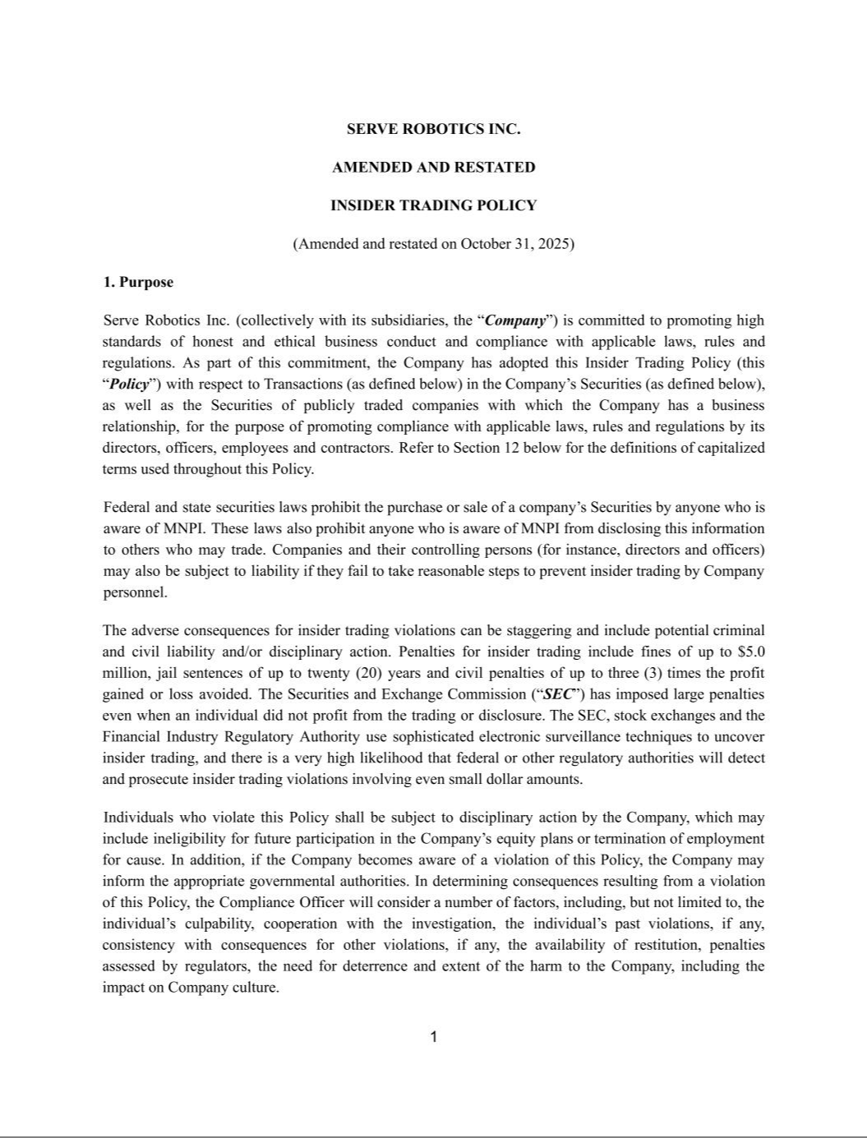

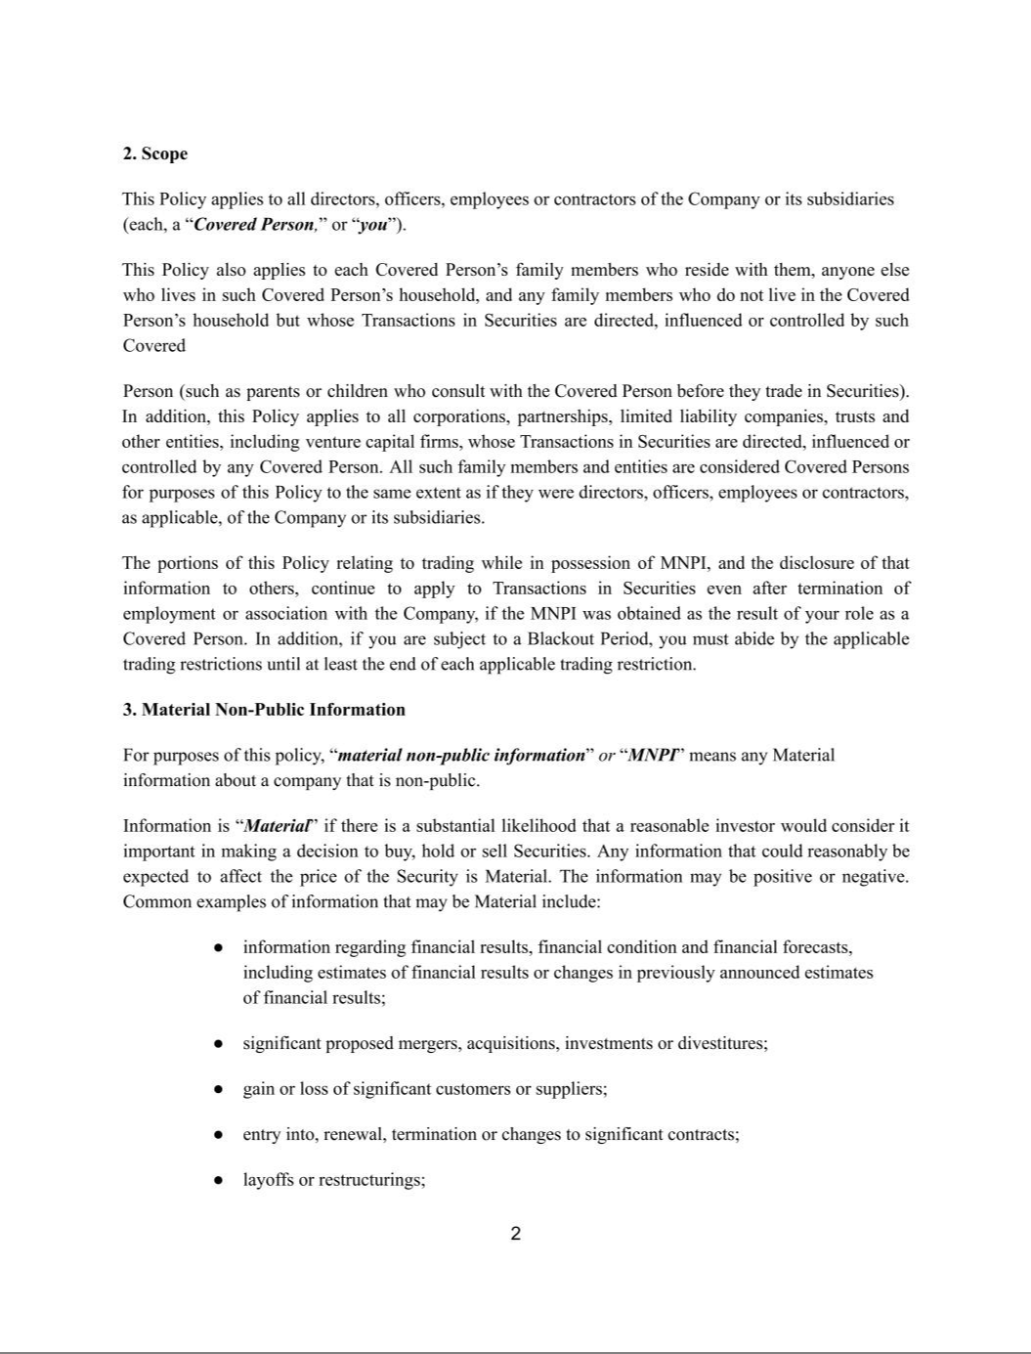

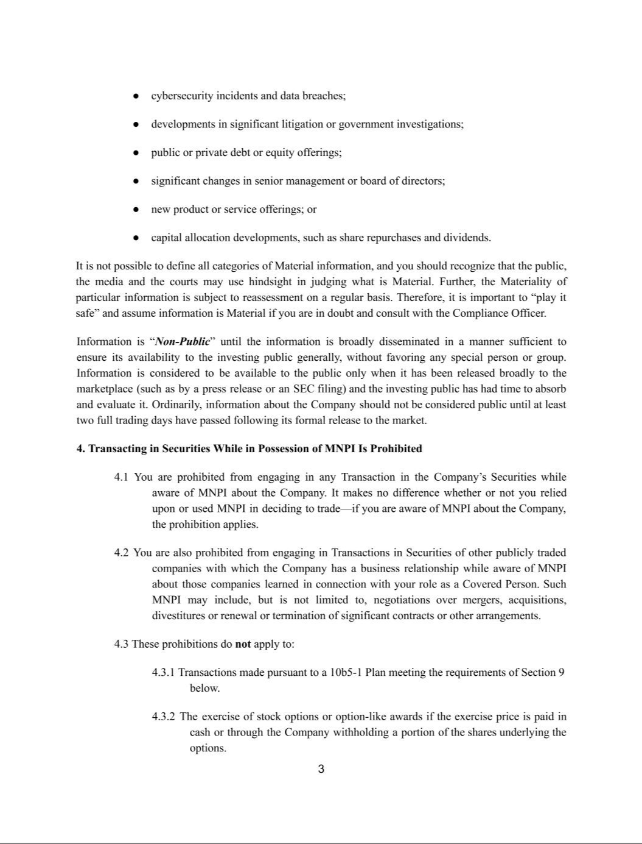

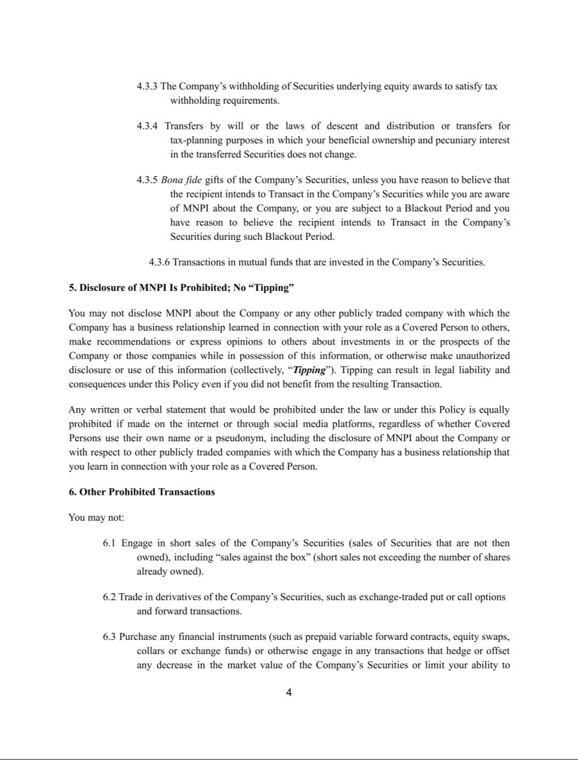

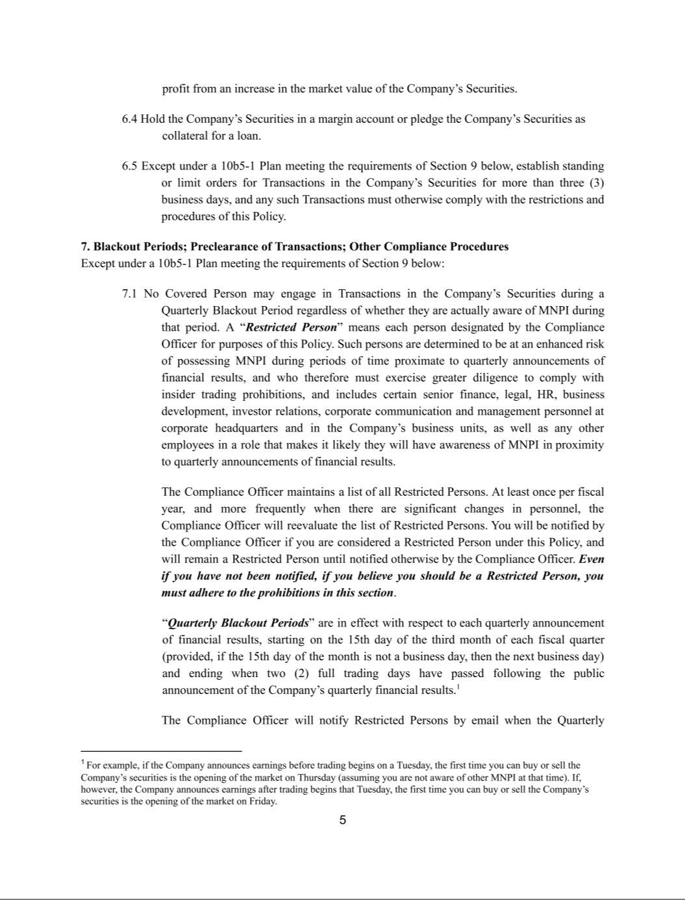

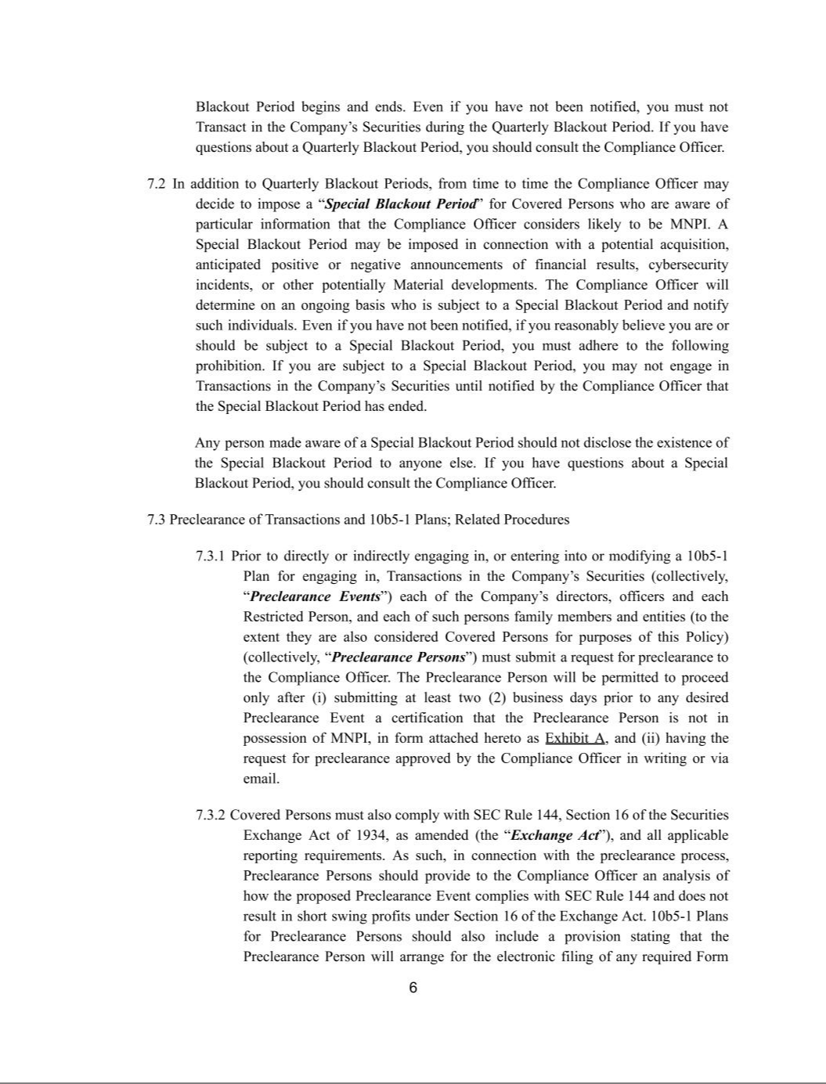

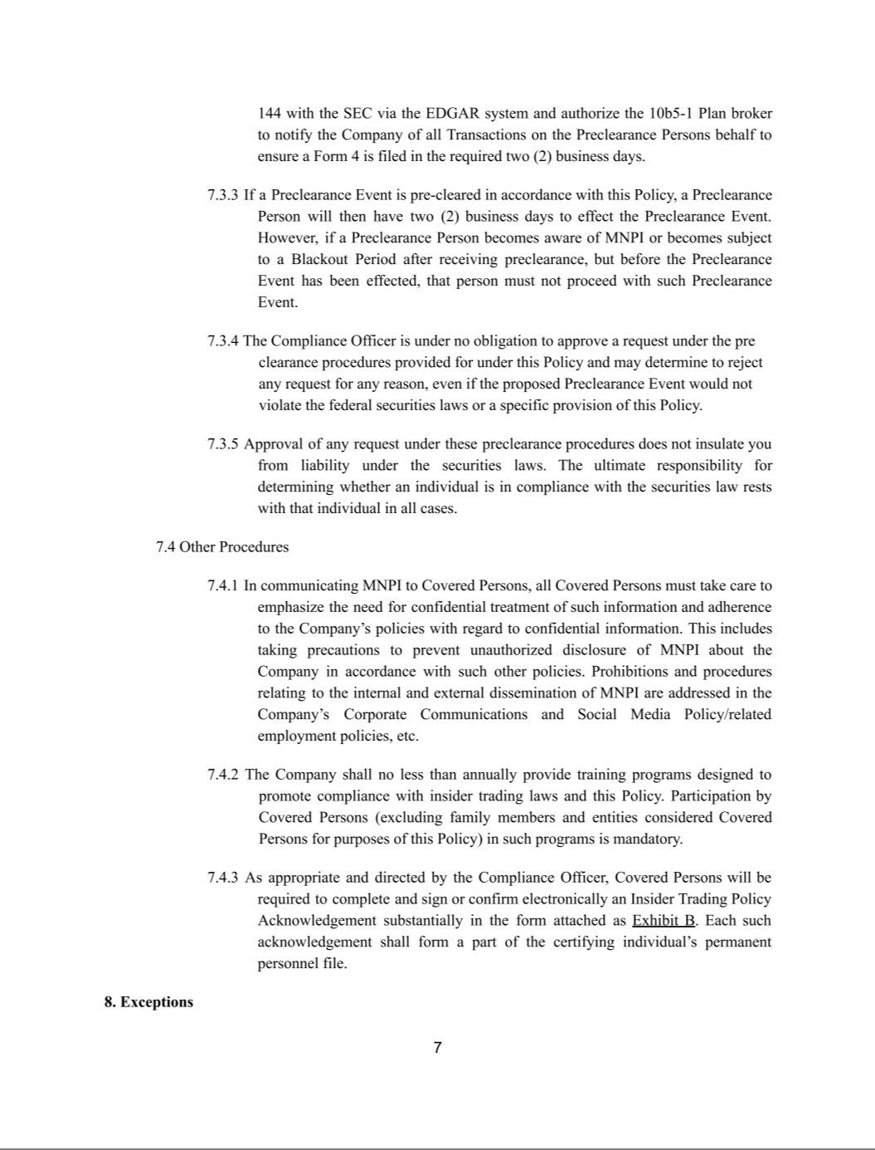

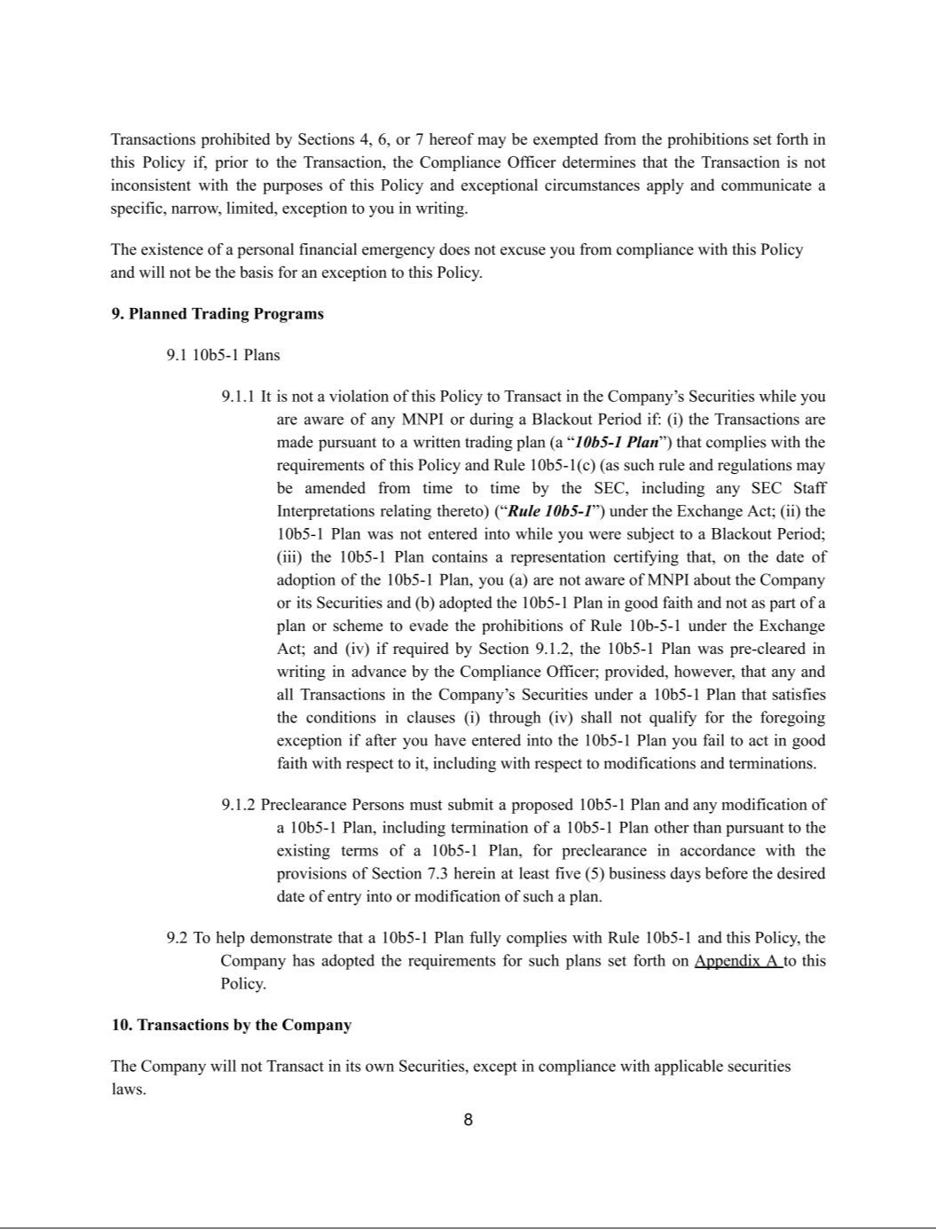

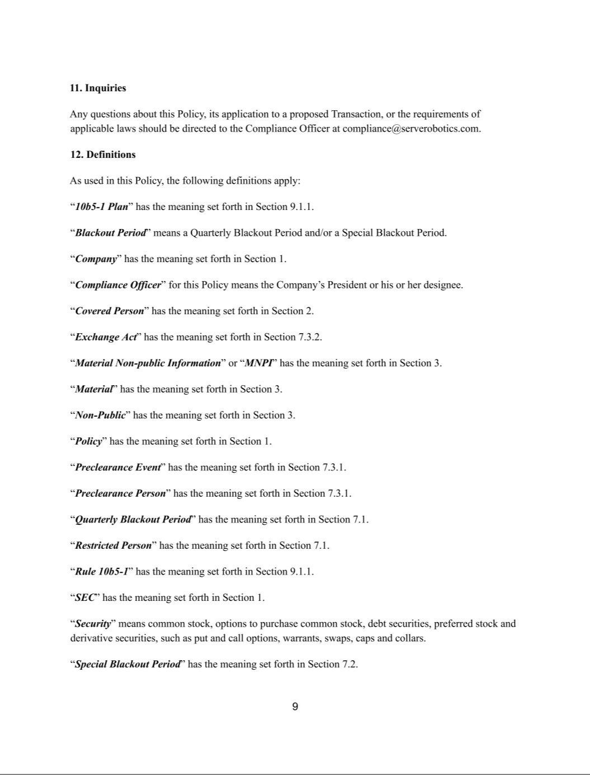

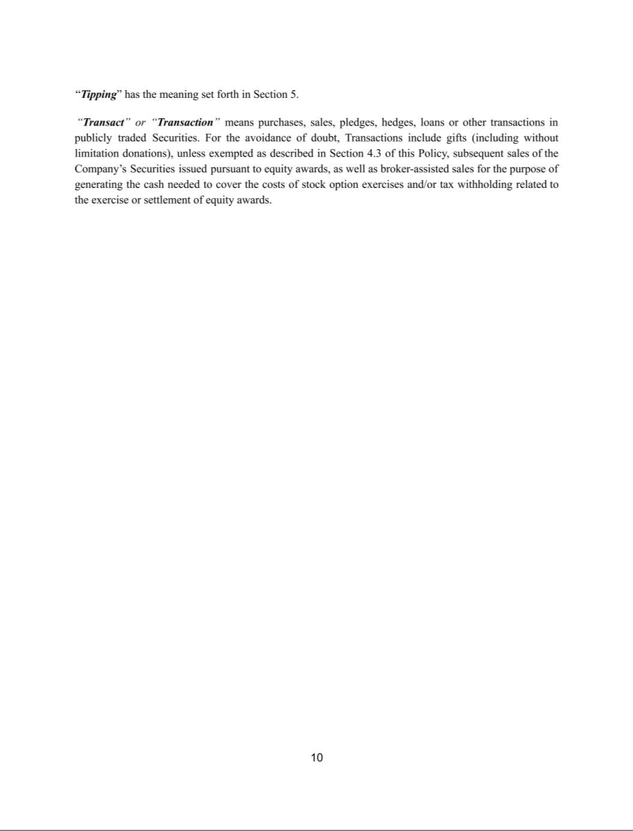

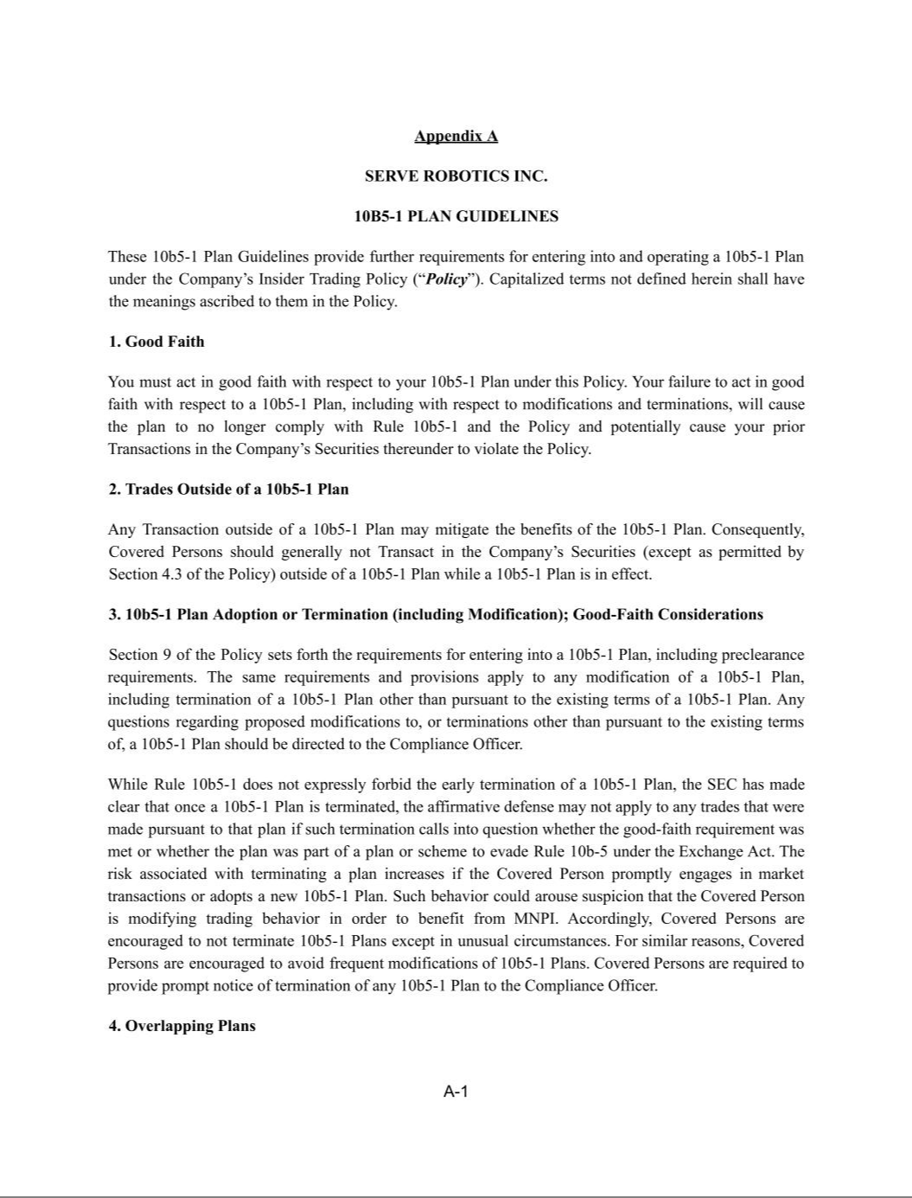

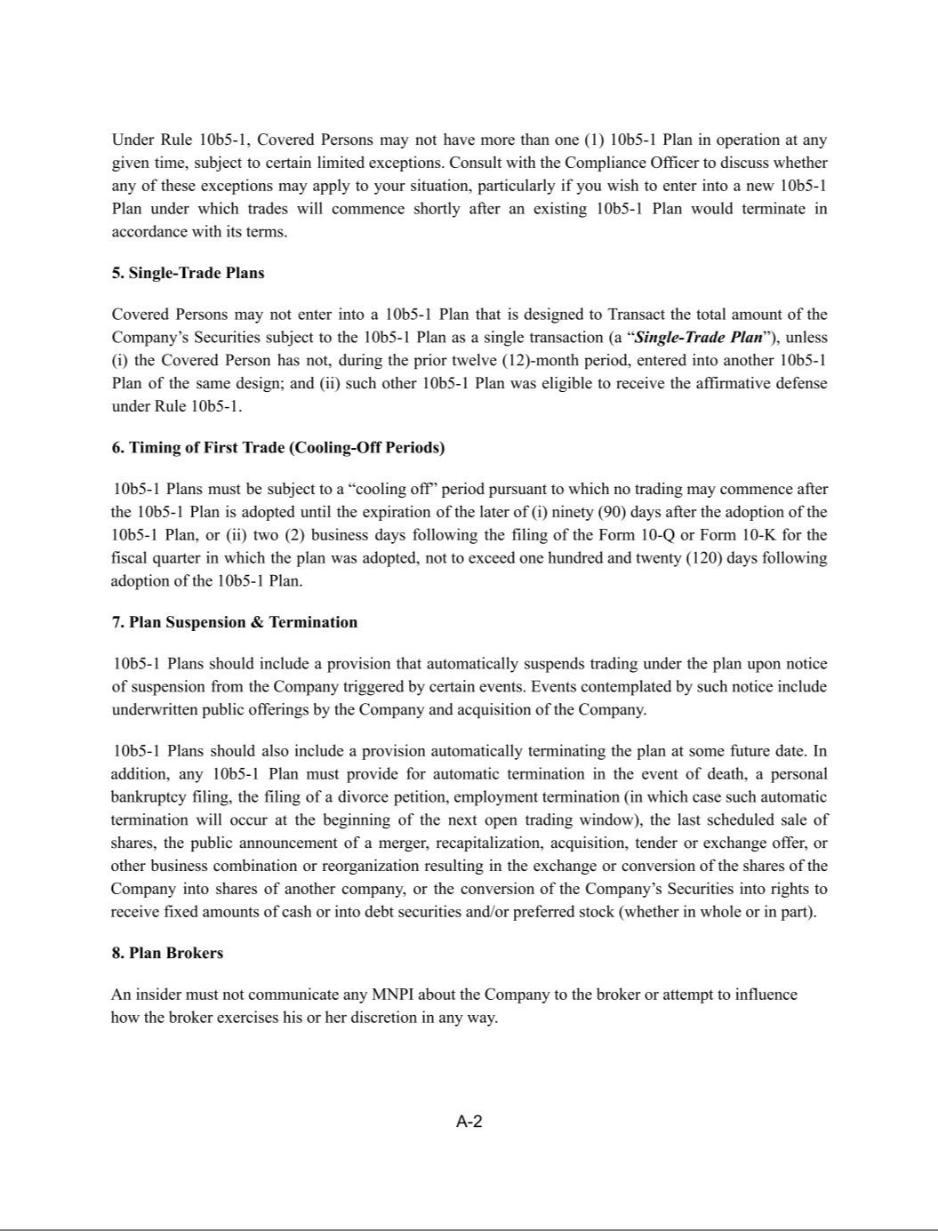

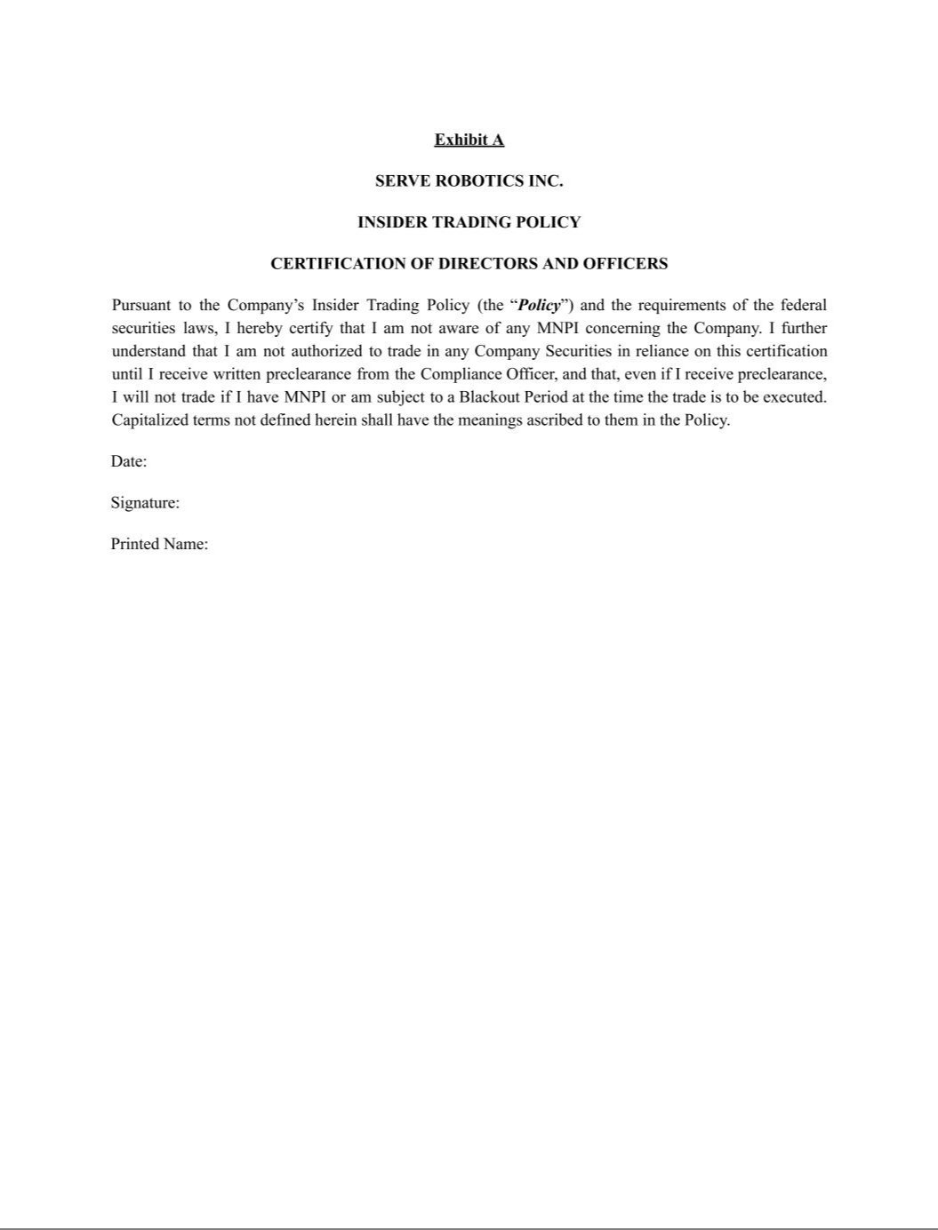

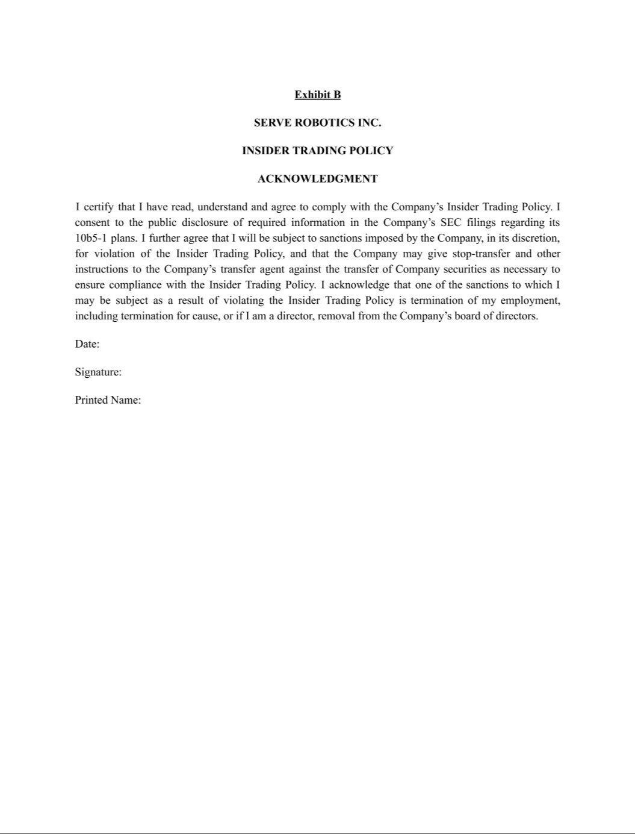

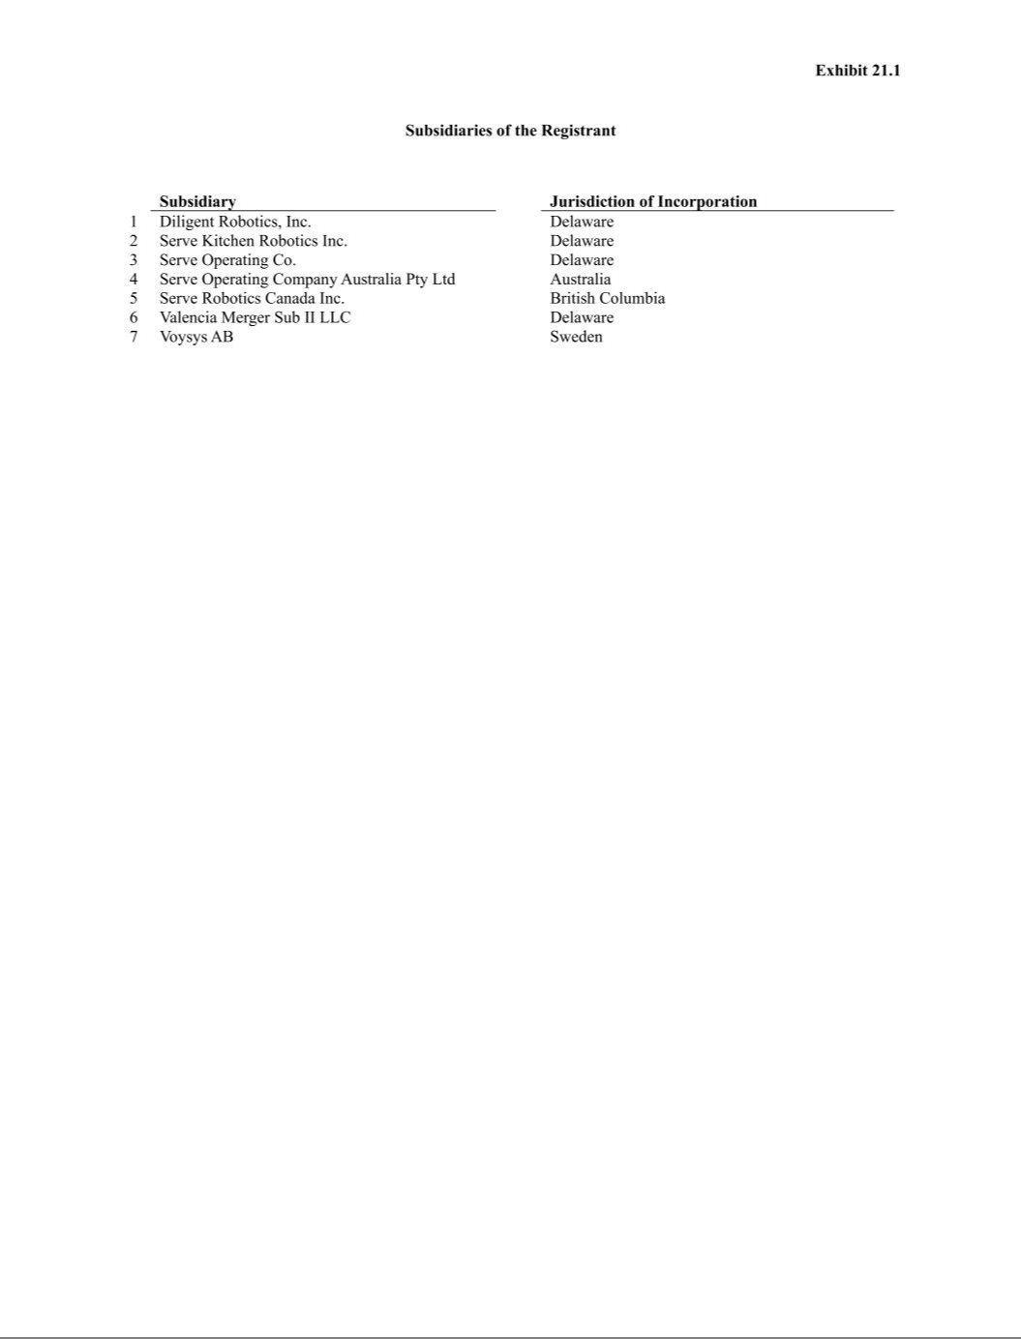

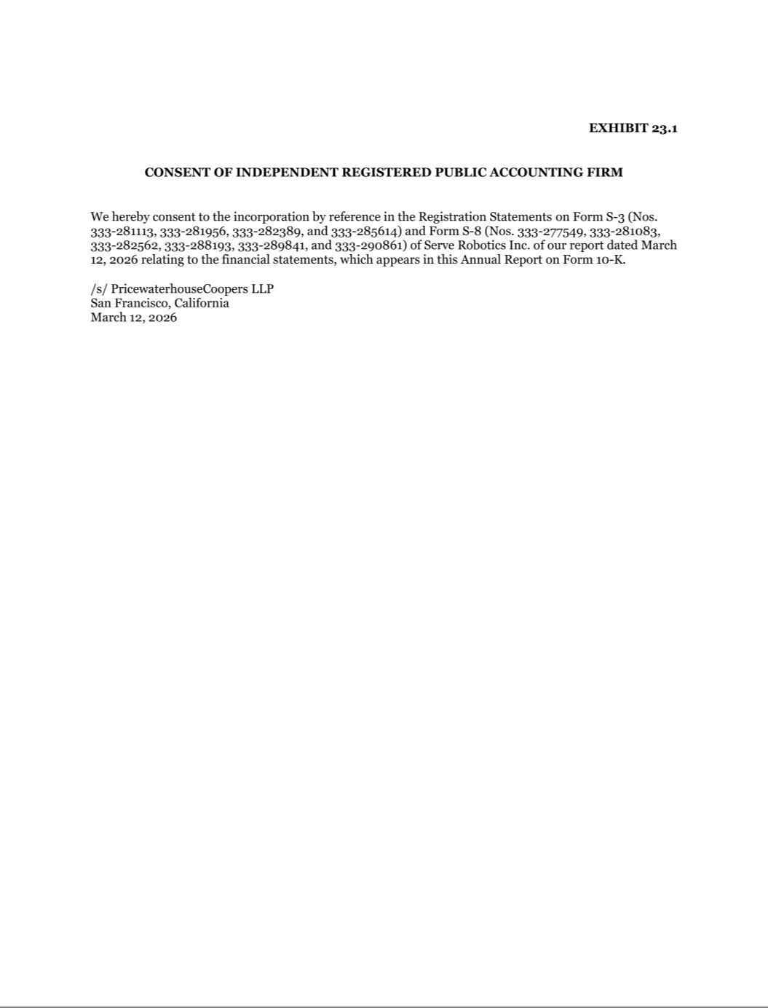

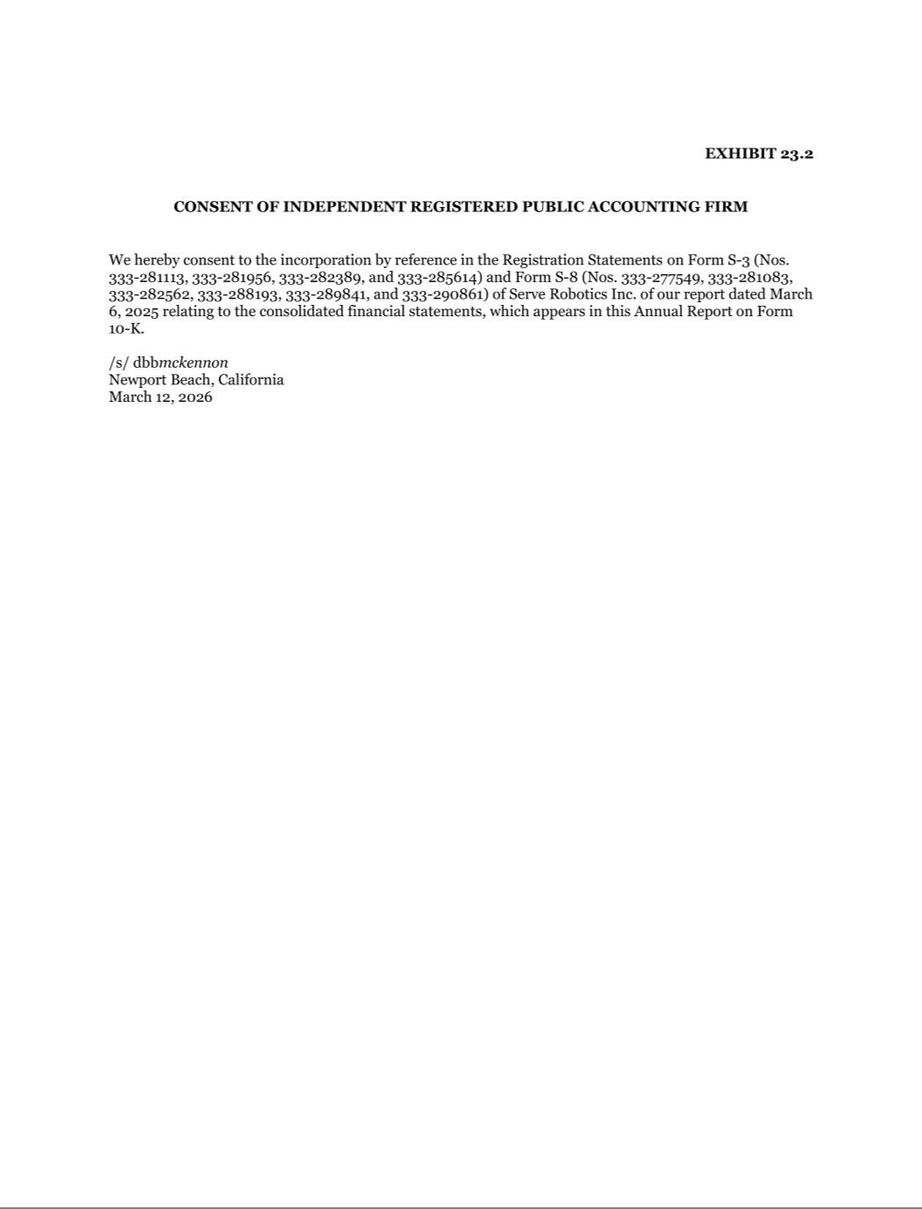

Exhibit 31.1

Certification of Principal Executive Officer Pursuant to Exchange Act Rule 13a-14(a)/15d-14(a) as Adopted

Pursuant to Section 302 of the Sarbanes-Oxley Act of 2002

I, Ali Kashani, certify that:

- I have reviewed this Annual Report on Form 10-K of Serve Robotics Inc.;

- Based on my knowledge, this report does not contain any untrue statement of a material fact or omit to state a material fact necessary to make the statements made, in light of the circumstances under which such statements were made, not misleading with respect to the period covered by this report;

- Based on my knowledge, the financial statements, and other financial information included in this report, fairly present in all material respects the financial condition, results of operations and cash flows of the registrant as of, and for, the periods presented in this report;

- The registrant’s other certifying officer(s) and I are responsible for establishing and maintaining disclosure controls and procedures (as defined in Exchange Act Rules 13a-15(e) and 15d-15(e)) and internal control over financial reporting (as defined in Exchange Act Rules 13a-15(f) and 15d-15(f)) for the registrant and have:

  - Designed such disclosure controls and procedures, or caused such disclosure controls and procedures to be designed under our supervision, to ensure that material information relating to the registrant, including its consolidated subsidiaries, is made known to us by others within those entities, particularly during the period in which this report is being prepared;

  - Designed such internal control over financial reporting, or caused such internal control over financial reporting to be designed under our supervision, to provide reasonable assurance regarding the reliability of financial reporting and the preparation of financial statements for external purposes in accordance with generally accepted accounting principles;

  - Evaluated the effectiveness of the registrant’s disclosure controls and procedures and presented in this report our conclusions about the effectiveness of the disclosure controls and procedures, as of the end of the period covered by this report based on such evaluation; and

  - Disclosed in this report any change in the registrant’s internal control over financial reporting that occurred during the registrant’s most recent fiscal quarter (the registrant’s fourth fiscal quarter in the case of an annual report) that has materially affected, or is reasonably likely to materially affect, the registrant’s internal control over financial reporting; and

- The registrant’s other certifying officer(s) and I have disclosed, based on our most recent evaluation of internal control over financial reporting, to the registrant’s auditors and the audit committee of the registrant’s board of directors (or persons performing the equivalent functions):

  - All significant deficiencies and material weaknesses in the design or operation of internal control over financial reporting which are reasonably likely to adversely affect the registrant’s ability to record, process, summarize and report financial information; and

  - Any fraud, whether or not material, that involves management or other employees who have a significant role in the registrant’s internal control over financial reporting.

Date: March 12, 2026 /s/ Ali Kashani

Ali Kashani

Chief Executive Officer

(Principal Executive Officer)

Exhibit 31.2

Certification of Principal Financial Officer Pursuant to Exchange Act Rule 13a-14(a)/15d-14(a) as Adopted

Pursuant to Section 302 of the Sarbanes-Oxley Act of 2002

I, Brian Read, certify that:

- I have reviewed this Annual Report on Form 10-K of Serve Robotics Inc.;

- Based on my knowledge, this report does not contain any untrue statement of a material fact or omit to state a material fact necessary to make the statements made, in light of the circumstances under which such statements were made, not misleading with respect to the period covered by this report;

- Based on my knowledge, the financial statements, and other financial information included in this report, fairly present in all material respects the financial condition, results of operations and cash flows of the registrant as of, and for, the periods presented in this report;

- The registrant’s other certifying officer(s) and I are responsible for establishing and maintaining disclosure controls and procedures (as defined in Exchange Act Rules 13a-15(e) and 15d-15(e)) and internal control over financial reporting (as defined in Exchange Act Rules 13a-15(f) and 15d-15(f)) for the registrant and have:

  - Designed such disclosure controls and procedures, or caused such disclosure controls and procedures to be designed under our supervision, to ensure that material information relating to the registrant, including its consolidated subsidiaries, is made known to us by others within those entities, particularly during the period in which this report is being prepared;

  - Designed such internal control over financial reporting, or caused such internal control over financial reporting to be designed under our supervision, to provide reasonable assurance regarding the reliability of financial reporting and the preparation of financial statements for external purposes in accordance with generally accepted accounting principles;

  - Evaluated the effectiveness of the registrant’s disclosure controls and procedures and presented in this report our conclusions about the effectiveness of the disclosure controls and procedures, as of the end of the period covered by this report based on such evaluation; and

  - Disclosed in this report any change in the registrant’s internal control over financial reporting that occurred during the registrant’s most recent fiscal quarter (the registrant’s fourth fiscal quarter in the case of an annual report) that has materially affected, or is reasonably likely to materially affect, the registrant’s internal control over financial reporting; and

- The registrant’s other certifying officer(s) and I have disclosed, based on our most recent evaluation of internal control over financial reporting, to the registrant’s auditors and the audit committee of the registrant’s board of directors (or persons performing the equivalent functions):

  - All significant deficiencies and material weaknesses in the design or operation of internal control over financial reporting which are reasonably likely to adversely affect the registrant’s ability to record, process, summarize and report financial information; and

  - Any fraud, whether or not material, that involves management or other employees who have a significant role in the registrant’s internal control over financial reporting.

Date: March 12, 2026 /s/ Brian Read

Brian Read

Chief Financial Officer

(Principal Financial and Accounting Officer)

Exhibit 32.1

Certification of Principal Executive Officer Pursuant to 18 U.S.C. Section 1350 as Adopted Pursuant

to Section 906 of the Sarbanes-Oxley Act of 2002

In connection with the Annual Report on Form 10-K of Serve Robotics Inc. (the “Company”) for the year ended December 31, 2025, as filed with the Securities and Exchange Commission (the “Report”), I, Ali Kashani, Chief Executive Officer (Principal Executive Officer) of the Company, hereby certify as of the date hereof, solely for purposes of Title 18, Chapter 63, Section 1350 of the United States Code, that to the best of my knowledge:

- The Report fully complies with the requirements of Section 13(a) or 15(d), as applicable, of the Securities Exchange Act of 1934, and

- The information contained in the Report fairly presents, in all material respects, the financial condition and results of operations of the Company at the dates and for the periods indicated.

Date: March 12, 2026 /s/ Ali Kashani

Ali Kashani

Chief Executive Officer

(Principal Executive Officer)

Exhibit 32.2

Certification of Principal Executive Officer Pursuant to 18 U.S.C. Section 1350 as Adopted Pursuant

to Section 906 of the Sarbanes-Oxley Act of 2002

In connection with the Annual Report on Form 10-K of Serve Robotics Inc. (the “Company”) for the year ended December 31, 2025, as filed with the Securities and Exchange Commission (the “Report”), I, Brian Read, Chief Financial Officer (Principal Financial and Accounting Officer) of the Company, hereby certify as of the date hereof, solely for purposes of Title 18, Chapter 63, Section 1350 of the United States Code, that to the best of my knowledge:

- The Report fully complies with the requirements of Section 13(a) or 15(d), as applicable, of the Securities Exchange Act of 1934, and

- The information contained in the Report fairly presents, in all material respects, the financial condition and results of operations of the Company at the dates and for the periods indicated.

Date: March 12, 2026 /s/ Brian Read

Brian Read

Chief Financial Officer

(Principal Financial and Accounting Officer)

